Local Discourse Alpha Test – see how you like my software and give me feedback
- “Local Discourse” is a place holder name. I don't yet know what it will actually be called
- use it to discuss any topic with people in your town
- it's like a blend of yik yak and reddit, with file sharing capabilities and a tagging system

I am asking you to be an alpha tester of this software. You just need to use the software, let me know of any bugs, and any suggestions you may have. Take a look at this document and let me know if you have any questions.

How the app works:
- what if you had a thought or an idea that you wanted to share with your community members?
  - Hop on the app and post it
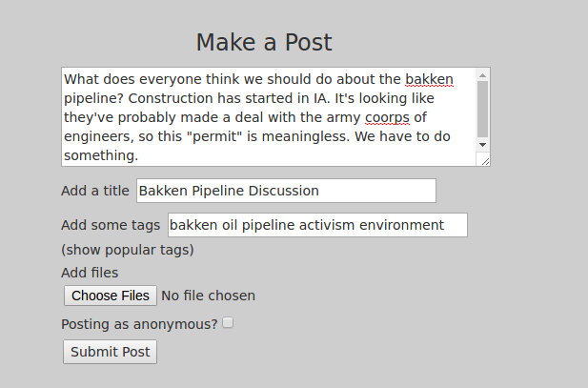
- What if you wanted to see what your community members were thinking about a certain topic or set of topics?
  - Hop on the app and look it up
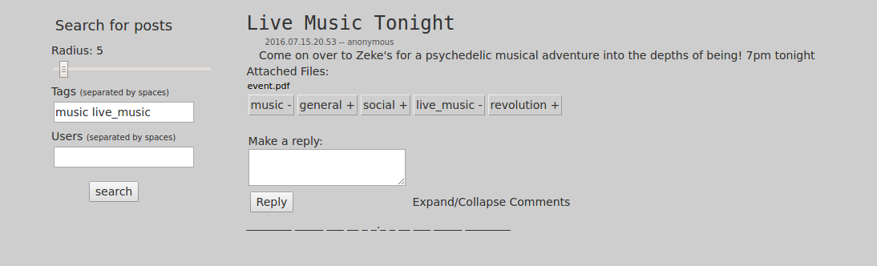

Features available in alpha test:
- posting and commenting
- uploading files
- searching by radius, tags, and users
- comment threads
- you can have a user account with a username and biography
- post as anonymous or identified

Right now you can use the software in the form of a website. It is running on a server in New York.

URL: https://192.81.217.92/yikkit (IP address because I have not registered a domain)

If you get an https warning, it's because it uses a self-signed ssl certificate. There is no cause for concern.

Planned features
- up/down vote
- polls
- have the option to include related tags in search query (more on related tags later)
- search by keywords
- search by files
- url system: you can click on a url and see every post that has included that url or the domain of that url
- anonymous commenters have an id within a comment thread
- see a world map showing instances of tag use
- decentralized server infrastructure
- mobile apps

Related tags:
- two tags will become more related each time:
  - they both are associated with the same post
  - a user includes both of the tags in their query

