CIVE 202 Project 1 Report: Air Quality
University of Nebraska-Lincoln

CIVE 202 Gavin Rothmeyer

February 3, 2026

Table of Contents
Introduction 3
Methods 3
Results & Discussion 3
Reference List 4

Introduction
Project Goals:
The goal of the project is to analyze the air quality data collected by AirPurple across Nebraska from February 2024 to March 2025 for the UNMC Water, Climate and Health Working Group. The analysis will consist of evaluating concentrations of PM2.5, PM10, and Volatile Organic Compounds (VOC) to identify if air quality meets NAAQS standards and determine potential locations of public health concern. The project will further analyze influence on air quality, such as how temperature, humidity, and location will influence the air quality levels. Results from this data analysis will be used to determine potential air quality hazards and assess the public health risks associated.

Task 1: Determine the 5 Nebraska Locations with the Highest Pollutant Concentrations
AirPurple sensor data will be grouped in this task to calculate the mean and median of each pollutant. The 5 locations in Nebraska will be identified and highlight potential concern for air quality. The results will highlight which locations have relatively poor air quality.

Task 2: Determine the Statistical Maximums
Maximum values for each pollutant recorded will be identified and used to determine the dates and locations of the sensors at which these maximums occurred. The analysis will consist of filtering the dataset to find maximum pollutant values and gather the corresponding dates and locations. Additional research includes utilizing Air Now to determine possible factors in the region that may have contributed to poor air quality. The result of this task provides background to the poor air quality.

Task 3: Humidity and Temperature Influence on Air Quality
Next, the previous data will be used to compare the dates with their respective humidity and temperature to evaluate whether there is a correlation in these conditions. Average concentrations will be compared to deciding if weather influenced the air quality.

Task 4: AQI relation to Health
Then, an assessment of PM2.5 and PM10 concentrations using the EPA's AQI ratings to determine whether any location experienced unhealthy conditions for sensitive populations Additional research will explore the potential causes of these events, looking at outside conditions such as sources of pollution or atmospheric conditions. This analysis will help further identify any potential public health risks across the state of Nebraska.

Task 5: Altitudes impact on air quality
This task will evaluate air quality and whether sensor altitude influences the measured concentrations. The air quality data will be grouped by its sensor elevation to draw a comparison and determine whether the pollutants have some correlation to altitude. The results will further help determine if the altitude is playing a role in air quality measurements across the monitors in Nebraska.

Table 1. Final Deliverables
Deliverable | Files Included | Date
Raw Data File | CIVE202_Spring2025_GavinRothmeyer_Project1_AirQuality.CSV | 2/3/26
Python Code | CIVE202_Spring2025_GavinRothmeyer_Project1_Code.ipynb | 2/3/26
Organized Files | GitHub Link containing this data | 2/3/26
Scope of Work | CIVE202_Spring2025_GavinRothmeyer_Project1_SOW.DOCX | 2/3/26
Annotated Code | CIVE202_Spring2025_GavinRothmeyer_Project1_ACD.DOCX | 2/3/26
A Written Report | CIVE202_Spring2025_GavinRothmeyer_Project1_SummaryReport.DOCX | 2/3/26

Methods
Following are the procedures used to complete the client requests outlined in a scope of work format. All computations were carried out in a Python notebook environment using pandas. Raw data collected from AirPurple was organized and summarized using statistics to evaluate the concentrations of the 3 pollutants of interest.
First the air quality data will group by location using the sensor name and calculate mean and median concentrations of PM2.5, PM10 and VOC using the AirPurple dataset in a Python Jupyter Notebook environment. The CSV file will be structured as a dataframe for analysis. This task will use Pythons pandas library, group data by sensor name, and use aggregation functions to calculate the statistics needed for a summary. The data will then be sorted to identify the highest values. The five locations in Nebraska with the highest mean and median concentrations for each of the pollutants will be identified and further summarized in tables. Additional research may include identifying city names from the given latitude/longitude locations. The results will highlight which locations have relatively poor air quality.
Next, the maximum values for PM2.5, PM10 and VOC recorded will be identified and used to determine the dates and locations of the sensors at which these maximums occurred. In Python, the analysis will consist of filtering the dataset to find maximum pollutant values and gather the corresponding dates and locations using aggregation functions. The iloc function was used to index rows and columns by their numerical location, not by their contents. The data will then be grouped by sensor name for consistency. Additional research includes utilizing Air Now to determine possible factors in the region that may have contributed to poor air quality. The result of this task provides background to the poor air quality.
Next, the previous data will be used to compare the dates with their respective humidity and temperature to evaluate whether there is a correlation in temperature, humidity, and air quality. In Python, the task will be to group data by humidity and temperature. Data for air quality will be grouped by its sensor name and categorized with the defined temperature and humidity ranges. Mean concentrations for each pollutant will be calculated within each category. These results will be used to determine if these weather conditions can be associated with high pollutant levels.
Then, an assessment of PM2.5 and PM10 concentrations using the EPA's AQI ratings to determine whether any location experienced unhealthy conditions for sensitive populations. In Python, AQI ratings will be applied to flag values that are potential risks. Where applicable, the dates and sensor locations will be identified and summarized. Additional research will explore the potential causes of these events, looking at outside conditions such as sources of pollution or atmospheric conditions. This analysis will help further identify any potential public health risks across the state of Nebraska.

This task will investigate the potential of a relationship between the altitude of the sensor and the measured pollutant concentration. The data will next need to be filtered by the sensor altitude and grouped with the PM2.5, PM10, and VOC concentrations to analyze them within Python. The pollutant concentrations will be analyzed using summary statistics to assess whether the elevations have an impact. The results will further help determine if the altitude is playing a role in air quality measurements across the monitors in Nebraska.

Results & Discussion
After analyzing the AirPurple data to determine the mean and median concentrations of the pollutants PM2.5, PM10 and VOC. Several locations recorded higher pollutant levels than others for each pollutant. The following figures show the top 5 locations for each pollutant mean and median. Overlap can be seen among several of the locations for each pollutant. McCook can be seen in the top 5 for all 3 pollutants means. These top 5 sensors displayed values much higher than the range considered safe for each pollutant.

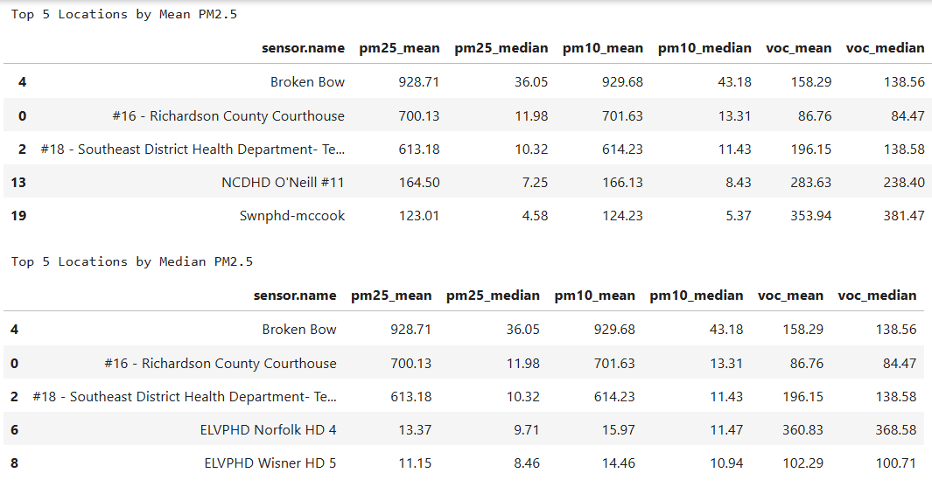
Figure 1. Top 5 locations for PM2.5 by mean and by median

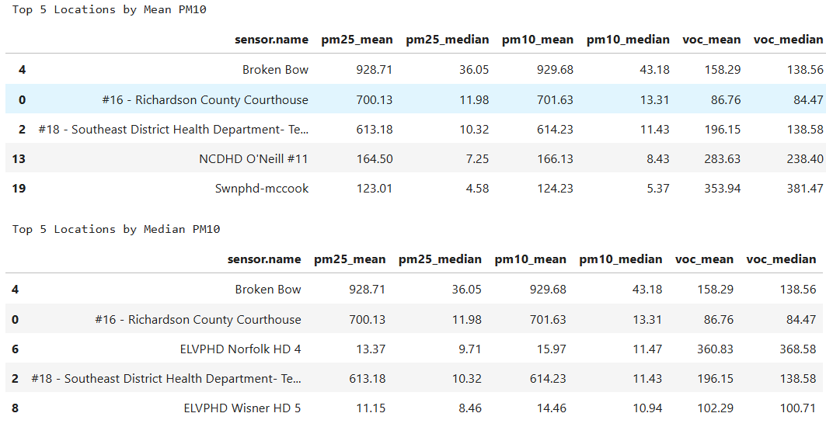
Figure 2. Top 5 locations for PM10.0 by mean and by median

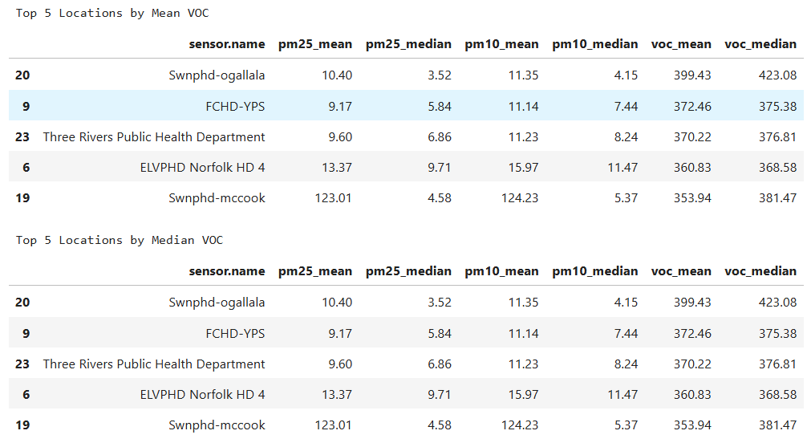
Figure 3. Top 5 locations for VOC by mean and by median

Next, the maximum recorded values for each pollutant were identified with the corresponding locations and dates as shown in table 2. These levels can be attributed to wildfires in the area around that time. Each pollutant displayed a peak event higher than the typical concentration statewide. The dates and sensor locations provide more context on when and where the most severe air pollution occurred between February 2024 and March 2025. These elevated levels can be connected to agriculture in the area which leads to dust storms and high pollutant levels (Nebraska, n.d.). This data was then used to find a possible connection between weather and pollutant levels.

Table 2. Maximum concentrations of each pollutant
 | Date | Concentration | Latitude | Longitude | Sensor Name
PM 2.5 | 2/18/25 | 3782.82 | 40.0622 | -95.6024 | Richardson County Courthouse
PM 10.0 | 2/18/25 | 3784.68 | 40.0622 | -95.6024 | Richardson County Courthouse
VOC | 6/24/24 | 1209.93 | 41.128284 | -101.72022 | SWNPHD-Ogallala

An analysis of the average concentration of each pollutant compared to a temperature and humidity levels as seen in Figure 4. For the pollutants PM10 and PM2.5, the average concentrations were higher when the temperature was below freezing. Meanwhile VOC was highest when temperatures fell in the Cool range between 32 and 50 degrees Fahrenheit. This means that the cooler temperatures seem to bring higher concentrations of the 3 pollutants. Similarly, the average pollutant level was highest for both PM2.5 and PM10 when the humidity was high, and for VOC when the humidity was low. Overall, these trends suggest that the weather conditions in Nebraska influence the pollutant levels in the air, meaning the temperature and moisture in the air can impact its quality.

Figure 4. Temperature and Humidity
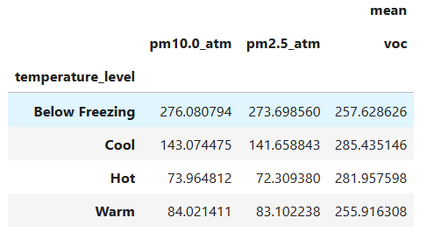
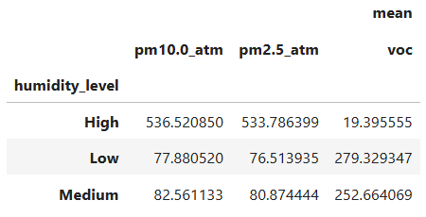
Now, comparing the pollutants concentrations to the EPA AQI categories, it displays any instances where there may be an elevated public health risk. The safe range for PM2.5 is between 0-35.4 micrograms per cubic meter, PM10 between 0-154 micrograms per cubic meter (U.S., n.d.).

The data showed 118 instances where the PM2.5 value was unhealthy for sensitive groups, likewise there were 3 instances where the PM10 was in this range. For discussion, the top 3 will be shown in a table and the top 1 of each will be discussed. Figure 5 below highlights the top 3 instances where these values fell in that range. The highest concentrations of PM2.5 and PM10 that were unhealthy for sensitive groups occurred on January 9, 2025, in the South Heartland District and on June 14, 2024, at the Loup Basin Public Health Department, respectively.

The high PM2.5 was likely caused by local wildfires or temperature inversions. Temperature inversions are a layer of warm air surrounding and trapping a colder layer of air and pollutants near the ground, allowing pollutants to accumulate. EPA AirNow states that the winter atmosphere can slow the mixing of air and promote these higher concentrations (U.S., n.d.). The high value for PM10 can likely be attributed to agriculture during this season in Nebraska, as PM10 is often caused by dust and soil in the air. Tilling of fields as well as planting of crops both disturb the soil and mix dust into the air, in turn elevating the PM10 levels (Nebraska, n.d.).

Figure 5. Top 3 Unhealthy for Sensitive Populations.
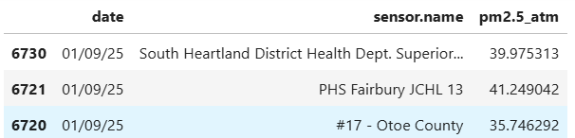

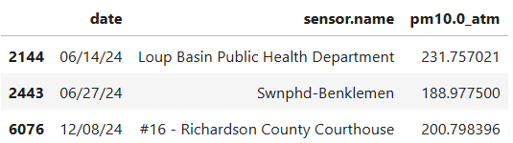

Finally, a comparison to the sensor altitude at each location allows analysis of whether pollutant levels recorded are affected by the elevation of the sensor. After sorting and displaying the data in tables, there is no clear trend indicating that the elevation plays a key role in the level of concentration recorded at each sensor. This outcome suggests that despite the elevation playing a role in air mixture on a local scale, there is no major impact. Overall, other factors play a more pivotal role in predicting the cause of air pollutant levels in Nebraska across these monitoring locations.

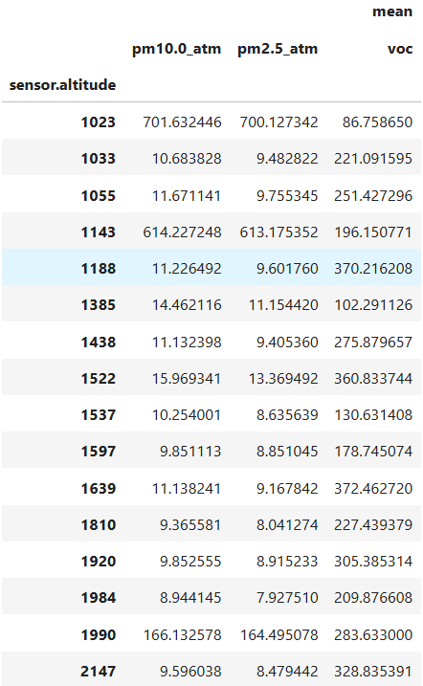

Reference List
U.S. Environmental Protection Agency. (n.d.). Air quality index (AQI) basics. AirNow. https://www.airnow.gov/aqi/aqi-basics

U.S. Environmental Protection Agency. (n.d.). Air data: Basic information. https://www.epa.gov/outdoor-air-quality-data/air-data-basic-information

U.S. Environmental Protection Agency. (n.d.). AQI breakpoints. https://aqs.epa.gov/aqsweb/documents/codetables/aqi_breakpoints.html

Nebraska Department of Environment and Energy. (n.d.). Smoke and air quality. https://dee.nebraska.gov/smoke-and-air-quality

