CIVE 202 Project 2 Report: NDOT Mix Design Automation
University of Nebraska-Lincoln

CIVE 202 Group 12

February 23, 2026

Table of Contents
Introduction 3
Methods 3
Results & Discussion 3
Reference List 4

Introduction
Project Goals:
The purpose of this project is to automate the concrete mix design process currently maintained in an Excel-based workflow by NDOT. The objective is to translate the logic contained in the “Mix Design” worksheet of the NDOT Concrete Mix Excel file into a structured, modular, and fully functional Python program. The final system will allow users to enter material properties and design parameters through sequential prompts and generate a professionally formatted weight chart for one cubic yard of concrete. This automation will improve repeatability, transparency, and reliability while supporting future integration into a web-based platform.

Task 1: Review and Analysis of Existing Excel Model
Our group will examine the NDOT Mix Design Excel workbook to discover all existing formulas, together with all cell references and all calculation dependencies. Then, we will document all input parameters together with all intermediate calculations and final outputs. Finally, we will map all Excel formulas to match mathematical expressions, which will be used for Python implementation.

Task 2: Python Code Development
Our group will create Python functions as individual modules that will implement all major calculations from the Mix Design worksheet, including water content calculations, cement content calculations, cement content calculations, aggregate proportion calculations, air content adjustment calculations, and unit weight calculation. The system will implement input() prompts, which will enable users to define their parameters through an orderly process that reflects the sequence of the Excel workflow. All the calculations will maintain unit consistency while following NDOT specifications. We will create a weight chart for one cubic yard of concrete which will display outputs through clearly labeled output sections.
Task 3: Scenario Development and Testing
The team will document four realistic concrete mix design scenarios which comply with NDOT standards and all related technical references. The system will ensure that all scenarios function correctly with the input structure developed in Python. The automated workflow system will handle every mix scenario through its process to test both accuracy and consistency. Then, we will analyze the results from all scenarios to determine whether input changes produce expected engineering variations in output results.

Task 4: Documentation and Reporting
Finally, our team will create a Jupyter Notebook (.ipynb) that presents the code structure and sequential prompts, along with results from all four scenarios. We will then create an Annotated Code Document, which will describe all Excel-to-Python logic conversions through detailed line-by-line explanations. The Technical Report will include an Introduction section together with the Methods section, Results and Discussion section, and References section. We will establish a GitHub repository that will store all code, along with documentation and a README file that contains User Guide information. Lastly, we will create a Gantt Chart which will display task sequences, task durations, and all project milestones.

Table 1. Final Deliverables
Deliverable | Files Included | Date
Raw Data File | CIVE202_Spring2025_Group12_Project2_ | 2/24/26
Python Code | CIVE202_Spring2025_ Group12_Project2_Code.ipynb | 2/24/26
Organized Files | GitHub Link containing this data | 2/24/26
Scope of Work | CIVE202_Spring2025_ Group12_Project2_SOW.DOCX | 2/24/26
Annotated Code | CIVE202_Spring2025_ Group12_Project2_ACD.DOCX | 2/24/26
Written Report | CIVE202_Spring2025_Group12_Project2_SummaryReport.DOCX | 2/24/26

Methods
Following are the procedures used to complete the client requests outlined in a scope of work format. All computations were carried out in a Python notebook environment using pandas.

First, the NDOT Excel “Mix Design” worksheet was reviewed to identify the calculations that the sheet performs to produce a final weight chart for one cubic yard of concrete. Emphasis was put on translating the core logic (water demand, cementitious volumes, air volume, water volume, remaining aggregate volume, and aggregate weights) into repeatable Python calculations.

Next, we established constant values used repeatedly in the excel and defined them. One cubic yard is 27 ft³ and the unit weight of water is 62.4 lb/ft³. This is helpful when converting between weights and volumes.

Then, we designed the program to collect user inputs in the same order the excel sheet expects them. Sequential prompts were used so the user enters project information first like project number and concrete class, then all the necessary information such as weights, volumes, etc. This step was essential to the project because it ensures the Python workflow mirrors the Excel workflow.
Next, after collecting the cementitious weights (cement, fly ash, silica fume, and other SCM), the total cementitious weight was calculated by summing those components. Multiple later calculations depend on the cementitious total, so this step was completed early. One example is the water weight calculation based on the user’s water–cementitious ratio.
Next, the Excel water calculation was written in Python by creating a function that computes the required mixing water weight. In Excel, the water weight is calculated by multiplying total cementitious weight by the water–cementitious ratio, so that exact relationship was used in Python as the first major computed output.
Next, the Excel volume conversions were input in Python by creating separate functions to compute the volume of each cementitious component. The relationships used were the same as the Excel: volume equals weight divided by the product of specific gravity and the unit weight of water. One function was defined for each of the inputs including cement volume, fly ash volume, silica fume volume, and other SCM volume so the code stays modular and matches the worksheet structure.
Next, air volume was implemented in Python by converting the input air percentage into a cubic-foot volume for one cubic yard of concrete. Multiplying the air fraction (air percent divided by 100) by 27 ft³ gave this result. This matches how the Excel sheet treats entrained air as a volume component of the mixture.
Next, we implemented water volume in Python by converting the computed water weight into water volume. We did this by dividing water weight by 62.4 lb/ft³, which matches Excel’s conversion from weight of water to volume of water.
Next, we computed the remaining volume available for aggregates. In Excel, total aggregate volume is calculated as the total volume (27 ft³) minus the volumes of cementitious materials, minus air volume, minus water volume. We replicated this exactly in Python in a dedicated function so that all mixture components correctly sum to one cubic yard.
Next, we used the user-entered aggregate percentages to split the total aggregate volume into fine aggregate volume, coarse aggregate volume, and other aggregate volume. This step mirrors the Excel logic where the total aggregate fraction is allocated by percentage.
Next, we converted aggregate volumes back into aggregate weights. We did this using the same structure used for cementitious volumes organized by weight: weight equals unit weight of water times specific gravity times the component’s volume. We also included the aggregate percentage factor, so each aggregate component receives the correct share of the total aggregate volume.
Next, once all weights were computed, we formatted and printed a final weight chart that lists each component in pounds per cubic yard. We included cement, fly ash, silica fume, other SCM (if applicable), fine aggregate, coarse aggregate, other aggregate (if applicable), and total water. This output layout was chosen to be client-readable and to match the expected NDOT deliverable.
Next, after the code was complete, we verified that the program ran start-to-finish without errors by executing the full sequential input process. Intermediate values were checked to ensure they were reasonable (for example, that total component volumes were consistent with one cubic yard and that aggregate volume did not become negative).
Finally, four realistic mix design scenarios were evaluated by running the workflow four separate times using different sets of input parameters. A comparison of the outputs across the scenarios confirmed the model responds logically to changes in water–cementitious ratio, air content, cementitious composition, and aggregate proportions. This scenario testing served as a basic validation step that the translated Python logic behaves consistently with expected concrete mix design behavior.

Results & Discussion
To evaluate the performance of our automated Python mix design model, four realistic concrete mix scenarios were simulated and analyzed. Each scenario represents a common case in transportation infrastructure and was designed to produce typical ranges used by the NDOT. The model was executed four separate times using these inputs, and the resulting weight charts were compared to assess how changes in design parameters influence the final mix proportions.

Typical Roadway Concrete: Used for roadways, curbs, and sidewalks
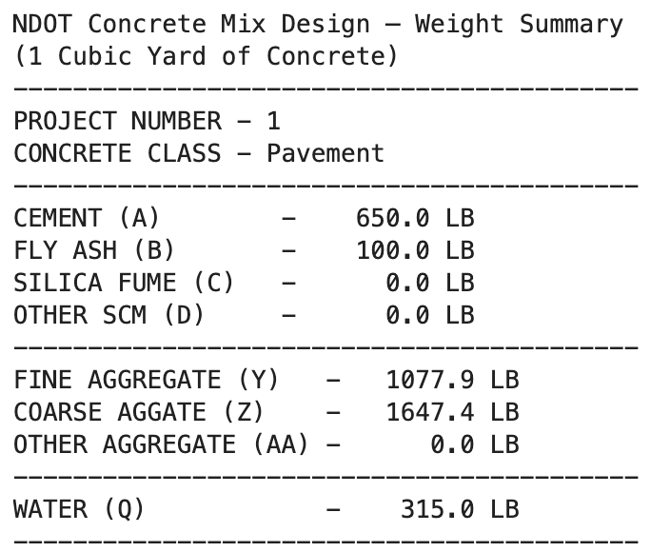
Figure 1. Mix Design Scenario 1 - Pavement

Structural Roadway Concrete: Used for bridge decks and buildings
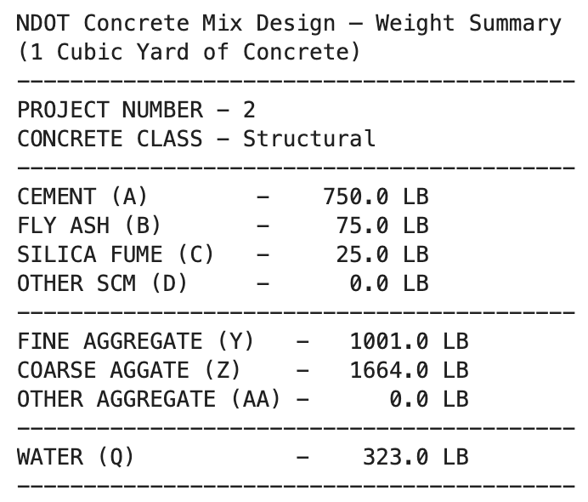
Figure 2. Mix Design Scenario 2 - Structural

Low Volume Concrete: Used for patch work and valued for being cheaper
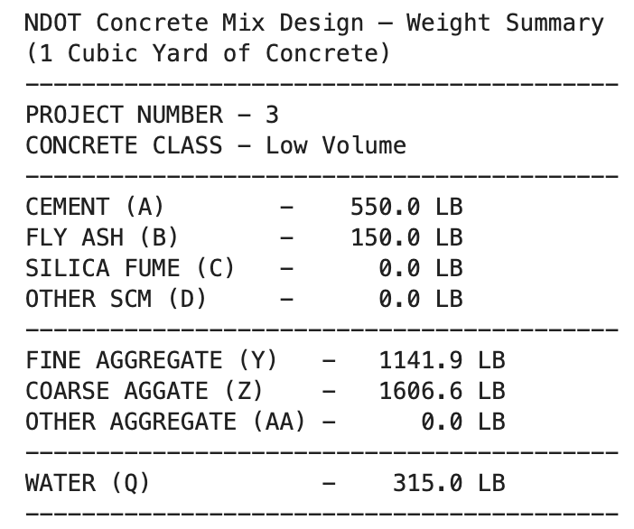
Figure 3. Mix Design Scenario 3 – Low Volume

Freeze-Thaw Concrete: Used for concrete in volatile conditions, valued for its ability to expand and contract without failing.
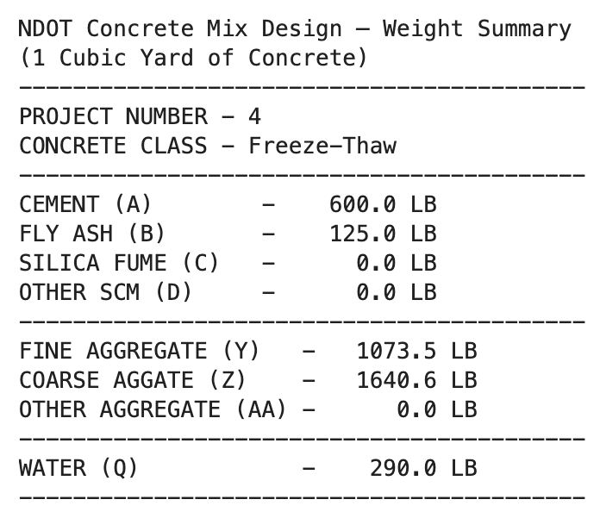
Figure 4. Mix Design Scenario 4 – Freeze-Thaw

Across all four cases, the automated workflow consistently maintained the required total volume of one cubic yard while redistributing components of weights according to the input used by the user. Several trends were visible.

First, increasing cementitious content increases paste volume and reduced aggregate volume. We also say that lower water-cementitious ratios reduce water weight relative to cementitious materials and are associated with higher-strength mixes. There is also a recognizable trend that higher air content decreases the volume available for solids, reducing aggregate weight. Finally, it was observed that substituting fly ash or silica fume alters paste composition without changing the fundamental volume relationships.

The model produced stable and reasonable outputs for all scenarios, indicating that the excel calculations were correctly translated into python functions. No numerical instabilities or confusing results were observed.

Running multiple scenarios served as a basic verification step for automation. Each set of inputs generates output consistently with established principles of mix designs. Strength mixes contain higher cementitious proportions. Cost efficient mixes shifted toward higher aggregate content. And durability focused mixes increase air volume. These results confirm once again that python implementation produces logical results.

The automated model provides a transparrent and repeatable method for producing concrete weight charts based on user-defined parameters. Compared to the original Excel worksheet, the Python version offers several advantages. Such as eliminating accidental formula changes, ensuring consistent calculations, supporting modular updates, and enabling integration into larger engineering software.

Reference List
Nebraska Department of Transportation (NDOT). Concrete Mix Design Submittal Workbook. Lincoln, NE: NDOT. https://dot.nebraska.gov/media/jp3paote/mix-design-submittal.xlsx
Nebraska Department of Transportation (NDOT). Optimized Aggregate Gradations for Portland Cement Concrete Mix Designs Evaluation (Project P336 Final Report). Lincoln, NE: NDOT. https://dot.nebraska.gov/media/3isfdv45/final-report-p336.pdf
Nebraska Department of Transportation (NDOT). (2017). Standard Specifications for Highway Construction. Lincoln, NE: NDOT. https://dot.nebraska.gov/media/g4qp4y0d/2017-specbook.pdf

