IEEE P802.11  
Wireless LANs

|  |  |  |  |  |
| --- | --- | --- | --- | --- |
| **Specification Framework for TGax** | | | | |
| **Date:** 2016-05-25 | | | | |
| **Author(s):** | | | | |
| **Name** | **Affiliation** | **Address** | **Phone** | **email** |
| Robert Stacey | Intel | 2111 NE 25th Ave, Hillsboro OR 97124, USA | +1-503-724-893 | [robert.stacey@intel.com](mailto:robert.stacey@intel.com) |

Abstract

This document provides the framework from which the draft TGax amendment will be developed. The document provides an outline of each the functional blocks that will be a part of the final amendment. The document is intended to reflect the working consensus of the group on the broad outline for the draft specification. As such it is expected to begin with minimal detail reflecting agreement on specific techniques and highlighting areas on which agreement is still required. It may also begin with an incomplete feature list with additional features added as they are justified. The document will evolve over time until it includes sufficient detail on all the functional blocks and their inter-dependencies so that work can begin on the draft amendment itself.

**Revision history**

|  |  |  |
| --- | --- | --- |
| Revision | Date | Changes |
| 0 | January 13, 2015 | As approved by TG motion at the November 2014 meeting [1] |
| 1 | January 13, 2015 | Added motioned text from PM1 session January 13, 2015 |
| 2 | January 15, 2015 | Added motioned text from January 14, 2014 |
| 3 | March 27, 2015 | Added motioned text from PM1 session March 12, 2015 |
| 4 | March 27, 2015 | Some corrections to the March PHY motion numbers and missing statement added. |
| 5 | May 14, 2015 | Removed duplicate statement on OFDMA operation in bandwidths less than 20 MHz. Added text for motions passed during the May 2015 session. |
| 6 | July 9, 2015 | Fixed typo in reference #14. Tomo Adachi notified the editor by email that MU Motion 5 was added in error since the motion failed. Text removed. |
| 7 | July 16, 2015 | Added text for motions passed July 16, 2015 |
| 8 | September 18, 2015 | Nrow 🡪 Nrot (per email from Youhan Kim). Grouped statements in appropriate subsections. Added missing MAC Motion 23 from July (thanks again Tomo Adachi). Added text that passed motion on September 17, 2015 as found in 15/0987r6. |
| 9 | September 22, 2015 | Updated based on comments from Hongyuan: missing 40 MHz for mandatory LDPC; RL-SIG in HE NDP PPDU format |
| 10 | November 24, 2015 | Added PHY motions passed November 12, 2015. Automated heading numbering. |
| 11 | November 28, 2015 | Added remaining motions from November meeting |
| 12 | December 1, 2015 | Previous revision appears to be an incomplete, perhaps a interim saved version of the document rather than the completed version. Corrected with this release. |
| 13 | December 7, 2015 | Added missing MAC Motion 29 from Spetember 2015 session. Fixed type on PHY Motion 80. |
| 14 | January 21, 2016 | Added motioned text from January session. |
| 15 | January 28, 2016 | Missed motion on slide 27 of 15/1516r3. Document referenced in motion is 16/0043r0. |
| 16 | March 18, 2016 | Added motioned text from March session. Fixed a problem with the figure “Pilot tone locations for 80 MHz”. |
| 17 | May 25, 2016 | Added motioned text from May session. |
|  |  |  |

# Definitions

# Abbreviations and acronyms

HE High Efficiency

UL Uplink

DL Dowlink

OFDMA Orthogonal Frequency-Division Multiple Access

# High Efficiency (HE) Physical Layer

## General

Section 3 describes the functional blocks in the physical layer.

For an 11ax device, the support of DL and UL OFDMA (non MU-MIMO) shall be mandatory.

For an 11ax device

* Support of Nss>1 is optional
* Support of STBC is optional.

For an 11ax device

* Support for single spatial stream HE-MCSs 0 to 7 (transmit and receive) is mandatory in all supported channel widths and RU sizes
* Transmit and receive support for HE-MCSs 8, 9 , 10 and 11 is optional

For an 11ax AP, support for DL MU-MIMO transmission, where MU-MIMO is being done on the entire PPDU BW, shall be mandatory if the AP supports Tx Nss>=4

Full BW DL MU-MIMO reception shall be mandatory at a non-AP STA. For the receiving STA, max Nss (per STA) supported for DL MU-MIMO shall be equal to the minimum of 4 and the max Nss supported for SU PPDUs. The *NSTS,total* that the STA can support in NDP sounding and in the DL MU-MIMO packet is a capability, 4 being the minimum value for both.

[May 2016, see [2]]

The HE extended Range SU PPDU is transmitted only on the primary 20 MHz.

[PHY Motion 116, January 2016, see [3]]

The HE extended range SU PPDU can only be transmitted with MCS0, MCS1, MCS2 and only with 1 spatial stream.

[PHY Motion 117, January 2016, see [3]]

There are two STA classes that support HE trigger-based PPDU with information exchanged as part of the device capability

* Class A: STAs that are high capability devices and
* Class B: STAs that are low capability devices

[PHY Motion 118, January 2016, see [4]]

A non-AP STA that is UL MU-MIMO Tx capable shall support DL MU-MIMO Rx.

[MU Motion 47, March 2016, see 16/0066r5]

A non-AP STA that is UL OFDMA Tx capable shall support DL OFDMA Rx.

[MU Motion 48, March 2016, see 16/0066r5]

STAs that participate in HE trigger-based PPDU shall support per chain max(P-32,-10dBm) as the min Tx power, with P the max power the STA can transmit at the antenna connector of that chain using MCS0 while meeting the TX EVM and spectral mask requirements. A STA transmitting at and above the min power shall support the EVM requirements for TBD MCS (but at least MCS7).

[PHY Motion 119, January 2016, see [4]]

STAs that participate in HE trigger-based PPDU shall support the following absolute Tx power requirements and the RSSI measurement accuracy requirements for the two device classes

|  |  |  |  |
| --- | --- | --- | --- |
| **Parameter** | **11ax Minimum Requirements** | | **Comments** |
| **Class A devices** | **Class B devices** |
| Absolute transmit power accuracy | +/- 3dB | +/- 9 dB | Accuracy of achieving a specified transmit power level |
| RSSI measurement accuracy | +/-3 dB | +/- 5 dB | Difference between the actual RSSI and the measured RSSI  Requirements are valid from minimum RX to maximum RX input power |

The RSSI accuracy requirements shall be applied to receive signal level range from -82 dBm to -20 dBm (2.4GHz) or -30 dBm (5GHz). The requirement is stated for nominal (room) temperature conditions. RSSI is measured over legacy preamble.

[PHY Motion 120, January 2016, see [4], updated May 2016, see [5]]

STAs that participate in HE trigger-based PPDU shall pre-compensate for carrier frequency offset (CFO) error and timing drift.  After compensation, the absolute value of residual CFO error with respect to the corresponding Trigger frame shall not exceed 350 Hz for data subcarriers when measured as the 10% point of CCDF of CFO errors in AWGN at a received power of -60 dBm in the primary 20 MHz. The residual CFO error measurement shall be made on the HE trigger-based PPDU packet after HE-SIG-A.

[PHY Motion 121, January 2016, see [4]]

STA that participate in HE Trigger based PPDU transmission shall have timing accuracy of +/-0.4µs relative to the Trigger frame. This requirement does not include round trip delay.

[PHY Motion 122, January 2016, see [4]]

STAs that participate in HE trigger-based PPDU shall support +/-3 dB Relative Tx power requirements for Class B devices. Relative Tx power accuracy is defined as the accuracy of the change of the transmit power in consecutive UL MU transmissions.

[MU Motion 54, March 2016, see 16/413r0]

The following TX LO leakage requirements are supported for all transmission modes in 11ax:

* The power measured at the location of the RF LO using resolution BW 78.125 kHz shall not exceed the maximum of –32 dB relative to the total transmit power and -20 dBm, or equivalently max(P-32,-20), where *P* is the transmit power per antenna in dBm. The transmit center frequency leakage is specified per antenna.

[PHY Motion 123, January 2016, see [4]]

Transmit center frequency and the symbol clock frequency for all transmit antennas and frequency segments shall be derived from the same reference oscillator.

[PHY Motion 124, January 2016, see [4]]

The non-contiguous channel bonding will be supported in 802.11ax by:

* Transmitting using OFDMA PPDU format by nulling the tones of one or more secondary channels in 80 MHz and 160 (80+80) MHz;
* Modes for non-contiguous channel bonding are TBD;
* Non-contiguous channels within primary or secondary 80 MHz only exists at AP side.

[PHY Motion 125, January 2016, see [6]]

The NDP always has extension of 4 us. The NDP shall support the CP values 0.8 us and 1.6 us.

[PHY Motion 147, March 2016, see 16/389]

Reuse the 11ac per stream CSD values for all HE PPDU.

UL MU-MIMO transmission the per stream CSD value is based on global stream index

Per antenna CSD values for in Pre HE modulation.

* Reuse the 11ac per antenna CSD values when beam change =1.
* Not specified (absorbed in the Q matrix) when beam_change=0

In UL MU transmission the per antenna CSD value is based on the antenna index of each STA (i.e. local index).

[May 2016, see [7]]

## HE preamble

### General

An HE PPDU shall include the legacy preamble (L-STF, L-LTF and L-SIG), duplicated on each 20 MHz, for backward compatibility with legacy devices. [PHY Motion #3, January 2015, see [8]]

In an HE PPDU, both the first and second OFDM symbols immediately following the L-SIG shall use BPSK modulation.

*NOTE–This is to spoof all legacy (11a/n/ac) devices to treat an HE PPDU as a non-HT PPDU.*

[PHY Motion 15, July 16, 2015, see [9]]

MU-MIMO shall only be supported on allocations sizes ≥ 106 tones.

[PHY Motion 35, July 16, 2015, see [10]]

The number of spatially multiplexed users in a DL or UL MU-MIMO transmission is up to 8 (in a given RU).

[PHY Motion 92, November 2015, see [11]]

There are only three pre-HE-STF preamble formats defined:

* SU format (mandatory) / Trigger based UL
* MU format (mandatory)
* Extended range SU format (mandatory)

[PHY Motion 68, November 2015, see [12], modified with PHY Motion 115, Janaury 2016, see [3]]

*Editorial note: Let’s refer to the associated PPDU formats as the HE SU PPDU, HE Trigger-based UL PPDU, HE MU PPDU and HE Extended Range SU PPDU. When discussing features associated with all formats, we use the term HE PPDU.*

The signaling of the three preamble formats is illustrated in Figure 1.

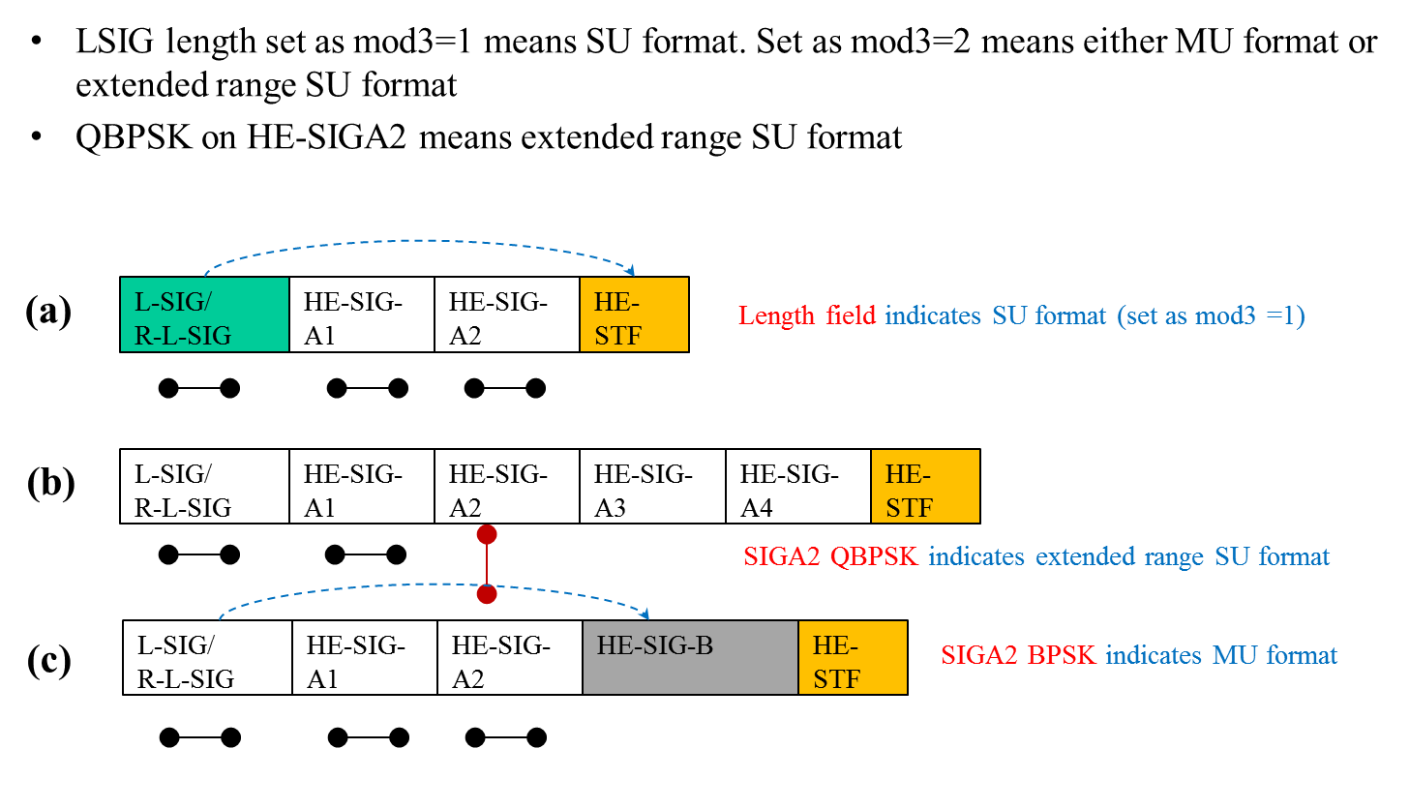

Figure 1 – Preamble format signaling

[PHY Motion 69, November 2015, see [12]]

The spec shall define an HE NDP PPDU for DL Sounding. The HE NDP PPDU format is based on the HE SU PPDU format and is shown in Figure 1. The presence and duration of packet extension at the end of HE NDP PPDU is TBD.

|  |  |  |  |  |  |  |  |
| --- | --- | --- | --- | --- | --- | --- | --- |
| L-STF | L-LTF | L-SIG | RL-SIG | HE-SIG-A | HE-STF | HE-LTFs | Packet Extension |

Figure 2 – HE NDP PPDU format

[PHY Motion 37, September 17, 2015, see [13], editorially changed TBD field to RL-SIG based on Motion 51]

If the Beam Change field in HE-SIG-A is 0 then the pre-HE-STF portion of the preamble shall be spatially mapped in the same way as HE-LTF1 on each tone.

[PHY Motion 84, November 2015, see [14]]

An HE PPDU has 4 extra subcarriers, two at each edge of each 20 MHz sub-channel for the L-SIG, RL-SIG, HE-SIG-A and HE-SIG-B fields:

* The 4 subcarriers added to the L-SIG and RL-SIG fields are transmitted with known TBD BPSK constellations (±1).
* The number of data subcarriers in HE-SIG-A and HE-SIG-B fields is increased by 4 in each 20 MHz sub-channel.
* The L-SIG, RL-SIG, HE-SIG-A and HE-SIG-B fields are always transmitted with same power per tone as the L-LTF field (in cases when L-LTF is not being boosted). The L-STF has the same total power as the L-LTF.

[PHY Motion 72, November 2015, see [15], PHY Motion 144, March 2016, see 16/367]

STBC is an optional feature in 11ax and it is ONLY defined for single spatial stream (Nss=1 and Nsts=2)

In an HE MU PPDU, all RUs are either STBC or not STBC.

[PHY Motion 75, November 2015, see [16]]

UL pre-HE-STF preamble is sent only on the 20MHz- CH(s) where the HE modulated fields are located.

The UL pre-HE-STF preamble includes legacy preamble, RL-SIG and HE-SIG-A and HE modulated fields refer to HE-STF, HE-LTF and data fields.

[PHY Motion 154, March 2016, see 16/395]

### L-STF and L-LTF

L-STF power is boosted by 3 dB in the extended range preamble.

[PHY Motion 66, November 2015, see [17]]

L-LTF power is boosted by 3 dB in the extended range preamble.

[PHY Motion 67, November 2015, see [17]]

For the HE extended range SU PPDU,

* L-LTF per-tone power is boosted by 3 dB relative to HE-SIG-A, L-STF is transmitted with the same total power as L-LTF;
* The extra four tones on the edge of L-SIG/RL-SIG in 20MHz band have the same per-tone transmission power as the per-tone transmission power of L-LTF tones, while the other populated tones in L-SIG and RL-SIG have 3dB lower per-tone transmission power than L-LTF tones.

[May 2016, see [18]]

### L-SIG and repeated L-SIG

In L-SIG, the L_LENGTH field is set to a value not divisible by 3.

[PHY Motion 52, September 17, 2015, see [19], modified with first motion January 2016, see [20]]

The 11ax preamble shall have a 4 µs symbol repeating the L-SIG content right after the legacy section. This symbol shall be modulated by BPSK and rate ½ BCC.

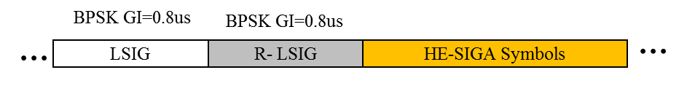

Figure 3 -- Repeated L-SIG

[PHY Motion 51, September 17, 2015, see [19]]

The content of 4 extra tones [-28,-27,27,28] of L-SIG and RL-SIG in 20 MHz HE PPDU is [-1,-1,-1,1].

[PHY Motion 114, January 2016, see [21]]

### HE-SIG-A

HE-SIG-A (using a DFT period of 3.2 µs and subcarrier spacing of 312.5 kHz) is duplicated on each 20 MHz after the legacy preamble to indicate common control information.

[Motion #4, January 2015, see [8]]

HE-SIG-A is present in all 11ax packets and is two OFDM symbols long when it uses MCS0

* Information bits in HE-SIG-A are jointly encoded as in VHT-SIG-A (using 52 tones).
* SU packets and UL Trigger based packets do not contain HE-SIG-B symbols.

[PHY Motion 16, July 16, 2015, see [22], modified with first motion January 2016, see [20]]

~~HE-SIG-A shall include the following fields in an SU PPDU (the size of each field is TBD and other fields are TBD):~~

* ~~Format indication~~
* ~~TXOP duration~~
* ~~BW~~
* ~~Payload GI~~
* ~~PE~~
* ~~MCS~~
* ~~Coding~~
* ~~LTF Compression~~
* ~~NSTS~~
* ~~STBC~~
* ~~BF~~
* ~~CRC~~
* ~~Tail~~

[PHY Motion 43, September 17, 2015, see [23], removed with PHY Motion 96, November 2015]

~~HE-SIG-A shall include the following fields in an MU DL PPDU the size of each field is TBD and other fields are TBD):~~

* ~~Format indication~~
* ~~TXOP duration~~
* ~~Number of HE-SIG-B symbols~~
* ~~MCS of HE-SIG-B~~
* ~~CRC~~
* ~~Tail~~

[PHY Motion 44, September 17, 2015, see [23], removed with PHY Motion 97, November 2015]

The MCS of HE-SIG-B field indicates the following MCS values for HE-SIG-B:

* MCS0, MCS 1, MCS 2, MCS 3, MCS4, MCS5
* Other MCS is TBD

The MCS of HE-SIG-B field is 3 bits in length. If two MCS values for BW >= 40 MHz are to be signaled, additional TBD bits used.

[PHY Motion 88, November 2015, see [24]]

~~HE-SIG-A shall include the following fields in an MU UL PPDU the size of each field is TBD and other fields are TBD):~~

* ~~Format indication~~
* ~~TXOP duration~~
* ~~CRC~~
* ~~Tail~~

[PHY Motion 45, September 17, 2015, see [23], removed with PHY Motion 98, November 2015]

~~The spec shall support adding a BSS Color field in the HE-SIG-A field. The BSS Color field is an identifier of the BSS (size TBD).~~

[PHY Motion 46, September 17, 2015, see [25], removed with PHY Motion 96, November 2015]

~~An UL/DL Flag field is present in the HE-SIG-A field of an HE SU PPDU. The UL/DL Flag field indicates whether the frame is UL or DL. The value of this field for TDLS is TBD.~~

[PHY Motion 48, September 17, 2015, see [25], removed with PHY Motion 96, November 2015]

~~HE-SIG-A includes a 1-bit DCM indication.~~

[PHY Motion 54, September 17, 2015, see [26], removed with PHY Motion 96, November 2015]

The format of the HE-SIG-A field for an HE SU PPDU is defined in Table 1.

Table 1 - HE-SIG-A field for an HE SU PPDU

|  |  |  |  |
| --- | --- | --- | --- |
| **Field** | **Length (bits)** | **Description** | **Encoding** |
| DL/UL | 1 | Indicates whether the frame is UL or DL.  The field is set to DL for TDLS.  *NOTE: The TDLS peer can identify the TDLS frame by To DS and From DS fields in the MAC header of the MPDU.*  [MAC Motion 57, November 2015, see [27]] |  |
| Format | 1 | Differentiate between an SU PPDU and a Trigger-based UL PPDU. See [23]. |  |
| BSS Color | 6 | Base station identifier. |  |
| Spatial Reuse | 4  [May 2016, see [28]] | Exact bits TBD, e.g., indication of CCA Level, Interference Level accepted, TX Power |  |
| TXOP Duration | 7  [May 2016] | Indicates the remaining time in the current TXOP. See [23]. |  |
| Bandwidth | 2 |  |  |
| MCS | 4 |  |  |
| CP+LTF Size | 2  [May 2016, see [29]] |  | 1x LTF + 0.8 µS  2x LTF + 0.8 µS  2x LTF + 1.6 µS  4x LTF + 3.2 µS |
| Coding | 2 |  |  |
| Nsts | 3 |  |  |
| STBC | 1 |  |  |
| TxBF | 1 |  |  |
| DCM | 1 | Dual carrier modulation indication |  |
| Packet Extension | 3 | “a”-factor field of 2 bits and 1 disambiguation bit |  |
| Beam Change | 1 | Indicate precoder change/no change between L-LTF and HE-LTF. See [14]. |  |
| Doppler | 1 | [PHY Motion 136, March 2016, see 15/1354r2] |  |
| CRC | 4 |  |  |
| Tail | 6 |  |  |

[PHY Motion 96, November 2015, see [30]]

The format of the HE-SIG-A field for an HE MU PPDU is defined in Table 2.

Table 2 - HE-SIG-A field for an HE MU PPDU

|  |  |  |  |
| --- | --- | --- | --- |
| **Field** | **Length (bits)** | **Description** | **Encoding** |
| DL/UL | 1 |  |  |
| BSS Color | 6 | Base station identifier. |  |
| Spatial Reuse | 4  [May 2016, see [28]] | TBD |  |
| TXOP Duration | 7  [May 2016] | Indicates the remaining time in the current TXOP. See [23]. |  |
| Bandwidth | 3  [May 2016, see [31]] | May accommodate more than in SU case to take advantage of OFDMA |  |
| SIGB MCS | 3 | See [24]. | MCS0, MCS1, MCS2, MCS3, MCS4, MCS5  Other MCS TBD |
| SIGB DCM | 1 |  |  |
| SIGB Number Of Symbols | 4 | Support about 16 users using MCS0 per BCC  When SIGB compression mode is enabled, the number of symbols are re-purposed to indicate the number of MU-MIMO users  [PHY Motion 141, March 2016, see 16/349r1] |  |
| SIGB Compression Mode | ≥ 1 | Differentiates full bandwidth MU-MIMO from OFDMA MU PPDU. More compression modes TBD. See [32]. |  |
| Number of HE-LTF Symbols | 3 | Up to 8 LTF symbols possible |  |
| CP+LTF Size | 2  [May 2016, see [29]] |  | 2x LTF + 0.8 µS  2x LTF + 1.6 µS  4x LTF + 3.2 µS |
| LPDC Extra Symbol | 1 |  |  |
| Packet Extension | 3 |  |  |
| Doppler | 1 | [PHY Motion 136, March 2016, see 15/1354r2] |  |
| STBC | 1 | This bit indicates STBC for all users in the payload and doesn’t apply to SIGB  STBC is not applied in MU-MIMO RUs  [PHY Motion 137, March 2016, see 15/1354r2] |  |
| CRC | 4 |  |  |
| Tail | 6 |  |  |

[PHY Motion 97, November 2015, see [30]]

In an HE MU PPDU the HE-SIG-A field shall indicate the number of STAs when full bandwidth MU-MIMO compressed SIG-B mode is indicated. When SIGB compression mode is enabled, the SIGB number of symbols are re-purposed to indicate the number of MU-MIMO users.

[PHY Motion 111, Janaury 2016, see [33], modified with PHY Motion 142, March 2016, see 16/349r0]]

The format of the HE-SIG-A field for an HE Trigger-based UL PPDU is defined in Table 3.

Table 3 - HE-SIG-A fields for the HE Trigger-based UL PPDU

|  |  |  |  |
| --- | --- | --- | --- |
| **Field** | **Length (bits)** | **Description** | **Encoding** |
| Format | 1 | Differentiate between an SU PPDU and a Trigger-based UL PPDU |  |
| BSS Color | 6 | Base station identifier. |  |
| Spatial Reuse | 4  [May 2016, see [28]] | multiple SR fields (>=2) are signaled, where each SR field corresponds to a different subband of the PPDU  [PHY Motion 138, March 2016, see 15/1354r2] | One TBD value for SR Disallow Flag, (under TBD restrictions)  One TBD value is reserved  Remaining 14 values for SRP   * SRP = TX PWRAP + Acceptable Receiver Interference LevelAP * SR STA shall back-off its TX power based on * TX PWRSR STA < SRP –RSSItrigger frame@SR STA   [May 2016, see [28]] |
| TXOP Duration | 7  [May 2016] | Indicates the remaining time in the current TXOP. See [23]. |  |
| Bandwidth | TBD |  |  |
| CRC | 4 |  |  |
| Tail | 6 |  |  |

[PHY Motion 98, November 2015, see [30]]

HE-SIG-A includes a 1-bit Beam Change field. A value 1 indicates that spatial mapping is changed and a value 0 indictes that spatial mapping is unchanged.

[PHY Motion 83, November 2015, see [14]]

A compression bit is carried in the HE-SIG-A MU format to differentiate full BW MU-MIMO from OFDMA MU PPDU. In case of full BW MU-MIMO, the following conditions hold:

* Only applicable for RU sizes 242, 484, 996, 2*996
* The HE-SIG-B common field is not signaled
* For bandwidths > 20 MHz, the user specific sub-fields are split equitably between the two HE-SIG-B Channels, i.e., for a k user MU-MIMO PPDU,  user specific subfields in HE-SIG-B channel 1 and  use specific subfields in HE-SIG-B channel 2

[PHY Motion 87, November 2015, see [32], modified with PHY Motion 143, March 2016, see 16/349r0]

The HE-SIG-A field shall have a repetition mode for range extension. In the repetition mode, HE-SIG-A symbols are repeated once in time. The bit interleaver is bypassed in the repeated HE-SIG-A symbols.

[PHY Motion 55, September 17, 2015, see [34], modified with first motion January 2016, see [20]]

The CRC bits of HE-SIG-A and each coding group of HE-SIG-B are generated as 4 LSB of HT CRC generator output.

[PHY Motion 105, January 2016, see [35]]

Include the “SR_allowed” signaling in HE-SIGA to indicate whether SR operation is allowed or not.

* use a value of Spatial Reuse field to indicate SR is disallowed
* The conditions to disallow SR are TBD

[SR Motion 6, March 2016, see 16/382r0]

In HE-SIG-A of HE extended range SU PPDU, HE MU PPDU and HE trigger-based PPDU, the size of TXOP Duration field is 7 btis and 1 bit is reserved.

[May 2016, see [36]]

For HE trigger-based PPDU, in HE SIG-A, 4 SR fields are signaled:

* For 20MHz one SR field corresponding to entire 20MHz (other 3 fields indicate identical values)
* For 40MHz two SR fields for each 20MHz (other 2 fields indicate identical values)
* For 80MHz four SR fields for each 20MHz
* For 160MHz four SR fields for each 40MHz
* The exact location of each 20MHz for 80MHz BW is TBD

[May 2016, see [28]]

### HE-SIG-B

HE-SIG-B only has one CP size equal to 0.8 µS.

[PHY Motion 71, November 2015, see [12]]

Downlink HE MU PPDU shall include HE-SIG-B field, and the number of OFDM symbols of HE-SIG-B field is variable.

NOTE—The HE-SIG-B field includes information required to interpret HE MU PPDU, and detail is TBD.

[PHY Motion #8, March 2015, see [37]]

HE-SIG-B shall use a DFT period of 3.2 µs and subcarrier spacing of 312.5 kHz. [Motion #14, May 2015]

HE-SIG-B does not have any OFDM symbol duplicated in each 20 MHz of the PPDU bandwidth. [PHY Motion 18, July 16, 2015, see [22]]

HE-SIG-B is encoded on a per 20 MHz basis using BCC with common and user blocks separated in the bit domain. [PHY Motion 22, July 16, 2015, see [38]]

SIGB bits for each SIGB content channel are continuously encoded with 1 BCC encoder.

[PHY Motion 106, January 2016, see [39]]

For bandwidths ≥ 40 MHz, the number of 20 MHz subbands carrying different content is two and with structure as shown in Figure 1. Each square in the figure represents 20 MHz subband and 1/2 represents different signalling information. [PHY Motion 23, July 16, 2015, see [38]]

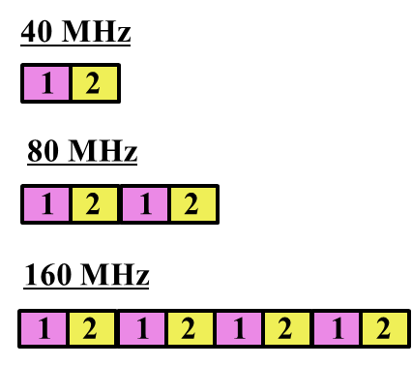

Figure 4 - 20 MHz subchannel content for HE-SIG-B for bandwidths ≥ 40 MHz

HE-SIG-B has a common field followed by a user specific field, where

* The common field includes the information for all of designated STAs to receive the PPDU in corresponding bandwidth
* The user specific field consists of multiple sub-fields that do not belong to the common field, where one or multiple of those sub-fields are for each designated receiving STA
* The boundary between the common and the user specific field is at the bit level and not the OFDM symbol level

[PHY Motion 19, July 16, 2015, see [40]]

The common field in HE-SIG-B contains Resource Unit (RU) allocation.

[PHY Motion 20, July 16, 2015, see [40]]

HE-SIG-B includes resource unit assignment and MCS per station for DL-OFDMA PPDU.

PHY Motion 21, July 16, 2015, see [41]]

The encoding structure of each BCC in HE-SIG-B is shown in Figure 3 and described below:

* Two users are grouped together and jointly encoded in each BCC block in the user specific section of HE-SIG-B
* The common block has a CRC separate from the CRC of the user specific blocks
* The last user information is immediately followed by a CRC and tail bits (regardless of whether the number of users is odd or even) and padding bits are only added after those tail bits

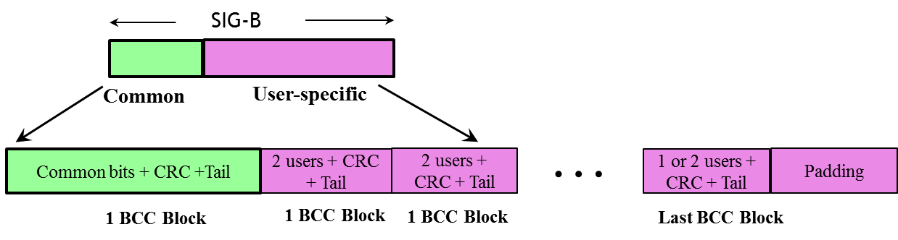

Figure 5 -- Encoding structure in HE-SIG-B

[PHY Motion 39, September 17, 2015, see [42], modified with PHY Motion 95, November 2015, see [43], modified with first motion January 2016, see [20]]

The user specific subfields of HE-SIG-B containing the per user dedicated information include the following fields:

* STAID
* For single-user allocations in an RU: NSTS (Number of Spatial Streams), TxBF (transmit beamforming ), MCS (Modulation and Coding Scheme), DCM (Dual Sub-Carrier Modulation) and Coding (Use of LDPC)
* For each user in a multi-user allocation in an RU: Spatial Configuraiton Fields, MCS, DCM and Coding.
* Other fields are TBD.

[PHY Motion 40, September 17, 2015, see [44], modified with PHY Motion 91, see [45]]

The STAID field in the user specific subfields of HE-SIGB is 11 bits in length.

[PHY Motion 90, November 2015, see [45]]

For MU-MIMO allocation of RU size > 20 MHz, the user-specific subfields is dynamically split between two HE-SIG-B content channels (1/2) and the split is decided by the AP (on a per case basis).

[PHY Motion 41, September 17, 2015, see [44]]

The RU allocation signaling in the common field of HE-SIG-B signals an 8 bit, per 20 MHz PPDU BW for signaling

* The RU arrangement in frequency domain
* Number of MU-MIMO allocations: The RUs allocated for MU-MIMO and the number of users in the MU-MIMO allocations.

The mapping of the 8 bits to the arrangement and the number of MU-MIMO allocations is defined in Table 1. Signaling for the center 26 unit in 80 MHz is TBD.

Table 4 - Arrangement and number of MU-MIMO allocations

|  |  |  |  |  |  |  |  |  |  |  |
| --- | --- | --- | --- | --- | --- | --- | --- | --- | --- | --- |
| **8 bits indices** | **#1** | **#2** | **#3** | **#4** | **#5** | **#6** | **#7** | **#8** | **#9** | **Num of entries** |
| **000 0 0000** | 26 | 26 | 26 | 26 | 26 | 26 | 26 | 26 | 26 | 1 |
| **000 0 0001** | 26 | 26 | 26 | 26 | 26 | 26 | 26 | 52 | | 1 |
| **000 0 0010** | 26 | 26 | 26 | 26 | 26 | 52 | | 26 | 26 | 1 |
| **000 0 0011** | 26 | 26 | 26 | 26 | 26 | 52 | | 52 | | 1 |
| **000 0 0100** | 26 | 26 | 52 | | 26 | 26 | 26 | 26 | 26 | 1 |
| **000 0 0101** | 26 | 26 | 52 | | 26 | 26 | 26 | 52 | | 1 |
| **000 0 0110** | 26 | 26 | 52 | | 26 | 52 | | 26 | 26 | 1 |
| **000 0 0111** | 26 | 26 | 52 | | 26 | 52 | | 52 | | 1 |
| **000 0 1000** | 52 | | 26 | 26 | 26 | 26 | 26 | 26 | 26 | 1 |
| **000 0 1001** | 52 | | 26 | 26 | 26 | 26 | 26 | 52 | | 1 |
| **000 0 1010** | 52 | | 26 | 26 | 26 | 52 | | 26 | 26 | 1 |
| **000 0 1011** | 52 | | 26 | 26 | 26 | 52 | | 52 | | 1 |
| **000 0 1100** | 52 | | 52 | | 26 | 26 | 26 | 26 | 26 | 1 |
| **000 0 1101** | 52 | | 52 | | 26 | 26 | 26 | 52 | | 1 |
| **000 0 1110** | 52 | | 52 | | 26 | 52 | | 26 | 26 | 1 |
| **000 0 1111** | 52 | | 52 | | 26 | 52 | | 52 | | 1 |
| **000 1 0yyy** | 52 | | 52 | | - | 106 | | | | 8 |
| **0001 1yyy** | 106 | | | | - | 52 | | 52 | | 8 |
| **00100 yyy** | 26 | 26 | 26 | 26 | 26 | 106 | | | | 8 |
| **00101 yyy** | 26 | 26 | 52 | | 26 | 106 | | | | 8 |
| **00110 yyy** | 52 | | 26 | 26 | 26 | 106 | | | | 8 |
| **00111 yyy** | 52 | | 52 | | 26 | 106 | | | | 8 |
| **01000 yyy** | 106 | | | | 26 | 26 | 26 | 26 | 26 | 8 |
| **01001 yyy** | 106 | | | | 26 | 26 | 26 | 52 | | 8 |
| **01010 yyy** | 106 | | | | 26 | 52 | | 26 | 26 | 8 |
| **01011 yyy** | 106 | | | | 26 | 52 | | 52 | | 8 |
| **0110 zzzz** | 106 | | | | - | 106 | | | | 16 |
| **0111 0000** | 52 | | 52 | | - | 52 | | 52 | | 1 |
| **0111 0001** | 242-tone RU empty | | | | | | | | | 1 |
| **0111 0010** | 484-tone RU empty | | | | | | | | | 1 |
| **0111 0011** | 996-tone RU empty | | | | | | | | | 1 |
| **0111 01xx** | Definition TBD | | | | | | | | | 4 |
| **0111 1xxx** | Definition TBD | | | | | | | | | 8 |
| **10 yyy yyy** | 106 | | | | 26 | 106 | | | | 64 |
| **11 0 00yyy** | 242 | | | | | | | | | 8 |
| **11 0 01yyy** | 484 | | | | | | | | | 8 |
| **11 0 10yyy** | 996 | | | | | | | | | 8 |
| **11 0 11yyy** | 2*996 | | | | | | | | | 8 |
| **11 1 xxxxx** | Definition TBD | | | | | | | | | 32 |

‘yyy’ = 000~111 indicates number of MU-MIMO STAs.

‘zz’ = 00~11 indicates number of spatially multiplexed STAs for 106-tone RU in partial bandwidth allocations Definition for entries with ‘x’ bits is TBD.

[PHY Motion 64, September 17, 2015, see [44], modified with PHY Motion 89, November 2015, see [45], modified May 2016, see [46], 01110010 and 01110011 entries [47]]

At least 1 state is reserved in the 8 bit RU allocation subfield of the HE-SIG-B common field for “no STA-specific information field assigned by the RU allocation subfield’. Details are TBD.

[PHY Motion 110, January 2016, see [48]]

The resource allocation signaling in the common control field and user specific subfields for an STA carried in the HE-SIG-B are transmitted in the same 20 MHz sub-channel as the data for 20 MHz and 40 MHz PPDU. For an 80 MHz PPDU, the default mapping per 20 MHz is as shown in Figure 6.

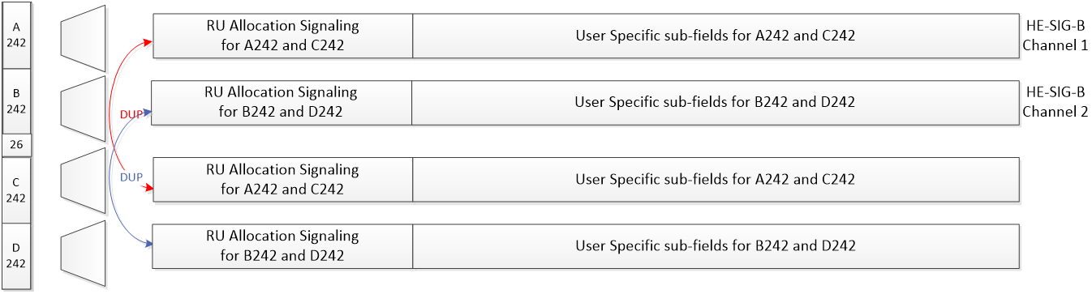

Figure 6 - Default mapping of the two HE-SIG-B channels for an 80 MHz HE PPDU

For a 160MHz PPDU, the default mapping per 20MHz is as shown in Figure 7.

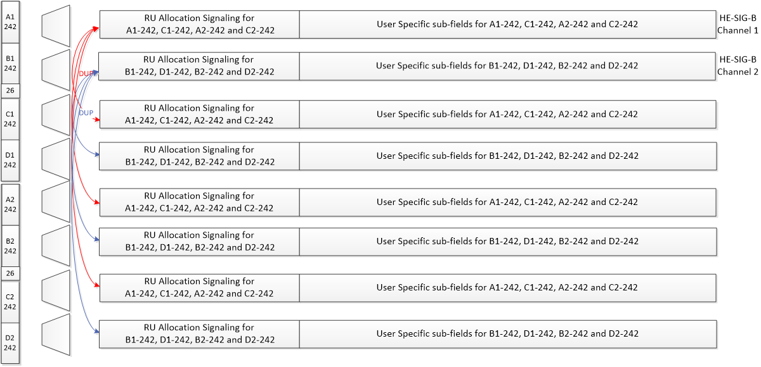

Figure 7 - Default mapping of the two HE-SIG-B channels for a 160 MHz HE PPDU

[PHY Motion 86, November 2015, see [32]]

The length of the user specific subfield in HE-SIG-B for a single-user allocation is equal to the length of the user specific subfield of each user in a multi-user allocation.

[PHY Motion 65, September 17, 2015, see [44]]

The Nsts value for each user in a MU-MIMO RU is less than or equal to 4.

[PHY Motion 93, November 2015, see [11]]

A MU-MIMO user block includes a Spatial Config subfield of 4 bits indicating the number of spatial streams for each multiplexed STA. The subfield is constructed by using the entries corresponding to the value of Nuser of this RU in Table 4.

Table 5 - Spatial Config subfield encoding

|  |  |  |  |  |  |  |  |  |  |  |
| --- | --- | --- | --- | --- | --- | --- | --- | --- | --- | --- |
| **Nuser** | **B0…B3** | **Nsts[1]** | **Nsts[2]** | **Nsts[3]** | **Nsts[4]** | **Nsts[5]** | **Nsts[6]** | **Nsts[7]** | **Nsts[8]** | **Number of Entries** |
| 2 | 0000~0011 | 1~4 | 1 |  |  |  |  |  |  | 10 |
| 0100~0110 | 2~4 | 2 |  |  |  |  |  |  |
| 0111~1000 | 3~4 | 3 |  |  |  |  |  |  |
| 1001 | 4 | 4 |  |  |  |  |  |  |
| 3 | 0000~0011 | 1~4 | 1 | 1 |  |  |  |  |  | 13 |
| 0100~0110 | 2~4 | 2 | 1 |  |  |  |  |  |
| 0111~1000 | 3~4 | 3 | 1 |  |  |  |  |  |
| 1001~1011 | 2~4 | 2 | 2 |  |  |  |  |  |
| 1100 | 3 | 3 | 2 |  |  |  |  |  |
| 4 | 0000~0011 | 1~4 | 1 | 1 | 1 |  |  |  |  | 11 |
| 0100~0110 | 2~4 | 2 | 1 | 1 |  |  |  |  |
| 0111 | 3 | 3 | 1 | 1 |  |  |  |  |
| 1000~1001 | 2~3 | 2 | 2 | 1 |  |  |  |  |
| 1010 | 2 | 2 | 2 | 2 |  |  |  |  |
| 5 | 0000~0011 | 1~4 | 1 | 1 | 1 | 1 |  |  |  | 6 |
| 0100~0101 | 2~3 | 2 | 1 | 1 | 1 |  |  |  |
| 6 | 0000~0010 | 1~3 | 1 | 1 | 1 | 1 | 1 |  |  | 4 |
| 0011 | 2 | 2 | 1 | 1 | 1 | 1 |  |  |
| 7 | 0000~0001 | 1~2 | 1 | 1 | 1 | 1 | 1 | 1 |  | 2 |
| 8 | 0000 | 1 | 1 | 1 | 1 | 1 | 1 | 1 | 1 | 1 |

[PHY Motion 94, November 2015, see [11]]

The STAID field that identifies the RU allocation in HE-SIG-B for broadcast traffic in DL OFDMA PPDU shall be defined as following:

* For single BSS AP, the STAID for Broadcast will be 0;
* For Multiple BSS AP, the STAID for Broadcast to a specific BSS will follow the group addressed AID assignment in the TIM according to the existing Multi-BSSID TIM operation;
* For Multiple BSS AP, the STAID for Broadcast to all BSSs of the AP will have a special STAID value reserved.

[MAC Motion 56, November 2015, see [49]]

AID value of 2046 is reserved to indicate unallocated RUs in the user-specific HE-SIG-B content blocks”

For an 80 MHz and 160 MHz PPDUs, in each SIG-B content channel, the HE-SIG-B common blocks of the multiple 20MHz channels that the content channel corresponds to, are transmitted in an increasing order of the absolute frequency.

For MU-MIMO allocations of RU sizes larger than 242 tones, user specific content blocks are ordered across the two SIG-B content channels from left to right on the 1st SIG-B content channel, followed by left to right on 2nd SIG-B content channel.

For HE MU PPDU transmissions on the UL, the STA-ID field of the HE-SIG-B per-user field shall carry the AID of the transmitter assigned by the AP.

[May 2016, see [50]]

PAPR reduction scheme for HE SIG-B:

* Phase rotation is applied to the HE SIG-B data tones after constellation mapping. For the kth data tone in the HE SIG-B, the phase rotation pattern is defined as
  + 1 for 0=<k<26 and (-1)k for 26=<k<52
* For DCM + MCS0, since the same rotation has already been applied in the DCM BPSK bit mapping, this step of phase rotation after constellation mapping shall be skipped
* Legacy gamma rotation still applies among different 20 MHz channels

[May 2016, see [51]]

The interleaver parameters for HE-SIG-B with DCM are given in the following table:

|  |  |
| --- | --- |
| Parameter | HE-SIG-B (tones) |
| 56 |
| *NCOL* | 13 |
| *NROW* | 2×NBPSCS |

[May 2016, see [52]]

For full BW 80MHz, add 1 bit to indicate if center 26-tone RU is allocated in the common block fields of both SIGB content channels with same value.

For full BW 160, 80+80 MHz, add 1 bit to indicate if center 26-tone RU is allocated for one individual 80MHz in common block fields of both SIGB content channels.

[May 2016, see [46]]

The user-specific field for center 26-tone RU in BW>=80 MHz is located at the end of the user specific fields in either SIGB content channel 1 or SIGB content channel 2 channel, if assigned?

* SIGB content channel 1 in 80 MHz BW
* SIGB content channel 1 for lower 80 MHz and SIGB content channel 2 for upper 80 MHz in 160 MHz BW

[May 2016, see [53]]

### HE preamble following the HE signalling fields

#### General

Gamma (tone rotation as defined in Clause 22.3.7.5 of 11ac amendment) is not applied on HE-STF and beyond.

* TBD in case of a duplicated HE PPDU (if ever defined)

[PHY Motion 82, November 2015, see [54]]

In all transmission modes, HE-STF and HE-LTF only populate RUs that are populated in the data field.

[PHY Motion 81, November 2015, see [54]]

HE-LTF/HE-STF power is boosted 3dB for BPSK and QPSK including DCM in the HE Extended Range SU PPDU preamble.

[PHY Motion 131, January 2016, see [3]]

#### HE-STF

HE-STF of a non-trigger-based PPDU has a periodicity of 0.8 µs with 5 periods.

* A non-trigger-based PPDU is not sent in response to a trigger frame

[PHY Motion #11, May 2015, see [55]]

The HE-STF of a trigger-based PPDU has a periodicity of 1.6 µs with 5 periods.

* A trigger-based PPDU is an UL PPDU sent in response to a trigger frame

[PHY Motion #12, May 2015, see [55]]

The HE-STF tone positions are defined in Equation 1 where *NSTF_sample* = 16 for a non-trigger-based PPDU and *NSTF_sample* = 8 for a trigger-based PPDU



[PHY Motion #13, May 2015, see [55]]

The HE-STF sequences for 0.8 µs and 1.6 µs periodicity are as follows:

20 MHz 1x HE-STF sequence:

40 MHz 1x HE-STF sequence:

80 MHz 1x HE-STF sequence:

20 MHz 2x HE-STF sequence:

40 MHz 2x HE-STF sequence:

80 MHz 2x HE-STF sequence:

[PHY Motion 79, November 2015, see [56]]

The 1x and 2x HE-STF sequences for 160/80+80MHz are defined as follows:

1x HE-STF160MHz(-1008:16:1008) = [*M*, 1, -*M*, 0, -*M*, 1, -*M*, 0, -*M*, -1, *M*, 0, -*M*, 1, -*M*] *(1+*j*)/sqrt(2)

M = {-1 -1 -1 +1 +1 +1 -1 +1 +1 +1 -1 +1 +1 -1 +1}

1x HE-STF80+80MHz = [1x HE-STF80MHz,Prime, 1x HE-STF80MHz,Second]

1x HE-STF80MHz,Prime(-496:16:496) = [*M*, 1, -*M*, 0, -*M*, 1, -*M*] *(1+*j*)/sqrt(2)

1x HE-STF80MHz, Second(-496:16:496) = [-*M*, -1, *M*, 0, -*M*, 1, -*M*] *(1+*j*)/sqrt(2)

2x HE-STF160MHz(-1016:8:1016) = [*M*, -1, *M*, -1, -*M*, -1, *M*, 0, -*M*, 1, *M*, 1, -*M*, 1, -*M*, 0, -*M*, 1, -*M*, 1, *M*, 1, -*M*, 0, -*M*, 1, *M*, 1, -*M*, 1, -*M*] *(1+*j*)/sqrt(2)

2x HE-STF160MHz(±1016) = 0

2x HE-STF160MHz(±8) = 0

2x HE-STF80+80MHz = [2x HE-STF80MHz,Prime, 2x HE-STF80MHz,Second]

2x HE-STF80MHz,Prime(-504:8:504) = [*M*, -1, *M*, -1, -*M*, -1, *M*, 0, -*M*, 1, *M*, 1, -*M*, 1, -*M*] *(1+*j*)/sqrt(2)

2x HE-STF80MHz,Prime(±504) = 0

2x HE-STF80MHz, Second(-504:8:504) = [-*M*, 1, -*M*, 1, *M*, 1, -*M*, 0, -*M*, 1, *M*, 1, -*M*, 1, -*M*] *(1+*j*)/sqrt(2)

2x HE-STF80MHz,Second(±504) = 0

[PHY Motion 132, March 2016, see 16/335r0]

#### HE-LTF

The HE-LTF shall adopt a structure of using P matrix in the data tones as in 11ac. In the data tones, every space-time stream is spread over all HE-LTF symbols by one row of the P matrix as defined in 11ac. Different space-time streams use different rows in P matrix. [PHY Motion #5, March 2015, see [57]]

The HE PPDU shall support the following LTF modes:

* HE-LTF symbol duration of 6.4 µs excluding GI
  + Equivalent to modulating every other tone in an OFDM symbol of 12.8 µs excluding GI, and then removing the second half of the OFDM symbol in time domain
* HE-LTF symbol duration of 12.8 µs excluding GI

[PHY Motion #6, March 2015, see [57]]

In an HE PPDU, the HE-LTF section shall start at the same point of time and end at the same point of time across all users. [PHY Motion #7, March 2015, see [57]]

In an OFDMA PPDU using *N* HE-LTF symbols, an RU with *Nsts,total* shall use the first *Nsts,total* rows of the *N × N* P matrix. [PHY Motion 29, July 16, 2015, see [58]]

Single stream pilot (like 11ac) in HE-LTF shall be used for SU, DL and UL OFDMA as well as in DL MU-MIMO transmissions. [PHY Motion 26, July 16, 2015, see [59]]

The HE-LTF sequences for UL MU-MIMO shall be generated as follows. For each stream, a common sequence shall be masked repeatedly in a piece-wise manner by a distinct row of an 8x8 orthogonal matrix. When the length of the LTF sequence is not divisible by 8, the last *M* elements of the LTF sequence (*M* being the remainder after the division of LTF length by 8) shall be masked by the first *M* elements of the orthogonal matrix row.

[PHY Motion 56, September 17, 2015, see [60]]

The orthogonal matrix used to mask the HE-LTF sequence for UL MU-MIMO is the 8x8 P-matrix used in 11ac.

[PHY Motion 57, September 17, 2015, see [60], modified with first motion January 2016, see [20]]

For UL MU MIMO transmissions, support of single stream pilots and masking the LTF sequence of each spatial stream by a distinct orthogonal code is mandatory at the transmitter side (non AP STA). When single stream pilot is used, no masking is applied to the HE LTF. The Trigger frame shall use 1 bit to indicate whether the UL MU MIMO transmission following it uses single stream pilots or a mask on each spatial stream of the LTF sequence by a distinct orthogonal code.

[PHY Motion 126, January 2016, see [61]]

The 4x HE−LTF sequence for 80 MHz is defined by the equation below:

HE−LTF996(−500:500) =

{+1, +1, −1, +1, −1, +1, −1, −1, −1, +1, −1, −1, −1, +1, +1, −1, +1, +1, +1, +1, +1, −1, −1, +1, +1, +1, +1, −1, +1, −1, +1, −1, −1, +1, +1, −1, +1, +1, +1, −1, −1, +1, −1, −1, −1, −1, +1, +1, +1, −1, −1, −1, −1, −1, −1, +1, +1, +1, +1, +1, +1, −1, +1, +1, +1, −1, +1, +1, −1, −1, −1, +1, −1, +1, −1, −1, +1, +1, −1, +1, −1, +1, +1, +1, +1, +1, −1, −1, +1, +1, +1, −1, +1, +1, −1, −1, −1, +1, −1, +1, +1, −1, +1, +1, −1, +1, −1, −1, +1, +1, +1, +1, −1, −1, +1, +1, +1, +1, +1, −1, +1, +1, −1, −1, −1, +1, −1, −1, −1, +1, −1, +1, −1, +1, +1, −1, +1, −1, +1, −1, +1, +1, +1, −1, +1, +1, +1, −1, −1, +1, −1, −1, −1, −1, −1, +1, +1, −1, −1, −1, −1, +1, −1, +1, −1, +1, +1, −1, −1, +1, −1, −1, −1, +1, +1, −1, +1, +1, +1, +1, −1, −1, −1, +1, +1, +1, +1, −1, +1, +1, +1, +1, +1, +1, +1, −1, +1, +1, +1, −1, +1, +1, −1, −1, −1, +1, −1, +1, −1, −1, +1, +1, −1, +1, −1, +1, +1, +1, +1, +1, −1, −1, +1, +1, +1, −1, +1, +1, −1, −1, −1, +1, −1, +1, +1, −1, +1, +1, −1, +1, −1, −1, +1, −1, +1, −1, +1, −1, +1, +1, +1, −1, +1, +1, +1, −1, −1, +1, −1, −1, −1, −1, −1, +1, +1, −1, −1, −1, −1, +1, −1, +1, −1, +1, +1, −1, −1, +1, −1, −1, −1, +1, +1, −1, +1, +1, +1, +1, −1, −1, −1, +1, +1, +1, +1, −1, +1, −1, −1, −1, −1, −1, −1, +1, −1, −1, −1, +1, −1, −1, +1, +1, +1, −1, +1, −1, +1, +1, −1, −1, +1, −1, +1, −1, −1, −1, −1, −1, +1, +1, −1, −1, −1, +1, −1, −1, +1, +1, +1, −1, +1, −1, −1, +1, −1, −1, +1, −1, +1, +1, +1, +1, +1, +1, −1, −1, +1, +1, +1, +1, +1, −1, +1, +1, −1, −1, −1, +1, −1, −1, −1, +1, −1, +1, −1, +1, +1, −1, +1, −1, +1, −1, +1, +1, +1, −1, +1, +1, +1, −1, −1, +1, −1, −1, −1, −1, −1, +1, +1, −1, −1, −1, −1, +1, −1, +1, −1, +1, +1, −1, −1, +1, −1, −1, −1, +1, +1, −1, +1, +1, +1, +1, −1, −1, −1, +1, +1, +1, +1, −1, −1, +1, +1, +1, +1, +1, +1, −1, +1, +1, +1, −1, +1, +1, −1, −1, −1, +1, −1, +1, −1, −1, +1, +1, −1, +1, −1, +1, +1, +1, +1, +1, −1, −1, +1, +1, +1, −1, +1, +1, −1, −1, −1, +1, −1, +1, +1, −1, +1, +1, −1, +1, −1, −1, −1, +1, −1, +1, −1, −1, −1, −1, +1, +1, +1, −1, −1, +1, 0, 0, 0, 0, 0, +1, −1, −1, −1, −1, −1, −1, +1, −1, +1, +1, −1, −1, +1, +1, −1, +1, −1, +1, +1, −1, −1, +1, −1, +1, −1, −1, −1, +1, +1, −1, +1, +1, +1, −1, +1, +1, +1, +1, +1, +1, +1, −1, +1, −1, −1, +1, −1, −1, +1, −1, +1, +1, +1, −1, −1, +1, −1, −1, −1, +1, +1, −1, −1, −1, −1, −1, +1, −1, −1, −1, −1, −1, +1, +1, −1, −1, −1, −1, −1, +1, −1, −1, +1, +1, +1, −1, +1, +1, +1, −1, +1, −1, +1, −1, −1, −1, −1, −1, +1, +1, +1, −1, −1, −1, −1, +1, −1, −1, +1, +1, +1, −1, +1, +1, −1, −1, +1, −1, +1, −1, −1, −1, −1, −1, −1, −1, +1, +1, −1, −1, −1, +1, −1, −1, +1, +1, +1, −1, +1, −1, −1, +1, −1, −1, +1, −1, +1, +1, +1, −1, +1, −1, −1, +1, +1, −1, +1, −1, +1, +1, +1, −1, −1, +1, −1, −1, −1, +1, −1, −1, −1, −1, −1, −1, −1, +1, −1, +1, +1, −1, +1, +1, −1, +1, −1, −1, −1, +1, +1, −1, +1, +1, +1, −1, −1, +1, +1, +1, +1, +1, −1, +1, −1, −1, −1, −1, +1, +1, −1, −1, −1, −1, −1, +1, −1, −1, +1, +1, +1, −1, +1, +1, +1, −1, +1, −1, +1, −1, −1, −1, −1, −1, +1, +1, +1, −1, −1, −1, −1, +1, −1, −1, +1, +1, +1, −1, +1, +1, −1, −1, +1, −1, +1, −1, +1, +1, +1, −1, +1, −1, −1, +1, +1, −1, +1, −1, +1, +1, +1, −1, −1, +1, −1, −1, −1, +1, −1, −1, −1, −1, −1, −1, −1, +1, −1, +1, +1, −1, +1, +1, −1, +1, −1, −1, −1, +1, +1, −1, +1, +1, +1, −1, −1, +1, +1, +1, +1, +1, −1, +1, +1, +1, +1, +1, −1, −1, +1, +1, +1, +1, +1, −1, +1, +1, −1, −1, −1, +1, −1, −1, −1, +1, −1, +1, −1, +1, +1, +1, +1, +1, −1, −1, −1, +1, +1, +1, +1, −1, +1, +1, −1, −1, −1, +1, −1, −1, +1, +1, −1, +1, −1, +1, −1, −1, −1, −1, −1, −1, +1, +1, −1, −1, −1, +1, −1, −1, +1, +1, +1, −1, +1, −1, −1, +1, −1, −1, +1, −1, +1, −1, +1, −1, +1, −1, −1, +1, +1, −1, +1, −1, +1, +1, +1, −1, −1, +1, −1, −1, −1, +1, −1, −1, −1, −1, −1, −1, −1, +1, −1, +1, +1, −1, +1, +1, −1, +1, −1, −1, −1, +1, +1, −1, +1, +1, +1, −1, −1, +1, +1, +1, +1, +1, −1, +1, −1, −1, −1, −1, +1, +1, −1, −1, −1, −1, −1, +1, −1, −1, +1, +1, +1, −1, +1, +1, +1, −1, +1, −1, +1, −1, −1, −1, −1, −1, +1, +1, +1, −1, −1, −1, −1, +1, −1, −1, +1, +1, +1, −1, +1, +1, −1, −1, +1, −1, +1, −1, +1}

The 2x HE−LTF sequence for 80 MHz is defined by the equation below:

HE−LTF996(−500:2:500) =

{+1, +1, −1, +1, +1, +1, −1, +1, +1, +1, +1, −1, −1, −1, +1, −1, −1, +1, +1, −1, +1, +1, +1, −1, −1, −1, −1, +1, +1, +1, +1, −1, +1, +1, +1, −1, +1, −1, −1, +1, −1, −1, −1, +1, +1, −1, −1, −1, +1, −1, −1, +1, −1, +1, +1, −1, +1, +1, −1, +1, −1, −1, −1, +1, −1, −1, −1, −1, +1, −1, −1, +1, +1, −1, +1, +1, +1, −1, −1, −1, −1, +1, −1, +1, +1, +1, −1, +1, +1, +1, +1, −1, −1, −1, +1, +1, +1, −1, −1, +1, +1, +1, −1, +1, +1, −1, +1, −1, −1, −1, −1, +1, −1, −1, −1, +1, −1, +1, +1, −1, +1, +1, −1, −1, −1, +1, −1, −1, −1, +1, −1, +1, +1, −1, +1, +1, +1, −1, −1, +1, +1, +1, −1, +1, +1, −1, +1, −1, −1, +1, −1, +1, +1, +1, −1, +1, +1, +1, +1, −1, −1, −1, +1, −1, −1, +1, +1, −1, +1, +1, +1, −1, −1, −1, −1, +1, +1, +1, −1, −1, −1, −1, +1, −1, −1, −1, +1, −1, +1, +1, +1, −1, −1, +1, +1, +1, −1, +1, +1, −1, +1, −1, −1, −1, −1, +1, −1, −1, −1, +1, −1, +1, +1, −1, +1, +1, −1, +1, +1, −1, −1, +1, −1, −1, −1, +1, +1, +1, +1, −1, +1, −1, −1, −1, +1, −1, −1, −1, −1, +1, +1, +1, +1, −1, −1, −1, +1, +1, +1, 0, 0, 0, +1, −1, −1, +1, +1, −1, +1, −1, −1, −1, +1, +1, +1, +1, −1, +1, +1, +1, −1, +1, −1, −1, −1, −1, +1, +1, +1, −1, +1, +1, −1, −1, +1, −1, −1, +1, −1, −1, +1, −1, +1, +1, +1, −1, +1, +1, +1, +1, −1, +1, −1, −1, +1, −1, −1, −1, +1, +1, −1, −1, −1, +1, −1, +1, +1, +1, −1, +1, +1, +1, +1, −1, −1, −1, +1, +1, +1, +1, −1, −1, −1, +1, −1, −1, +1, +1, −1, +1, +1, +1, −1, −1, −1, −1, +1, −1, −1, −1, +1, −1, +1, +1, −1, +1, −1, −1, +1, −1, −1, −1, +1, +1, −1, −1, −1, +1, −1, −1, +1, −1, +1, +1, +1, −1, +1, +1, +1, −1, +1, −1, +1, +1, −1, +1, −1, −1, −1, +1, −1, −1, −1, −1, +1, −1, +1, +1, −1, +1, +1, +1, −1, −1, +1, +1, +1, −1, −1, −1, +1, +1, +1, +1, −1, +1, +1, +1, −1, +1, −1, −1, −1, −1, +1, +1, +1, −1, +1, +1, −1, −1, +1, −1, −1, −1, −1, +1, −1, −1, −1, +1, −1, +1, +1, −1, +1, +1, −1, +1, −1, −1, +1, −1, −1, −1, +1, +1, −1, −1, −1, +1, −1, −1, +1, −1, +1, +1, +1, −1, +1, +1, +1, +1, −1, −1, −1, −1, +1, +1, +1, −1, +1, +1, −1, −1, +1, −1, −1, −1, +1, +1, +1, +1, −1, +1, +1, +1, −1, +1, +1}

The 4x HE−LTF sequence for 40 MHz is defined by the equation below:

HE−LTF484(−244:244) =

{ +1, −1, −1, −1, −1, +1, −1, −1, +1, +1, −1, +1, −1, +1, −1, +1, +1, −1, +1, −1, −1, −1, +1, +1, −1, −1, −1, −1, −1, −1, −1, +1, −1, −1, +1, +1, −1, +1, −1, −1, −1, −1, −1, +1, −1, +1, +1, +1, −1, −1, +1, +1, +1, −1, −1, +1, +1, +1, +1, −1, +1, +1, −1, −1, +1, −1, +1, −1, +1, −1, −1, +1, −1, +1, +1, +1, −1, −1, +1, +1, +1, −1, −1, −1, −1, +1, −1, −1, +1, +1, −1, +1, −1, −1, −1, −1, −1, +1, −1, +1, +1, +1, −1, −1, +1, +1, +1, +1, +1, +1, +1, +1, −1, +1, +1, −1, −1, +1, −1, +1, +1, +1, +1, +1, −1, +1, −1, −1, −1, +1, +1, −1, −1, −1, −1, −1, −1, −1, −1, +1, −1, −1, +1, +1, −1, +1, −1, +1, −1, +1, +1, −1, +1, −1, −1, −1, +1, +1, −1, −1, −1, −1, −1, −1, −1, +1, −1, −1, +1, +1, −1, +1, −1, −1, −1, −1, −1, +1, −1, +1, +1, +1, −1, −1, +1, +1, +1, −1, −1, −1, −1, −1, −1, +1, −1, −1, +1, +1, −1, +1, −1, +1, −1, +1, +1, −1, +1, −1, −1, −1, +1, +1, −1, −1, −1, +1, +1, +1, +1, −1, +1, +1, −1, −1, +1, −1, +1, +1, +1, +1, +1, −1, +1, −1, −1, −1, +1, +1, −1, −1, −1, +1, 0, 0, 0, 0, 0, −1, +1, +1, +1, +1, −1, +1, +1, −1, −1, +1, −1, +1, −1, +1, −1, −1, +1, −1, +1, +1, +1, −1, −1, +1, +1, +1, +1, +1, +1, +1, −1, +1, +1, −1, −1, +1, −1, +1, +1, +1, +1, +1, −1, +1, −1, −1, −1, +1, +1, −1, −1, −1, +1, +1, −1, −1, −1, −1, +1, −1, −1, +1, +1, −1, +1, −1, +1, −1, +1, +1, −1, +1, −1, −1, −1, +1, +1, −1, −1, −1, +1, +1, +1, +1, −1, +1, +1, −1, −1, +1, −1, +1, +1, +1, +1, +1, −1, +1, −1, −1, −1, +1, +1, −1, −1, −1, +1, −1, −1, −1, −1, +1, −1, −1, +1, +1, −1, +1, −1, +1, −1, +1, +1, −1, +1, −1, −1, −1, +1, +1, −1, −1, −1, +1, −1, −1, −1, −1, +1, −1, −1, +1, +1, −1, +1, −1, +1, −1, +1, +1, −1, +1, −1, −1, −1, +1, +1, −1, −1, −1, −1, −1, −1, −1, +1, −1, −1, +1, +1, −1, +1, −1, −1, −1, −1, −1, +1, −1, +1, +1, +1, −1, −1, +1, +1, +1, −1, +1, −1, −1, −1, −1, +1, −1, −1, +1, +1, −1, +1, −1, +1, −1, +1, +1, −1, +1, −1, −1, −1, +1, +1, −1, −1, −1, +1, +1, +1, +1, −1, +1, +1, −1, −1, +1, −1, +1, +1, +1, +1, +1, −1, +1, −1, −1, −1, +1, +1, −1, −1, −1, −1}

The 2x HE−LTF sequence for 40 MHz is defined by the equation below:

HE−LTF484(−244:2:244) =

{+1, −1, −1, −1, −1, −1, +1, +1, −1, −1, +1, −1, +1, −1, −1, −1, −1, −1, −1, +1, +1, +1, +1, −1, +1, −1, +1, +1, −1, −1, −1, −1, −1, +1, +1, −1, −1, +1, −1, +1, −1, +1, +1, +1, +1, +1, −1, −1, −1, −1, +1, −1, +1, −1, +1, +1, +1, +1, +1, −1, +1, −1, −1, +1, −1, +1, −1, −1, +1, +1, +1, +1, +1, −1, −1, +1, +1, −1, +1, −1, +1, +1, +1, +1, +1, +1, −1, −1, −1, −1, +1, −1, +1, −1, −1, −1, −1, −1, −1, −1, +1, +1, −1, −1, +1, −1, +1, −1, +1, +1, +1, +1, +1, −1, −1, −1, −1, +1, −1, +1, −1, 0, 0, 0, −1, −1, −1, −1, −1, +1, +1, −1, −1, +1, −1, +1, −1, −1, −1, −1, −1, −1, +1, −1, +1, +1, −1, +1, −1, +1, +1, +1, +1, +1, +1, +1, −1, −1, +1, +1, −1, +1, −1, +1, −1, −1, −1, −1, −1, +1, −1, +1, +1, −1, +1, −1, +1, +1, +1, +1, +1, +1, +1, −1, −1, +1, +1, −1, +1, −1, +1, −1, −1, −1, −1, −1, +1, +1, −1, −1, +1, −1, +1, −1, −1, −1, −1, −1, −1, +1, −1, +1, +1, −1, +1, −1, +1, +1, −1, −1, −1, −1, −1, +1, +1, −1, −1, +1, −1, +1, −1, +1, +1, +1, +1, +1, −1, +1, −1, −1, +1, −1, +1, −1, +1}

The 4x HE−LTF sequence for 20 MHz is defined by the equation below:

HE−LTF242(−122:122) =

{−1, −1, +1, −1, +1, −1, +1, +1, +1, −1, +1, +1, +1, −1, −1, +1, −1, −1, −1, −1, −1, +1, +1, −1, −1, −1, −1, +1, +1, −1,  +1, −1, +1, +1, +1, +1, −1, +1, −1, −1, +1, +1, −1, +1, +1, +1, +1, −1, −1, +1, −1, −1, −1, +1, +1, +1, +1, −1, +1, +1,  −1, −1, −1, −1, +1, −1, −1, +1, +1, −1, +1, −1, −1, −1, −1, +1, −1, +1, −1, −1, −1, −1, −1, −1, +1, +1, −1, −1, −1, −1,  −1, +1, −1, −1, +1, +1, +1, −1, +1, +1, +1, −1, +1, −1, +1, −1, −1, −1, −1, −1, +1, +1, +1, −1, −1, −1, +1, −1, +1, +1,  +1, 0, 0, 0, −1, +1, −1, +1, −1, +1, +1, −1, +1, +1, +1, −1, −1, +1, −1, −1, +1, −1, +1, −1, +1, +1, +1, −1, +1, +1,  +1, −1, −1, +1, −1, −1, −1, −1, −1, +1, +1, −1, −1, −1, −1, −1, −1, +1, −1, +1, −1, −1, −1, −1, +1, −1, +1, +1, −1, −1,  +1, −1, −1, −1, −1, +1, +1, −1, +1, +1, +1, +1, +1, +1, +1, −1, +1, +1, −1, −1, −1, −1, +1, −1, −1, +1, +1, −1, +1, −1,  −1, −1, −1, +1, −1, +1, −1, −1, +1, +1, +1, +1, −1, −1, +1, +1, +1, +1, +1, −1, +1, +1, −1, −1, −1, +1, −1, −1, −1, +1, −1, +1, −1, +1, +1}

The 2x HE−LTF sequence for 20 MHz is defined by the equation below:

HE−LTF242(−122:2:122) =

{−1, − 1, −1, +1, +1, −1, +1, −1, −1, −1, −1, +1, −1, +1, −1, −1, +1, +1, −1, +1, +1, +1, +1, +1, −1, +1, −1, +1, −1, −1, +1, +1, −1, +1, −1, −1, −1, −1, +1, −1, +1, +1, +1, −1, −1, +1, −1, −1, −1, −1, −1, +1, −1, −1, −1, +1, +1, +1, −1, −1, +1, 0, +1, −1, +1, +1, −1, +1, +1, −1, +1, +1, −1, −1, +1, −1, +1, +1, +1, +1, −1, +1, −1, +1, +1, −1, −1, +1, −1, −1, −1, −1, −1, +1, −1, +1, +1, −1, −1, +1, +1, −1, +1, −1, −1, −1, −1, +1, −1, +1, +1, +1, −1, −1, +1, −1, −1, −1, −1, −1, +1, −1, +1}

[PHY Motion 80, November 2015, see [54]]

4x HE-LTF160MHz(-1012:1:1012) =[ 4x LTF80MHz_primary , zeros(1,23), 4x LTF80MHz_secondary ]

4x LTF80MHz_primary = [L-LTF80M, 0, R-LTF80M] as agreed for 80MHz 4x HE-LTF;

4x LTF80MHz_secondary = [L-LTF80M, 0, (-1)* R-LTF80M]

4x HE-LTF80+80MHz = [4x LTF80MHz_primary , 4x LTF80MHz_secondary]

[PHY Motion 107, January 2016, see [62]]

2x HE-LTF160MHz(-1012:2:1012) = [ 2x LTF80MHz_primary , zeros(1,11), 2x LTF80MHz_secondary ]

2x LTF80MHz_primary  as agreed for 80MHz 2x HE-LTF = [{1st 242-RU}, {2nd 242-RU}, {central 26-RU}, {3rd 242-RU}, {4th 242-RU}];

2x LTF80MHz_secondary = [{1st 242-RU}, (-1)*{2nd 242-RU}, {central 26-RU}, {3rd 242-RU}, (-1)*{4th 242-RU} ];

2x HE-LTF80+80MHz= [2x LTF80MHz_primary , 2x LTF80MHz_secondary]

[PHY Motion 108, Janaury 2016, see [62]]

1x HE-LTF20MHz(-120:4:120) =

[ -1, +1, +1, -1, +1, -1, +1, +1, +1, +1, -1, -1, +1, +1, +1, -1, -1, -1, +1, -1, -1, +1, +1, -1, -1, +1, -1, -1, +1, -1, 0, -1, +1, +1, +1, +1, +1, +1, -1, -1, -1, -1, -1, +1, -1, -1, -1, +1, -1, -1, +1, -1, -1, +1, -1, +1, -1, -1, -1, -1, -1 ] ;

1x HE-LTF40MHz(-244:4:244) =

[ +1, +1, +1, +1, -1, +1, +1, -1, -1, +1, -1, +1, -1, +1, -1, -1, +1, -1, +1, +1, +1, -1, -1, +1, +1, +1, +1, +1, +1, +1, +1, -1, +1, +1, -1, -1, +1, -1, +1, -1, +1, -1, -1, +1, -1, +1, +1, +1, -1, -1, +1, +1, +1, +1, -1, +1, -1, +1, -1, -1, -1, 0, +1, +1, -1, -1, +1, -1, +1, +1, +1, +1, +1, +1, -1, +1, +1, -1, -1, +1, -1, +1, +1, +1, +1, +1, -1, +1, -1, -1, -1, +1, +1, -1, -1, -1, +1, -1, -1, -1, -1, +1, -1, -1, +1, +1, -1, +1, -1, -1, -1, -1, -1, +1, -1, +1, +1, +1, -1, -1, +1, +1, +1]

1x HE-LTF80MHz(-500:4:500) =

[-1, -1, +1, +1, +1, +1, +1, -1, -1, -1, +1, +1, -1, -1, +1, -1, +1, -1, -1, -1, -1, -1, -1, +1, +1, -1, -1, +1, -1, +1, -1, -1, -1, -1, -1, +1, +1, -1, -1, +1, -1, +1, -1, +1, +1, +1, +1, +1, -1, -1, +1, +1, -1, +1, -1, +1, -1, -1, -1, -1, +1, -1, -1, -1, -1, -1, -1, +1, +1, +1, -1, -1, +1, +1, -1, +1, -1, +1, +1, +1, +1, +1, +1, -1, -1, +1, +1, -1, +1, -1, +1, +1, +1, +1, -1, +1, +1, -1, -1, +1, -1, +1, -1, +1, +1, +1, +1, +1, -1, -1, +1, +1, -1, +1, -1, +1, -1, -1, -1, -1, +1, -1, +1, -1, -1, 0, -1, +1, +1, -1, -1, +1, +1, -1, -1, +1, +1, -1, +1, -1, +1, +1, +1, +1, +1, +1, -1, -1, +1, +1, -1, +1, -1, +1, +1, +1, +1, +1, -1, -1, +1, +1, -1, +1, -1, +1, -1, -1, -1, -1, -1, +1, +1, -1, -1, +1, -1, +1, -1, +1, +1, +1, +1, -1, +1, -1, -1, +1, -1, -1, +1, +1, +1, -1, -1, +1, +1, -1, +1, -1, +1, +1, +1, +1, +1, +1, -1, -1, +1, +1, -1, +1, -1, +1, +1, +1, +1, -1, +1, +1, -1, -1, +1, -1, +1, -1, +1, +1, +1, +1, +1, -1, -1, +1, +1, -1, +1, -1, +1, -1, -1, -1, -1, +1, -1, +1, -1, -1, -1, +1, +1]

[PHY Motion 109, January 2016, see [62]]

The only mandatory combinations of LTF size and CP size are:

* 2x LTF + 0.8 µS
* 2x LTF + 1.6 µS
* 4x LTF + 3.2 µS

with HE-LTF and payload using the same CP size. The LTF size and CP size are jointly signaled using 3 bits.

[PHY Motion 70, November 2015, see [12]]

4x LTF + 3.2 µS as an optional mode for the NDP frame.

[May 2016, see [29]]

A 1x LTF as an optional mode in 11ax for SU PPDUs (TBD for MU-MIMO). The 1x LTF + 0.8 µs GI is one optional combination as indicated by the “GI and LTF size” sub-field in HE-SIG-A.

[PHY Motion 85, November 2015, see [14]]

11ax allows 1xLTF as an optional mode in the following cases:

* SU, with GI = 0.8 µs only
* Full-BW UL-MUMIMO, with GI=1.6 µs only
* Full BW DL-MUMIMO with GI=0.8 µs is TBD

[PHY Motion 103, January 2016, see [63]]

When 1x/2x HE-LTF is transmitted, it is recommended that the spatial mapping matrix applied to HE-STF and beyond is chosen such that it preserves the smoothness of the physical channel, achieved by limiting the variation of each element’s real and imaginary values in the spatial mapping matrix across successive tones.

[PHY Motion 104, January 2016, see [64]]

2X HE-LTF sequence shall be the only mandatory mode for NDP. 4X HE-LTF shall not be supported in NDP.

[PHY Motion 146, March 2016, see 16/389]

## HE Data field

### General

The Data field in UL MU transmissions shall immediately follow the HE-LTF section.

[PHY Motion 17, July 16, 2015, see [22]]

Data symbols in an HE PPDU shall use a DFT period of 12.8 µs and subcarrier spacing of 78.125 kHz. [PHY Motion #1, January 2015, see [65]]

Data symbols in an HE PPDU shall support guard interval durations of 0.8 µs, 1.6 µs and 3.2 µs. [PHY Motion #2, January 2015, see [65]]

HE PPDUs shall have single stream pilots in the data section

* All streams use the same pilot sequence even in UL MU-MIMO

[PHY Motion 24, July 16, 2015, see [66]]

### Tone plan

#### Resource unit, edge and DC tones

HE-PPDU for UL-OFDMA shall support UL data transmission below 20 MHz for an HE STA. [MU Motion #3, March 2015]

Define 20 MHz OFDMA building blocks as follows:

* 26-tone with 2 pilots, 52-tone with 4 pilot and 106-tone with 4 pilots and with 7 DC Nulls and (6,5) guard tones, and at locations shown in Figure 2
* An OFDMA PPDU can carry a mix of different tone unit sizes within each 242 tone unit boundary
* ~~The following is TBD: Exact location of extra leftover tones~~ *[Ed: deleted, see 3.3.2.2]*

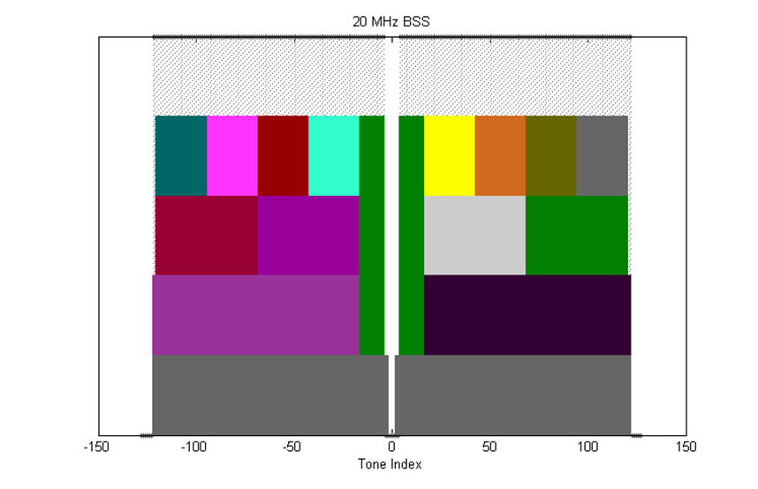

Figure 8 – 20 MHz tone plan

Define 40 MHz OFDMA building blocks as follows

* 26-tone with 2 pilots, 52-tone with 4 pilots, 106-tone with 4 pilots and 242-tone with 8 pilots and with 5 DC Nulls and (12,11) guard tones, and at locations shown in Figure 3
* ~~The following is TBD: exact location of extra leftover tones~~ *[Ed: deleted, see 3.3.2.2]*

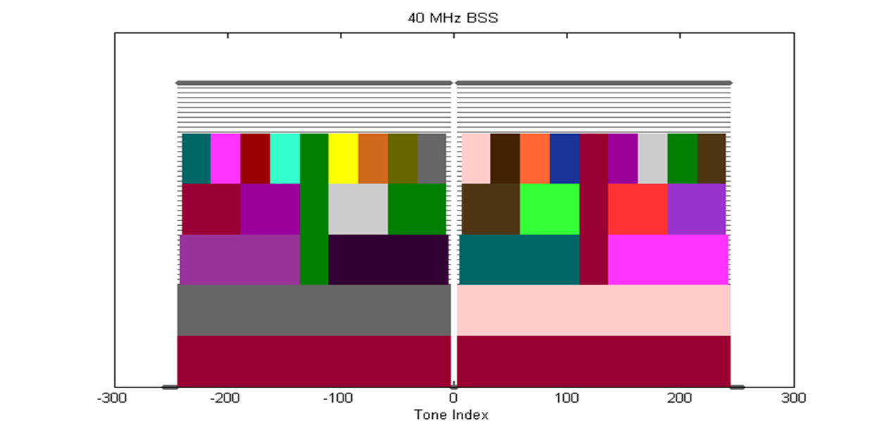

Figure 9 – 40 MHz tone plan

Define 80 MHz OFDMA building blocks as follows:

* 26-tone with 2 pilots, 52-tone with 4 pilots, 106-tone with 4 pilots, 242-tone with 8 pilots and 484-tone with 16 pilots and with 7 DC Nulls and (12,11) guard tones, and at locations shown in Figure 4
* ~~The following is TBD: exact location of extra leftover tones~~ *[Ed: deleted, see 3.3.2.2]*

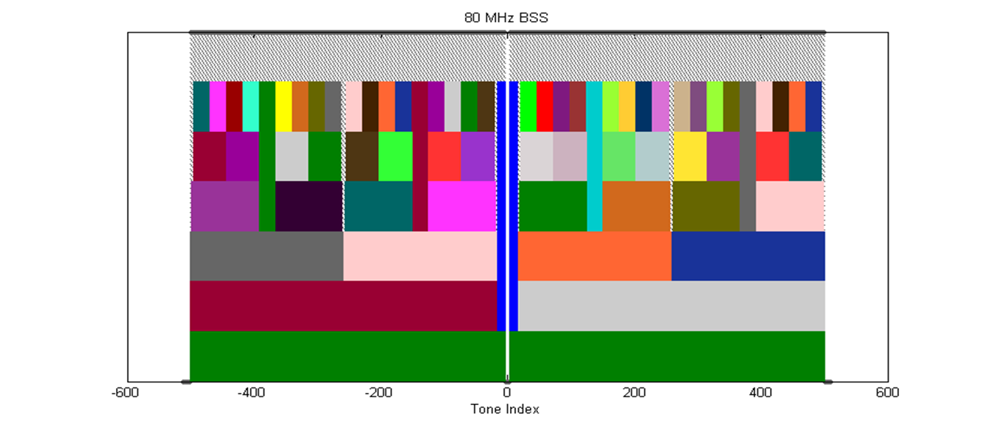

Figure 10 - 80 MHz tone plan

Define 160 MHz/80 MHz+80 MHz OFDMA building blocks as follows:

* 26-tone with 2 pilots
* 52-tone with 4 pilots
* 106-tone with 4 pilots
* 242-tone with 8 pilots
* 484-tone with 16 pilots
* 996-tone with 16 pilots (note that 996-tone is defined for 80 MHz HE-SA-PPDU or 80 MHz HE-SA-MU-PPDU)
* The following is TBD: exact location of extra leftover tones

[PHY Motion #10, May 2015, see [67]]

The 2x996-tone RU employs a segment parser (as in 11ac) between the two 996-tone frequency segments and the LDPC tone mapper in each 996-tone segment uses *DTM* = 20.

[PHY Motion 74, November 2015, see [68]]

Multiple RU allocation for one STA shall not be allowed in 11ax.

[PHY Motion 128, January 2016, see [69]]

#### Left over tones

The left over tone locations for the 20 MHz, 40 MHz and 80 MHz tone plans are shown in Figure 5, Figure 6 and Figure 7 respectively.

NOTE—Left over tones have zero energy

[PHY Motion 25, July 16, 2015, see [59]]

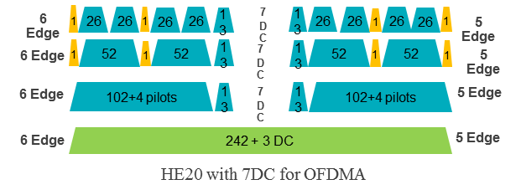

Figure 11 – Left over tone locations for 20 MHz

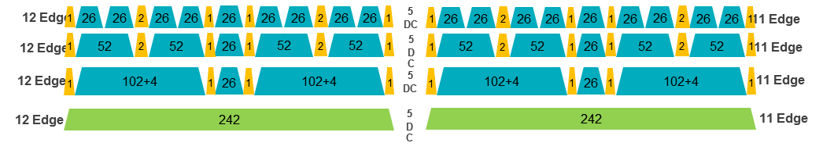

Figure 12 – Left over tone locations for 40 MHz

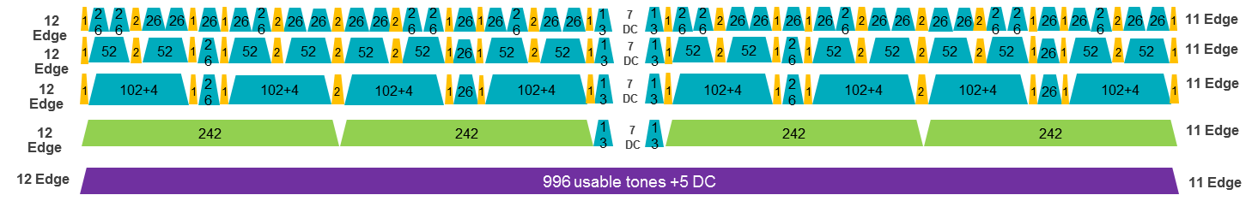

Figure 13 – Left over tone locations for 80 MHz

#### Pilot tones

All pilot tones in 4x data OFDMA symbol are at even indices. If pilots present in 4x HE-LTF, their tone indices shall be the same as those pilots in 4x data symbol. If pilots present in 2x HE-LTF, their tone indices shall be the same as the indices of those pilots in 4x data symbol divided by 2. [PHY Motion 27, July 16, 2015, see [59]]

The pilot tone locations for 20 MHz, 40 MHz and 80 MHz bandwidth are as shown in Figure 8, Figure 9 and Figure 10 respectively.

Note—80 MHz pilot positions are enumerated below for reference:

RU-26 pilots: ±10, ±24, ±38, ±50, ±64, ±78, ±92, ±104, ±118, ±130, ±144, ±158, ±172, ±184, ±198, ±212, ±226, ±238, ±252, ±266, ±280, ±292, ±306, ±320, ± 334, ±346, ±360, ±372, ±386, ±400, ±414, ±426, ±440, ±454, ±468, ±480, ± 494

RU-106/242/484 pilots: ±24, ±50, ±92, ±118, ±158, ±184, ±226, ±252, ±266, ±292, ±334, ±360, ±400, ±426, ±468, ±494

RU-996 pilots: ±24, ±92, ±158, ±226, ±266, ±334, ±400, ±468

The pilot locations for 160 MHz or 80+80 MHz use the same structure as 80 MHz for each half of the BW.

[PHY Motion 28, July 16, 2015, see [59]]

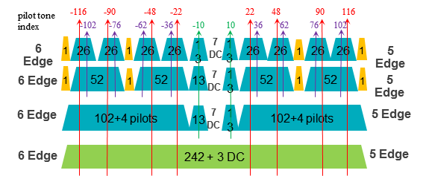

Figure 14 – Pilot tone locations for 20 MHz

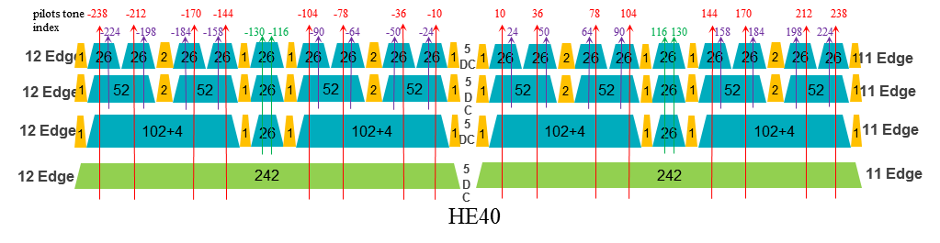

Figure 15 – Pilot tone locations for 40 MHz

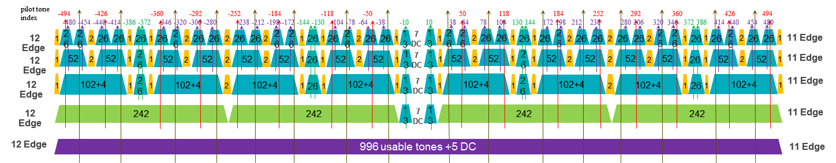

Figure 16 – Pilot tone locations for 80 MHz

The 11ax pilot sequences shall reuse the 11ac/ah pilot sequences shown in below:

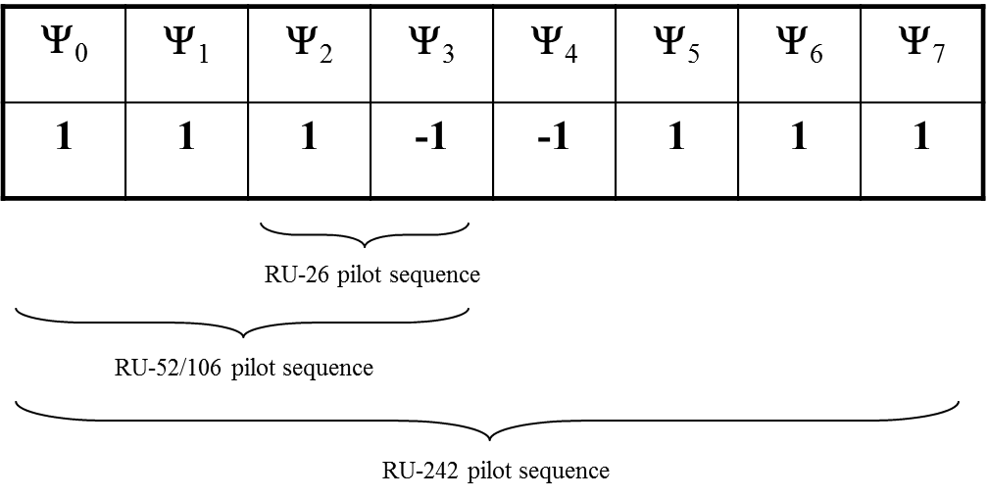

For 2 pilots in any 26-tone RU, use single stream pilot sequence of 11ah 1MHz

For 4 pilots in any 52/106-tone RU, use single stream pilot sequence of 11ac 20MHz

For 8 pilots in any 242-tone RU, use single stream pilot sequence of 11ac 80MHz

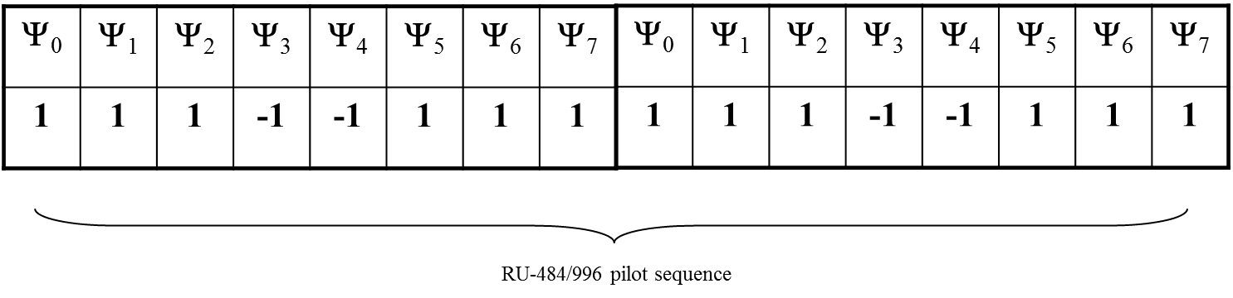

For 16 pilots in any 484/996-tone RU, use single stream pilot sequence of 11ac 160MHz

Duplicate pilots of 996-tone RU for 2x996-tone RU (HE160MHz SU)

[PHY Motion 139, March 2016, see 16/346r0]

11ax pilot sequence shall be applied in the same way as in 11ac SSP

Pilot values are shifted on pilot tones from symbol to symbol for each RU

Overlaying pilot polarity value: same as in 11ac

[PHY Motion 140, March 2016, see 16/246r0]

### Interleaver and encoder

LDPC is the only coding scheme in the HE PPDU Data field for allocation sizes of 484 tones, 996 tones and 996*2 tones.

[PHY Motion 30, July 16, 2015, see [70], modified with PHY Motion 36, September 17, 2015, see [71]]

Support of BCC code is limited to less than or equal to four spatial streams (per user in case of MU-MIMO), and is mandatory (for both TX and RX) for RU sizes less than or equal to 242 tones (20MHz).

Support of LDPC code for both TX and RX is mandatory for HE STAs declaring support for at least one of HE 40/80/160/80+80 SU PPDU bandwidths, or for HE STAs declaring support for more than 4 spatial streams. Otherwise, support of LDPC code for either TX or RX is optional.

[PHY Motion 31, July 16, 2015, see [70]]

The 11ax MCS table shall not have any MCS exclusion and, when LDPC is applied, *NDBPS* is computed as follows

, where *R* is the coding rate

[PHY Motion 32, July 16, 2015, see [70]]

The BCC interleaver and LDPC tone mapper parameters are defined in Table 1.

Table 1 - BCC interleaver and LDPC tone mapper parameters

|  |  |  |  |  |
| --- | --- | --- | --- | --- |
| **RU size (tones)** | **BCC** | | **LDPC** | **LDPC**  **(with DCM)** |
|  | ***Ncol*** | ***Nrot*** | ***DTM*** | ***DTM*** |
| 26 | 8 | 2 | 1 | 1 |
| 52 | 16 | 11 | 3 | 1 |
| 106 | 17 | 29 | 6 | 3 |
| 242 | 26 | 58 | 9 | 9 |
| 484 | - | - | 12 | 9 |
| 996 | - | - | 20 | 14 |

[PHY Motion 33, July 16, 2015, see [70], DCM column added with PHY Motion 130, January 2016, see [72]]

The interleaver parameters for DCM are given in the following table:

|  |  |  |  |  |
| --- | --- | --- | --- | --- |
| Parameter for DCM | RU Size (tones) | | | |
| 26 | 52 | 106 | 242 |
| *NCOL* | 4 | 8 | 17 | 13 |
| *NROW* | 3×NBPSCS | 3×NBPSCS | 3×NBPSCS | 9×NBPSCS |
| *NROT* | 2 | 2 | 11 | 29 |

Value of NBPSCS for DCM modulations equals to NBPSCS of non DCM modulations with same constellation size.

[May 2016, see [52]]

### Modulation

1024-QAM is an optional feature for SU and MU using resource units equal to or larger than 242 tones in 11ax.

[PHY Motion 42, September 17, 2015 see [73]]

Move to add the following new MCS levels as an optional feature to the 11ax SFD:

* MCS10: 1024 QAM with 3/4 code rate
* MCS11: 1024 QAM with 5/6 code rate

[PHY Motion 112, Janaury 2016, see [74]]

1024QAM uses uniform constellation with Gray mapping.

[May 2016, see [75]]

TX EVM requirement of -35dB is used for MCS 10 and MCS 11.

[PHY Motion 113, January 2016, see [74]]

Dual sub-carrier modulation (DCM) is an optional modulation scheme for the HE-SIG-B and Data fields. DCM is only applied to BPSK, QPSK and 16-QAM modulations.

[PHY Motion 53, September 17, 2015, see [26]]

Move to add the following QPSK DCM modulation scheme to the IEEE802.11ax SFD

* The coded/interleaved bits are modulated as QPSK and mapped to the lower half frequency segment: [d1, d2, … dN_SD/2];
* The modulated symbols of the lower half frequency segment are repeated and conjugated and then mapped to the upper half frequency segment: [dN_SD/2+1, dN_SD/2+2, … dN_SD] = conj([d1, d2, … dN_SD/2])

[PHY Motion 129, January 2016, see [72]]

When DCM = 1, the *NSD*, *NCBPS*, and *NDBPS* are set by the following expressions:

In the case of MCS0, DCM=1, Nss=1, 106-RU or 242-RU, if the coding is BCC, then for each OFDM symbol 1 bit is padded after the NDBPS*2 BCC encoded bit before going into the BCC interleaver; if the coding is LDPC, LDPC encoding flow should be based on *NDBPS* and *NCBPS* as defined in the above equations

[May 2016, see [76]]

Make the following changes to D0.1 MCS Tables:

* When DCM=1, change the *NSD* parameter to be ½ of DCM=0 cases for the same RU size.
* When DCM=1, change the *NCBPS* parameter to be ½ of DCM=0 case.
* When DCM=1, change the *NDBPS* parameter to be ½ of DCM=0 case, or take the floor for the two cases: 106-RU, MCS0, DCM=1, Nss=1, and 242-RU, MCS0, DCM=1, Nss=1.
* When DCM=1, change the coding rate *R* parameter to be identical to the DCM=0 case.
* Limit DCM=1 only to the allowed Nss.

[May 2016, see [76]]

DCM+MCS0 has same transmission flow as other DCM MCSs.

[May 2016, see [52]]

MCS0 DCM constellation mapping for data subcarriers *k* and *k+NSD*

is BPSK modulated



*Note: NSD is defined for DCM which is half of *

[May 2016, see [77]]

DCM is only applied to MCS0, MCS1, MCS3 and MCS4.

DCM is only applied to 1 and 2 spatial streams.

DCM is only applied to HE SU PPDU, HE extend range SU PPDU, and SU RUs in HE MU PPDU.

DCM is not applied to MU-MIMO. The DCM field in the HE-SIGB per user for MU-MIMO is changed to a reserved field.

DCM is not applied to STBC.

[May 2016, see [77]]

DCM capability:

* Max constellation supported: 2 bits.
  + 00: does not support DCM; 01: BPSK; 10: QPSK; 11: 16QAM
* Max number of streams supported: 1 bit.
  + 0: 1 stream;  1: 2 streams

[May 2016, see [77]]

When DCM=1, 16QAM constellation mapping is done by swapping b0 and b1, and also b2 and b3 for the second half of tones, where b0 ~ b3 are the encoded bits that maps to one 16QAM constellation for the first half of the tones, i.e.:



where NSD is defined for DCM=1, which is half of the NSD value for the same RU size when DCM=0.

[May 2016, see [78]]

### Padding and packet extension

An 11ax SU  PPDU should apply the MAC/PHY pre-FEC padding scheme as in 11ac, to pad toward the nearest of the four possible boundaries (*a-factor*) in the last Data OFDM symbol(s), and then use post-FEC padding bits to fill up the last OFDM symbol(s).

* Packet Extension (PE) field is defined at the end of HE PPDU
* PE should have the same average power as data field

[PHY Motion 58, September 17, 2015, see [79]]

11ax shall define the max packet extension modes of 8 µs and 16 µs, correspond to the short symbol segment padding boundaries (*a-factor*) according to the following PE duration (TPE) values:

* Max packet extension mode 8 µs: *TPE* = [0 0 4 8] µs for a = 1~4 respectively;
* Max packet extension mode 16 µs: *TPE* = [4 8 12 16] µs for a = 1~4 respectively.

HE Capability field shall define two constellation level thresholds (*threshold16* and *threshold8*) for a given {NSS, BW} combination, to determine if and when max packet extension modes 8 µs and 16 µs are applied, i.e.

* 3 bits are used to specify each threshold as the table below.
* If constellation ≥ *threshold16* apply max PE 16 µs mode, else if constellation ≥ *threshold8* apply max PE 8 µs mode, else no packet extension.
* If no PE is required for all constellations both *threshold8* and *threshold16* are set to 111
* If only max PE 8 µs mode is required, set *threshold16* to be 111, and *threshold8* to be the constellation at which max PE 8 µs mode starts
* If only max PE 16 µs mode is required, set *threshold16* to be the constellation at which max PE 16 µs mode starts, and *threshold8* to be 111
* Packet extension device capability thresholds are defined for all RU sizes greater than or equal to 242 tones. No thresholds defined for an RU size less than 242 tones
* Table 2 - Threshold encoding in HE capability

|  |  |
| --- | --- |
| **Constellation** | **Threshold Encoding in HE Capability** |
| BPSK | 000 |
| QPSK | 001 |
| 16QAM | 010 |
| 64QAM | 011 |
| 256QAM | 100 |
| 1024QAM (TBD) | 101 |
| None | 111 |

[PHY Motion 59, September 17, 2015, see [79], modified with PHY Motion 127, January 2016, see [80]]

The number of uncoded bits for each of the first 3 short symbol segments (a=1~3) equals to the number of uncoded bits corresponding to *NSD.short* subcarriers as specified by the following table, and the number of uncoded bits for the last short symbol segment (a=4) equals to the number of bits of the whole OFDM symbol subtracting the total number of uncoded bits of the first three short symbol segments.

Table 3 - NSD.short

|  |  |  |
| --- | --- | --- |
| **RU Size** | ***NSD.short*** | |
|  | ***DCM=0*** | ***DCM=1*** |
| 26 | 6 | 2 |
| 52 | 12 | 6 |
| 106 | 24 | 12 |
| 242 | 60 | 30 |
| 484 | 120 | 60 |
| 996 | 240 | 120 |
| 996x2 | 492 | 246 |

[PHY Motion 60, September 17, 2015, see [79], modified with PHY Motion 134, March 2016, see 16/344r0]

HE-SIG-A field contains an a-factor field of 2 bits and a PE Disambiguity field of 1 bit that are set as described below.

In L-SIG, the L-LENGTH field is set by:

where

is the PE duration

The ecoding of the a-factor field in HE-SIG-A is defined in Table 4.

Table 4 - A Factor field encoding

|  |  |
| --- | --- |
| *a-factor* value | a-factor field encoding |
| 1 | 01 |
| 2 | 10 |
| 3 | 11 |
| 4 | 00 |

The PE Disambiguity field in HE-SIG-A is set as follows:

* If , where , then this field is set to 1; otherwise this field is set to 0.
* At the receiver, the following equations are used to compute *NSYM* and *TPE* respectively:

[PHY Motion 61, September 17, 2015, see [79], modified with PHY Motion 73, November 2015]

When the AP transmits a DL MU PPDU:

* All users use the same *NSYM* and *a-factor* values according to the user with the longest span
* Based on the *a-factor* value and each user’s PE capabilities, compute the PE duration for each user, *TPE,u*, and the PE duration of the DL MU PPDU, *TPE* = max*u*(*TPE,u*)
* In HE-SIG-A field, the a-factor field, the PE Disambiguity field and the LDPC Extra Symbol field are common to all users

[PHY Motion 62, September 17, 2015, see [79]]

For an UL MU PPDU transmission:

* The AP indicates its desired *NSYM*, *a-factor*, LDPC extra symbol indication and PE duration values in the Trigger frame
* Possible PE values for UL MU are TBD
* Each user transmitting an UL MU PPDU shall encode and conduct PHY padding using the following parameters:
  + *NSYM* as indicated in the Trigger frame
  + *a-factor* as indicated in the Trigger frame
  + LDPC Extra Symbol as indicated in the Trigger frame
  + Append PE specified in the Trigger frame

[PHY Motion 63, September 17, 2015, see [79]]

The post-FEC bits are un-specified by 11ax spec

The content of PE field is un-specified by 11ax spec

[PHY Motion 135, March 2016, see 16/0344]

## Transmit spectral mask

The spectral masks for non-OFDMA 20 MHz, 40 MHz, 80 MHz, 160 MHz and 80+80 MHz PPDUs are are defined below.

* The bandwidth of the applied spectrum mask for a (non-OFDMA) PPDU shall be determined by the bandwidth occupied by the pre HE-STF portion of the preamble in this PPDU, regardless of the BSS bandwidth
* The spectral mask requirements do not apply to LO leakage

The HE 20 MHz spectral mask is the 11ac 80 MHz mask downclocked by 4 (6/5 guard tones) as shown in Figure 15.

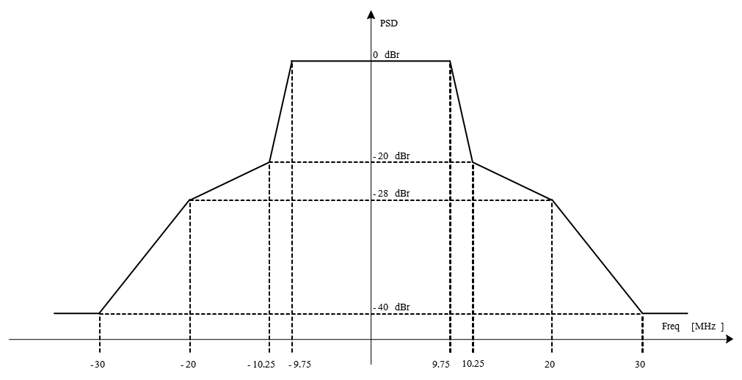

Figure 17 - Transmit spectral mask for an HE 20 MHz PPDU

The HE 40 MHz and 80 MHz spectral masks are the 11ac 80 MHz and 160 MHz masks downclocked by 2 (12/11 guard tones) as shown in Figure 16 and Figure 17.

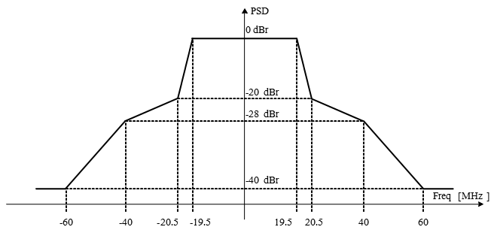

Figure 18 - Transmit spectral mask for HE 40 MHz PPDU

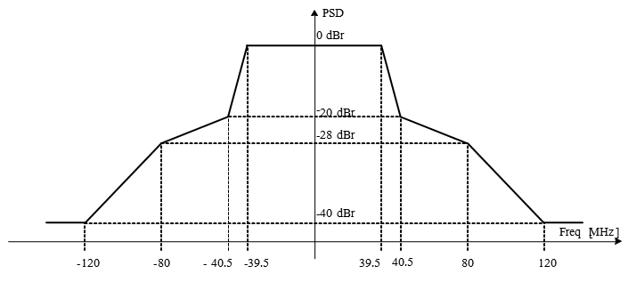

Figure 19 - Transmit spectral mask for HE 80 MHz PPDU

The HE 80+80 MHz and 160 MHz are similar to 11ac. The HE 160 MHz mask as shown in Figure 18 has the same skirt as that of 11ac 160 MHz and the 1st rolloff identical to HE 40/80 MHz. The 160 MHz tone plan has the same number of guard tones (12/11) as HE 40/80 MHz. The HE 80+80 MHz mask is a combination of two 80 MHz interim spectral masks as shown in Figure 19.

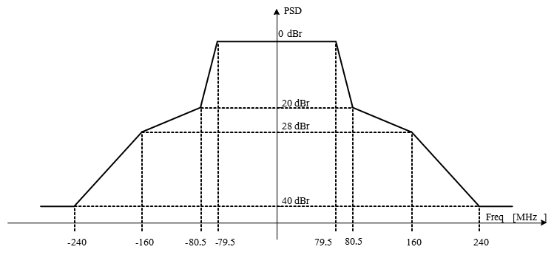

Figure 20 - Transmit spectral mask for HE 160 MHz PPDU

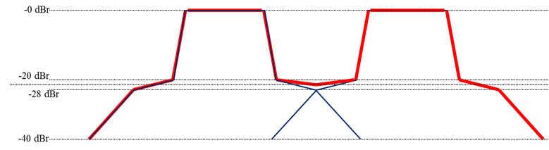

Figure 21 - Transmit spectral mask for HE 80+80 MHz PPDU

[PHY Motion 76, November 2015, see [81]]

For 20MHz PPDU, the transmit spectrum shall not exceed the maximum of the interim transmit spectral mask and –53 dBm/MHz at any frequency offset, for both 2.4GHz and 5GHz bands.

For 40MHz PPDU, the transmit spectrum shall not exceed the maximum of the interim transmit spectral mask and –56 dBm/MHz at any frequency offset, for both 2.4GHz and 5GHz bands.

For 80MHz and 160MHz PPDUs, the transmit spectrum shall not exceed the maximum of the interim transmit spectral mask and –59 dBm/MHz at any frequency offset.

[PHY Motion 133, March 2016, see 16/343r0]

# Multi-user (MU) features

## General

This section describes MU related features. MU features include UL and DL OFDMA and UL and DL MU-MIMO.

A TXOP can include both DL MU and UL MU transmissions.

[MAC Motion 14, July 16, 2015, see [82]]

The spec shall include the definition of a cascading TXOP structure, allowing alternating DL and UL MU PPDUs starting with a DL MU PPDU in the same TXOP

* The TXOP sequence has only one DL transmitter
* The TXOP sequence may have different UL transmitters within each UL MU PPDU
* The TXOP sequence may have a different set of transmitters in an UL MU PPDU as compared to the DL MU PPDU that follows the UL MU PPDU within the same TXOP

[MAC Motion 15, July 16, 2015, see [82]]

DL/UL OFDMA can multiplex different types of unicast frames in frequency domain. Types of frames can be data frame/control frame/management frame.

[MAC Motion 16, July 16, 2015, see [82]]

DL/UL MU-MIMO can multiplex different types of unicast frames in spatial domain. Types of frames can be data frame/control frame/management frame. Different types of frames are to/from different users. [MAC Motion 17, July 16, 2015, see [82]]

The transmission for all the STAs in a DL MU (MIMO, OFDMA) PPDU shall end at the same time.

The A-MPDU padding per each STA follows the 11ac procedure.

[MAC Motion 22, July 16, 2015, see [83]]

The transmission from all the STAs in an UL MU PPDU shall end at the time indicated in Trigger frame.

The A-MPDU padding per each STA follows the 11ac procedure.

[MAC Motion 23, July 16, 2015, see [83]]

DL-OFDMA may reuse the same sharing mechanism of an EDCA TXOP as DL MU-MIMO.

[MAC Motion 36, September 17, 2015, see [84]]

The spec shall allow multiple TIDs in a single PSDU between AP and a STA for DL/UL OFDMA/MU-MIMO. Multiple TIDs aggregation rules are TBD if necessary.

[MU Motion 16, September 17, 2015, see [85]]

MPDUs with multiple TIDs that ask for Ack and/or BA acknowledgement and a management frame that asks for Ack acknowledgement may be aggregated in one A-MPDU of MU transmission.

[MAC Motion 66, January 2016, see [86]]

## DL MU operation

The amendment shall include a mechanism to multiplex BA/ACK responses to DL MU transmission. [MU Motion #4, March 2015, see [87]]

In each payload within a DL MU PPDU a Trigger frame may be present that carries the information that enables the recipient of the STA to send its ACK/BA response frame a TBD IFS after the DL MU PPDU. [MU Motion 11, July 16, 2015, see [88]]

A unicast Trigger frame for a single user may be included in an A-MPDU for that user in the DL MU PPDU that precedes the UL MU transmission by TBD IFS. [MAC Motion 20, July 16, 2015, see [89]]

Broadcast trigger transmitted in a subchannel of DL OFDMA shall not include the resource allocation information of the STAs which are recipients of frames in the other subchannels of the DL OFDMA. The subchannel of the broadcast trigger frame is identified by TBD signaling. [MAC Motion 21, July 16, 2015, see [89]]

The spec shall allow that the schedule information for OFDMA acknowledgement from STAs is contained in the MAC header of DL MPDU.

[MU Motion 23, September 17, 2015, see [90]]

The contents of the scheduling information for an UL OFDMA ACK/BA includes UL PPDU Length (9 bits) and RU Allocation (TBD).

[MU Motion 24, September 24, 2015, see [90]]

In a HE MU PPDU, at most one A-MPDU is allowed to contain one or more MPDUs that solicit an immediate response, except when an immediate response is carried in HE TB UL PPDU. In such case, one or more A-MPDUs are allowed to contain one or more MPDUs that solicit an immediate response carried in an HE TB UL PPDU.

[MAC Motion 29, September 2015, see [91]]

Scheduling information for UL MU Acknowledgement from STA may be contained within the HE variant of the HT Control Field.

[MU Motion 29, November 2015, see [92]]

Within an A-MPDU the trigger information for a STA, if present, shall be signaled either in Trigger frame(s) or in the MAC header of MPDU(s) contained in the A-MPDU but not both.

[MU Motion 38, November 2015, see [93]]

Ack Policy field set to 01 (Trigger based UL MU Ack) has the following normative behavior for an HE STA:

* The addressed recipient that receives the trigger information, within a DL MU PPDU returns an immediate Ack/BlockAck response, either individually or as part of an A-MPDU after the PPDU carrying the frame, according to the trigger information carried in the same DL MU PPDU
* The addressed recipient that does receive no valid trigger information takes no action upon the receipt of the frame, except for recording the state (if necessary)

[MAC Motion 42, November 2015, see [94]]

Ack Policy field in a frame soliciting an immediate response is set to 00 (Normal Ack or Implicit Block Ack Request ) if the immediate response is carried in SU PPDU, or it is set to 01 (Trigger based UL MU Ack) if the immediate response is carried in MU PPDU.

[MAC Motion 43, November 2015, see [95]]

When an AP initiates a DL MU transmission soliciting more than one immediate response frames, the DL MU transmission is successful if the AP receives the response frame correctly from at least one STA indicated by any trigger information in the DL MU transmission.

[MAC Motion 46, November 2015, see [96]]

The spec shall allow UL MU transmission of Multi-STA Block ACK frame in response to multi-TID A-MPDU of DL MU transmission. The value of the AID field in M-BA is TBD.

[MAC Motion 65, January 2016, see [86]]

In an HE MU PPDU, the AP may set different transmit powers for different resource units.

[MU Motion 51, March 2016, see 16/331r1]

## UL MU operation

An UL MU PPDU (MU-MIMO or OFDMA) is sent as an immediate response (IFS TBD) to a Trigger frame (format TBD) sent by the AP. [MAC Motion #3, March 2015]

The inter frame space between a PPDU that contains a Trigger frame and its triggered HE trigger-based PPDU is SIFS.

[MU Motion 44, Janaury 2016, see [97]]

The spec shall define a MAC padding scheme (TBD) for trigger frame sent in Non-HT PPDUs

[MU Motion 45, Janaury 2016, see [97]]

The CP length for UL OFDMA/MU-MIMO transmissions shall be explicitly indicated by AP in the Trigger frame that allocates resources for the UL OFDMA/MU-MIMO transmission. The value of CP length for all users addressed by the Trigger frame shall be the same. [PHY Motion 34, July 16, 2015, see [98]]

A Trigger frame that addresses STAs in multiple BSSs corresponding to a multiple BSS set shall use a common address TBD in the A2 field.

[MAC Motion 55, November 2015, see [99]]

An UL OFDMA MPDU/A-MPDU is the acknowledgement of the trigger frame. When the AP receives MPDU correctly from at least one STA indicated by trigger frame, the frame exchange initiated by the trigger frame is successful. [MAC Motion 13, July 16, 2015, see [100]]

The amendment shall define a mechanism for multiplexing DL acknowledgments sent in response to UL MU transmissions. [MU Motion #1, January 2015, see [101]]

An AP shall not allocate UL subchannel in any 20 MHz channel that is not occupied by the immediately preceding DL PPDU that contains trigger information. In each 20 MHz channel occupied by the immediately preceding DL PPDU that contains trigger information, there is at least one allocated subchannel. [MAC Motion #10, May 2015, see [102], modified with MAC Motion 40, September 17, 2015, see [103]]

Non-AP STAs support using the QoS Control field in QoS Data and QoS Null frames to report per-TID Buffer Status information.

[MAC Motion 37, September 17, 2015, see [104]]

An AP can poll STAs for buffer status reports using the frame carrying the trigger info. The poll can request for specific buffer status information with TBD granularity.

[MAC Motion 38, September 17, 2015, see [104]]

A STA that is polled from a Trigger frame for UL MU transmission considers the NAV in determining whether to respond unless one of the following conditions is met

* The NAV was set by a frame originating from the AP sending the trigger frame
* The response contains ACK/BA and the duration of the UL MU transmission is below a TBD threshold
* The NAV was set by a frame originating from intra-BSS STAs
* Other condition TBD

[MU Motion 15, September 17, 2015, see [105], modified with MU Motion 28, November 2015, see [106]]

~~A STA shall consider CCA status to respond to a Trigger frame under a non-null TBD set of conditions.~~

[MU Motion 14, September 17, 2015, see [107], replaced with MU Motion 43, Janaury 2016]

Trigger frame carries an indication of whether or not the carrier sensing is required for the STA to transmit a UL MU PPDU in response to a Trigger frame. If a Trigger frame indicates that the carrier sensing is required, the STA shall consider the channel status of the physical channel sensing (meaning ED) and virtual carrier sense (NAV) before UL MU transmission in response to the Trigger Frame. Otherwise, the STA may transmit a UL MU PPDU without the carrier sensing. The AP shall require the carrier sensing except under TBD conditions.

[MU Motion 43, January 2016, see [108]]

When a STA is required to sense the medium before its UL MU transmission in response to a trigger frame,  it senses the medium using ED after receiving the PPDU that contains the trigger frame (i.e. during the TBD IFS time).

[MU Motion 40, January 2016, see [109]]

When a STA needs to perform the energy-detect (ED) before its UL MU transmission in response to a trigger frame, it shall perform the energy-detect (ED) at least in the subchannel that contains the STA’s UL allocation, where the sensed subchannel consists of either a single 20 MHz channel or multiple of  20 MHz channels.

[MU Motion 41, January 2016, see [109]]

When required to sense the medium before its UL MU transmission in response to a trigger frame, if a STA detects the 20MHz channels containing the allocated UL RU are not all idle, then the STA shall not transmit anything in the allocated UL RU.

[MU Motion 42, January 2016, see [110]]

The spec shall allow DL OFDMA transmission of Multi-STA Block ACK frame in response to UL MU PPDUs.

[MAC Motion 44, November 2015, see [111]]

When an AP selects rate, MCS, NSS of M-BA or OFDMA BA that acknowledges the UL OFDMA, the AP may ignore the MCS, NSS of UL OFDMA PPDU that elicits the DL acknowledgement.

The AP shall transmit the M-BA using one of rate, MCS, NSS that all of the acknowledgement receivers support.

[MAC Motion 45, November 2015, see [112]]

The recipient of a MU-BAR frame can transmit other data or management frame in addition to BA/ACK frame if it does not exceed the indicated UL MU duration.

[MAC Motion 58, January 2016, see [113]]

If the Trigger frame requests a specific frame type as response, the response to this Trigger frame shall contain at least the frame with the required type if the required type is available at the STA side; if the STA has no frame with the required type, the STA should transmit QoS Null frame to AP.

[MAC Motion 59, January 2016, see [114]]

The ACK Policy of the QoS data frame(s) sent in an HE trigger-based PPDU shall be set to 00 (Normal Ack or Implicit BAR) when the QoS data frame requires to be acknowledged (i.e., the Ack Policy cannot be set to 11 (Block Ack)).

[MAC Motion 77, March 2016, see 16/361r0]

In an HE trigger-based PPDU transmission, a power pre-correction mechanism is needed.

[MU Motion 49, March 2016, see 16/331r2]

The power control mechanism shall be flexible enough to allow for scheduling both class A and class B devices in the same HE trigger-based PPDU transmission.

[MU Motion 50, March 2016, see 16/331r2]

STAs that participate in HE trigger-based PPDU transmit the power headroom in triggered UL MU transmissions to assist in the AP’s MCS selection. Details of STA headroom definition are TBD

[MU Motion 53, March 2016, see 16/413r0]

Allow the AP to choose any access category for contending to send the trigger frame

* The chosen AC may give to the AP higher priority in accessing the channel compared to its associated STAs

[May 2016, see [115]]

## MU RTS/CTS procedure

The spec shall define a frame that solicits simultaneous CTS responses from multiple STAs to protect DL MU transmission. [MU Motion 6, July 16, 2015, see [116]]

The scrambler seed of a simultaneous CTS is same as the scrambler seed of the frame that triggers the simultaneous CTS. The transmission rate of a simultaneous CTS shall use the primary rate based on the rate or MCS of the frame that triggers the simultaneous CTS. [MU Motion 7, July 16, 2015, see [116]]

MU-RTS/CTS frame exchange may be used for protection of MU transmissions during that TXOP.

[MU Motion 31, November 2015, see [117]]

The CTS sent in response to a frame that solicits simultaneous CTS shall be transmitted on one or more 20 MHz channels.

[MU Motion 33, November 2015, see [117]]

MU-RTS may request STAs to send non-HT CTS immediate response.

[MU Motion 34, November 2015, see [117]]

MU-RTS will carry signaling for each STA to indicate the 20 MHz channel(s) for transmitting CTS responses when CTS is sent in (duplicate) non-HT PPDU

* When a STA sends CTS in response to MU-RTS, the CTS response shall be transmitted in the 20 MHz channel(s) indicated in MU-RTS
  + provided other transmission conditions TBD are met (e.g. channel idleness)
* The indicated 20 MHz channel(s) can be either Primary20, Primary40, Primary80 or 160/80+80 MHz. Other indications are TBD.
* Exact Signaling TBD

[MU Motion 35, November 2015, see [117]]

MU-RTS shall not be carried in an HE MU PPDU. The CTS response to an MU-RTS shall be carried in a non-HT or a non-HT duplicate PPDU.

[May 2016, see [118]]

## UL OFDMA-based random access

The spec shall define a Trigger frame that allocates resources for random access. [MU Motion 8, July 16, 2015, see [119]]

An HE AP is allowed to broadcast a TBD parameter in the trigger frame to the STAs so that STAs can initiate the random access process after the trigger frames.

[MAC Motion 41, September 17, 2015, see [120]]

When an STA has a frame to send, it initializes its OBO (OFDMA Back-off) to a random value in the range 0 to CWO (OFDMA Contention window). For an STA with non-zero OBO value, it decrements its OBO by 1 in every RU assigned to AID value TBD within the TF-R. For a STA, its OBO decrements by a value, unless OBO=0, equal to the number of RUs assigned to AID value TBD in a TF-R. OBO for any STA can only be 0 once every TF-R. A STA with OBO decremented to 0 randomly selects any one of the assigned RUs for random access and transmits its frame.

[MU Motion 27, September 17, 2015, see [121]]

The spec shall indicate cascaded sequence of Trigger frames by using a bit in the Trigger frame.

[MU Motion 21, September 17, 2015, see [122], modified with MAC Motion 50, November 2015, see [123]]

The spec shall include a mechanism that allows the Beacon frame to indicate the target transmission time(s) of one or more Trigger frame(s) that allocate resources for random access.

[MU Motion 22, September 17, 2015, see [122]]

The AP may send trigger frame to elicit buffer status report (BSR) using random access.

[MU Motion 39, November 2015, see [124]]

An AP indicates the value of OCWmin used by all STAs for the random RU allocation process for the next UL MU OFDMA transmissions. The value of OCWmin is transmitted through a dedicated field in the beacon frame.

[May 2016, see [125]]

## Sounding procedure

The amendment shall include a CSI feedback mechanism which allows for a minimum feedback granularity of less than 20 MHz.

[MU Motion 9, July 16, 2015, see [126]]

The amendment shall define a mechanism to enable multiplexing of the Compressed Beamforming Action frame (CSI feedback) from multiple stations using UL MU (MIMO or OFDMA) mode.

[MU Motion 17, September 17, 2015, see [127]]

The amendment shall define a channel sounding sequence (Figure 22) initiated by an HE AP that includes a Trigger frame that is sent SIFS after the NDP frame in order to solicit UL MU mode of Compressed Beamforming Action frame from multiple HE STAs.

[MU Motion 18, Spetember 17, 2015, see [127], modified with MU Motion 37, November 2015, see [127]]

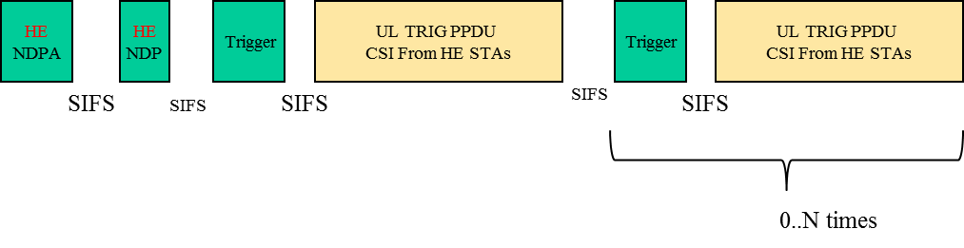

Figure 22 -- Illustration of DL Sounding Sequence

NDPA addressed to multiple STAs.

[MU Motion 20, September 17, 2015, see [128], modified with MAC Motion 81, see 16/377r1]

The amendment shall define a mechanism to reduce the MIMO compressed beamforming feedback overhead.

[MU Motion 25, September 17, 2015, see [129]]

That mechanism shall use the compressed beamforming feedback as defined in section 8.4.1.48 in 802.11ac as a baseline.

[PHY Motion 100, November 2015]

Move to add to the SFD the following sounding sequence:

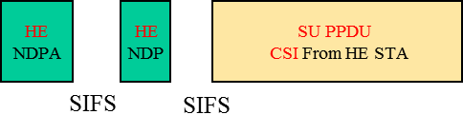

HE NDPA is addressed to 1 STA.

[MAC Motion 80, March 2016, see 16/377r1]

The HE beamformer shall have the supported MPDU size large enough to avoid fragmentation except if the MPDU size 11,454 B is reached assuming that RU, MCS, and PPDU length for beamforming feedback are large enough.

[May 2016, see [130]]

## GCR BA operation

The amendment shall include a mechanism to multiplex acknowledgment frames in response to Multicast receptions under GCR BA operation.

[MU Motion 12, September 17, 2015, see [131]]

# Coexistence

This section describes the functional blocks that support coexistence.

## Features for operation in dense environments

This section describes features that improve overlapping BSS (OBSS) operation in dense environments. This includes features such as deferral rules and CCA levels.

The STA determines whether the detected frame is an inter-BSS or an intra-BSS frame by using BSS color or MAC address in the MAC header. If the detected frame is an inter-BSS frame, under TBD condition, uses TBD OBSS PD level that is greater than the minimum receive sensitivity level

*NOTE–Maybe extra rules need to be added to ensure that all 11ax STAs can make the decision in a consistent manner.*

[MAC Motion 34, September 17, 2015, see [132]]

A STA should regard an Inter-BSS PPDU with a valid PHY header and that has a receive power/RSSI below the OBSS PD level used by the receiving STA and that meets additional TBD conditions, as not having been received at all (e.g., should not update its NAV), except that the medium condition shall indicate BUSY during the period of time that is taken by the receiving STA to validate that the PPDU is from an Inter-BSS, but not longer than the time indicated as the length of the PPDU payload. The OBSS PD level is greater than the minimum receive sensitivity level.

[SR Motion 1, September 17, 2015, see [133]]

If the SR field in the HE-SIG-A of the HE SU PPDU or HE extended range SU PPDU is set to a TBD value, the medium condition for the STA shall indicate BUSY for the duration of the HE SU PPDU or HE extended range SU PPDU. Note that the TBD value of the SR field in the HE-SIG-A of the HE SU PPDU or HE extended range SU PPDU can be set when trigger frame is carried in the HE SU PPDU or HE extended range SU PPDU or under other TBD conditions.

[May 2016, see [134]]

If the SR field in the HE-SIG-A of the HE MU PPDU is set to a TBD value, the spatial reuse transmission in the HE MU PPDU is limited to within the duration of the HE MU PPDU. Note that the TBD value of the SR field in the HE-SIG-A of the HE MU PPDU can be set when trigger frame is carried in the HE MU PPDU or under other TBD conditions.

[May 2016, see [134]]

The amendment shall include one or more mechanisms to improve spatial reuse by allowing adjustments to one or more of the CCA-ED, 802.11 Signal Detect CCA, OBSS_PD or TXPWR threshold values. The constraints on selecting threshold values are TBD.

[SR Motion 2, September 17, 2015, see [135]]

The specification to consider a procedure that may revise the NAV depending on TBD conditions at the recipient of the ongoing OBSS frame.

[SR Motion 3, September 17, 2015, see [136]]

An 11ax STA regards a valid OBSS PPDU as not having been received at all (e.g., should not update its NAV), except that the medium condition shall indicate BUSY during the period of time that is taken by the receiving STA to validate that the PPDU is from an Inter-BSS, but not longer than the time indicated as the length of the PPDU payload if the RXPWR of the received PPDU is below the OBSS_PD threshold and TBD conditions are met, noting that the OBSS_PD threshold is accompanied by a TXPWR value following adjustment rules:

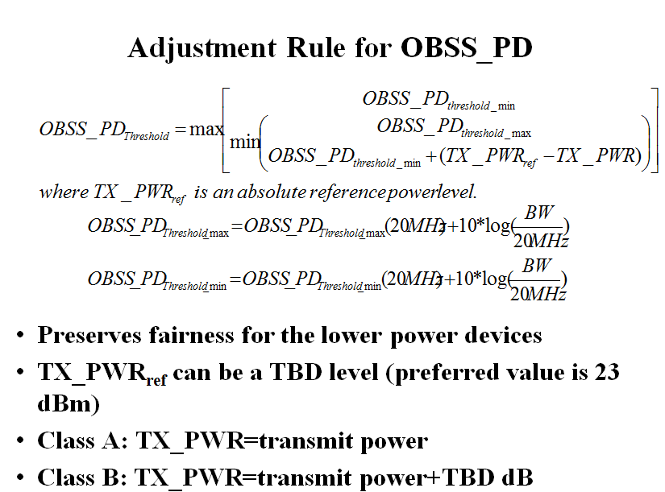

[SR Motion 4, September 17, 2015, see [137], modified with SR Motion 7, March 2016, see 16/414r0]

An HE STA should have a mechanism to remember and distinguish NAVs set by intra-BSS frame and OBSS frame. A CF-end frame that comes from intra-BSS should not reset NAV that was set by a frame from OBSS. To determine which BSS is the origin of a frame, the HE STA may use BSS color.

[SR Motion 5, November 2015, see [138]]

When a STA, that receives an HE PPDU with the same BSS Color as the BSS Color announced by its associated AP, identified from MAC header fields that the frame is an inter-BSS frame, the STA shall treat the frame as an inter-BSS frame after the FCS has been verified, unless the frame is identified as TDLS frame.

[May 2016, see [139]]

# MAC

## General

This section describes general MAC functional blocks.

The amendment shall define a mechanism to allow the AP to configure the use of RTS/CTS initiated by non-AP STA.

[MAC Motion #1, January 2015, see [140]]

In 2.4 GHz HE STAs should send beacon and probe (request & response) frames at rates ≥ 5.5 Mb/s. [MAC Motion 24, 2015, see [141]]

HE STAs shall support the Multiple BSSID Set.

[MAC Motion 28, September 17, 2015, see [142]]

When a STA receives a CF-End from an OBSS STA, if the last NAV update was caused by an Intra-BSS frame, the STA should not reset its NAV.

[MAC Motion 33, September 17, 2015, see [143]]

A STA maintains two NAVs

* One is the NAV for Intra-BSS frame, and second one is the NAV for Inter-BSS frame or frame that cannot be determined to be Intra-BSS or Inter-BSS
* Note that maintaining two NAVs does not imply maintaining two NAV timers
* The detailed method of maintaining two NAVs (e.g., two NAV timers or one NAV timer with difference of two NAV values, etc.) is TBD
* Mandatory or Optional TBD

[MU Motion 36, November 2015, see [144]]

AP and STAs in one BSS of a Multiple BSSID set shall consider a frame from another BSS of the same Multiple BSSID set as an intra-BSS frame (Signaling for a Multiple BSSID set is TBD).

[MAC Motion 60, January 2016, see [145]]

A same BSS Color shall be used for the virtual APs which are defined by TBD Multiple BSSID element.

[MAC Motion 61, January 2016, see [146]]

A HE STA can announce its maximum A-MPDU length limits to 221 or 222.

[MAC Motion 67, March 2016, see 16/359]

The AP may send a TBD IE that includes a field 'N‘. If the value indicated by the field N is greater than 0, then the AP shall allocate AIDs according to the formula



The TBD IE contains the number of partial BSS color bits used and the partial BSS color bits

[MAC Motion 83, March 2016, see 16/364r3]

An HE STA may send the buffer status report (BSR) in the HE variant HT Control field for one or more queues (whether content of queue is per TID or per AC is TBD) when the AP supports its reception

* A new Control ID value of the HE variant HT Control field identifies a BSR
* One or more (number is TBD) Queue Size subfields report the queue size
* Identifier of AC/TID (and for which) is currently TBD

[May 2016, see [147]]

## Target Wake Time (TWT)

The spec shall include a mechanism that allows a target transmission time for a Trigger frame to be indicated. The mechanism is based on implicit TWT operation and additionally enables:

* Broadcast triggered TWT by including a TWT element in the Beacon
* Solicited triggered TWT by using implicit TWT negotiation procedure

[MAC Motion 25, July 16, 2015, see [148]]

When the broadcast triggered TWT is enabled, STA and AP may exchange TWT request/response to indicate the target Beacon frame to be monitored by the PS STA.

[MAC Motion 26, July 16, 2015, see [148]]

The TWT Flow Identifier field in the TWT IE included in the Beacon frame specifies the different types of flows allowed during the TWT SP.

[MAC Motion 48, November 2015, see [123]]

Multiple TWTs can be indicated in the TWT IE in the Beacon frame by allowing multiple TWT parameter sets in the same TWT IE.

[MAC Motion 49, November 2015, see [123]]

Spec shall define a mechanism to protect TWT SP.

A TWT requesting STA sets the TWT Protection subfield to 1 in TWT Request frame to request the AP to provide protection of the set of TWT SPs using a NAV protection mechanism defined in 802.11ax (e.g. (MU)RTS/CTS or CTS-to-self, etc)

[MAC Motion 82, March 2016, see 16/353]

## Power Save

An HE non-AP STA may enter the Doze state until the end of an HE DL MU PPDU if both the following conditions are true:

* The value of the PPDU’s BSS Color field is equal to the BSS color of its BSS
* The value derived from any of the STA identifiers in the HE-SIG-B field does not match its own identifier or that of a broadcast/multicast identifier

An HE non-AP STA may enter the Doze state until the end of an HE UL MU PPDU if:

* The value of the PPDU’s BSS Color field is equal to the BSS color of its BSS

[PHY Motion 47, September 17, 2015, see [25]]

An HE STA may enter the Doze state until the end of an HE SU PPDU if both the following conditions are true:

* The value of the PPDU’s BSS Color field is equal to the BSS color of its BSS
* The value of the UL/DL Flag field indicates that the frame is UL

[PHY Motion 49, September 17, 2015, see [25]]

HE STA may use a notification of its operating mode changes for 802.11ax power saving mechanism.

[MAC Motion 30, September 17, 2015, see [149]]

The spec shall define a mechanism for a transmitting STA to indicate its RX operating mode, i.e. RX NSS, RX channel width, in a transmitted DATA type MAC header, so that the responding STA shall not transmit a subsequent PPDU using an NSS or channel width value not indicated as supported in the RX operating mode of the transmitting STA. The responding STA shall not adopt the new NSS and BW until a time TBD.

[MAC Motion 32, September 17, 2015, see [150]]

For each of the ROMI parameters Rx NSS and Rx BW, the following rules are used:

* When the HE STA changes a parameter from higher to lower, it should make the change for that parameter only after receiving the ACK for the ROMI packet.
* When the HE STA changes a parameter from lower to higher, it should make the change for that parameter right after the ACK timeout or receiving the ACK for the ROMI packet.

[May 2016, see [151]]

## Fragmentation

The spec shall support fragmentation negotiation in A-MPDUs for HE STAs.

[MU Motion 19, September 17, 2015, see [152]]

The 11ax fragmentation negotiation shall allow the following fragmentation types (levels) to be indicated:

* Level 0: No support for fragments
* Level 1: Support for a fragment in a VHT single MPDU only
* Level 2: Support for up to one fragment per MSDU in an A-MPDU
* Level 3: Support for multiple fragments of an MSDU per A-MPDU

[MAC Motion 47, November 2015, see [153]]

Under 11ax fragmentation, the following acknowledgement rules apply:

* Fragmentation – Level I
  + Recipient shall respond with an Ack to a fragment carried in a “VHT” single MPDU soliciting immediate response
* Fragmentation – Level II
  + Recipient shall respond with:
    - Ack frame to a fragment carried in a “VHT” single MPDU soliciting immediate response
    - C-BA frame to an A-MPDU soliciting immediate response
    - Each bit in BlockAck Bitmap indicates successful reception of the carried fragment or of the full MSDU
* Fragmentation – Level III
  + Recipient shall respond with:
    - Ack frame to a fragment carried in a “VHT” single MPDU soliciting immediate response
    - C-BA frame to an A-MPDU that does not carry fragments and soliciting immediate response
    - “Dedicated” C-BA frame to an A-MPDU carrying fragments and soliciting immediate response
      * Each bit in BlockAck Bitmap indicates successful reception of each of the carried fragments
      * The max number of fragments for which the BA frame signals the receive status is contained in a nonzero value of the FN subfield of the BA frame
  + Maximum number of fragments per MSDU in the eliciting A-MPDU transmitted by the originator shall be 4

[MAC Motion 63 and 64, January 2016, see [154]]

An HE STA specifies the following parameters related to fragmentation:

* Minimum Fragment Size: The minimum payload size for the first fragment of an MSDU supported by the STA
  + Possible values: 128, 256, 512, Unspecified/No Limit
* Maximum Number of F-MSDUs: The maximum number of fragmented MSDUs/MMPDUs that can be concurrently received by the STA
  + Possible values: 1, 2, 4, 8, 16, 32, Unspecified/No Limit
  + Note: Whether the counter is per <RA, TA> or per <RA, TA, TID> is currently TBD.

[MAC Motion 78, March 2016, see 16/347r0]

## Block acknowledgment

Move to add to the SFD the definition of a variant of the Compressed BA frame format with a 256-bits BA Bitmap field.

[MAC Motion 71, March 2016, see 16/378r1]

The spec shall define a length indication of Block Ack Bitmap subfield included in Fragment Number subfield of the Block Ack Starting Sequence Control field for a multi-STA BA frame, if the Block Ack Bitmap and the Block Ack Starting Sequence Control subfields are present.

MAC Motion 72, March 2016, see 16/404]

The RA field of a Multi-STA BA for a single STA should be set to the MAC address of that STA.

[MAC Motion 73, March 2016, see 16/365r1]

The BA Bitmap length of BA frames generated during a BA session is negotiated during the BA setup

* If the negotiated buffer size is within [1, X] then a BA Bitmap length of X bits will be used during the BA session for the negotiated TID
* If the negotiated buffer size is within [X+1, Y] then a BA Bitmap length of Y bits will be used during the BA session for the negotiated TID
* Note: X and Y correspond to the agreed BA Bitmap lengths of the respective BA frame (e.g., 32, 64, etc.)
* Per-PPDU BA selection rules within a BA session for the BA Bitmap length of the BA frames is TBD for <RA, TA, TID>

[May 2016, see [155]]

Multi STA BA frames shall be supported if either UL MU or multi-TID A-MPDU operation is supported

Originator indicates support for reception of ALL ACK signaling (Ack Type subfield set to 0 when responding to the soliciting A-MPDU) in Multi STA Block Ack frame that is sent as a response to the A-MPDU via a capability bit.

[May 2016, see [155]]

HE STAs follow the solicitation/response rules listed in slides 17-20, (Document 11-16-616r2)

A STA shall not send a Multi TID BAR to a STA that has not indicated support for multi-TID A-MPDU.

Also applicable to each BAR information carried in the MU BAR variant Trigger frame.

[May 2016, see [155]]

## A-MPDU operation

The recipient indicates the maximum number of TIDs of the MPDUs that the originator can aggregate in a multi-TID A-MPDU in MU PPDU.

[MAC Motion 68, March 2016, see 16/362]

Within a single A-MPDU containing MPDUs with different value of TIDs, the MPDUs with the same TID value are not required to be in contiguous A-MPDU subframes.

[MAC Motion 69, March 2016, see 16/362]

The draft specification shall specify that M-BA/BA/ACK may be aggregated with a trigger frame in an A-MPDU without accompanying Data.

[MAC Motion 76, March 2016, see 16/369r1]

The maximum number of TIDs of QoS data frames that an originator can aggregate in a multi-TID A-MPDU is indicated in the HE Capabilities element sent by the recipient

* A nonzero value also indicates that the recipient supports reception of multi-TID A-MPDUs
  + Note: A multi-TID A-MPDU allows the aggregation of an Action Ack frame as well

A STA that transmits a trigger-based PPDU as an immediate response to the Basic variant Trigger frame follows the indication of max number of TIDs contained in the Trigger Dependent Per User Info field of the Trigger frame addressed to the STA (i.e., AID of the Per User Info field is that of the STA) and can transmit an A-MPDU that contains a number of aggregated TIDs in the A-MPDU that is up to that value.

[May 2016, see [155]]

# Frame formats

## Fields

### HT Control field

The spec shall define an HE variant (of the VHT variant) of the HT Control field that carries one or more control fields for HE control information

* B0 and B1 of the HT Control field in this case are set to 1
* The control fields can be called HE Control field

[MAC Motion 39, September 17, 2015, see [156]]

HE link adaptation shall define reference payload size for the reported MCS in MFB.

Reference payload size may be dependent on the frames involved in link adaptation or fixed in specification. Details are TBD.

[PHY Motion 77, November 2015, see [157]]

The HE link adaptation field, which is part of HE variant of HT control field, consists of MFB and TBD subfields. The MFB subfield includes NSS and MCS subfield.

[PHY Motion 78, November 2015, see [157]]

The HE A-Control field for UL acknowledgement through OFDMA (acknowledgement through MU MIMO and MUMIMO in OFDMA are not supported) is defined as following:

* 5-bit UL PPDU Length indicates OFDMA symbols of the Data field.
* 5-bit DL TX Power indicates the transmission power of the Trigger frame in unit of 2db.
* 5-bit Target UL RX Power indicates the target RX power in unit of 2db.
* 8-bit RU Allocation which is same as Trigger frame.
* 2-bit MCS indicates the MCS of the UL acknowledgement, MCS 0 to 3.
* One SS is used for UL acknowledgement
* The STAs that are the receivers of HE A-Control don’t do CCA sensing before sending UL MU acknowledgement.
* One HE LTF is used for UL acknowledgement
* Spatial reuse is disallowed.
* The CP+LTF Type is TBD.
* The other missed parameters are same or derived from related parameters in DL MU transmission or some default value

[May 2016, see [158]]

HE A-Control field for UL acknowledgement is optional in RX.

[May 2016, see [158]]

The Receive Operating Mode A-Control field shall include an UL MU Disable field that allows an HE STA to suspend and resume being scheduled by a Trigger frame or UL MU resource scheduling A-Control field.

[May 2016, see [159]]

The Receive Operating Mode A-Control field shall include the following transmit operating parameters: max Tx NSS and max Tx power.

Editorial note: we may want to change the name since it would now include transmit operating parameters.

[May 2016, see [159]]

### QoS Control field

|  |  |  |
| --- | --- | --- |
| **Bits in QoS Control field** | | **Meaning** |
| **Bit 5** | **Bit 6** |
| 0 | 1 | No explicit acknowledgment or PSMP Ack or Trigger based UL MU Ack.  When bit 6 of the Frame Control field (see 8.2.4.1.3 (Type and Subtype fields)) is set  to 1:  …  When bit 6 of the Frame Control field (see 8.2.4.1.3 (Type and Subtype fields)) is set  to 0:  The acknowledgment for a frame indicating PSMP Ack when it appears in a PSMP  downlink transmission time (PSMP-DTT) is to be received in a later PSMP uplink  transmission time (PSMP-UTT).  …  If the DL PPDU is HE MU PPDU, the addressed recipient returns an Ack/BA in MU format as an immediate response to a DL MU PPDU. |

[MAC Motion 43, November 2015]

## Frames

### Trigger frame

The spec shall define a new control frame format that carries sufficient information to identify the STAs transmitting the UL MU PPDUs and allocating resources for the UL MU PPDUs. The format of the new frame is given in Figure 11. The presence of A1 is TBD. [MAC Motion 19, July 16, 2015, see [160]]

|  |  |  |  |  |  |  |  |  |  |  |
| --- | --- | --- | --- | --- | --- | --- | --- | --- | --- | --- |
|  | Frame Control | Duration | RA | TA | Common Info | Per User Info | … | Per User Info | Padding | FCS |
| Octets: | 2 | 2 | 6 | 6 | TBD | TBD |  | TBD |  | 4 |

Figure 23 - Trigger frame

Trigger frame is a new subtype of the control type as indicated in the FC B4 to B7 with the subtype not equal to 6.

[MAC Motion 53, November 2015, see [160], modified with MU Motion 55, March 2016, see 16/379r0]

The Common Info field includes the following subfields:

* Length [12 bits]
  + Value of the L-SIG Length of the UL MU PPDU
  + A responding STA will copy this value in its L-SIG length field, hence the encoding shall be same as defined for the L-SIG Length of the UL MU PPDU
* Info bits content of the SIG-A of the response UL MU PPDU [# of bits TBD]
  + May Exclude the bits that may be implicitly already known by all responding STAs, if any TBD
* CP + HE LTF type [TBD # of bits]
* Allowed response type / trigger type [# of bits TBD]
  + Types TBD
* Doppler [PHY Motion 136, March 2016, see 15/1354r2]

[MAC Motion 51, November 2015, see [160]]

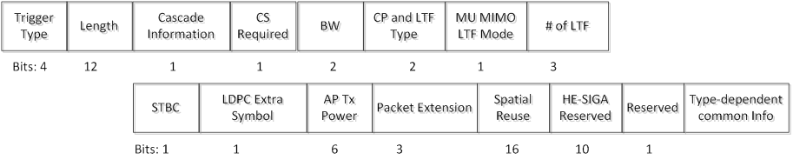

Common Info field

|  |  |  |  |  |  |  |  |  |
| --- | --- | --- | --- | --- | --- | --- | --- | --- |
|  | User Indentifier | RU Allocation | Coding Type | MCS | DCM | SS Allocation | Target RSSI | Type dependent Per User Info |
| Bits: | 12 | 8 | 1 | 4 | 1 | 6 | TBD | variable |

Per User Info field

[MU Motion 55, March 2016, see 16/379r0, updated May 2016, see [161], [162]]

The Per User Info field includes the following subfields:

* MCS [4 bits]
* Coding type [# bits TBD]
* RU allocation information [# bits TBD]
* SS allocation [# bits TBD]
* DCM [1 bit]
* User identifier field [12 bits]
  + AID for STAs associated with AP; TBD for unassociated STAs

[MAC Motion 52, November 2015, see [163]]

SS Allocation in Per User Info field is defined by Starting Spatial Stream (3 bits) and Spatial Stream Number (3 bits).

[May 2016, see [162]]

The spec shall define optional type-specific Common Info and optional type-specific Per User Info of Trigger frame. The locations of type-specific Common Info and type-specific Per User Info are TBD.

[MAC Motion 54, November 2015, see [164]]

The MU BAR frame is a variant of Trigger frame whose Trigger Type subfield is MU BAR that carries additional BAR Control subfield (TBD) and an additional BAR Information subfield (TBD) in Common Info and/or each Per-User info.

[MU Motion 30, November 2015, see [165]]

The MAC format of MU-RTS is a variant of trigger frame format.

[MU Motion 32, November 2015, see [117]]

Use 8 bits to signal the RU allocation for each STA in per user info field of Trigger frame.

* The first bit indicates the allocated RU is located in the primary or non-primary 80MHz.
* The mapping of the subsequent 7 bits indices to the RU allocation is defined in the table below.

|  |  |  |
| --- | --- | --- |
| 7 bits indices | Message | Number of entries |
| 0000000 ~ 0100100 | Possible 26 RU cases in 80MHz | 37 |
| 0100101 ~ 0110100 | Possible 52 RU cases in 80MHz | 16 |
| 0110101 ~ 0111100 | Possible 106 RU cases in 80MHz | 8 |
| 0111101 ~ 1000000 | Possible 242 RU cases in 80MHz | 4 |
| 1000001 ~ 1000010 | Possible 484 RU cases in 80MHz | 2 |
| 1000011 | 996 RU cases in 80MHz | 1 |
| 1000100 | 160MHz/80+80MHz case | 1 |
| **Total** |  | 69 |

[MAC Motion 74, March 2016, see 16/383r0]

The draft specification shall specify that when a Trigger needs to be padded to allow sufficient UL PPDU transmission preparation time, the padding shall be at the MAC layer and the padding shall not include an FCS

[MAC Motion 75, March 2016, see 16/368r1]

AP signals the following in the Trigger frame that schedules the UL MU transmission

* In the common info field: AP Tx Power:
* In the per user info field: for each STA that is scheduled in the Trigger frame
  + The number of bits in the Target RSSI is TBD

STA sets its Tx power per the following equation

* where is the DL path loss computed by the STA based on the AP transmit power signaled in the Trigger message and the measured RSSI of the Trigger message
* is signaled by the AP in the trigger message

The STA’s actual Tx power is further subject to its minimum and maximum TX power limit due to hardware capability, regulatory requirements as well as non-802.11 in-device coexistence requirements.

[MU Motion 52, March 2016, see 16/413r0, last sentence May 2016, see [5]]

BW subfield length in the Common Info Field of the Trigger frame is 2 bits

PE subfield length in the Common Info Field of the Trigger frame is 3 bits

‘CP and LTF Type’ subfield length in the Common Info Field of the Trigger frame is 2 bits

The AP specifies in the Trigger frame, the value of SR and Reserved bits which is used by the STA in HE-SIG-A of a trigger-based PPDU.

The HE AP shall set the MU MIMO LTF Mode bit in the trigger to indicate:

* Single-stream pilots for any OFDMA transmission (including the case where MU-MIMO happens on part of the BW)
* The appropriate LTF mode (single stream pilots or masked LTFs) for full BW MU-MIMO

[May 2016, see [161]]

The AP Tx power is signaled in Trigger frame using 6 bits. Value 0 to 60 maps to -20 dBm to 40 dBm with 1 dB resolution. Value 61, 62 and 63 are reserved. AP Tx power is defined as the averaged power in 20 MHz unit and is the combined power over all Tx antennas.

[May 2016, see [5]]

The target received power (RSSI) in trigger frame is signaled using 7 bits.

* Value 0 to 90 maps to -110 to -20dBm target received signal level with 1dB resolution.
* Value 127 indicates STA to transmit at its max power allowed for the assigned MCS
* Other values are reserved.

[May 2016, see [5]]

Define the following options to be signaled in the Trigger frame for UL Trig PPDU

* 2x LTF + 1.6 uS (mandatory)
* 4x LTF + 3.2 uS (mandatory)
* 1x LTF + 1.6 uS for full BW only. TBD whether mandatory to transmit in UL Trig PPDU

[May 2016, see [29]]

Trigger frame includes a two-bits MPDU MU Spacing Factor subfield in trigger dependent per-user info subfield within per-User Info field of the basic variant of trigger frame

* A STA uses *Minimum MPDU Start Spacing (in AP’s HT Capabilities element) * (*MPDU MU Spacing Factor +1*)* as the MU minimum MPDU start spacing in UL MU transmission.

[May 2016, see [166]]

The BRP variant of the Trigger frame includes 8-bit Feedback Segment Retransmission Bitmap in Per STA Info.

[May 2016, see [130]]

The basic variant Trigger frame shall contain the TID Aggregation Limit subfield in the Trigger Dependent Per User Info field that indicates the limit of the number of TIDs that can be aggregated by a STA in a multi-TID A-MPDU carried in the responding Trigger-based PPDU

* The responding STA shall not aggregate QoS Data frames in the multi-TID A-MPDU with a number of TIDs that exceeds the value indicated in the TID Aggregation Limit sub-field intended to it

[May 2016, see [167]]

The spec shall define that AID=0 in the User Identifier subfield of the Per User Info field in a Trigger Frame indicates the resource allocation can be used for random access by any STA.

[May 2016, see [168]]

### BlockAck frame

#### General

Mapping for the FN subfield of BA frames:

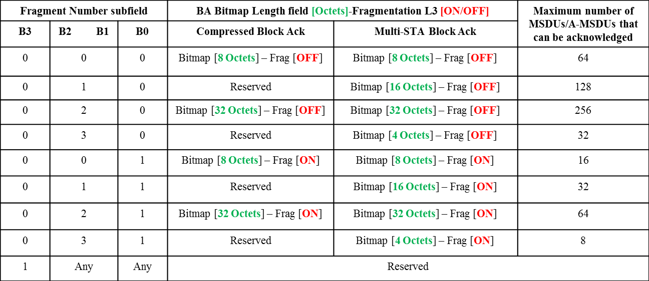

[May2016, see [155]]

#### Compressed BlockAck frame

Move to add to the SFD the definition of a variant of the Compressed BA frame format with a 256-bits BA Bitmap field.

[MAC Motion 70, March 2016, see 16/378r1]

#### Multi-STA BA frame

The spec shall define a multi-STA BA frame by using the Multi-TID BlockAck frame format with the following changes:

* Add an indication that the frame is a multi-STA BA (TBD)
* Each BA Information field can be addressed to different STAs
* B0-B10 of the Per TID Info field carry a (Partial) AID identifying the intended receiver of the BA Information field

[MAC Motion #1, March 2015, see [169]]

The spec shall define a signaling in the Multi-STA BA frame that can indicate an ACK, as follows:

* If B11 in the per-TID info field is set, then the BlockAck bitmap and the SC subfields in the BA Info field are not present and this BA Info field indicates an ACK of either single MPDU or all MPDUs carried in the eliciting PPDU that was transmitted by the STA whose AID is indicated in the per-TID info field. [Modifed with MAC Motion #8, May 2015, see [170]]

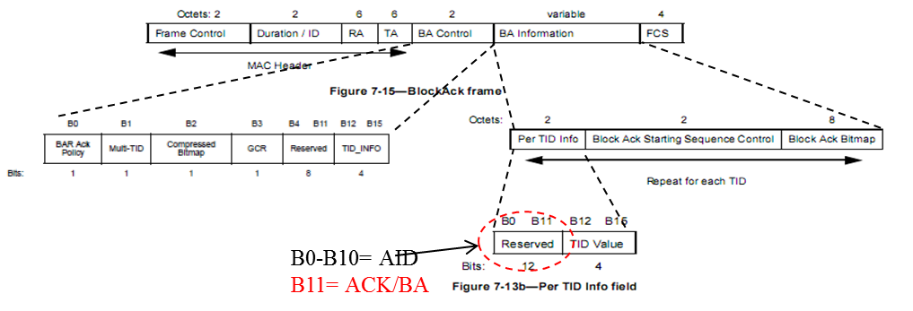

Figure 24 - Multi-STA BA frame

[MAC Motion #2, March 2015, see [169]]

A value of 15 in the TID subfield in the Per STA Info field of the M-BA frame indicate the successful acknowledgement of a management frame that requires an immediate response and is carried in the soliciting A-MPDU.

[MAC Motion 79, March 2016, see 16/359]

### MU-BAR frame

The spec shall define a MU-BAR frame to solicit BA/ACKs from multiple STAs in UL MU transmissions.

[MU Motion 13, September 17, 2015, see [171]]

### HE NDPA frame

The proposed HE NDPA frame format reusing the type/subtype of VHT NDPA is shown as below:

* Only for HE NDPA aimed at more than one STAs

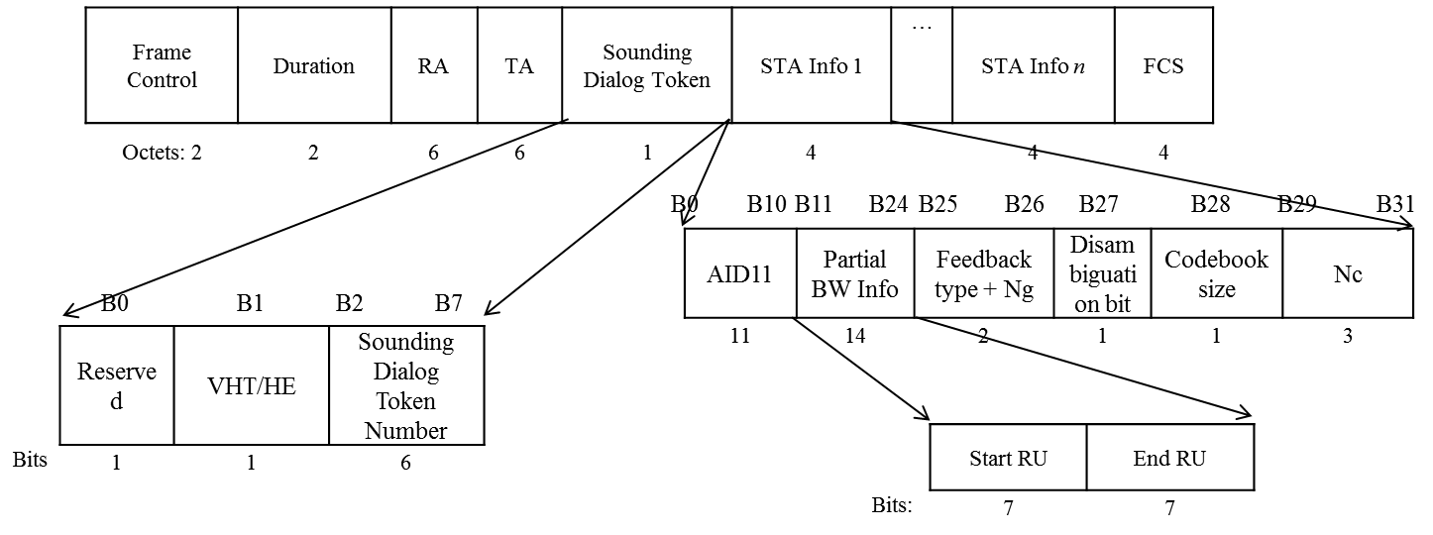

VHT/HE (B1 of sounding dialog token): to help all HE STAs to differentiate between VHT NDPA and HE NDPA.

* Per STA Info extends from 2 Byte to 4 Byte to include more info:
* AID11: 11 LSB of the AID of an HE STA expected to process the following HE NDP and prepare the sounding feedback.
* Partial BW Info: signals the start index and the end index 26 tone RUs requested for feedback (7 bit is needed for maximum 74 RUs for start/end RUs).
* Disambiguation bit (B27): set to 1 to prevent VHT STA from parsing B16-B27 as his own AID
* Feedback + Ng + codebook size (2+1 bits) jointly indicate:

|  |  |
| --- | --- |
| **Feedback type + Ng + codebook size** | **Description** |
| 000 | SU, Ng4, quantization resolution = {2,4} |
| 001 | SU, Ng4, quantization resolution = {4,6} |
| 010 | SU, Ng16, quantization resolution = {2,4} |
| 011 | SU, Ng16 quantization resolution = {4,6} |
| 100 | MU+Ng4, quantization resolution = {5,7} |
| 101 | MU+Ng4, quantization resolution = {7,9} |
| 110 | CQI only feedback |
| 111 | MU+Ng16, quantization resolution = {7,9} |

[May 2016, see [172]]

## Sounding feedback

802.11ax spec shall not support *Ng = 1* for sounding feedback.

*NOTE*—*The tone grouping factor, Ng is defined with respect to data tones of the HE PPDU.*

[PHY Motion 38, September 17, 2015, see [173]]

802.11ax spec shall support *Ng* = 4 and 16 for sounding feedback with SU/MU-MIMO-OFDM(A).

*NOTE—The tone grouping factor, Ng is defined with respect to data tones of the HE PPDU.*

[PHY Motion 101, January 2016, see [174]]

In the MU Exclusive Beamforming Report for the delta SNR, the locations of the feedback tones shall be identical to the tone locations of the compressed V matrices fed back.

[PHY Motion 102, January 2016, see [175]]

An HE AP indicates the necessary TBD parameters so that multiple HE STAs can construct the compressed beamforming feedback matrix immediately after receiving the HE NDP frame.

[MU Motion 46, Janaury 2016, see [127]]

The tones used for channel feedback shall be a subset of the sets given below:

NDP bandwidth 20 MHz:

*Ng* = 4 → [-120:4:-4, 4:4:120] + edge(±2,±122)

*Ng* = 16 → [-116:16:-4, 4:16:116] + edge(±2,±122)

NDP bandwidth 40 MHz:

*Ng* = 4/16 → [-244:*Ng*:-4, 4:*Ng*:244]

NDP bandwidth 80 MHz:

*Ng* = 4/16 → [-500:*Ng*:-4, 4:*Ng*:500]

[PHY Motion 145, March 2016, see 16/389]

AP can request beamforming feedback over partial BW which is less than the NDP BW. The indication of the feedback BW goes in NDPA.

[PHY Motion 148, March 2016, see 16/389]

The granularity of channel feedback requested by the AP is a 26 tone RU. The AP signals start and end 26 tone RUs requested for feedback.

[PHY Motion 149, March 2016, see 16/389]

The max *Nc* for sounding feedback that a BFee can support shall be negotiated through a capability exchange at association.

[PHY Motion 150, March 2016, see 16/389]

AP shall control the *Ng*, quantization, and *Nc* of the sounding FB in NDPA except in the special case of a NDPA addressed to a single STA which requests SU type feedback. In the aforementioned special case, the STA controls these quantities.

[PHY Motion 151, March 2016, see 16/389]

A channel quality indicator only (CQI-only) feedback (exact metric TBD) will be supported by the sounding protocol in 11ax. The request for CQI-only feedback goes in NDPA.

[PHY Motion 152, March 2016, see 16/389]

Feedback structure for MU type feedback:

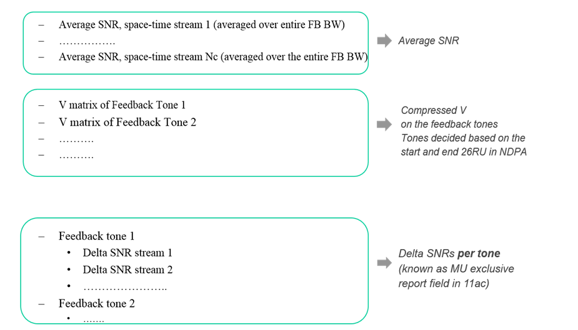

Feedback structure for SU type feedback:

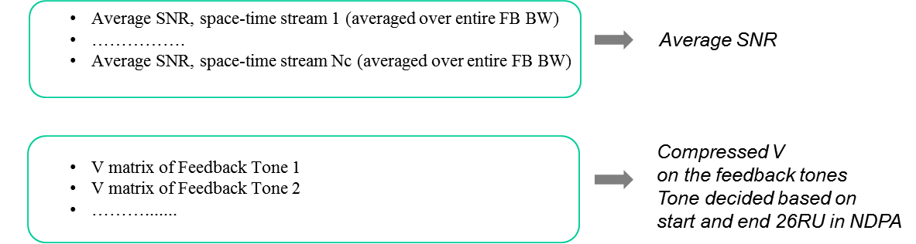

Feedback structure for CQI feedback:

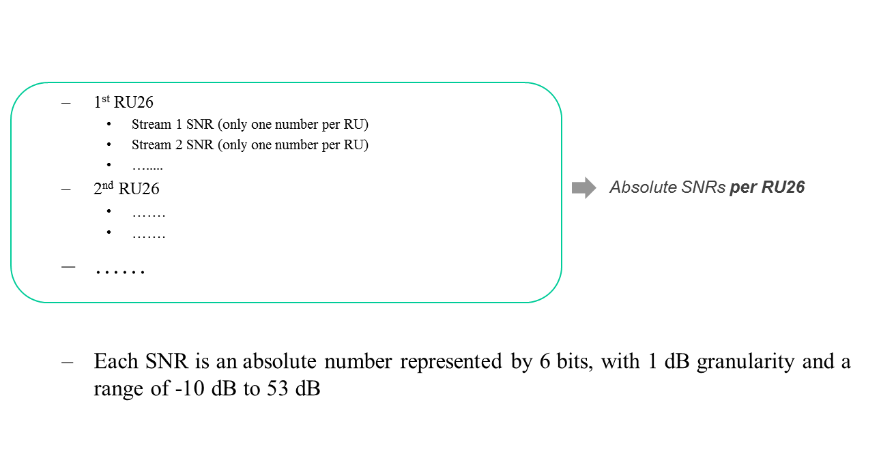

HE-MIMO control field:



Changes from VHT are listed below

* BW (2 bits) – Same meaning as channel width field of VHT
* RU_Start_Index (7 bits): The index of the first RU26 of the feedback being sent
* RU_End_Index (7 bits): The index of the last RU26 of the feedback being sent
* Grouping is 1 bit
* 0: Ng=4, 1: Ng=16
* Feedback type is 2 bits
* 0: SU, 1: MU, 2: CQI only, 3: Reserved
* 4 bits unused (reserved)

[May 2016, see [176]]

For all feedback types, the AP shall use 7 bits each to signal the start and end 26 RU for partial bandwidth feedback. The index used to signal a 26 RU increases with frequency, with the minimum value of the index being 0. For NDP bandwidths of 20, 40, 80, 160 MHz, the maximum value of the index shall be 8, 17, 36 and 73 respectively. The start and end 26 RUs in the HE MIMO Control Field shall use the same indexing as above.

[May 2016, see [177]]

The STA feeds back the channel on all tones from the feedback roster (Table 1, document 11-16/0649r0, on slide 13 ) between

“S” tone corresponding to start 26 RU index

and

“E” tone corresponding to end 26 RU index

where the “S” and “E” tones are defined as function of RU index in Table 2a for Ng = 4 and Table 2b for Ng = 16 (document 11-16/0649r0 on slide 13)

Note: For 160 MHz, to determine the “S” and “E” tones, RUs 37-73 occupying the higher 80 MHz use the same table as RUs 0-36 occupying the lower 80 MHz

[May 2016, see [177]]

The only quantization resolutions for the Givens angles ϕ, ψ in

* MU feedback shall be (9,7) and (7,5) bits
* SU feedback shall be (6,4) and (4,2) bits

Note: MU resolution with Ng = 16 is limited to (9,7)

[May 2016, see [177]]

# References

|  |  |
| --- | --- |
| [1] | Robert Stacey (Intel), “14/1453r2 Spec Framework Proposal”. |
| [2] | Sameer Vermani (Qualcomm), “16/0612r1 Mandatory/Optional Support Issues for 802.11ax”. |
| [3] | Jiayin Zhang (Huawei), “16/0047r0 Discussion on the HE Extended Range SU PPDU”. |
| [4] | Arjun (Qualcomm), “16/0053r0 Requirements for UL MU Transmissions”. |
| [5] | Bin Tian (Qualcomm), “16/0617r0 Remaining Topics in Power Control”. |
| [6] | Yunbo Li (Huawei), “16/0059r1 Non-contiguous Channel Bonding in 11ax”. |
| [7] | Bin Tian (Qualcomm), “16/0618r1 11ax CSD Design”. |
| [8] | Jiayin Zhang (Huawei), “15/0101r1 Preamble structure for 11ax system”. |
| [9] | Hongyuan Zhang (Marvell), “15/0579r3 Preamble Design and Autodetection”. |
| [10] | Jiayin Zhang (Huawei), “15/0832r1 Performance evaluation of SU/MU MIMO in OFDMA”. |
| [11] | Yakun Sun (Marvell), “15/1350r1 Spatial Configuration And Signaling”. |
| [12] | Ron Porat (Broadcom), “15/1353r1 Preamble Formats”. |
| [13] | Young Hoon Kwon (Newracom), “15/1051r1 HE NDP frame for sounding”. |
| [14] | Jianhan Liu (Mediatek Inc.), Yakun Sun (Marvell), “15/1322r0 Channel Estimation Enhancement and Transmission Efficiency Improvement Using Beam-Change Indication and 1x HE-LTF”. |
| [15] | Xiaogang Chen (Intel), “15/1357r1 Extra tones in the preamble”. |
| [16] | Hongyuan Zhang (Marvell), “15/1305 STBC and Padding Discussions”. |
| [17] | Sameer Vermani (Qualcomm), “15/1309r1 Extended Range Support for 11ax”. |
| [18] | Xiaogang Chen (Intel), “16/0652r2 Power scaling of 4 extra tones”. |
| [19] | Hongyuan Zhang (Marvell), “15/0579r4 Preamble Design and Autodetection”. |
| [20] | John Son (WILUS), “16/0043r0 Clarifications of SFD Texts”. |
| [21] | Jiayin Zhang (Huawei), “16/0046r0 Content for the extra tones in LSIG and RLSIG”. |
| [22] | Jianhan Liu (Mediatek Inc.), “15/0822r2 SIG-A Structure in 11ax Preamble”. |
| [23] | Jiayin Zhang (Huawei), “15/1077r0 HE-SIG-A Content”. |
| [24] | Dongguk Lim (LG), “15/1324r0 MCS for HE-SIG-B”. |
| [25] | Alfred Asterjadhi (Qualcomm Inc.), “15/1122r0 Identifiers in HE PPDUs for power saving”. |
| [26] | Jianhan Liu (Mediatek), “15/1068r1 Reliable Transmission Schemes for HE-SIG-B and Data”. |
| [27] | Yingpei Lin (Huawei), “15/1355r0 Considerations for TDLS transmission in 11ax”. |
| [28] | James Wnag (Mediatek), “16/0699r0 Spatial Re-Use OA-CCA and SR Field”. |
| [29] | Ron Porat (Broadcom), “16/654r0 CP and LTF Options and Signaling”. |
| [30] | Ron Porat (Broadcom), “15/1354r1 SIGA fields and Bitwidths”. |
| [31] | Yunbo Li (Huawei), “16/635r2 BW indication for Non-contiguous Channel Bonding”. |
| [32] | Kaushik Josiam (Samsung), “15/1315r1 HE-SIG-B Mapping and Compression”. |
| [33] | Yujin Noh (Newracom), “16/0040r0 Issues with Compressed SIG-B Mode”. |
| [34] | Jiayin Zhang (Huawei), “15/0826r3 HE-SIG-A transmission for range extension”. |
| [35] | Yakun Sun (Marvell), “16/0036r0 CRC Generation for HE-SIG”. |
| [36] | Jeongki Kim (LG Electronics), “16/636r2 TXOP Duration field in HE-SIG-A”. |
| [37] | Young Hoon Kwon (Newracom), “15/0344r2 SIG Field Design Principle for 11ax”. |
| [38] | Ron Porat, “15/0873r0 SIG-B Encoding Structure”. |
| [39] | Yakun Sun (Marvell), “16/0037r1 Continuous Puncturing for HE-SIGB Encoding”. |
| [40] | Joonsuk Kim (Apple), “15/0821r2 HE SIG-B Structure”. |
| [41] | Katsuo Yunoki (KDDI R&D Laboratories), “15/0827r2 Considerations on HE-SIG-A and B”. |
| [42] | Ron Porat (Broadcom), “15/1059r1 SIG-B Encoding Structure Part II”. |
| [43] | Ron Porat (Broadcom), “15/1059r2 SIG-B Encoding Structure Part II”. |
| [44] | Kaushik Josiam (Samsung), “15/1066r0 HE-SIG-B Contents”. |
| [45] | Le Liu (Huawei), “15/1335r2 HE-SIG-B Contents”. |
| [46] | Yan Zhang (Marvell), “16/0633r3 Left over Issues in RU Signaling for HE-SIGB”. |
| [47] | Ming Gan (Huawei), “16/637r0 Load balancing indication for MU-MIMO over 484-tone and larger RU in OFDMA”. |
| [48] | Daewon Lee (Newracom), “16/0039r1 RU Allocation in SIG-B”. |
| [49] | Liwen Chu (Marvell), “15/1352r0 broadcast STAID in HE SIG B”. |
| [50] | Lochan Verma (Qualcomm), “16/0613r0 SIG-B related issues”. |
| [51] | Bin Tian (Qualcomm), “16/0619r0 PAPR Reduction of HE-SIGB”. |
| [52] | Tianyu Wu (Mediatek), “16/0621r1 DCM interleaver”. |
| [53] | Jinsoo Choi (LG Electronics), “16/639r0 Follow-up on HE-SIG-B user-specific field”. |
| [54] | Le Liu (Huawei), “15/1334r1 HE-LTF Sequence Design”. |
| [55] | Yakun Sun (Marvell), “15/0381r1 HE-STF Proposal”. |
| [56] | Eunsung Park (LG Electronics), “15/1323r1 HE-STF Sequences”. |
| [57] | Hongyuan Zhang (Marvell), “15/0349r2 HE-LTF Proposal”. |
| [58] | Yakun Sun (Marvell), “15/0817r0 P Matrix for HE-LTF”. |
| [59] | Bin Tian (Qualcomm), “15/0819r1 11ax OFDMA Tone Plan Leftover Tones and Pilot Structure”. |
| [60] | Xiaogang Chen (Intel), “15/0602r6 HE-LTF squence for UL MU-MIMO”. |
| [61] | Sriram Venkateswaran (Broadcom), “16/0089r1 Single Stream Pilots in UL MU MIMO”. |
| [62] | Le Liu (Huawei), “16/0052r0 Remaining HE-LTF sequence design”. |
| [63] | Hongyuan Zhang (Marvell), “16/0033r0 1x HE-LTF for ULMUMIMO”. |
| [64] | Hongyuan Zhang (Marvell), “16/0034r0 Beamforming with HE-LTF Compression”. |
| [65] | Sriram Venkateswaran (Broadcom), “15/0099r4 Payload Symbol Size for 11ax”. |
| [66] | Sameer Vermani (Qualcomm), “15/0812r1 Pilot Design for Data Section”. |
| [67] | Shahrnaz Azizi (Intel), “15/0330r5 OFDMA Numerology and Structure”. |
| [68] | Bin Tian (Qualcomm), “15/1310r0 11ax LDPC Tone Mapper for 160MHz”. |
| [69] | Ken Taniguchi (Toshiba), “16/0079r2 Allocation sizes for BCC in OFDMA”. |
| [70] | Hongyuan Zhang (Marvell), “15/0580r1 11ax coding discussion”. |
| [71] | Hongyuan Zhang (Marvell), “15/0580r2 11ax coding discussion”. |
| [72] | Jianhan Liu (Mediatek), “16/0056r0 On QPSK DCM Modulation and LDPC Tone Mapper for DCM”. |
| [73] | Eunsung Park (LG Electronics), “15/1070r3 1024 QAM Proposal”. |
| [74] | Eunsung Park (LG Electronics), “16/0044r0 MCS Levels and TX EVM Requirement for 1024 QAM”. |
| [75] | Jianhan Liu (Mediatek Inc.), “16/0656r1 1024QAM Modulation”. |
| [76] | Hongyuan Zhang (Marvell), “16/0620r0 DCM PHY Parameters”. |
| [77] | Jianhan Liu (Mediatek Inc.), “16/0655r0 On MCS0 DCM Modulation and DCM Capability”. |
| [78] | Sudhir Srinivasa (Marvell), “16/0622r0 16QAM Mapping for DCM”. |
| [79] | Hongyuan Zhang (Marvell), “15/0810r1 HE PHY Padding and Packet Extension”. |
| [80] | Andrew Blanksby, “16/0071r1 Packet Extension Follow Up”. |
| [81] | Bin Tian (Qualcomm), “15/1311r0 11ax Sppectral Masks”. |
| [82] | David Xun Yang (Huawei), “15/0841r0 Cascading Structure”. |
| [83] | Simone Merlin (Qualcomm), “15/0876r1 Duration and MAC Padding for MU PPDUs”. |
| [84] | Jinsoo Ahn (Yonsei Univ.), “15/1116r1 Trigger Frame Channel Access”. |
| [85] | Chao-Chun Wang (Mediatek), “15/1065r1 11ax uplink Multi-TID aggregation”. |
| [86] | Liwen Chu (Marvell), “16/0069r0 Multi-TID A-MPDU in MU Transmission”. |
| [87] | Reza Hedayat (Newracom), “15/0379r1 DL OFDMA Performance and ACK Multiplexing”. |
| [88] | Reza Hedayat (Newracom), “15/0829r3 Uplink ACK and BA Multiplexing”. |
| [89] | Liwen Chu (Marvell), “15/0831r2 Broadcast and Unicast in DL MU”. |
| [90] | Liwen Chu (Marvell), “15/1123r1 acknowledgement to DL MU”. |
| [91] | Yongho Seok (NEWRACOM), “15/1033r0 Data field in HE PPDU”. |
| [92] | Yujin Noh (Newracom), “15/1328r1 Scheduling information for UL OFDMA Acknowledgement”. |
| [93] | Chittabrata Ghosh (Intel), “15/1364r0 Signaling Trigger Information for STAs in 11ax”. |
| [94] | Yongho Seok (NEWRACOM), “15/1278r1 HE MU Acknowledgment Procedure”. |
| [95] | Kiseon Ryu (LG Electronics), “15/1346r2 Ack Policy for UL MU Ack transmission”. |
| [96] | Young Hoon Kwon (Newracom), “15/1300r0 DL MU transmission sequence”. |
| [97] | Liwen Chu (Marvell), “16/0067r0 MAC Padding in Trigger Frame”. |
| [98] | Zhigang Rong (Huawei), “15/0813r0 CP Indication for UL MU Transmission”. |
| [99] | Kaiying Lv (ZTE Corp.), “15/1389r0 TA Address Field in Trigger Frame”. |
| [100] | Liwen Chu (Marvell), “15/0615r3 UL OFDMA Bandwidth”. |
| [101] | Tomoko Adachi (Toshiba), “15/0064r1 Consideration on UL-MU overheads”. |
| [102] | Liwen Chu (Marvell), “15/0615r2 UL OFDMA Bandwidth”. |
| [103] | Young Hoon Kwon (Newracom), “15/1052r0 Bandwidth for UL MU transmission”. |
| [104] | Alfred Asterjadhi (Qualcomm Inc.), “15/1120r0 Buffer Status Report”. |
| [105] | Po-Kai Huang (Intel), “15/1062r1 NAV Consideration for UL MU Response to Trigger frame”. |
| [106] | Yingpei Lin (Huawei), “15/1301r1 NAV Rule for UL MU Response”. |
| [107] | Kiseon Ryu (LG Electronics), “15/1058r0 CCA consideration for UL MU transmission”. |
| [108] | Kiseon Ryu (LG Electronics), “16/0057r0 Indication for UL MU Carrier Sensing”. |
| [109] | Lei Wang (Marvell), “16/0031r0 Proposed UL MU CS Rules”. |
| [110] | Kaiying Lv (ZTE Corp.), “16/0054r1 UL MU CCA Response”. |
| [111] | Jeongki Kim (LG Electronics), “15/1330r0 A method of transmitting Multi-STA Block frame”. |
| [112] | Liwen Chu (Marvell), “15/1351r0 Rate MCS Selection Rules for M-BA and DL OFDMA BA”. |
| [113] | Yongho Seok (NEWRACOM), “16/0015r0 Explicit Block Ack Request in DL MU PPDU”. |
| [114] | Ross Jian Yu (Huawei), “16/0051r1 Response Give Trigger Type”. |
| [115] | Jing Ma (NICT), “16/0662r2 Further consideration on channel access rule to facilitate MU transmission opportunity”. |
| [116] | Po-Kai Huang (Intel), “15/0867r1 MU-RTS/CTS for DL MU”. |
| [117] | Po-Kai Huang (Intel), “15/1325r0 MU-RTS/CTS Follow Up”. |
| [118] | Po-Kai Huang (Intel), “16/0648r0 MU-RTS/CTS PHY Format”. |
| [119] | Chittabrata Ghosh (Intel), “15/0875r1 Random Access with Trigger Frames using OFDMA”. |
| [120] | Russell Huang (MediaTek), “15/1137r1 Triggered OFDMA Random Access Observations”. |
| [121] | Chittabrata Ghosh (Intel), “15/1105r0 UL OFDMA-based Random Access Procedure”. |
| [122] | Chittabrata Ghosh (Intel), “15/1107r0 Power Save with Random Access”. |
| [123] | Alfred Asterjadhi (Qualcomm Inc.), “15/1319r0 Scheduled Trigger frames-Follow up”. |
| [124] | Woojin Ahn (Yonsei Univ.), “15/1369r1 Random access based buffer status report”. |
| [125] | Patrice Nezou (Canon), “16/0591r1 Issues related to OCW management”. |
| [126] | Kome Oteri (InterDigital), “15/0818r1 Further Analysis of Feedback and Frequency Selective Scheduling (FSS) for TGax OFDMA”. |
| [127] | Narendar Madhavan (Toshiba), “15/1097r1 Reducing Channel Sounding Protocol Overhead for 11ax”. |
| [128] | Chittabrata Ghosh (Intel), “15/1103r0 DL Sounding Sequence with UL MU Feedback”. |
| [129] | Filippo Tosato (Toshiba), “15/1129r1 Feedback overhead in DL-MU-MIMO”. |
| [130] | Liwen Chu (Marvell), “16/646r1 HE Beamforming Feedback”. |
| [131] | Kazuyuki Sakoda (Sony Electronics), “15/1043r1 Overall Protocol of UL MU BA for Multicast Transmission”. |
| [132] | Chao-Chun Wang (MediaTek), “15/1063r1 11ax Channel access procedure”. |
| [133] | Rossi Jun Luo(Huawei), “15/1109r1 OBSS NAV and PD Threshold Rule for Spatial Reuse”. |
| [134] | Po-Kai Huang (Intel), “16/647r0 Consideration of Spatial Reuse for Trigger Frame”. |
| [135] | Filip Mestanov (Ericsson), “15/1138r1 To DSC or not to DSC”. |
| [136] | Reza Hedayat (Newracom), “15/1104r3 TXOP Considerations for Spatial Reuse”. |
| [137] | James Wang (Mediatek), “15/1069r3 Adaptive CCA and TPC”. |
| [138] | Sigurd Schelstraete (Quantenna), “15/1348r0 Multiple NAVs for Spatial Reuse”. |
| [139] | Geonjung Ko (WILUS), “16/0640r3 BSS Color Collision”. |
| [140] | Sigurd Schelstraete (Quantenna), “15/0059r1 Uplink RTS/CTS Control”. |
| [141] | Guido R. Hiertz (Ericsson), “15/0874r0 Minimal data rates management frame transmissions in 2.4 GHz”. |
| [142] | Guido R. Hiertz (Ericsson), “15/1014r0 Multiple BSSID element”. |
| [143] | Jeongki Kim (LG Electronics), “15/1067r0 MU TXOP truncation”. |
| [144] | Po-Kai Huang (Intel), “15/1326r2 NAV Consideration for UL MU Response Follow Up”. |
| [145] | Geonjung Ko (WILUS), “16/0042r2 BSS Color Settings for a Multiple BSSID Set”. |
| [146] | Liwen Chu (Marvell), “16/0068r1 BSS Color and Multiple BSSID”. |
| [147] | Jayh Hyunhee Park (LG Electronics), “16/0628r1 Buffer Status Report in HE Control field”. |
| [148] | Alfred Asterjadhi (Qualcomm Inc.), “15/0880r2 Scheduled Trigger frames”. |
| [149] | Yongho Seok (NEWRACOM), “15/1034r0 Notification of Operating Mode Changes”. |
| [150] | Eric Wong (Apple), “15/1060r0 Receive Operating Mode Indication for Power Save”. |
| [151] | Jayh Hyunhee Park (LG Electronics), “16/0627r0 ROM Recovery Rules”. |
| [152] | Chittabrata Ghosh (Intel), “15/1102r0 Fragmentation with MU Operation”. |
| [153] | Alfred Asterjadhi (Qualcomm Inc.), “15/1318r0 Fragmentation for MU frames-Follow up”. |
| [154] | Alfred Asterjadhi (Qualcomm Inc.), “16/0050r1 Fragmentation for MU frames-Follow up on acks”. |
| [155] | Alfred Asterjadhi (Qualcomm Inc.), “16/0616r1 BlockAck generation and selection rules”. |
| [156] | Alfred Asterjadhi (Qualcomm Inc.), “15/1121r0 HE A-Control field”. |
| [157] | Yujin Noh (Newracom), “15/1329r1 Link Adaptation for HE WLAN”. |
| [158] | Liwen Chu (Marvell), “16/0643r0 HE Control Scheduling”. |
| [159] | Robert Stacey (Intel), “16/0657r0 In-device Multi-radio Coexistence and UL MU operation”. |
| [160] | Simone Merlin (Qualcomm), “15/0877r0 Trigger Frame Format”. |
| [161] | Sameer Vermani (Qualcomm), “16/0611r2 Remaining Issues in Trigger Frame Design”. |
| [162] | Liwen Chu (Marvell), “16/0644r0 SS Allocation in Trigger”. |
| [163] | Simone Merlin (Qualcomm), “15/1344r1 Trigger Frame Content”. |
| [164] | Kiseon Ryu (LG Electronics), “15/1345r1 Trigger type specific information”. |
| [165] | Reza Hedayat (Newracom), “15/1312r2 MU BAR Frame Format”. |
| [166] | Liwen Chu (Marvell), “16/645r0 MU Minimum MPDU Start Spacing”. |
| [167] | Chittabrata Ghosh (Intel), “16/667r0 Signaling of Multi-TID Aggregation Limit”. |
| [168] | Evgeny Khorov (IITP RAS), “16/0582r3 Random Access RU Allocation”. |
| [169] | Simone Merlin (Qualcomm), “15/0366r2 Multi-STA BA”. |
| [170] | Jeongki Kim (LG Electronics), “15/0626r1 Further consideration on Multi-STA Block ACK”. |
| [171] | Guoqing Li (Apple), “15/1053r1 Multiuser Block ACK Request (MU-BAR)”. |
| [172] | Ross Jian Yu (Huawei), “16/609r1 HE NDPA Frame Format”. |
| [173] | Sameer Vermani (Qualcomm), “15/1071r2 Tone Grouping Factors and NDP format for 802.11ax”. |
| [174] | Kome Oteri (InterDigital), “16/0030r1 Maximum Tone Grouping Size for 802.11ax Feedback with MU-MIMO”. |
| [175] | Sriram Venkateswaran (Broadcom), “16/0088r0 Ng for Compressed Beamforming feedback”. |
| [176] | Sameer Vermani (Qualcomm), “16/0608r0 Beamforming Feedback Report Structure”. |
| [177] | Sriram Venkateswaran (Broadcom), “16/649r0 Feedback Tone Map and Quantization”. |
| [178] | Narendar Madhavan (Toshiba), “15/1340r2 NDP Announcement for HE Sequence”. |
| [179] | Narendar Madhavan (Toshiba), “16/0091r2 Regarding HE NDPA frame for DL Sounding Sequence”. |