Oracle Service Bus Thread Model

Introduction

This subject has been misunderstood by most of the Oracle Fusion Middleware’s developers over the last several years. I can tell you that understanding this topic is of the utmost importance because we need to ensure the stability of the production environment, especially when your services begin to experience a high volume of consumption. It's about performance and how it can be improved with a simple understanding of the Oracle Service Bus architecture and following some best practices.

In this post, you will learn how the OSB Thread Model works and how you can make good use of it during the development of your project. The following subjects will be explained: Service Callout, Routing, Publish, Quality of Service (Qos), Work Manager and a few differences between blocking and non blocking architectures.

Objective

Understanding the difference between Routing, Service Callout and Publish and how their internal threading structure works throughout development of a practical use case in which a slowly partner WebService (that contains an intentional sleep of 5 seconds) will be consumed in a high volume way using the Jmeter tool and its stress features. Look at the following picture:

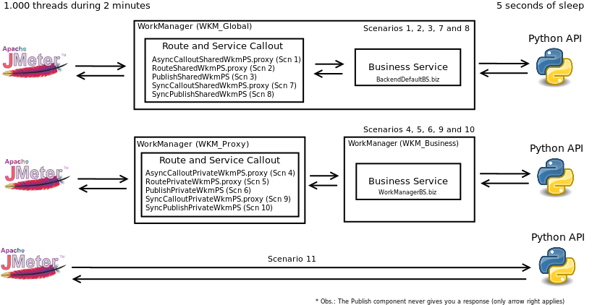

Practical Experience

In this experience, we built a Python Api that contains an intentional 5 seconds of sleep which was consumed through Oracle Service Bus using as much combinations of scenarios as possible, mixing Service Callout, Route and Publish with private and shared WorkManagers. To add some emotion to this experiment the Jmeter tool was used in order to stress the OSB with 1.000 threads during 2 minutes, as you can see in the following picture:

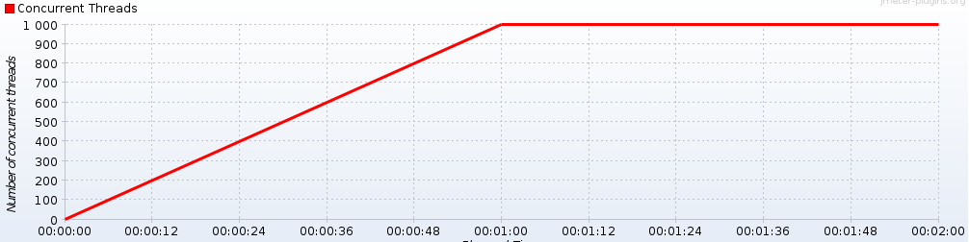

References:

Antony (read)
https://blogs.oracle.com/reynolds/entry/following_the_thread_in_osb

Official Oracle documentation (read)
http://docs.oracle.com/cd/E23943_01/dev.1111/e15866/architecture.htm#i1035778

Ateam (read)
http://www.ateam-oracle.com/wp-content/uploads/2013/09/OSBThreadingModelHTTPTransport_1.1.pdf

WorkManager
http://www.c2b2.co.uk/middleware-blog/oracle-weblogic-work-managers-a-practical-overview.php

(offline)
http://mazanatti.info/index.php?/archives/73-Oracle-Service-Bus-thread-blocking-evidences,-transport-level.html

OSB performance issue
http://sgrosjean.blogspot.ca/2013/02/osb-performance-issue-v.html

http://jaredsoablogaz.blogspot.ca/2013/01/choosing-between-route-service-callout.html

