# **Aquaseca: Model Scenarios 1-4**

Abe Farley

Dave Murray

Rachel Spinti

## Exercise

Build a model representative of the Aquaseca basin to analyze the effects of the proposed GroMore development. The following scenarios were run to compare pre and post development effects on the basin’s hydrology. All scenarios were run without the propose agricultural development.

1. Run the model as steady state with no pumping from the town's well.
2. Run the model as transient for 25 years with no pumping from the town's well. Recharge occurs at a constant rate all year, but ET takes place from April through September (inclusive) at the rate given in the problem description.
3. Build the pre-development model with seasonality and extend the run time to 100 years PLUS your burn in time. This represents the 100 years that the town has been pumping to date. There was no pumping during the pre-development period. The town's water demand has increased exponentially, with the pumping rate changed every 10 years following the equation: Q = 1.5 * t^1.5, for Q in m3/day and t in years. To avoid confusion, the pumping rate is zero for the burn-in time (I'll assume 25 years, here). Then, on April 1 of year 25, the pumping increases to 47 m3/day. On April 1 of year 35 it increases to 134 m3/day. Then, on a 10-year schedule, it continues to: 246; 379; 530; 697; 878; 1073; and 1281 m3/day. This model defines the system at the current time - remember, the town has been pumping for 100 years already.
4. Project your post-development model with seasonality an additional 100 years into the future. (Remember to project the town's water demand, too!) Compare this model with your pre-development model with seasonality.

**Questions:**

1. Calculate the flux from the stream to the groundwater. Also show a reverse particle track map to identify the source of the water to the stream. Finally, report the water level at the monitoring wells and at the town's well (even though it isn't pumping for this scenario).
2. How long does it take for the model to reach a cyclical steady state (annual variations, but no trends)? Use monthly water levels at the monitoring wells to support your conclusion. This is the required 'burn in' time of your model.
3. What are your observations from this scenario?
4. How can you quantify the impacts of the town's water extraction on the hydrologic system? Describe your metrics as precisely as you can and quantify the impact(s).

## Solution

**Model setup:**

Refer to the ipython notebook to view all the steps in the model setup.

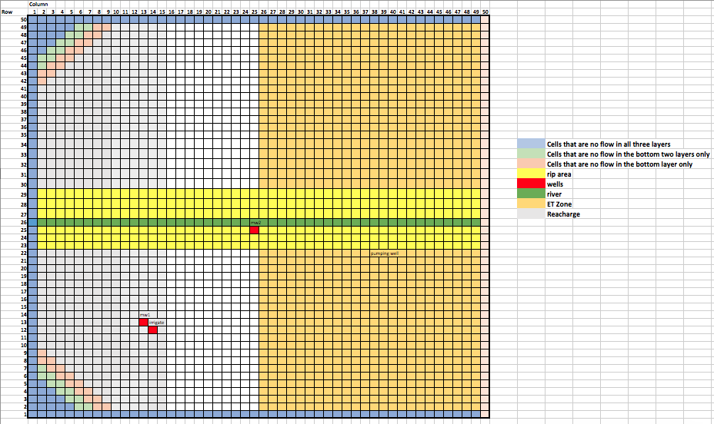

*Figure 1: Target Domain setup*

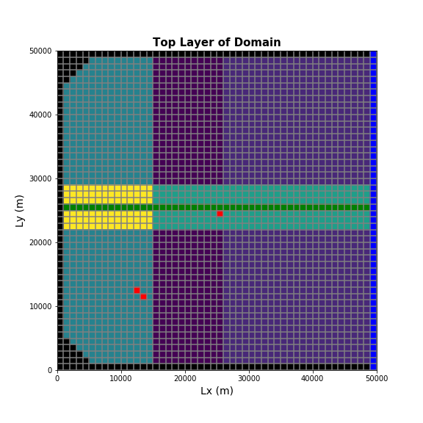

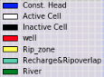

*Figure 2: Model Map View of Domain*

**Results:**

1. The flux of water entering the aquifer from the stream is 13,021 m/d. In this steady-state scenario, the water in the river infiltrates into the soil and then reappears in the river at a later time downstream (Figure 3). As shown in the Table 1, the starting head values at the wells decrease as we move from the left to right in the domain, which matches the head gradient across the domain.

*Figure 3*. Particle path lines exiting into the river are shown above.

*Table 1*. The head values at the Aquaseca and monitoring wells are displayed below.

|  |  |
| --- | --- |
| Well ID | Head (m) |
| Well 1 (Aquaseca well) | 75.22 |
| Well 2 (Monitoring well 1) | 78.68 |
| Well 3 (Monitoring well 2) | 90.33 |

1. The head in the 4 wells (Aquaseca well, Monitoring wells 1&2, and Proposed irrigation well) over 50 years with seasonal fluctuations pre-development (Figure 4a-d).

b

a

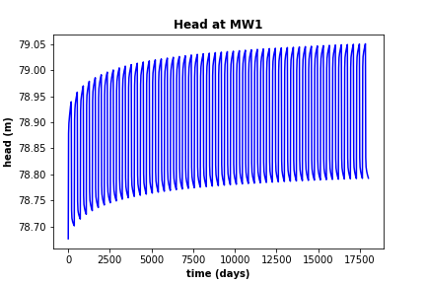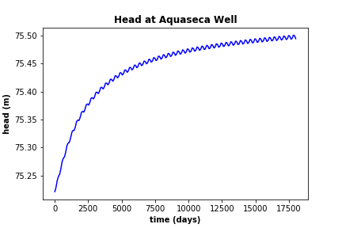

d

c

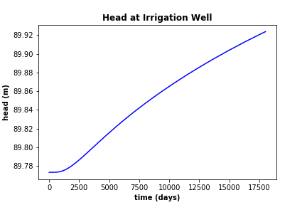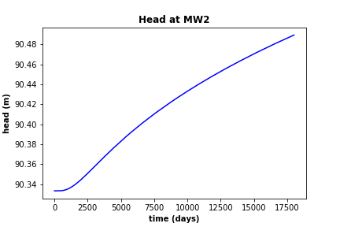

*Figure 4 (a-d): Head plots for the 4 wells (Aquaseca well, Monitoring wells 1&2, and Proposed irrigation well) for 50 years with seasonality (180 days of ET and 180 days of no ET each year).*

Over 50 years there is still a slight upward trend in all the wells; however, the year to year increase is minimal. The MW1 and Aquaseca supply well both flatten out after 35 years. This is considered our “burn time” for the system to reach a near steady state with seasonal variations.

1. The town’s supply well is now pumping at a rate that increases exponentially every ten years (Q=1.5t1.5). The water levels in all four wells in the domain are shown below (Figure 5a-d). As expected, the head value decreased at the supply well, which caused a minor decrease in head at the other wells.

a

b

d

c

e

*Figure 5 (a-e): Head plots for the 4 wells (Aquaseca well, Monitoring wells 1&2, and Proposed irrigation well) for 135 years with seasonality (180 days of ET and 180 days of no ET each year). The first head plot at Monitoring well 1 displays the head for the entire simulation time, whereas the second shows a snapshot of the cyclical pattern.*

1. A comparison of Figures 5a-e and 6a-d shows the availability of water in the basin. The head value in the supply well continues to decrease over time (Figures 5a and 6a). In MW1, the head values drop slightly lower than 79m when the model was run for another 100 years (Figures 5b and 6b). The most interesting result of the longer simulation was Figures 6c and 6d. In these two plots, the head increases before peaking and then decreasing around 60,000 days (164 years). We ran the scenario without pumping for 200 years and saw the same upward trend, which did not end. Thus, the decrease in head at MW2 and the irrigation well must stem from the cone of depression from pumping finally reaching that part of the aquifer. In addition, the recharge can no longer offset the pumping rate.

The impact that the town’s well has on the hydrologic system is dependent on the ratio of amount of water pumped to the amount of water in the system. We wanted to quantify what percentage of the total water budget the well is removing. However, due to some bugs in our code, we were unable to obtain this value. We did compare the pumping and leakage rates for each stress period (Figure 7 and b). The decrease in leakage over time is greater than the magnitude of the pumping rate increase. The leakage rate also seems to be reaching an asymptote, which could be the base flow in the river. We also know that the pumping well has started to affect the head at the monitoring wells, so we could try to quantify the depth and extent of the cone of depression. This would show us how much impact the cone has on the river and the water supply at the proposed irrigation well site.

b

a

d

c

*Figure 6 (a-d): Head plots for the 4 wells (Aquaseca well, Monitoring wells 1&2, and Proposed irrigation well) for 135 years with seasonality (180 days of ET and 180 days of no ET each year).*

b

a

*Figure 7(a-b): Total leakage for each stress period and total pumping for each stress period.*