# **Aquaseca: Scenarios 5 and 6**

Abe Farley

Dave Murray

Rachel Spinti

## Exercise

Build a model representative of the Aquaseca basin to analyze the effects of the proposed GroMore development. The following scenarios were run to compare post development effects on the basin’s hydrology. All scenarios were run with the proposed agricultural development.

1. Add the proposed agricultural element (pumping and localized recharge) for growing pistachios to your post-development model with seasonality. Agriculture starts now, 100 years after the end of the burn-in. Both pumping and recharge related to agriculture occur at the rates described and are continuous throughout the year.
2. Moving forward, we will be running more models to try to decide whether to allow the agricultural activity and/or whether to propose changes to its design. Whenever you are faced with running many models (or calibrating a model), it is worth considering carefully whether the model can be simplified. But we want to make sure that we don't misrepresent any important impacts of the farm. Consider the question of ignoring seasonality from the point of view of four stakeholders: the agricultural company proposing the new facility, the town, a local environmental group, and the Environmental Protection Agency.

**Questions:**

1. How can you quantify the impacts of the proposed agricultural element on the hydrologic system 100 years into the future? How do these impacts compare with the impacts of the town's pumping? How will the agricultural element affect the town's ability to meet its water demand (both for quantity and quality?) Describe your metrics as precisely as you can and quantify the impact(s).
2. Can we justify ignoring seasonality in ET? If so, we could use a constant rate which would make our model less dynamic and probably faster-running. Provide a one paragraph supportive of your position.

## Solution

**Model setup:**

Refer to the ipython notebook to view all the steps in the model setup. The main modification made to these scenarios was the addition of the proposed agricultural development.

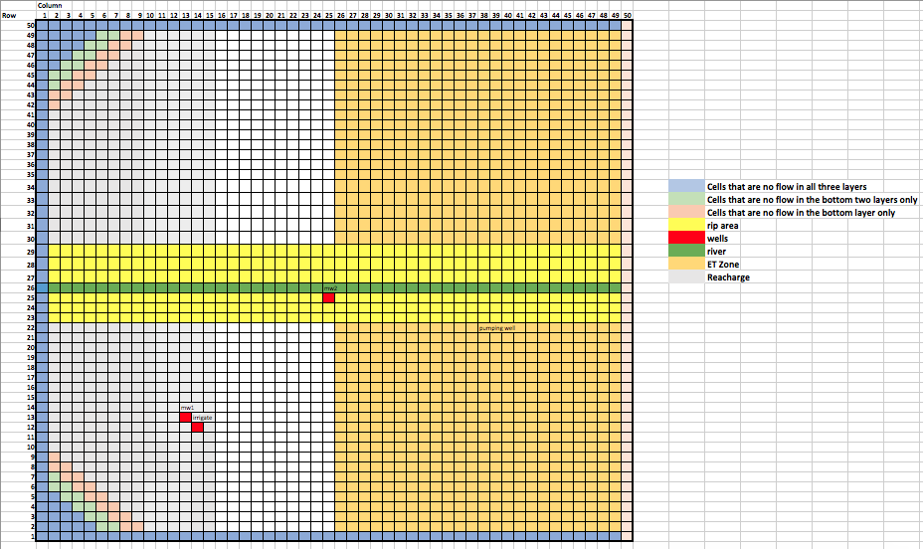

*Figure 1. Domain setup*

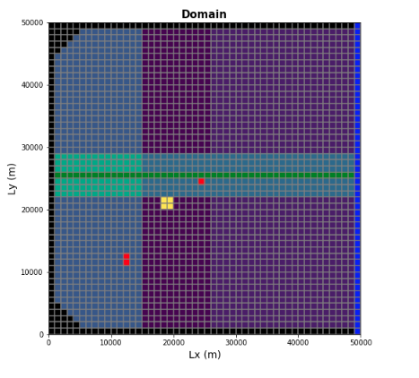A screenshot of a cell phone

Description generated with high confidence

*Figure 2. Model Map View of Domain*

**Results:**

1. We first looked at the head changes at the town and irrigation wells. Surprisingly, the head drop at the town well was the same with and without the irrigation well pumping (Figure 3a-b). Figure 3a does show a slight increase in head before it begins the negative trend; however, this head change is negligible (20cm). Because of pumping at the irrigation well, the head profile looked radically different for the two scenarios (Figure 4a-b). The decrease in head due to pumping for 100 years is only 3.5m, which is a fairly small impact on the hydrologic system for that amount of time. That value is also greater than the 0.8m change in the supply well.

*Figure 3a-b*. a. Head profile at the Aquaseca supply well for 100 years of town well pumping. b. Head profile at the Aquaseca supply well for 100 years of town and irrigation well pumping.

*Figure 4a-b*. a. Head profile at the irrigation well for 100 years of town well pumping. b. Head profile at the irrigation well for 100 years of town and irrigation well pumping.

Next, we compared various values from the water budget to quantify the impact of the proposed agriculture development (Table 1). The “current” status of the system is what the water budget looks like after 100 years of pumping from the town well. The “100-year no agricultural” is the water budget after an additional 100 years of town pumping. And, the “100-year agricultural” refers to the water budget after 100 years of irrigation and town pumping.

It is clear from Table 1 that the pumping rate has an impact on the other inputs and outputs to the system. For example, the addition of irrigation well changed the water budget of the system for every variable. The pumping budget doubles between Scenarios 4 and 5 because of the additional pumping. The ET decreases, which could be because it was accounted for in the recharge of the pistachios. The decrease in groundwater outflow stems from the fact that more water is being pulled from storage.

*Table 1*. Different components from the annual water budget are displayed for Scenarios 3, 4 and 5 in ac-ft/year and m3/yr.

**A screenshot of a social media post

Description generated with very high confidence**

*Figure 5.* Plot displaying the water budget over time for leakage, ET, groundwater outflow, and recharge.

We also plotted cumulative storage over time for Scenarios 4 and 5. This time we used the storage calculated by Modflow in the water budget. We obtained different values than those displayed in Table 1, but the trends are the same. As the amount of pumping increases, the amount of water drawn from storage also increases (Figure 6a-b).

A screenshot of a cell phone

*Figure 6a-b*. a. Cumulative storage over time for Scenario 4 (100 years). b. Cumulative storage over time for Scenario 5.

Even though the water budget changed, the impact of the agricultural development on the town’s pumping was minimal. Figures 3a and b revealed that the total head drop in the town’s well was the same with and without the irrigation well. Figures 7-9 also show that the current setup of the irrigation well does not affect the cone of depression around the Aquaseca well. Thus, the quantity of water available for the town remained the same. We were also interested in determining if the water quality at Aquaseca’s well would be affected by the water recharged at the agricultural field. We again compared the cones of depression and head contours in Figures 7-9. The cones of depression do not overlap in any of the layers. In addition, the head contours show no indication that recharged water enters the well. If anything, the recharged water enters the river or stays in the topmost layer and becomes diluted.

A screenshot of a computer

Description generated with very high confidence

*Figure 7*. Head contours for the top layer of the domain.

A screenshot of a computer

Description generated with very high confidence

*Figure 8*. Head contours for the middle layer of the domain.

A screenshot of a computer

Description generated with very high confidence

*Figure 9.* Head contours for the bottom layer of the domain.

1. Based on our analysis, the ET seasonality can be ignored for this hydrologic model. The difference in the affect ET has on the system can be seen in Figures 3a and b. in particular, Figure 3b shows very little seasonal differences in head, which is likely due to the dampening effect that additional pumping had on it. We recommend using a constant ET rate, which could be the average of the two ET values from each season. We are more concerned with the impact of the irrigation well on Aquaseca’s water supply than we are with the seasonal variations in water level that are less than 10cm. If the seasonality had a larger effect on the head in the supply well (e.g. magnitude of 1m or greater), we would keep the varying ET.