**Friends of the Environment Report – Scenarios 3-4**

Groundwater Modelling, HWRS518

Jake Ridlinghafer, Ben Mitchell, Danielle Tadych

4/23/2020

### Scenario 3: Post development with seasonality

***Objective:***

Build the pre-development model with seasonality and extend the run time to 100 years PLUS your burn in time. This represents the 100 years that the town has been pumping to date. There was no pumping during the pre-development period. The town's water demand has increased exponentially, with the pumping rate changed every 10 years following the equation: Q = 1.5 * t^1.5, for Q in m3/day and t in years. To avoid confusion, the pumping rate is zero for for the burn-in time (I'll assume 25 years, here). Then, on April 1 of year 25, the pumping increases to 47 m3/day. On April 1 of year 35 it increases to 134 m3/day. Then, on a 10 year schedule, it continues to: 246; 379; 530; 697; 878; 1073; and 1281 m3/day. This model defines the system at the current time - remember, the town has been pumping for 100 years already.

To accomplish this, we created a for-loop with an else-if function defining the changing pumping rate for the town well every 10 years.

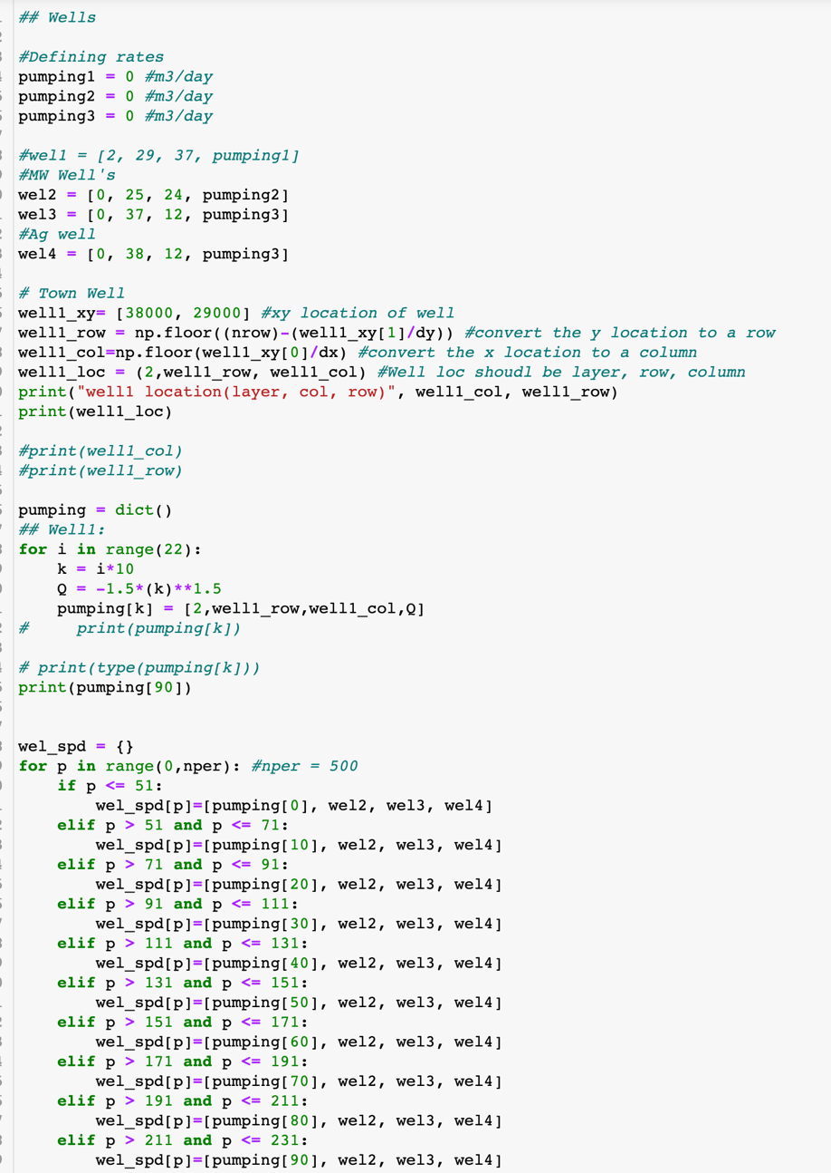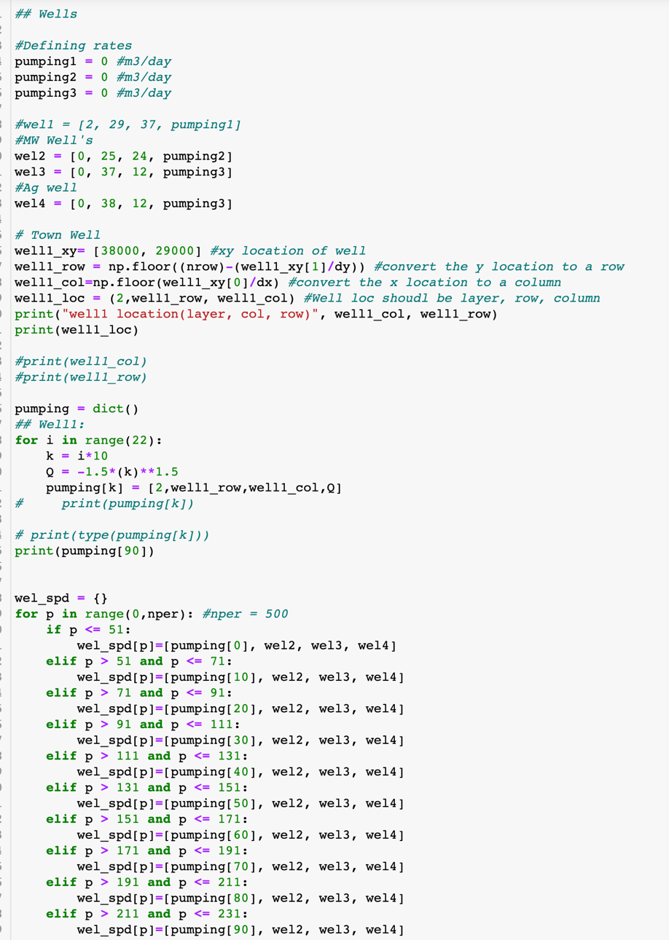

Figure . Code for specifiying increasing pumping rate at the town well for 100 years (25 years burn-in)

### Scenario 4: Post development with seasonality, future projection

***Objective:***

Project your post-development model with seasonality an additional 100 years into the future. (Remember to project the town's water demand, too!)

* Compare this model with your pre-development model with seasonality.
* How can you quantify the impacts of the town's water extraction on the hydrologic system? Describe your metrics as precisely as you can and quantify the impact(s).

***Results:***

An interesting trend we see after running the model 125 years and 225 years without pumping (pre-development; Figure 2) and with pumping (post-development; Figure 3) is that there is not a significant change in head values from pumping of the aquifer. This could be because the water procured by well town well could be primarily drawing from a different source, such as the river. Since the river package acts similar to a constant head boundary, it is possible the river is supplying constant amount of water to the well. Since the decreasing head in the river package is not simulated, this could lead to unrealistically small changes of head in the aquifer and over estimation of loss from the river. Our group ran out of time, but to quantify this, we would calculate the loss of storage from the budget files and also check the leakage from the stream over time for pre and post-development.

Another important comment though is that from our predevelopment graph (Figure 2) we can see that the model needs more time for burn in, and according to Figure 3 that would probably be around 200 years. One way proposed in class is to run the model for burn in, read out the head values, and for future simulations, load the head values. This will save significant computational time and our group plans to do this in the future.

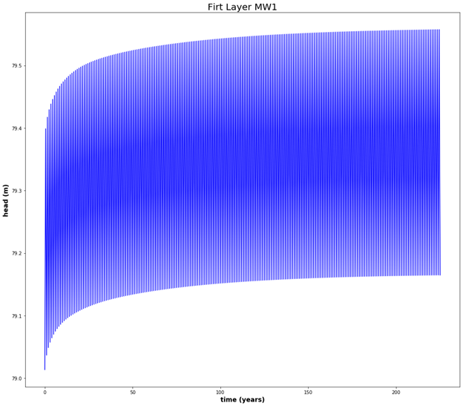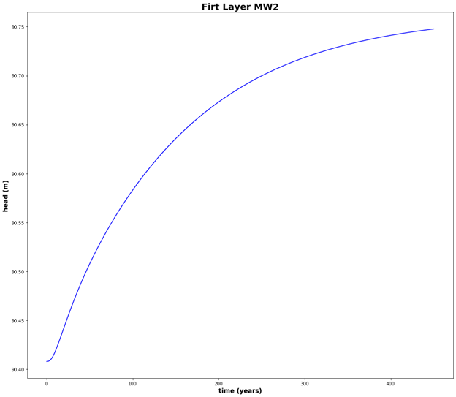

Figure 2. Pumping Pre-development for monitoring wells 1 and 2 on the top layer

*Figure 3. Heads for 225 years at the monitoring wells with pumping from the town well*