# GroMore: Scenario Five and Six Report

## **Group Members:** *Vivek Singh Grewal, Amanda Triplett, Justin Warlick, Gebremeskel Tesfa*

## Scenario 5: Post agriculture model with seasonality – future projection

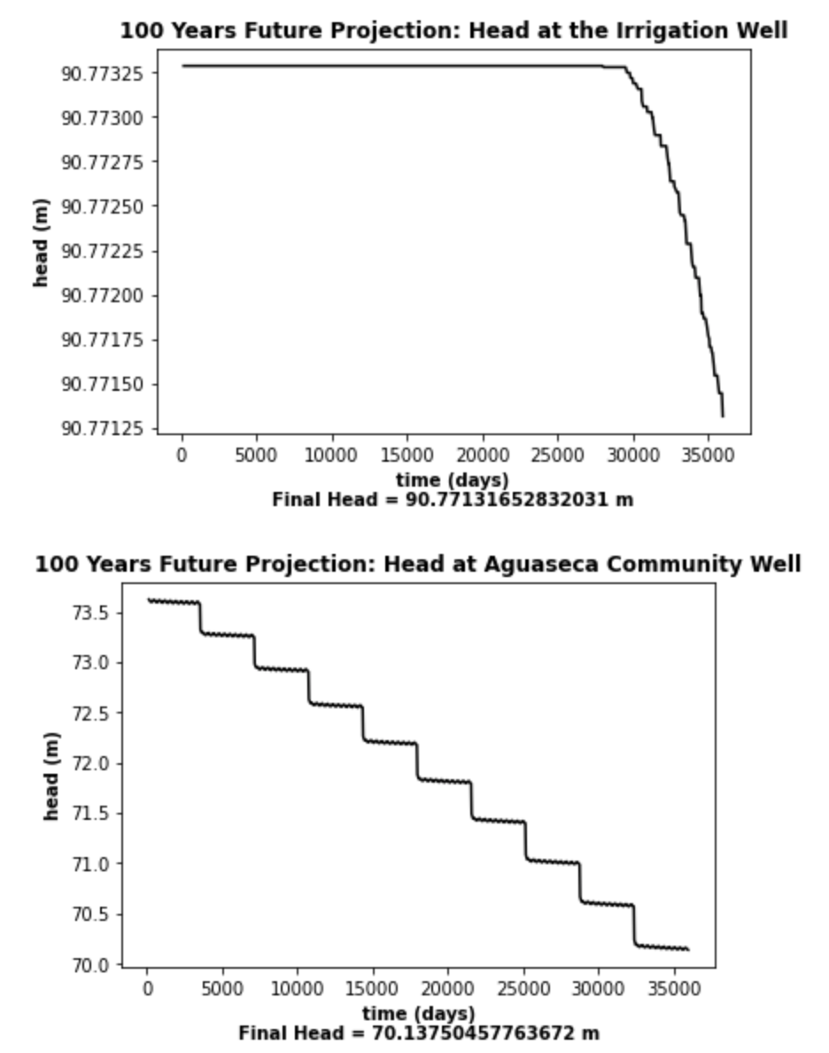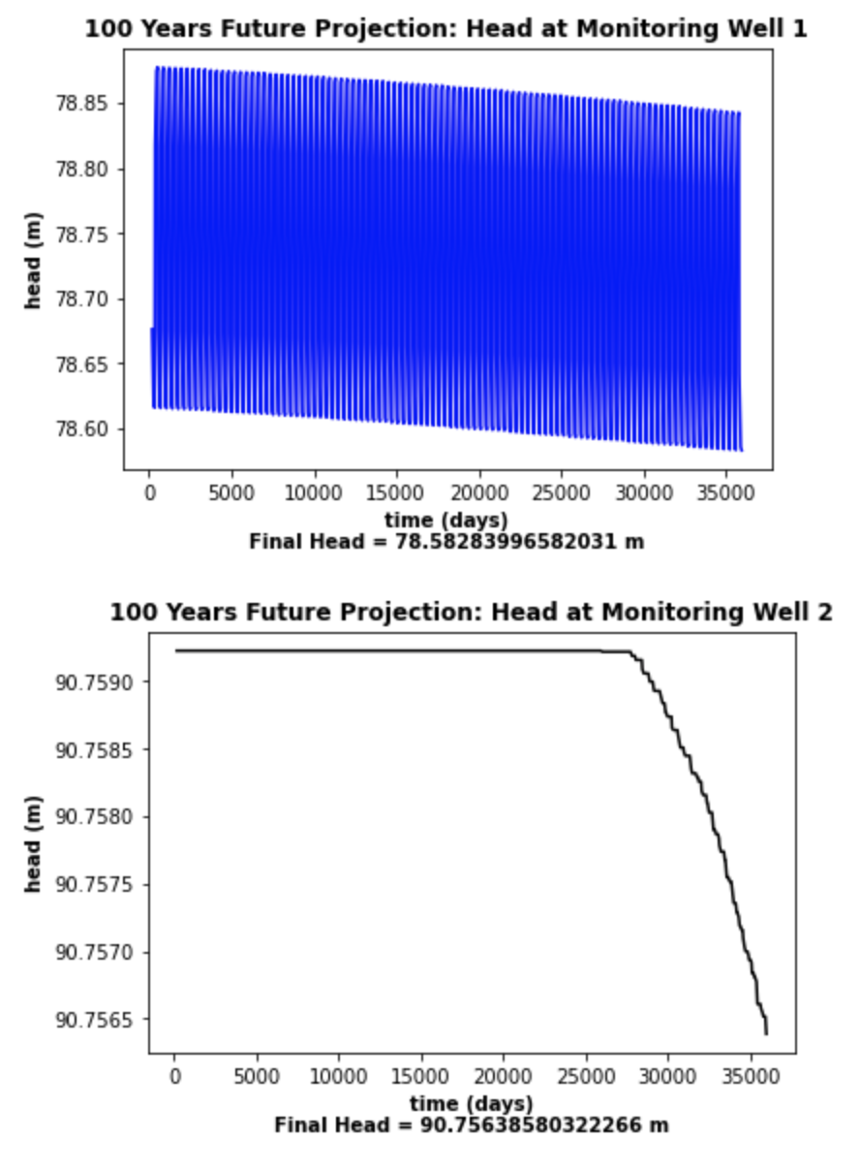In this scenario, the proposed agricultural field was added, along with the pumping from the irrigation supply well, and the resulting recharge from irrigating the fields. To quantify the impacts of adding this agricultural element, head plots, final heads, ET, river leakage and storage changes were analyzed comparing a 100 year future projection of just pumping the town well from scenario 4, and a 100 year projection with the town well and agriculture. Figure one shows the time series of head values with final head for scenario 4 (only town well) and figure two shows the same thing but for scenario 5 with the town and irrigation well. As expected, the head at the irrigation well and monitoring well2 are significantly different between the scenarios, about 3.5 and 2.2m respectively, because there is no pumping in scenario 4. However, we see that those changes have minimal propagation to the rest of the domain. The head at monitoring well 1, close to the river has a difference of .07m, or .09% of the total head from scenario 4. At the community well, the head changes from 70.14m, to 70m, a difference of .14m or .2% of the total head.

Next, ET changes in each scenario were looked at. As there is seasonality, there are certain stress periods where there is no ET occurring, so we only looked at trends in ET during the stress periods where it occurs. Figure 3 shows the time series of ET for scenario 4, while figure 4 shows the same for scenario 5. There is a general pattern of reduction of ET coming out of the domain across the scenarios because of the reduction in head values, increasing the depth to water. There is slightly less ET coming out of scenario 5, showing there are generally slightly lower head values across the ET zones. However, this is a minimal difference of 97.47 m3/day or .69% of the original ET out, showing that there is not a large difference in overall head values in the ET zones.

Figure 1

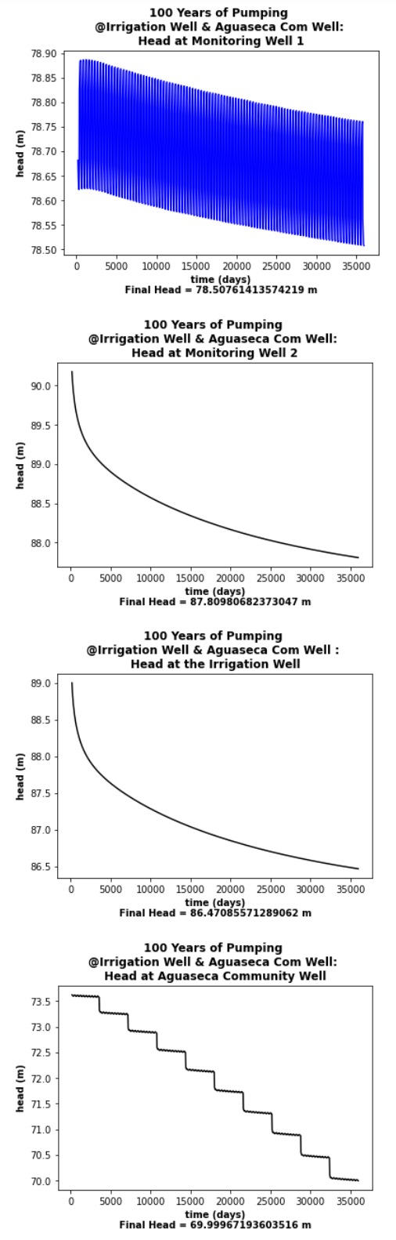

Figure 2

Next, net storage and storage change time series were compared between scenarios 3 and 4. Figure 5 show the storage change time series for scenario 4, and figure 6 shows the same for scenario 5. The net storage for

Scenario 4 was 161,533 m3, while it was 1,547,871 m3 for scenario 5. The reason for this large magnitude of difference is obvious when looking at the time series. In scenario 4, the storage flues are almost in seasonal equilibrium, with a slight positive trend towards increasing storage, so this cancels out storage changes, resulting in a

smaller net storage

change. Scenario 5 has a much stronger positive net storage than negative, as well as a trend

towards increasing negative storage rather than positive. This leads to a much larger net

positive storage change. The reasons for this could be increased fluxes into the domain from

river leakage to counter the water being pumped out of the domain by the agricultural well. The

negative trend could be showing an inability for the river to keep up with positive fluxes into the

domain, resulting in increasingly negative storage trends. The role of the river will be explored

more closely in the next section

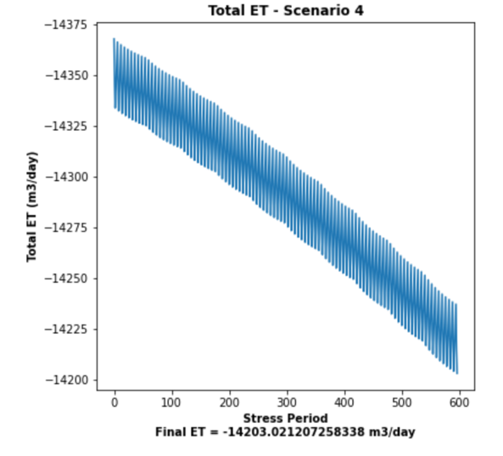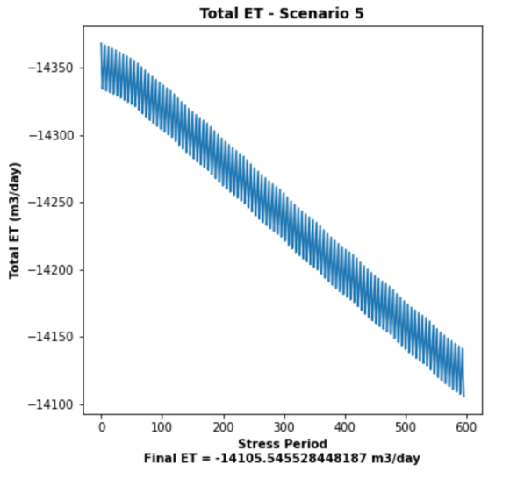

Figure 3

Figure 4

Figure 6

Figure 5

Next, river leakage totals were looked at. Figure 7 shows the total leakages between zero and non-zero ET periods between the two scenarios. There are significant increases in total leakage between the scenarios, an increase of 2507.01 m3/day for the no ET periods and an increase of 2340.97 m3/day during ET periods. These are increases of 51.28% and 21.21% from scenario 4 respectively. This shows significant impacts on the river from

the addition of agricultural pumping, and implies that much of the changes in head and storage

were buffered by increases in leakage from the river and the subsurface between the two scenarios. The model is treating the river as a constant source of water, where the stage doesn’t change. If this is not the case in reality, then our other metrics such as head and storage

may not be reflecting the actual magnitude of change that is likely to occur,



Figure 7c

## Scenario 6: Is Seasonality Necessary?

The ET in the previous scenarios was on for 6 months and off for 6 months. In order to check the effects of removing seasonality, the ET rate for both valley and riparian areas was reduced to half (5*e-6 and 25e-6 m/d) and was applied for all the 12 months. The effect of removal of seasonality was then checked for Scenario 3 (current state with 200 year burn-in and 100 year Aguaseca pumping) and for Scenario 4 (additional 100 years of both Aquaseca and Irrigation well pumping after Scenario 3).

Figure 8 below on the left, has heads at the three relevant wells at the end of 100 years of past pumping from the Aguaseca well, with seasonality. It is notable that the effect of seasonality is the most stark in MW1 which is near the riparian ET area. There is some seasonality induced perturbation on the Community Well but none in the far away MW2.

Figure 9 on the right, has the heads in the same wells without seasonality. It can be seen that while the perturbations are gone in MW1 and Community Well, the head values are very close to the average of the perturbations (~ 78.75 meters in MW 1).

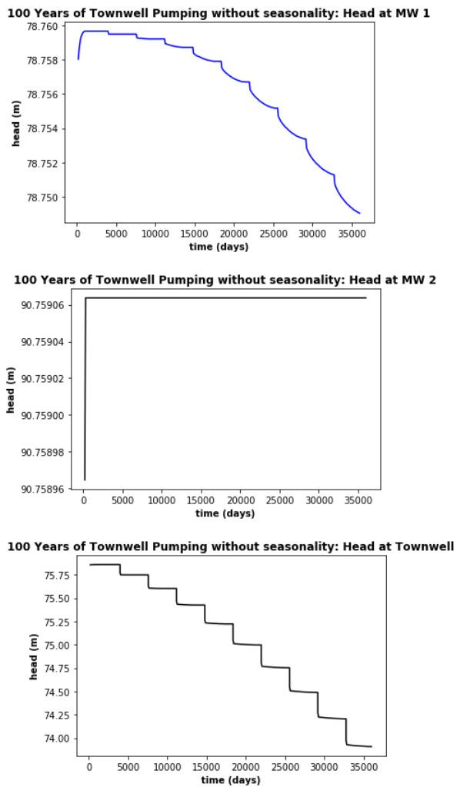

Figure 9

Figure 8

Similarly, the Figure 10 on the left on the next page, has heads at all the relevant wells for future projections with pumping of both the Aguaseca well and the irrigation well, with seasonality. Again, seasonality results in comparatively stark perturbations in MW1 which is near the riparian ET area.

Figure 11 on the right on the next page, has the same heads without seasonality. It can be seen that while the perturbations are gone in MW1 and Community Well, the head values are near the average of the perturbations (~ 78.70 meters in MW 1).

To quantify the effect of seasonality on the leakage from the river, the daily leakage numbers were calculated for the future predictions (both community and irrigation well pumping), as that would be when the seasonality difference would be maximum, due to stress. It was found that the total daily leakage from the river with seasonality was 10,387.32 m3/day and that without leakage was 10,080.53‬ m3/day, a difference of less than 3%.

Therefore, after building counterfactual models without the seasonality, we found that there is no significant change in relevant parameters of interest, like heads and leakage. In terms of different stakeholder interest, it can be said that the head at the community well does not change with and without seasonality therefore Aguaseca should concur on ignoring the seasonality. Similarly the head does not change significantly at the irrigation well therefore GroMore has decided to concur on ignoring it. The change in leakage is of the order of 3%. The overall quantity of leakage is significant and Friends of the Environment may have a problem with it, but the change due to ignoring seasonality is not as significant therefore they should also be fine with it.

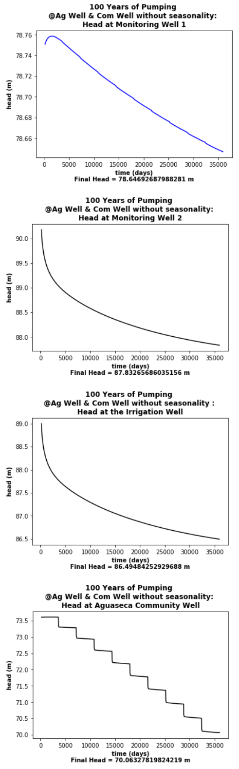

Figure 11

Figure 10