# Homepage





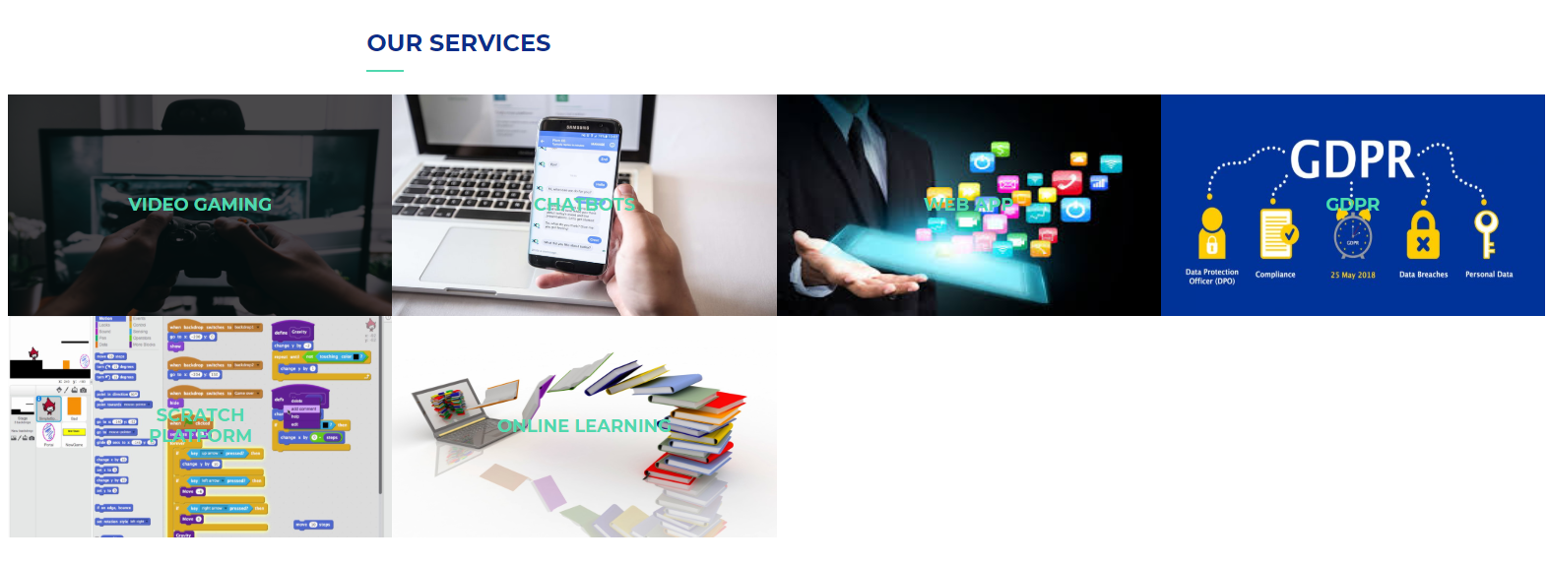

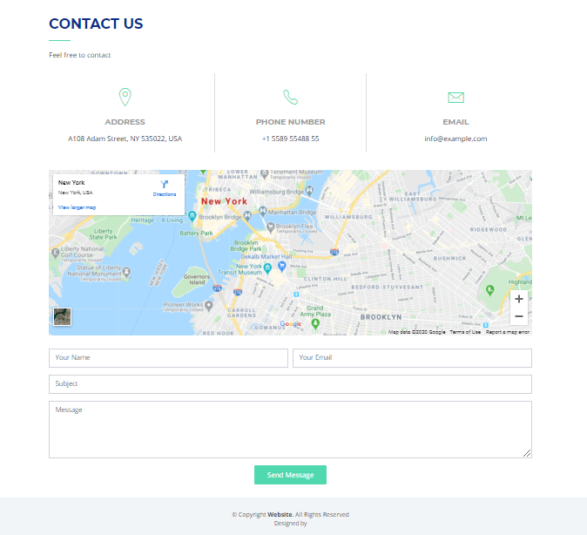

# Our Services

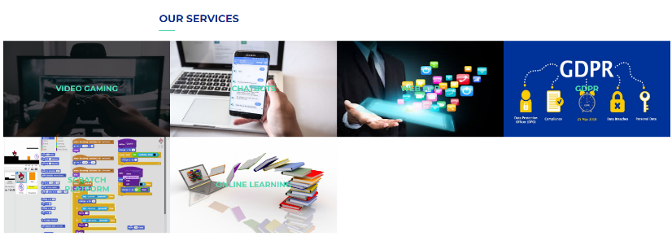

## VIDEO GAMING & E GAMING

### ***If you are interested in gaming. So you are at right place.***

Video game is an electronic game that includes interaction with a user interface to create visual comments on a 2D or 3D video projector such as a touch screen, virtual reality headset or projector / TV.

Online game is a video game that is played partially or mainly over the internet or any other computer network available.Online games are ubiquitous on modern gaming platforms, including computers, consoles, and mobile devices, and extend to many genres, including first-person shooting games, strategy games, and online multiplayer role-playing games. (MMORPG).

#### The Legend of Zelda: Ocarina of Time

**Critic score**: 99/100  
**User score**: 9.2/10  
**Plot summary (from Metacritic)**:  
As a young boy, Link is tricked by Ganundorf, the king of Gerodo's thieves. The evil man uses Link to reach the sacred world, placing his polluted hands on Triforce and turning the beautiful Hyrulean landscape into a barren wasteland. Link was determined to fix the problems he helped create, so with Rauru's help he travels over time to gather the powers of the Seven Wise Men.   
**Platforms**:  
Nintendo 64, Nintendo DS, Virtual Console (various platforms)

#### Tony Hawk's Pro Skater 2

**Critic score**: 98/100  
**User score**: 7.4/10  
**Plot summary (from Metacritic)**:  
Hook appeared - with new technology, new pros and new tricks! "THPS2," you ride the legend! Skate like the legendary Tony Hawk or any one of 12 other professional skiers. Create your own custom skiers. Multiple operating modes including single player modes, Career and Free Skate, as well as player modes like Trick Attack, Graffiti Tag and Horse. Create your own custom skate parks with real-time 3D theme park editor   
**Platforms**:  
PlayStation, PC, Game Boy Color, Dreamcast, Mac, Game Boy Advance, Nintendo 64, iOS, Xbox

#### Grand Theft Auto IV

**Critic score**: 98/100  
**User score**: 7.5/10  
**Plot summary (from Metacritic)**:  
What does the American dream mean today? According to Niko Belic, he recovered from the boat from Europe. It is the hope that he can escape from his past. For his cousin, Roman, it is the vision through which they can find wealth in Liberty City, a gateway to the land of opportunity. When they slip into debt and run into a criminal criminal world by a series of snoopers, thieves and social healers, they discover that reality is quite different from a dream in a city that worships money and prestige, a paradise for those who have a living nightmare for those who do not.   
**Platforms**:  
PlayStation 3, Xbox 360, PC

#### SoulCalibur

**Critic score**: 98/100  
**User score**: 8.6/10  
**Plot summary (from Metacritic)**:  
This is a story of souls and swords, transcending the world and its history, forever told ... the greatest weapons-based fighter, this time on Sega Dreamcast. Soul Calibur unleashes incredible graphics, great fighter, and incredible combos, making your head spin!   
**Platforms**:  
Dreamcast, iOS, Arcade, Xbox 360, Xbox One

#### Super Mario Galaxy

**Critic score**: 98/100  
**User score**:8.6/10  
**Plot summary (from Metacritic)**:  
What does the American dream mean today? According to Niko Belic, he recovered from the boat from Europe. It is the hope that he can escape from his past. For his cousin, Roman, it is the vision through which they can find wealth in Liberty City, a gateway to the land of opportunity. When they slip into debt and run into a criminal criminal world by a series of snoopers, thieves and social healers, they discover that reality is quite different from a dream in a city that worships money and prestige, a paradise for those who have a living nightmare for those who do not.   
**Platforms**:  
Wii

#### SoulCalibur

**Critic score**: 97/100  
**User score**: 9.0/10  
**Plot summary (from Metacritic)**:  
The ultimate Nintendo hero is taking the ultimate step ... out into space. Join Mario as he ushers in a new era of video games, defying gravity across all the planets in the galaxy. When some creature escapes into space with Princess Peach, Mario gives chase, exploring bizarre planets all across the galaxy. Mario, Peach and enemies new and old are here. Players run, jump and battle enemies as they explore all the planets in the galaxy. Since this game makes full use of all the features of the Wii Remote, players have to do all kinds of things to succeed: pressing buttons, swinging the Wii Remote and the Nunchuk, and even pointing at and dragging things with the pointer. Since he's in space, Mario can perform mind-bending jumps unlike anything he's done before. He'll also have a wealth of new moves that are all based around tilting, pointing and shaking the Wii Remote. Shake, tilt and point! Mario takes advantage of all the unique aspects of the Wii Remote and Nunchuk controller, unleashing new moves as players shake the controller and even point at and drag items with the pointer.   
**Platforms**:  
Wii

## CHATBOTS

### ***If you are interested in Chatbots. So you are at right place. Keep exploring us..***

Chatbot is a software application that is used to chat over the Internet via text or text to speech, rather than providing direct contact with a direct human agent. Designed to simulate the way a person behaves convincingly as a conversation partner, automated chat software systems require continuous tuning and testing, and many in production are still unable to speak adequately or pass the industry-standard Turing test. The term "ChatterBot" was originally coined by Michael Molden (first creator of Verbot) in 1994 to describe these conversational programs.

## Chatbots

#### HelloFresh’s Freddy

HelloFresh addresses the question everywhere, "What should we eat for dinner?" Whether through their meal delivery service and chatbot. Freddy Freshbot is a Facebook Messenger chat program that helps customers meet their recipe and order needs. If users type in a dish or ingredient, Freddy searches for relevant recipes on the HelloFresh Blog. When it's time to choose new meals, Freddy sends a reminder. Friendly robots even keep users interacting with food-related tests.

#### Capital One’s Eno

Capital One sought to improve relationships with its bank customers, and the Eno mobile app was born. The friendly banking chat program helps keep customers alert about suspicious transactions, duplicate fees, and unusually high spending. Customers can contact Eno 24/7 via the website, mobile application or SMS to verify their bank balance and recent transactions or to report any problem with the card. Eno will send alerts even when a customer pays more than usual for an invoice.

#### World Health Organization’s WHO Health Alert

Wrong information tends to spread during the crisis. As the coronavirus continues to penetrate the world, and the population remains stuck inside, many people search for help and answers online. The World Health Organization helps people stay healthy and inform them about the new automated chat program to alert health. The exclusive WhatsApp robot is designed to give fast and reliable information about coronaviruses. With keyword commands and emojis, users can choose from several topic options to learn more about the virus and its effect.

#### Amtrak’s Julie

Amtrak Jolly created an online self-service improvement for site visitors 375,000+ daily. Julie can answer questions and assist with transactions so customers don't need to call or email an agent. Chatbot Julie, developed by Next IT, is Amtrak's latest customer-friendly innovation to pursue a successful voice service assistant.

#### OMQ Chatbot

The automated chat software OMQ is a pre-designed AI chat solution for companies. Chatbot was designed in 2019 and is designed to reduce the workload of customer service agents across industries. It uses the fast and efficient chatbot solution used by major companies like EMP and Baby Walz directly outside the box.

## WEB APPS

### ***If you are interested in learning Web Apps. So you are at right place. Keep exploring us..***

The web application is a computer program that uses web browsers and web technology to perform tasks online.

* Postmark
* Buffer
* Freshdesk
* Mint
* MailChimp

## General Data Protection Regulation (GDPR)

### ***If you are interested in GDPR. So you are at right place. Keep exploring us..***

The General Data Protection Regulation (GDPR), approved by the European Parliament and Council in April 2016, will replace the Data Protection Directive 95/46 / ec in the spring of 2018 as the primary law that regulates how companies protect the personal data of EU citizens. ... anonymize the collected data to protect privacy

Millions of companies use the Internet as a cost-effective communication channel. It allows them to exchange information with the target market and conduct fast and secure transactions. However, active participation is only possible when the company is able to capture and store all the necessary data, and it has a means to process this information and provide results to the user.

Web applications use a set of server-side scripts (PHP and ASP) to handle data storage and retrieval, and client-side scripts (JavaScript and HTML) to provide information to users. This allows users to interact with the company using online forms, content management systems, shopping carts and more. In addition, the applications allow employees to create documents, share information, collaborate on projects, and work on popular documents regardless of location or device.

## SCRATCH PLATFORM

### ***If you are interested in Scratch platform. So you are at right place. Keep exploring us..***

Scratch (free) is a Web application that teaches basic programming concepts in a visual way. Designed by the Lifelong Kindergarten Group at the MIT Media Lab, Scratch is designed for kids from eight to 16 years old, but its easy-to-use interface means anyone can use it to learn how to program. If you are interested in getting your kids to program—or if you are ready to dip your own toe in the coding waters—Scratch is the intro-to-coding Editors' Choice you need to check out.

### ***If you are interested in Online Learning tools and platform. So you are at right place. Keep exploring us..***

* Skillshare. Skillshare is a large marketplace focused on creative education.
* LinkedIn Learning. LinkedIn Learning (formerly Lynda) is another online course marketplace tailored to business professionals.
* Udemy.
* Treehouse.
* Coursera.
* Online Learning tools and Platforms

The e-learning and online course market are soaring to new heights and estimated to be worth $325 billion by 2025. With higher education shifting from lectures to virtual classrooms, you can also profit from online course platforms. I reviewed and ranked the 13 best online course platforms and provided the top 10 ways to create and sell online courses. This ultimate guide ranks and compares software based on reliability, features, marketing tools, profit potential, technical support, and pricing. Disclaimer: This article contains affiliate links where I may receive a small commission for at no cost to you if you decide to purchase one. However, these are the tools I fully recommend when it comes to launching online courses and the commissions help me provide free content. You can read my full affiliate disclosure in my privacy policy. Let’s get started.