Systems Design Specification Document
for
Telecom Customers Churn Prediction System
Prepared by
 | Names | Registration Number | Signature
1 | KYANZI HASSAN MUSISI | 17/U/19979/EVE
2 | WAMALA EDGAR WATSON | 17/U/20633/EVE
3 | KASOZI JAFFAR | 17/U/4741/EVE
4 | BWAYO JOEL | 17/U/3777/EVE

Makerere University
July 2019
Table of Contents
Table of Contents
1.Introduction 3
1.1 Purpose 3
2.Data pipeline architecture 3
2.1 Data pipeline diagram 3
2.2 Data pipeline description 4
3. Data cleaning. 4
4.Data Exploratory 4
5.Visualization 5
6.Feature selection 5
7.Data Analysis and visualization 6
8.Application of Logistic Regression 6
8.1 Model building in Scikit-learn 7
9.0 Model Evaluation 7

1.Introduction

1.1 Purpose
This systems design document describes stages of data pipeline for the telecom customers churn prediction system from data sources to visualization.

2.Data pipeline architecture
This section describes this system from capturing,wrangling, and visualizing of data so that it can be used to gain a predictive model. The original data contained too many data points that may not be relevant as per this project.

2.1 Data pipeline diagram

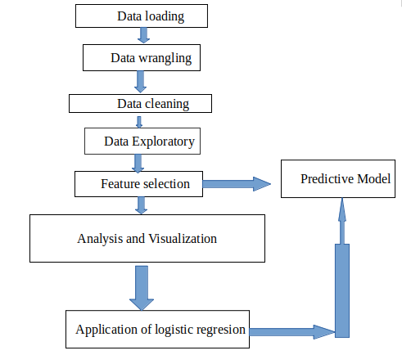

2.2 Data pipeline description
This section explains each of the component showed in the data pipeline in detail.
- Data Loading
We used pandas library read_csv function to read comma-separated values(csv) called Telco-Customer-Churn dataset into a data frame. We have used df1.head(5) function of pandas to return the first five rows. It is useful for quick testing if the object has the right type of data in it. This dataset happens to have one customer per line with many columns (attributes) as shown in the screenshot below.
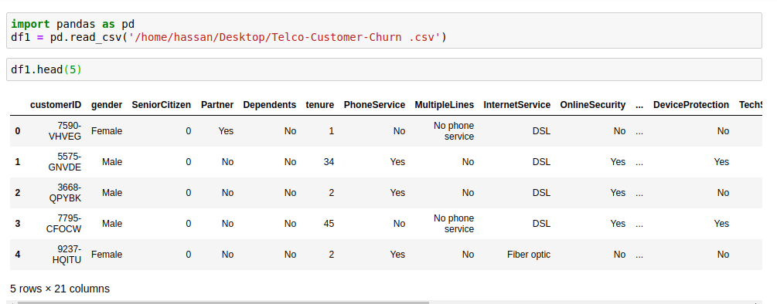
Few samples of the Telco-Customer-Churn dataset

- Data wrangling
This is the process of transforming and mapping data from one "raw" data form into another format with the intent of making it more appropriate and valuable for a variety of downstream purposes such as analytics. It is used to finding out missing values in the data set and label encoding the libraries that will be used are under wrangling are;
pandas library for reading csv file using read_csv() function
numpy library which is used in computations
Labelencoder library that is used encode strings into numerical data like binary data for example with churn category has string values (Yes or No) , they will be encoded to (1 or 0) respectively.

3. Data cleaning.
This is the process of cleaning data with errors and removing noise for example NaN values and empty cells .The following are the libraries used ;
pandas library
numpy library

4.Data Exploratory
This is an approach to analyzing dataset to summarize their main characteristics, often with visual methods. It will help us to find the relationship between the different and deep understanding of each feature or variable. Exploratory of each feature with respect to its count here we shall explore each each variable for deeper understanding
We shall use the following libraries
matplotlib library and seaborn library for visualization of each feature
pandas library

5.Visualization
A histogram takes in a series of data and divides the data into a number of bins. It then plots the frequency data points in each bin ( the interval of points). It is useful in understanding the count of data ranges.
We shall use a histogram on the count of the variable in a plot.
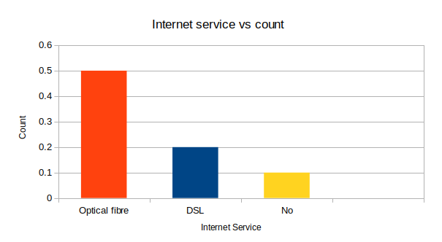

6.Feature selection
This is the process of selecting the best features to be used in the analysis. This helps to remove irrelevant features .It helps us to make accurate and best analysis. Here we shall compute the correlation of each feature with respect to the target feature or variable which is churn as our target feature in this case.
We shall drop features that have a small correlation with the target feature for example -0 or -0.006
We shall also Identify the correlation of other features for example tenure and total charges. And if it is a high correlation like 0.9, then we take one one feature for analysis. How it will be done;

Correlation matrix
We shall plot a visual correlation matrix because it can plot against each feature at the same time.
Before plotting, all the features shall be encoded to numerical value using Label encoding and One hot encoding methods from sk-learn library .
The libraries likely to be used are;
pandas library
numpy library
matplotlib library and seaborn library for plotting and visualization

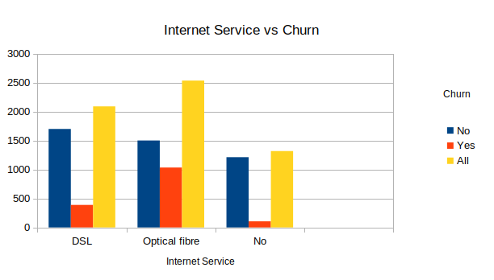
7.Data Analysis and visualization

This is the final stage of our analytic pipeline, in this case we shall see the impact of each selected feature or variable by plotting each individual feature against the target feature which is churn in this case. We shall use a histogram since we shall dealing with counts of features.
We shall compute the ratio of each feature with respect to churn and then draw a final insight from both the ratio and the histogram results. The following libraries shall be used
pandas library to provide function for reading csv file
numpy library for computations
matplotlib library and seaborn library for plotting and visualization

percentage of optical fibre internet service people hat left the company 69.23
percentage of DSL internet service people hat left the company 22.23
percentage of No internet service people that left the company 8.03

8.Application of Logistic Regression
Logistic regression was chosen because its simple and easy to implement .The other reason is logistic regression produces a discrete output and our desired output is discrete. It is used as the baseline for this binary classification problem. Its basic fundamental concepts are also constructive in deep learning. Logistic regression also describes and makes estimates of the relationship between the dependent binary “churn” variable and independent variables.

8.1 Model building in Scikit-learn
When building the telecom customer churn prediction model we use the logistic regression classifier as stated above . We start by selecting features which involves dividing all features to dependent “Churn” and independent ”Feature” variables. Which is followed by splitting the data, to understand the model we need to divide the dataset into train and test sets. From sklearn.cross_validation we imported train_test_split .
8.2.Model Development and Prediction
We start by importing the Logistic Regression module and create a Logistic Regression classifier object using LogisticRegression() function.
We then fit our model on the train set using fit() and perform prediction on the test set using predict().
From sklearn.linear_model library we import LogisticRegression.

9.0 Model Evaluation
Here we evaluate the logistic model using model evaluation functions such as accuracy, precision, and recall.

