TELECOM CUSTOMERS CHURN PREDICTION SYSTEM

By
Group KWKB(initials of group members)

DEPARTMENT OF NETWORK
SCHOOL OF COMPUTING AND INFORMATICS TECHNOLOGY

A Concept Paper submitted to the School of Computing and Informatics Technology

Supervisor
Mr. Grace Kamulegeya
Department of Networks
School of Computing and Informatics Technology, Makerere University
gkamuleg@cit.mak.ac.ug, +256-41-540628, Fax: +256-41-540620

July 2019

GROUP MEMBERSHIP:

# | Names | Registration Number | Signature
1 | KYANZI HASSAN MUSISI | 17/U/19979/EVE
2 | WAMALA EDGAR WATSON | 17/U/20633/EVE
3 | KASOZI JAFFAR | 17/U/4741/EVE
4 | BWAYO JOEL | 17/U/3777/EVE

1.0 Introduction
Customers subscribe to a number of services offered by telecom companies, customer retention is virtue to look at because it is cheaper keeping an old customer than obtaining a new one. The latter involves a lot of expenses in things like advertisements and basically pushing the products to the would be users. Even then losing a formerly loyal client due to dissatisfaction is also very possible and the competition between companies is also very stiff. Customer churn is defined as a tendency of customers to abandon a brand and stop spending money on payment of particular business products.. The percentage of customers that discontinue using a products offered by a company or packages during a particular time period is what they term as customer churn rate or attrition rate.
2.0 Background to the Problem
Churn may be the largest problem facing telecom companies in particular. According to business consultants around the world, Customer retention is way better than looking for new ones and more cost friendly. And so being able to predict customer defection is important as a business function. We are going to use a structured data set called Telco-Customer -Churn .csv from Kaggle.com.
2.1 Telco-Customer-Churn.csv Data set
This data set is structured with rows and columns. Each row represents all information about a customer/client,each column has customer’s attributes described on the column Metadata and the row data comprises 7043 rows (customers) and 21 columns (features). Our major focus is on a column called Churn.
2.1.1 Data set composition.
This data set comprises;
- Customers who churned within the last month.
- Telecom services that each client subscribed to basically phone, multiple lines, internet, online security, online backup, device protection, tech support, and streaming TV and movies
- Customer account information which includes tenure or how long one has been a customer, contract, payment method, paperless billing, monthly charges, and total charges
- Demographic information about clients basically gender or sex, age range(adult or minor), and if they have partners and dependents.

Sample data displayed in jupyterLab
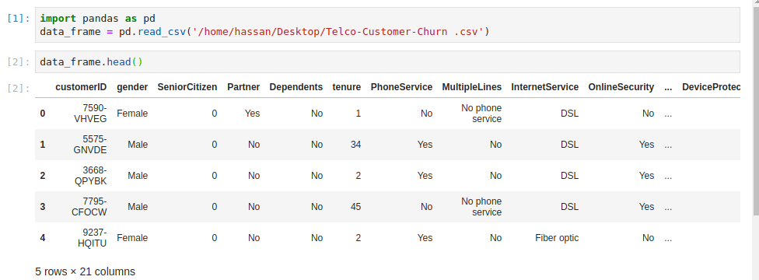
Figure 2.1.2 shows the data set loaded into anaconda jupyterLab to show some data in rows and columns.

3.0 Problem Statement
Customer churn is a disadvantage and one of the biggest worries of large companies. This is due to its direct effect on the company’s revenues, take a case of telecom business. We need to find means of predicting potentiality of customers churning using a computer based churn prediction methodology that is capable of accurately identifying any loss of clients in advance, so that proactive retention strategies can be deployed in a bid to retain the customer. So,trying to figure out factors that increase customer churn is very important to take necessary measures to reduce this vice’s effects on this business. Our major task is coming up with a churn prediction model which will assist Telco telecom company operators in predicting customers who are most likely to churn.

4.0 Objectives
- Main Objective
The main objective of system is to developing a computer based churn prediction model which will assist Telco company operators in predicting customers who are likely to churn.
- Other Objective
Another objective is to use this data set to predict products or services less needed and those most used by customers.
5.0 Methodology
We are going go use both a descriptive analytics approach which gives details of what happened and a predictive analytics approach which answers questions on what is likely to happen.
5.1 How we shall describe and predict customer churn.
The best way to predict future customer churn is looking at data from the past. We are going to look at data of customers who have already churned which is termed as the response and their characteristics before they defected which is denoted as the predictors. We shall come up with a statistical model to relate the predictors to the responses. We shall follow these data-pipe lining phases described in a table to do these predictions and descriptions;
Phase | Activities
1. Data Loading | This involves loading the data set onto Anaconda jupyterLab notebook.
2. Data wrangling | This is majorly cleaning the data by dropping irrelevant data,removing noise, dealing with missing values , removing outliers and removing incomplete entries and attributes,one hot encoding or label encoding in case the data is non numerical or categorical like some of our columns . Feature scaling for imbalanced data.
3.Visualization | This involves putting data in a visual context to see the actual churn percentage plotted. In this phase we also determine skewed ness of data and determine correlation of features.
4.Applying logistic regression | Starts with transformation of data which involves normalizing data attributes to enable production of the best results. It also involves splitting our data to train and set ,then apply logistic regression to it.
5.Evaluation and testing using logistic regression. | This involves deciding whether our machine learning algorithm will give the best score by testing it.
6.Deployment | These involves presentation of our computer based churn prediction model product.

5.2 Tools to use
We shall use pandas a package in python, Anaconda jupyterLab,jupyter Notebook to do the data loading,plotly,matplotlib,seaborn packages to plot graphs.

6.0 Outcomes
The results from this system show that predicting the customer churn can be successful with high accuracy. The classification model of logistic regression can produce an accuracy of over 90 and above.
The disadvantage of this logistic regression classifier is its execution time and the need for the vast memory resources.

7.0 References
[1],Mark Peterson Senior Data Scientist at Alliance Data,Predicting customer churn.Accessed on: July10, 2019. [Online]. Available:https://www.datacamp.com/courses/predicting-customer-churn-in-python
[2],Altex soft Customer Analyst and machine learning expert,Customer churn prediction using machine learning main approaches and models. Accessed on: July11, 2019. [Online]. Available:https://www.kdnuggets.com/2019/05/churn-prediction-machine-learning.html
[3],Colleen Farelly,Data Scientist/Poet/Social Scientist/Topologist. Data pipelining methods. Accessed on: July11, 2019. [Online]. Available:https://www.quora.com/What-is-a-data-science-pipeline

