**Software Requirements Specification**

for

**Connect Four**

Group 4:

Jacob Hopkins

Andrew Kelly

Angela Leach

Daniel Lopez

Version: 1.0 July 18, 2019

Table of Contents

1. Preface

1.1 Introduction

1.2 Purpose

1.3 Document Organization

1.4 Intended Audience

1.5 Proposed Document Scope

1.6 Definitions

1. Description

2.1 Product Overview

2.2 Product Functions

2.2.1 Set – Up

2.2.2 Daily Use

2.3 User Characteristics

2.4 User Constraints

2.5 Assumptions and Dependencies

1. Functional Requirements

3.1 Model of Connect Four System

3.2 Application Use Case Scenarios

3.2.1 Use Case 1: Login to Application

3.2.2 Use Case 2: Begin Single Player Game

3.2.3 Use Case 3: Begin Multiplayer Game

3.2.4 Use Case 4: Chat with Online Player

3.2.5 Use Case 5: Access Leaderboard

1. Non-Functional Requirements

4.1 Reliability:

4.1.1. Dual-connection Functionality.

4.2 Robustness:

4.2.1. Connection Failure

4.2.2. Application Error/Failure

4.3 Performance:

4.3.1. Connection Consistency

4.4 Maintainability:

4.4.1. Application Updates

4.4.2. Server connectivity

4.5 Usability:

4.5.1. Web Integration

4.5.2. Web Application

4.6 Modifiability:

4.6.1. Modifiable for updates

1. Design and Implementation Compliance

5.1. Standards compliance

5.1.1. Connection

5.3 Development constraints:

5.3.1. Inputs.

5.3.2. Resolutions.

5.3.3. Security

1. References

**1.Preface**

**1.1 Introduction**

This document explains the usage and requirements of an online Connect Four system designed for personal gameplay. The game system would operate either dependently or independently to an online server, depending on the game mode chosen by the user.

**1.2 Purpose**

This document describes the general functionality of a web application for a Connect Four game as well as the network connection functionalities and requirements.

**1.3 Document Organization**

This document uses a numbered format to order the information. The order of the information is irrelevant if the information is not numbered.

**1.4 Intended Audience**

This document is intended for developers of the system, as well as users of the Connect Four game application.

**1.5 Proposed Document Scope**

The Connect Four system will consist of the following subsystems:

* + - The user interface application will allow the user to select a game mode of their choosing. One options to choose from is a single player mode, where a user will be playing a match against the AI.
    - Another subsystem is a multiplayer mode, where the user has the choice to either play with a random person online or play locally on the same computer system.
    - The user interface application will also allow the user to view a leaderboard, where a display of the top 10 highest ranked players is shown, along side the user’s own personal ranking.
    - Network connection software will allow the players to connect online and allow the leaderboards to update regularly.

**1.6 Definitions**

|  |  |
| --- | --- |
| **Term** | **Definition** |
| User | User with access to all standard user functions. Must have an account to have access to the full extent of the application. |
| Match | Term used to describe the game play. A match consists two players. Either both are users, or if in single player match: a user and a computer AI. |
| Main Landing Page | The first page displayed once opening up the computer application. |
| Network Connection Software | Software components used to connect computers or other devices together. |
| User Interface Application | Online computer application that will allow users to access the system |

**2. Description:**

**2.1 Product Overview**

In the classic *boardgame* of Connect Four, two players sit opposite a board that sits on its side, with a grid of forty-two (six by seven) cells. Alternating turns, each player drops a yellow or red disk into a column, eventually building stacks. To be a victor, one must manage to create a unbroken line (horizontal, vertical, or diagonal) of their disk color. In this *software*, the same rules to be a victor apply, but a player can play against a friend, or against the program itself, with easy and hard mode.

**2.2. Product Functions**

The game will allow any player(s) who has downloaded the software to play one-player mode on their local machine, or two-player mode by connecting to a remote server which facilitates a game between two remote human players.

**2.2.1. Set-up**

Setup is dependent on user preference. The software will start on a menu screen, where the user has three choices: single-player, two-player, and leaderboard. Should the user click single player, they are presented with a popup to query if they want easy or hard mode. Then the gameboard is loaded. Should the user click two-player, an attempt to connect to the server is made. Upon success (and a waiting player) the gameboard loads for both players, and their moves are synchronized by the server. In either gaming mode, the end result for each player is one of three: quit, lose, win. The latter is the only option that allows for a chance at the leaderboard. Finally, chose the user click leaderboard as a menu option, they will be presented with the best local scores.

**2.2.2 . Daily Use**

Frequency of use is dependent upon the player(s).

**2.3 User Characteristics**

The target group of users will be players who like strategy games, or even coders who like to decorate or improve upon simple programs.

**2.4 Constraints**

The two-player mode depends upon a remote connection to a server. A constraint is that the server must always be listening and operational. The burden of the server rests upon the users of the software, as they must implement a server on their own machine.

**2.5 Assumptions and dependencies**

The assumption of the software is that the user knows (or has the technological means to look up) the rules and strategy of Connect Four. The software assumes at least one user has setup a server.

**3. Statement of Functional Requirements**

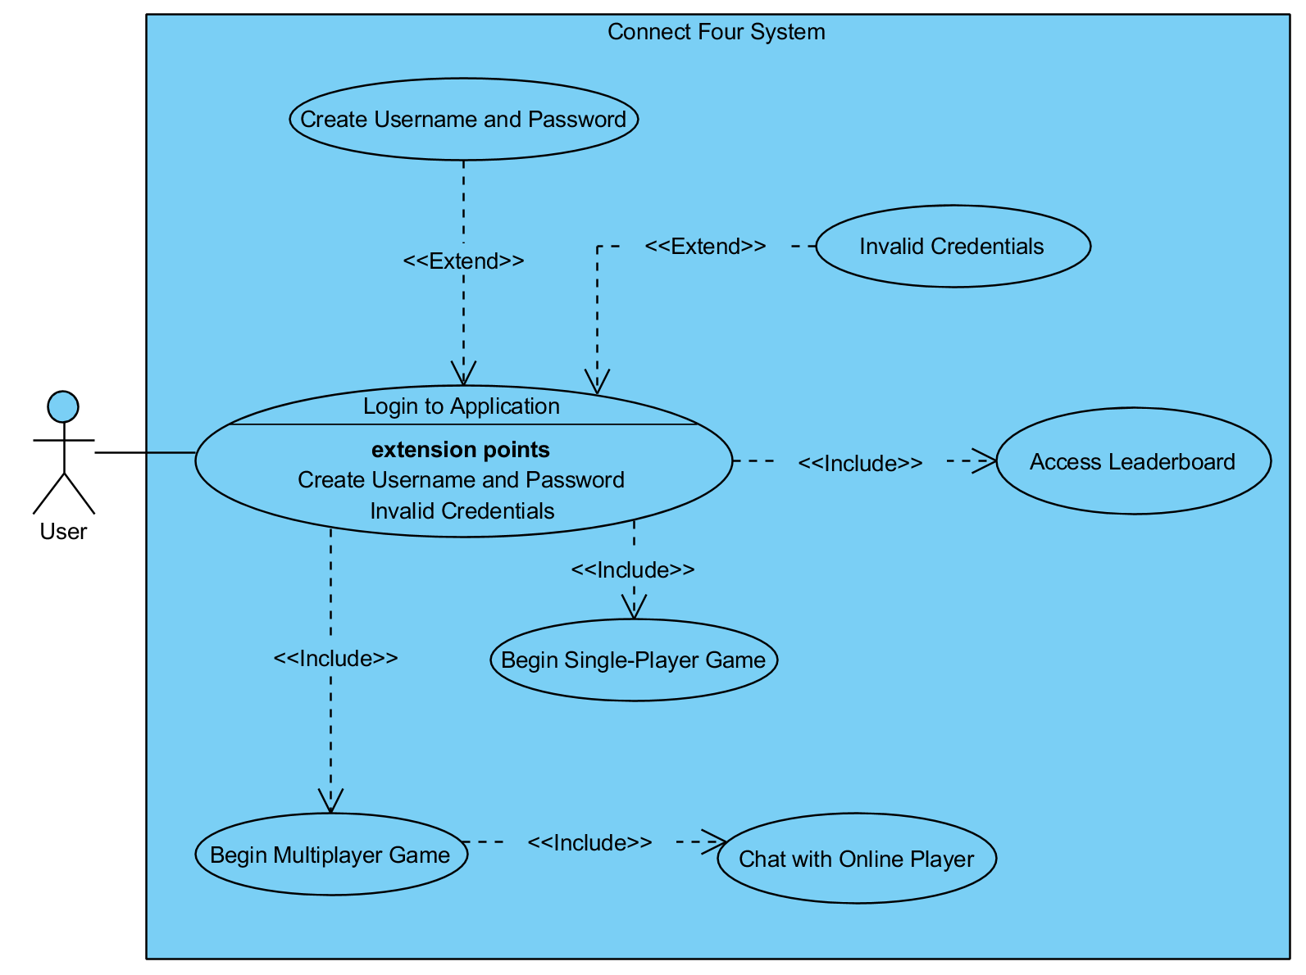**3.1 Model of Connect Four System**

**3.2. Application Use Cases**

**3.2.1. - Use Case 1**

**Name:** Login to Application

**Actor:** User

**Brief Description:** From the main landing page, user enters his or her username and password in order to login to the application.

**Entry-Conditions:** The game is on and is displaying the main landing page, along with the text fields to enter user credentials.

**Exit-Conditions:** The player will be logged in the Connect Four application and the main landing page will update, displaying the options “Single Player”, Multiplayer”, and “Leaderboard”.

**Path Outline:**

1. User opens the Connect Four game application.
2. If the user is not already logged in
   1. The main landing page displays a text box prompting the user to enter personal login credentials
   2. If the entered credentials are incorrect
      1. The textbox resets all text from the previous attempt.
      2. The textbox prompts user to enter credentials again.
      3. If the user has failed to enter the proper credentials 5 times
         1. Application locks out the user for an amount of time.
3. If the user has not created a username or password
   1. Main landing page displays a textbox, prompting the user to create a username and password
   2. User enters a username and a password
   3. User clicks “Create”.
4. The main landing page is reloaded, prompting the user to click “Single Player”, Multiplayer”, or “Leaderboard” (Figure 1.1)

**System Requirements:**

1. User must be running an operating system that supports Connect Four.
2. Application must be connected to the internet.

**GUI Screenshots:**

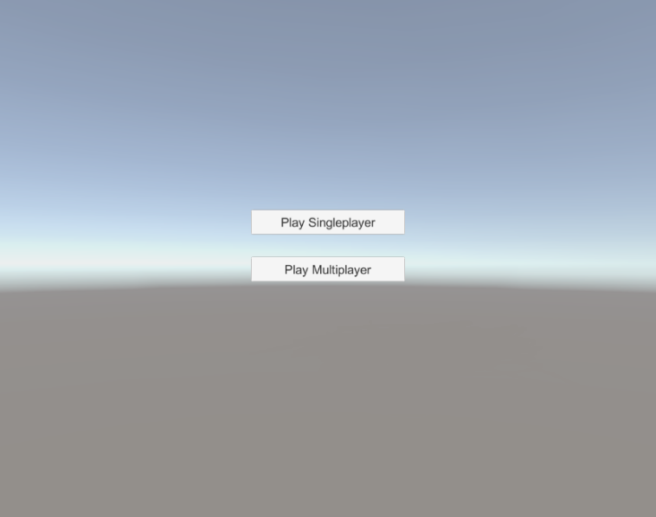

**Figure 1.1: Once the user is logged into the system application, the interface displays options to click “Single Player”, Multiplayer”, or “Leaderboard”. The main landing page branches off into every other pages of the system application.**

**3.2.2. - Use Case 2**

**Name:** Play Single Player Game

**Actor:** User

**Brief Description:** From the main menu, the player chooses a specific single player game.

**Path Outline:**

1. The user clicks on the “Single Player” option in the main landing page.
2. The application loads a new page, prompting the user to select a difficulty level, “Easy” or “Hard”. (Figure 1.2)
3. If user selects “Beginner”
   1. Application is sent a message to allow the use of a “REDO” button in game.
4. The application prompts the user to select a “RED” or “BACK” piece icon to play as (Figure 1.3)
5. The user then selects “Play” and begins the game.
6. The application loads a new page with the Connect Four board.
7. The user clicks on a column to drop his or her piece into the board.
8. If user is in “Beginner” mode
   1. If the user wishes to undo a move
      1. The user clicks on the “UNDO” button after placing a piece in a column.
9. If the user has not made a move for 5 minutes
   1. The game automatically quits, dealing a “Loss” to the user.
10. If the user wishes to quit the game
    1. The user clicks on “Quit Game”
    2. The game automatically deals the user a “Loss”.
11. The user finishes the game.
12. Application updates the user’s record.
13. Application prompts user to either “Restart” or “Quit” (Figure 1.4)
14. If user clicks “Restart”
    1. Application reloads page and begins a new game.
15. Else
    1. Application returns to the main landing page.

**Entry Condition:**

1. The game is on and the game is displaying the main menu.
2. The user is already logged in with valid login credentials.

**Exit Condition:**

1. The player will be engaging in a single player game against an AI opponent.
2. Player record is updated.

**System Requirements:**

1. Application must be connected to a steady network connection.
2. “UNDO” option must only be available for “Beginner” mode.
3. After a game is either finished or exited, the application must update the user’s win/loss score.

**GUI Screenshots:**

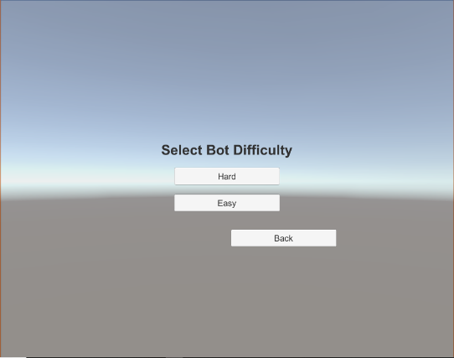**Figure 1.2: Once the user has chosen to select “Single Player” mode, the newly loaded interface displays an option to select an icon color.**

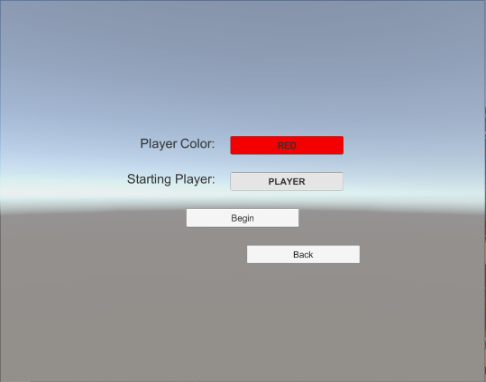

**Figure 1.3: Once the user has chosen to select “Single Player” mode, the newly loaded interface displays an option to select an icon color.**

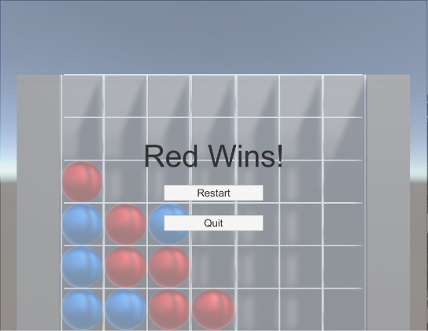

**Figure 1.4: Once the user has completed a match, the application prompts the user to either “Restart” or “Quit”.**

**3.2.2. - Use Case 3**

**Name:** Play Multiplayer Game

**Actor:** User

**Brief Description:** From the main menu, the player chooses a specific single player game.

**Path Outline:**

1. The user clicks on the “Multiplayer” option in the home page.
2. The application loads a new page, prompting the user to select “Play Online” or “Play Local”. (Figure 1.5)
3. If user selects “Play Online”
   1. User is redirected to play against another user online.
4. Else if user selects “Play Local”
   1. A message is sent to the application to allow gameplay on one terminal.
5. The application flips a virtual coin in order to determine which user goes first.
6. The application prompts the user who goes first to select a “RED” or “BACK” piece icon to play as.
7. Both users then press “Play” to start the match.
8. If one user presses “Play” and the other does not within 2 minutes
   1. Player who does not press “Play” is automatically forfeited and is given a “Loss”
9. The application loads a new page with the Connect Four board and a chat box.
10. The user clicks on a column to drop his or her piece into the board.
11. If one user has not made a move for 5 minutes
    1. The game automatically deals a “Loss” to the user who ran out of time .
12. If a user wishes to quit the game before completion.
    1. The user clicks on “Quit Game”.
    2. The game automatically deals the user a “Loss”.
13. The game finishes.
14. If there is no “four in a row” pattern on the board.
    1. No changes are made to either user’s win/loss records.
15. Application updates the user’s win/loss record.
16. Application prompts users to either “Restart” or “Quit” (Figure 1.6)
17. If both users click “Restart”
    1. Application reloads page and begins a new game.
18. Else
    1. Application returns to the main landing page.

**Entry Condition:**

1. The game is on and the game is displaying the main menu.
2. The user is already logged in with valid login credentials
3. The system is connected to a steady network connection.

**Exit Condition:**

1. The player will be engaging in a multiplayer game against a local opponent.
2. Both player records will be updated.

**System Requirements:**

1. Application must be connected to a steady network connection.
2. After a game is either finished or exited, the application must update the user’s win/loss score.
3. Chat system must allow an option to be turned “ON” or “OFF”.
4. Chat system must allow a “MUTE” option.

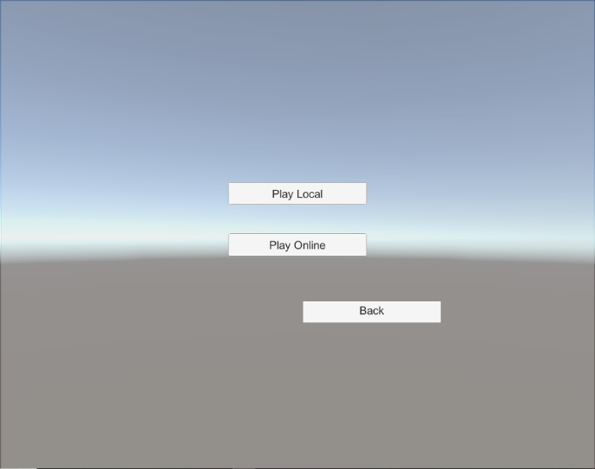**GUI Screenshots:**

**Figure 1.5: Once the user has chosen to select “Multiplayer”, the application displays a new page prompting the user to choose “Local”, “Online”, or “Back”.**

**Figure 1.6: Once the user has completed a match, the application prompts the user to either “Restart” or “Quit”.**

**3.2.2. - Use Case 4**

**Name:** Chat with Online Player

**Actor:** User

**Brief Description:** In multiplayer mode, the user chooses to send a message to the opposing online player.

**Path Outline:**

1. The user has decided to play on “Online Multiplayer” mode.
2. The user starts the Connect Four match with another user online.
3. If the user wishes to turn off the chat system
   1. The user clicks on the option to switch chat system to “OFF”.
4. Else
5. The user types in the chat system’s text box a message to be sent to the other user.

(Figure 1.7)

1. The user clicks “Send”.
2. If the other user has chat system turned “OFF”
   1. User message does not send.
3. Else if the other user has chat system on “MUTE”
   1. User can still send the message.
   2. Other user does not get a notification of the sent message.
4. Else
5. Chat log is updated to display the user’s message
6. Other user chooses to respond in the same manner.

**Entry Condition:**

1. The system is connected to a steady network connection.
2. The user is playing in “Online Multiplayer” mode.
3. Both users have their chat mode turned “ON”.

**Exit Condition:**

1. The player will be talking back and forth with another online user in “Multiplayer” mode.

**System Requirements:**

1. Application must be connected to a steady network connection.
2. The chat system must be initialized to “ON” for first time players.
3. The chat system must allow a “MUTE” button.
4. Chats may only be sent if both users have chat system turned “ON”.

**GUI Screenshots:**

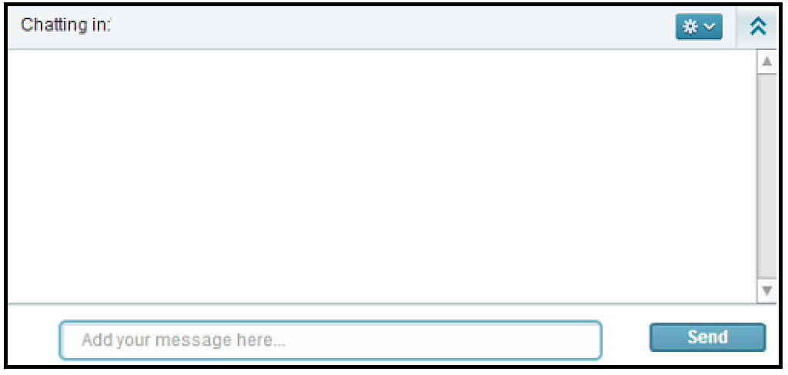

**Figure 1.7: If the user chooses to send a message to the opposing online player, a chat box on the side of the screen is displayed. To send a message, type in the chat box where it says “Add your message here…” and then click “Send”.**

**3.2.2. - Use Case 5**

**Name:** View Leaderboard

**Actor:** User

**Brief Description:** From the main menu, the player chooses to view the leaderboard.

**Path Outline:**

1. The user has decided to click “Leaderboard” option in the main menu.
2. The application loads a new page, displaying the “Top 10” leaderboard.
3. The application prompts the user to view personal win/loss record and ranking.
4. If the user is done viewing the “Leaderboard” page
   1. The user clicks “Return”
   2. The application reloads the home page.

**Entry Condition:**

1. The game is on and the game is displaying the main menu.
2. The user is already logged in with valid login credentials
3. The system is connected to a steady network connection.

**Exit Condition:**

1. The player will be viewing the page displaying the “Top 10” leaderboard and their own personal records.

**System Requirements:**

1. Application must be connected to a steady network connection.
2. The leaderboard must be updated after every match played.
3. The user record must be updated after every match played.

**4. Non-functional requirements**

**4.1 Reliability:**

4.1.1. Dual-connection Functionality:

An issue that may occur in the application is when attempting to connect to a multiplayer session. To assist with overcoming the issue, the user(s) will be notified when a connection could not be found, is attempting to be established, and if the connection was successful.

**4.2 Robustness:**

When the system is working under unexpected conditions, the Connect Four game system will remain functional.

4.2.1. Connection Failure:

In the event that a connection to the multiplayer session were to drop, the application will continue to try and reestablish connection. The users will be notified about the connection issue while the connection is attempting to be restored. There will be an option to retry establishing connection if the user was not able to connect to the game, or an option to exit.

4.2.2. Application Error/Failure:

The issue may arise that the application does not allow for the continuation of a game after user selections. In order to prevent the application to be terminated from an outside source, there will be an option to exit the session or game in each of the screens.

**4.3 Performance Constraints:**

In developing the system, the major constraints noted were with network connection.

4.3.1. Connection Consistency

In order for the game to continue without interruption, the clients must be able to maintain connection with the server to avoid delay or conclusion of the game.

**4.4 Maintainability:**

4.4.1. Application Updates:

Utilizing the MVC model we will be able to adjust the user interface for any new versions of device software, or improved event list. The controller will not need to be changed with these improvements. This will also be beneficial if additional features and functionality need to be added to the application.

4.4.2. Server connectivity:

In order to maintain minimal connectivity issues, adjustment to the server-client settings can be made to improve this feature.

**4.5 Usability:**

4.5.1. Web Integration:

The application will be able to run on macOS, Linux, and Windows with a compatible version of Java (requires JavaFX).

4.5.2. Web Application:

The application will allow for ease of use and proof of functionality without requiring knowledge in networking or coding. The user can launch the application and decide on whether to play a single player mode or multiplayer mode of Connect 4 by selecting the desired button on screen. The application will walk the player through on how difficult they would like the game to be if they selected single player, or how to connect to their opponent if they selected multiplayer.

**4.6 Modifiability**

4.6.1 Modifiable for updates:

The source code of the application uses the MVC pattern to allow for an evident method for applying modifications and updates. Modifications and updates require the use of the Java language using version JavaSE-1.8.

**5. Design and Implementation Constraints**

**5.1. Standards compliance:**

5.1.1. Connection:

Demands on the network must be sustainable for a continuous connection.

**5.2 Development constraints:**

5.2.1. Inputs:

Game inputs must be standard three button mouse and QWERTY keyboard keys.

5.2.2. Resolution:

The game resolution should not exceed 920x1080 to accommodate most monitors.

5.2.3. Security:

Game scripts should be protected to prevent players from accessing and changing variables.

**6. References**

[1] H. Ku, D. Wells, J.-L. Scherer. “Public Ethernet connection management systems for IP access networks.” 2004 *IEEE/IFIP Network Operations and Management Symposium,* Volume 1, April, 2004.