Comparative Genomics Practical 04

Phylogenomics

Group 6: Tianlin He Xueqing Wang

Summary

The purpose of this practical is to generate a phylogenic tree of for four prokaryotic species. We started by selecting E.coli as the reference proteome, and blast it against the other three proteomes. The best scoring hits were collected, from which ten random genes were chosen. These ten ortholog genes were further used to construct a phylogenic tree. Finally, the accuracy of the reconstructed tree was estimated by bootstrapping, and we also compare the difference in tree topologies when the tree is either generated from the metagene, or from a consensus tree by combining ten small trees.

Activity
Perform the following steps in this order
Orthologous gene datasets
In this exercise you will select as reference one of your prokaryotic genomes for
which you will be searching for orthologs in remaining prokaryotic genomes. For this purpose BLAST tool will be used.

1. For all of your prokaryotic genomes (including reference) find multi-fasta files
with proteins from one of previous exercises.
a. This multi-fasta file contains all protein sequences inferred from your
genomes and will be called proteome file.
Use command line to extract protenomes of four prokaryotic genomes from Glimmer prediction
python2 parseGlimmer.py 03.fa.txt 03.glimmertigt.predict –translate
python2 parseGlimmer.py 03.fa.txt 08.glimmertigt.predict –translate
python2 parseGlimmer.py 03.fa.txt 09.glimmertigt.predict –translate
python2 parseGlimmer.py 03.fa.txt 30.glimmertigt.predict --translate

2. Configure BLAST
a. To be able to use blast commands copy configuration file
cp /afs/pdc.kth.se/home/a/arnee/.ncbirc ~/
3. Create a BLAST database for you proteomes
a. In previous exercises you used makeblastdb to create a database for blastn,
repeat that for all of your selected proteomes individually (this time
indexed file is of protein type).
Make the protein database from the four proteomes we obtained from last step. The type of database is protein.
Makeblastdb 03.protein.fa -dbtype prot
Makeblastdb 08.protein.fa -dbtype prot
Makeblastdb 09.protein.fa -dbtype prot
Makeblastdb 18.protein.fa -dbtype prot

4. Do a blast​ p ​ (for proteins) search against your reference proteome (against one
selected proteome)
blastp -outfmt 5 -query <ref-proteome.fa> -db <query-proteome.fa> -out
<output file>
a. Added -m5 parameter returns XML output which is easy to parse in
b. Repeat this for all your query proteomes and create output XML files
blastp -outfmt 5 -query 09.protein.fa -db 03.protein.fa -out 03.blastp.txt
blastp -outfmt 5 -query 09.protein.fa -db 08.protein.fa -out 03.blastp.txt
blastp -outfmt 5 -query 09.protein.fa -db 18.protein.fa -out 03.blastp.txt

Biopython

5. Modify your script from the previous lab to parse the XML output.
a. The input for the script should be
<xml output> <tag for reference genome> <tag for target genome>
b. Reference genome tag and target genome tag parameters are used to assign
the genome name (file name) for query and target sequences.
c. The output for the script should be in ​ one line (lines below are wrapped)
with following four columns:
<tag for reference genome> <query protein id in reference genome>
<tag for target genome> <best hit protein id in target genome>
for example
human proteinI chicken proteinXV
human proteinI mouse proteinXX
human proteinII chicken proteinIX
The modified code is in attachment no. 1
python2 blastResultParser.py 03.blastp.txt E.coli B.thetaiotaomicron
python2 blastResultParser.py 08.blastp.txt E.coli D.turgidum
python2 blastResultParser.py 18.blastp.txt E.coli Synechocystis sp.

6. Combine the best hits into one cluster file
a. Use the output of your BLAST parser as input
b. Each query protein can have best hits in different species (i.e proteinI in
chicken and mouse from example above)
c. Group them in one line as in example below
human_proteinI chicken_proteinXV mouse_proteinXX ...
d. Each such line now represents cluster of orthologs

7. Select 10 different ortholog clusters such that all your prokaryotic genomes are
included and acquire the corresponding protein sequences from the multifasta
files.
The ten orthologs that we select (using E.coli as reference) are listed below:
1. E.coli./09.fa.txt_orf00002
2. E.coli./09.fa.txt_orf00003
3. E.coli./09.fa.txt_orf00005
4. E.coli./09.fa.txt_orf00007_rev
5. E.coli./09.fa.txt_orf00009_rev
6. E.coli./09.fa.txt_orf00010_rev
7. E.coli./09.fa.txt_orf00011
8. E.coli./09.fa.txt_orf00012
9. E.coli./09.fa.txt_orf00013_rev
10. E.coli./09.fa.txt_orf00016_rev

a. The result should be a number of multifasta files, one for each ortholog
cluster
b. The multifasta file should include all sequences that appear in cluster of
orthologs (including query sequence)

Metagene approach

8. Make a multiple alignment for each of your mulitfasta cluster files (so you have
one alignment for each cluster of orthologous genes).
a. Concatenate the alignments into a single, long metagene.
The metagene multifasta file is in attachment no. 2.

b. The end result should be a single fasta file with a sequence for each
bacterial genome consisting of the aligned genes from each genome.
c. Perform tree reconstruction using Belvu. What is the tree like?

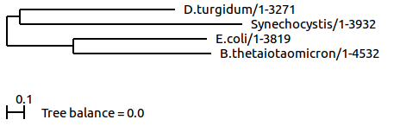

d. Perform sequence bootstrapping on the metagene. Can you say any-thing on the quality of the reconstruction ?
Bootstrapping estimates the degree of support in each branching from different possible tree topologies, and display the degree of support in terms of number in percentage. In our case, the value at the first branch is D.turgidum-Synechocystis is 49, indicating that almost half of the trees agree on this topology, therefore it is relatively reliable, however, the value at the E.coli-B.thetaiotaomicron is only 8, showing that there is no consensus between the trees, therefore this topology has a poor quality.

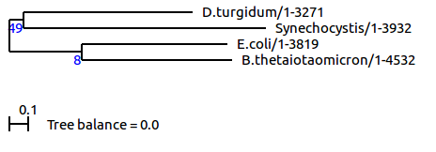

9. Perform tree reconstruction using belvu for each individual alignment
a. You should get ten different trees (one for each ortholg cluster) in Newick format.

1. E.coli./09.fa.txt_orf00002
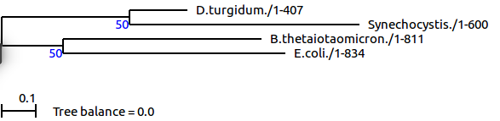
2. E.coli./09.fa.txt_orf00003
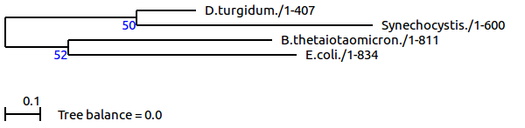
3. E.coli./09.fa.txt_orf00005
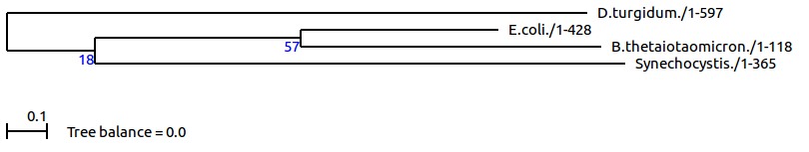
4. E.coli./09.fa.txt_orf00007_rev
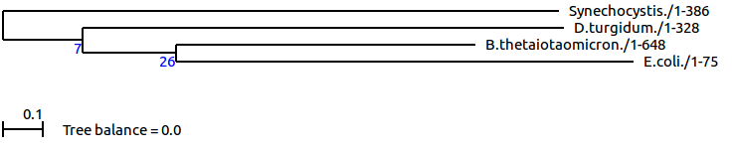
5. E.coli./09.fa.txt_orf00009_rev
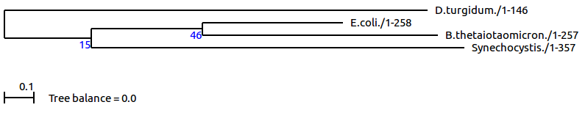
6. E.coli./09.fa.txt_orf00010_rev
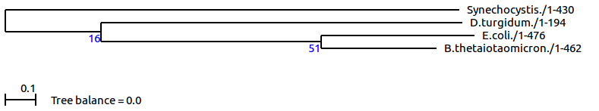
7. E.coli./09.fa.txt_orf00011

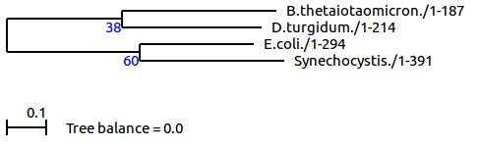

8. E.coli./09.fa.txt_orf00012

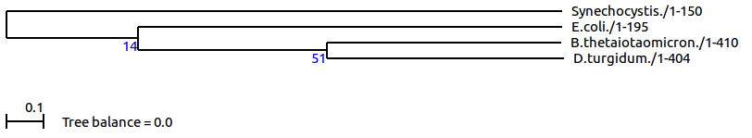

9. E.coli./09.fa.txt_orf00013_rev
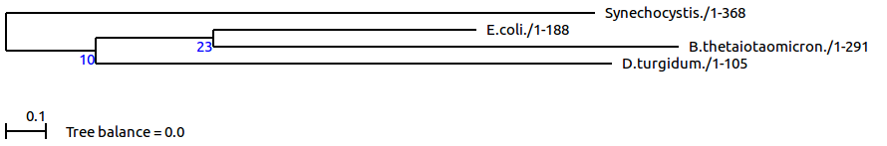
10. E.coli./09.fa.txt_orf00016_rev
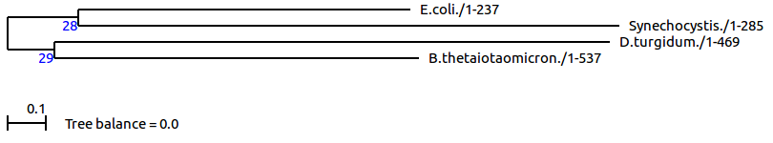

b. How precise are those trees ?
1) They are not so precise as the values obtained from bootstrapping are hardly larger than 50, which means that the branching is not supported in more than half of the cases.¹
2) They also show 5 types of in the pattern of branching:
- Type 1: gene 1 and gene 2
- Type 2: gene 4, 6, 9
- Type 3: gene 8
- Type 4: gene 3 and gene 5
- Type 5: gene 7 and gene 10

c. Can you point a few specific genes or classes of genes that cause
disagreement ?
Based on question b, we can only conclude that there is no general agreement between these 10 genes.

d. How do you think that happens ?
In genome, there are essential genes, species-specific genes, tissue-specific genes…... Based on their effect on survival, they have different mutation rate. For example, essential gene, such as 16S RNA is less prone to mutation then others, and orthologues may also exert environment-dependent rate of mutation in different species. Hence, different genes can give us different tree topologies.

10. Construct a consensus tree from the gene trees using Phylip example
a. For combining the tree, it is important that you use the species names as
protein identifier in each tree (for example protein1 Mmusculus, where
Mmusculus is species name)
b. Use phylip consense to construct a consensus tree, put the tree files
together into a file containing a list of trees. Phylip should be pre-installed
phylip consense
c. Name this file intree.
d. Phylip reads the file named intree in the present directory, asks you a few
questions, and then gives you the consensus tree.
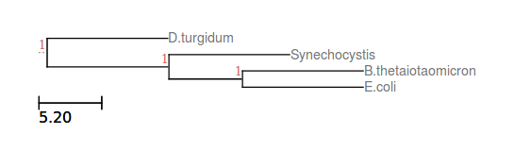

Discussion

There are two fundamental assumptions in building a phylogenic tree:
1) all of the sequences evolve at the same mutation rate for all the mutations at all the time
2) divergence between sequences is moderate such that there is at most a single mutation at each position of the alignment.²

However, these two assumptions can hardly be fulfilled under most of the circumstances, giving rise to discrepancy between reconstructed phylogenic tree and the real evolution events that have taken place.

The phylogenic tree is generated by two methods, from a “fusion” metagene of 10 orthologues (figure a) and from the consensus between 10 smaller tree generated individually from the same orthologues (figure b). They yield different result:

Figure a

Figure b
The discrepancy is probably caused by difference in their calculation methdologies. The metagene-based method regards the ten orthologs as one metagene, makes use of the alignment between 4 species, so that the substitution rate at each position can be estimated. In contrast, the consensus-based method fuses the 10 smaller tree and obtain a merged tree which is most agreed from those ten trees.

It is also noticed that the value at each branch after bootstrapping is relatively low, suggesting the poor quality of the phylogenic tree. This poor quality may be attributed to our choice of these 10 orthologs: as they were picked randomly, they are not essentially conserved. This implies that depending on their functionality, they may carry different mutation rate, render the back-calculation of genetic distance inaccurate.

Reference

1. DM Hillis and JJ Bull. 1993. An Empirical Test of Bootstrapping as a Method for Assessing Confidence in Phylogenetic Analysis. System Biology: 42, 182-192.
2. M Zvelebil and JO Baum. 2007. Understanding Bioinformatics: chapter 7. Garland Science.

