Comparative Genomics Practical 06

Orthology Prediction

Group 6: Tianlin He Xueqing Wang

OBJECTIVES
The report should be formatted in one PDF file and sent in by the end of the week. It
should cover all points listed below. Missing or faulty items will result in a reduced grade
for this practical.
1. Short summary of what you have done (e.g. how did you find protein identifiers
etc.).
2. Describe algorithms used in databases you are comparing.
3. How predictions differ (missing/same orthologs) ?
4. Detailed discussion of the results achieved with different methods and the
differences between their predictions (pairs, ortholog groups).

ACTIVITY
Perform the following steps in this order
You want to compare the orthology predictions from one database with other methods
for three of your genes. Since you want genes present in at least two methods (i.e
TreeFam and InParanoid) you should restrict your gene selection to a species that is
present in selected databases.
Some databases provide files with trees reporting which species were used
1. To search for orthologs you first need correct protein identifiers for your
predicted genes (instead of orf1234..):
a. One way to find correct identifiers is to do a local blast search with the
sequence of your protein against the source files of the InParanoid
database. The source files can be found in
http://inparanoid.sbc.su.se/download/current/sequences/processed/
1. Download the proteome of target species (e.g. E.coli) from InParanoid in the directory
wget http://inparanoid.sbc.su.se/download/current/sequences/processed/226186.fasta
2. Convert the fasta file into a protein database
makeblast db -in 83333.fasta -dbtype protein
3. Conduct a local blast search of the protein sequence (e.g. 09.fa.txt_orf00002) against the protein database generated
blastp -query 09.fa.txt_orf00002 -db 226186.fasta -out geneA.out.txt
4. Record the name of the best hit as identifier (e.g. P00561)

 | ORF name | Identifier | E-value
Protein seq 1 | E.coli./09.fa.txt_orf00002 | P00561 | 0
Protein seq 2 | E.coli./09.fa.txt_orf00011 | P0A867 | 0
Protein seq 3 | E.coli./09.fa.txt_orf00010_rev | P30143 | 0
 | E.coli./09.fa.txt_orf00003 | P00547
 | ./03.fa.txt_orf00001_rev
 | E.coli./09.fa.txt_orf00016_rev | P75617

b. You can also do an online blast search (e.g. at ncbi or ensembl).
2. Once you have the correct identifiers you need to find three genes which are also
present in other databases. For each of the three genes pick at least 3 species for
comparison. Compare the predictions (i.e GeneTree in TreeFam vs InParanoid
pairs) of selected methods.
InParanoid:

1. Open the web server with InParanoid
2. Search the identifier of a protein sequence (e.g. P00561 of E.coli) aganist protenome of one of the three species (e.g. B. thetaiotaomicron).
3. It generates the ortholog cluster of the target protein

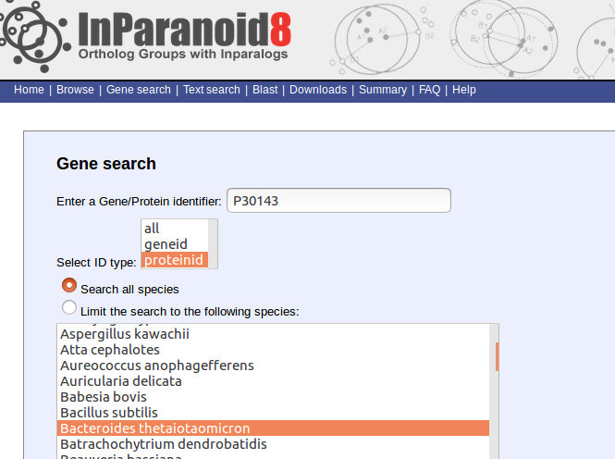

Target protein | B.thetaiotaomicron | D.turgidum | Synechocystis sp. | S.cerevisae | Micromonas sp. | A.thaliana | S.pombe | c.albican
P0A867 |  |  | P72797 | P15019 | C1EBM7 | Q5A017 | O42700 | Q5A017
P00547 |  | B8E0J7 | P73646 | P17423 | C1FFB6 | M4B3R1 | O43056 | Q92209
P00561 | Q8A541 | B8E0J9 | P74569 | P10869 | C1EGY7 | O81852 | O60163 | -

2. PhylomeDB

Target protein | S.cerevisae | A.thaliana | C.albican | S.pombe
P0A867 | NQM1/TAL1 | T28K15.4 | TAL1 | TAL1
P00547 | - | HSK | THR1 | O43056
P00561 | HOM3 | AK1/AK2/AK3 | HOM3/HOM32 | O60163
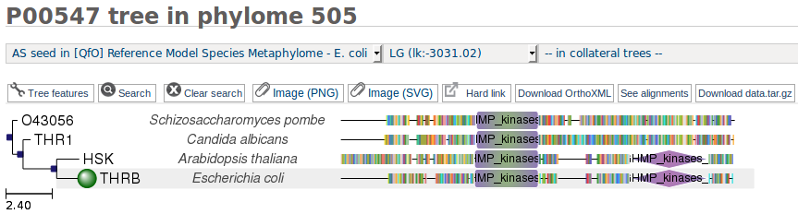
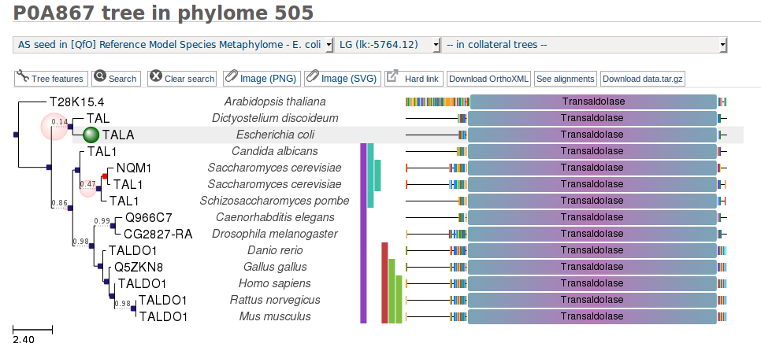
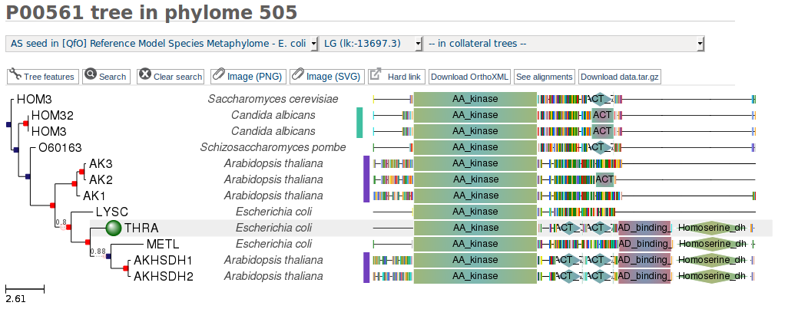

3. OMA
Target protein | S.cerevisae | A.thaliana | C.albican | S.pombe
P0A867 | YEAST04250 | -- | CANAW03234 | SCHPO04445
P00547 | YEAST02875 | ARATH05271 | CANAW04609 | SCHPO03580
P00561 | - | ARATH02098 | - | -

a. How does predicted orthologs differ (missing or same)?
We use three orthologues-searching method, namely InParanoid, PhylomeDB and OMA to predict the orthologues of three E.coli genes (P0A867, P00547 and P00561) in four species (S.cerevisiae, A. thaliana, C. albican and S.pombe)
These three methods generate different results, which are listed in three tables above.
The reason why these four species are selected is that they present in all databases. However, from these three tables it is observed that they produce different orthologues pair.
For example, using phylomeDB we are able to identify orthologues of P00561 in all 4 species, but we can only find one using OMA.
b. Can you find orthologs in one database that are not orthologous in another
database but appear as different pairs ? Why do you think this happens ?
c. How big are ortholog groups for your selected genes in your compared
databases ?
Size of Ortholog groups are displayed below

Target protein | InParanoid | PhylomeDB | OMA
P0A867 | 220 | 14 | 632
P00547 | 123 | 4 | 1131
P00561 | 98 | 12 | 431
d. Can you say something about quality of predictions ?

