Simple one-gene analysis using Phobius
6. We will use Phobius, a fast and accurate predictor of TM topology.

Before you start the genome analysis, make sure that Phobius works from the command line. Make a test file called Q8TCT8 with the sequence of Q8TCT8 (see software documentation http://phobius.sbc.su.se/instructions.html).

/afs/pdc.kth.se/home/e/erison/Public/bin/phobius/1.01/phobius Q8TCT8.fa
Then run it on the web server. The results should be the same.

We run Phobius both in the command line and on the website, and got exactly the same predictions about the topology of Q8TCT8 sequence. The results are shown in AnnexI, which includes both the long and the short output format.

Whole-proteome analysis with Phobius
7. Now we want to run Phobius for all proteins in a genome. This assumes you have a fasta file with all proteins in each proteome from previous practicals. We need a script that launches Phobius for each sequence, and parses the output of Phobius. This is a very typical script in bioinformatics so it is a very general exercise. All we want to collect for now is the number of predicted signal peptides and TM (predicted transmembrane segments) segments for each protein, and find out for one proteome:
a. The fraction of proteins with 0 TM segments.
b. The fraction of proteins with > 0 TM segments.
c. The average number of TM segments for those with >0 segments.
d. The fraction of proteins with > 0 signal peptide.
e. The fraction of those (with > 0 signal peptide) with > 0 TM segment.
Tips:
You can call Phobius for each of sequence, or simply run
phobius -short <proteome file>
to get a one-line summary for each protein that is easily parsed without BioPython.

We first run phobius for each proteome in command line, and exported the short output into a txt file (one output file for each fasta file). Then we wrote a script to parse these output files and calculated the statistics outcomes required for this practical. The script is described in AnnexII. The outcomes are as follows:
Species 03 Proteome
The fraction of proteins with 0 TM segments in species 03= 0.7887796691440901
The fraction of proteins with > 0 TM segments in species 03= 0.21122033085590985
The fraction of proteins with > 0 signal peptide= 0.3176696235914649
The fraction of those (with > 0 signal peptide) with > 0 TM segment= 0.0890566037735849
The average number of TM segments for those with >0 segments= 4.545970488081725

Species 08 Proteome
The fraction of proteins with 0 TM segments in species 08= 0.784219001610306
The fraction of proteins with > 0 TM segments in species 08= 0.21578099838969403
The fraction of proteins with > 0 signal peptide= 0.11701556629092862
The fraction of those (with > 0 signal peptide) with > 0 TM segment= 0.15137614678899083
The average number of TM segments for those with >0 segments= 4.355721393034826

Species 09 Proteome
The fraction of proteins with 0 TM segments in species 09= 0.7972947585947774
The fraction of proteins with > 0 TM segments in species 09= 0.2027052414052226
The fraction of proteins with > 0 signal peptide= 0.14221303776066127
The fraction of those (with > 0 signal peptide) with > 0 TM segment= 0.21400264200792601
The average number of TM segments for those with >0 segments= 5.537534754402224

Species 18 Proteome
The fraction of proteins with 0 TM segments in species 18= 0.7805328409390662
The fraction of proteins with > 0 TM segments in species 18= 0.21946715906093378
The fraction of proteins with > 0 signal peptide= 0.11026114481667107
The fraction of those (with > 0 signal peptide) with > 0 TM segment= 0.22009569377990432
The average number of TM segments for those with >0 segments= 3.9122596153846154

Comparative proteome analysis with Phobius
8. Now run the previous analysis on all your (real) genomes. Make an xy scatter plot showing the fraction of TM proteins on one axis and the average nr of TM segments on the other axis. Is there a trend?

We collected the fractions and average numbers of transmembrane segments obtained in the last section, and made a scatter plot with average nr against fraction of TM proteins. The plot is shown as follows:
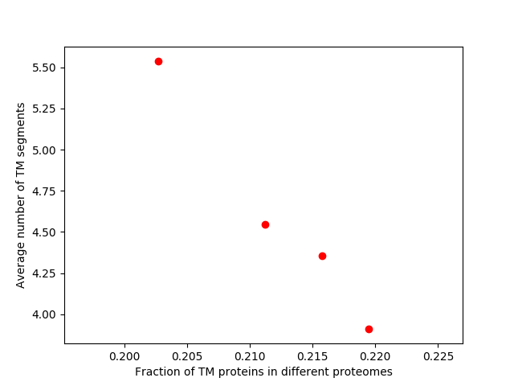
From the plot we could roughly tell that, when the fraction of proteins with > 0 TM segment increases in the proteome, the average number of transmembrane segments in the transmembrane proteins in that proteome drop down.

More protein localization analysis with targetP
TargetP can predict more subcellular localizations, namely mitochondrial (only eukaryotes) and chloroplast (only for plants). Test it on your yeast chromosome via: http://www.cbs.dtu.dk/services/TargetP/

9. What does Plant/Non-Plant parameter do?
TargetP predicts the peptide locations based on chloroplast transit peptide (cTP), mitochondrial targeting peptide (mTP) and secretory pathway signal peptide (SP). If we select Plant parameter it would detect through out the submitted sequences with all these three signals; if we select non-plant it would only predict against mTP and SP. Since we are testing on yeast genomes we only need the Non-plant prediction.[1]
a. What fraction are predicted mitochondrial proteins ?
In total there are 248 protein sequences in the proteome of yeast predicted by Genscan. When we run TargetP on the website without setting a cutoff, 29 peptides are predicted as mitochondrial proteins, taking of 11.7% of the total number. However, among the predicted mitochondrial proteins only 10 have relatively high reliability (difference between being interpreted as mitochondiral and the type with the second highest probability larger than 60%). To improve the quality of the predicted topology, we set the cutoff into 0.95, in which way only 12 proteins were considered as mitochondrial in TargetP.
b. How many are both predicted mitochondrial and to have a signal peptide?
(Comment on such predictions, are they biologically sound?)
All the predicted mitochondrial protein sections have a probability to be signal peptide; however, most of these probabilities are extremely low compared to the probability of being in mitochondron.
Both the mitochondrial and signal peptide proteins have biological meanings. Mitochondrial proteins are targeted into mitochondron by its targeted part in the N-terminal, which is cleaved after it fulfilled its mission (leading the peptide into mitochondrial). The peptide will then stay in the mitochondrial and perform function in it. On the other hand, signal peptide is utilized by the secretory protein to enter the secretory pathway[1]. Secretory proteins can be found in the ER membrane (smooth or rough), ER lumen, as well as within the cytoplasm matrix and extracellular sites as they are secreted into different places. Thus, mitochondrial proteins and secretory signal peptides are totally distinctive both in localization and function, and the prediction of both mitochondrial and signal peptide makes no sense in practical.

10. Would your run targetP for all of your genomes? Why?

We would not run TargetP for the prokaryote genomes, as the location assignment is based on the predicted presence of any of the N-terminal presequences: chloroplast transit peptide (cTP), mitochondrial targeting peptide (mTP) or secretory pathway signal peptide (SP). All these three peptide fractions are only found in eukaryotes as they have the corresponding organallas. If we test prokaryote genomes based on these detections it would make no biological sense.

References:
[1] Predicting subcellular localization of proteins based on their N-terminal amino acid sequence.
Olof Emanuelsson, Henrik Nielsen, Søren Brunak and Gunnar von Heijne. J. Mol. Biol., 300: 1005-1016, 2000.
[2] Identification of prokaryotic and eukaryotic signal peptides and prediction of their cleavage sites.
Henrik Nielsen, Jacob Engelbrecht, Søren Brunak and Gunnar von Heijne. Protein Engineering, 10:1-6, 1997.

