Experimental gene sets
Imagine an experiment has been performed and e.g. differentially expressed genes have
been detected. Obviously, these would be a subset of your yeast chromosome.

1. Download the ​ S.cerevisiae ​ S228C proteome from Uniprot
(http://www.uniprot.org/proteomes/) and use BLAST to match your predicted
genes against UniProt proteome.
makeblastdb -in YeastChrX.fa -dbtype prot
blastp -outfmt 5 -query protein30.fa -db YeastChrX.fa -out out.yeast.blastp.txt

2. Parse blast results to extract gene names (GN=) for genes present on chromosome.

3. Find two experimental gene sets (experiments.txt) that overlap most with genes
on your chromosome. The goal is to find out if any of these are present on the
chromosome.
python2 blastResultParser.py out.yeast.blastp.txt

4. Report how many genes overlap and save two experimental gene sets for further
analysis.
[('line40', 0), ('line34', 0), ('line17', 0), ('line39', 0), ('line51', 0), ('line5', 0), ('line4', 0), ('line19', 0), ('line55', 0), ('line16', 0), ('line30', 0), ('line1', 1), ('line22', 1), ('line53', 1), ('line43', 1), ('line8', 1), ('line42', 1), ('line31', 1), ('line49', 1), ('line20', 1), ('line28', 1), ('line7', 1), ('line6', 1), ('line50', 1), ('line33', 1), ('line52', 1), ('line25', 1), ('line2', 1), ('line27', 1), ('line38', 1), ('line12', 1), ('line23', 1), ('line37', 2), ('line24', 2), ('line48', 2), ('line47', 2), ('line45', 2), ('line44', 2), ('line11', 2), ('line21', 2), ('line3', 2), ('line10', 2), ('line14', 2), ('line41', 2), ('line36', 2), ('line46', 2), ('line18', 2), ('line35', 2), ('line15', 2), ('line29', 2), ('line13', 2), ('line9', 2), ('line32', 2), ('line26', 3), ('line54', 4)]

Line 54 and line 26 in experiments.txt should be selected for further use, as they have the most overlaps (4 proteins and 3 proteins respectively) with the out.yeast.blastp.txt.

Comparative network analysis using FunCoup and STRING
1. Using your two experimental gene sets query FunCoup and STRING for
sub-networks containing these genes.
a. FunCoup works with space delimited list of gene names, STRING expects
each gene name in new line for a query.
b. Use the same expansion depth or max number of interactors for searching
both databases, so the results are comparable.
In FunCoup, we set the expansion depth as 0, while in STRING, we set the max number of interactions as “none/query proteins only”, so that this parameter is comparable in the two methods.

2. Compare results
a. How do these networks differ in terms of nodes, links, and hubs (the three
nodes with highest degree)?
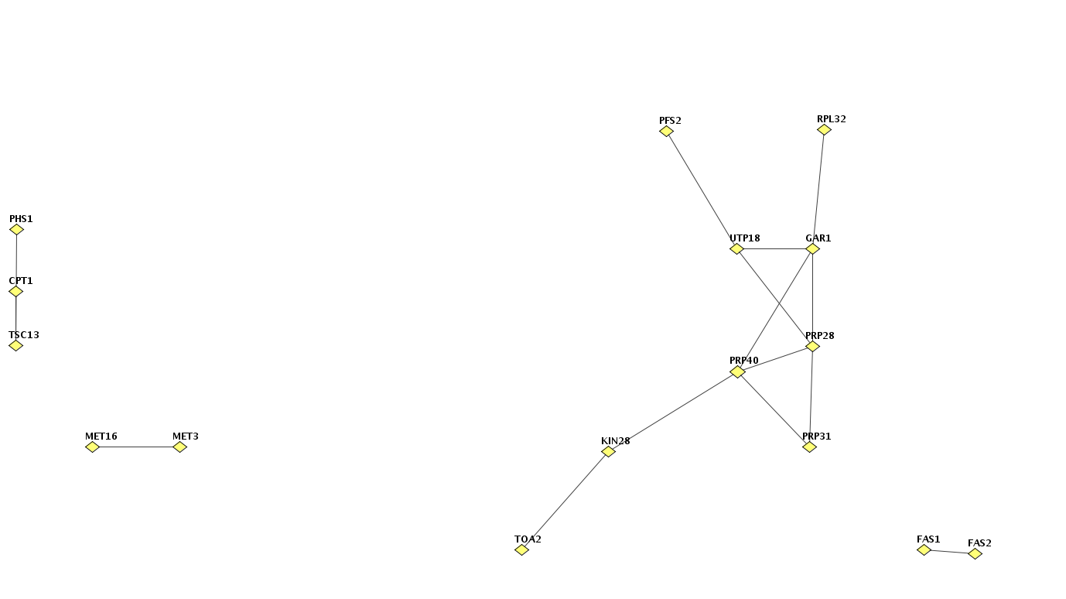
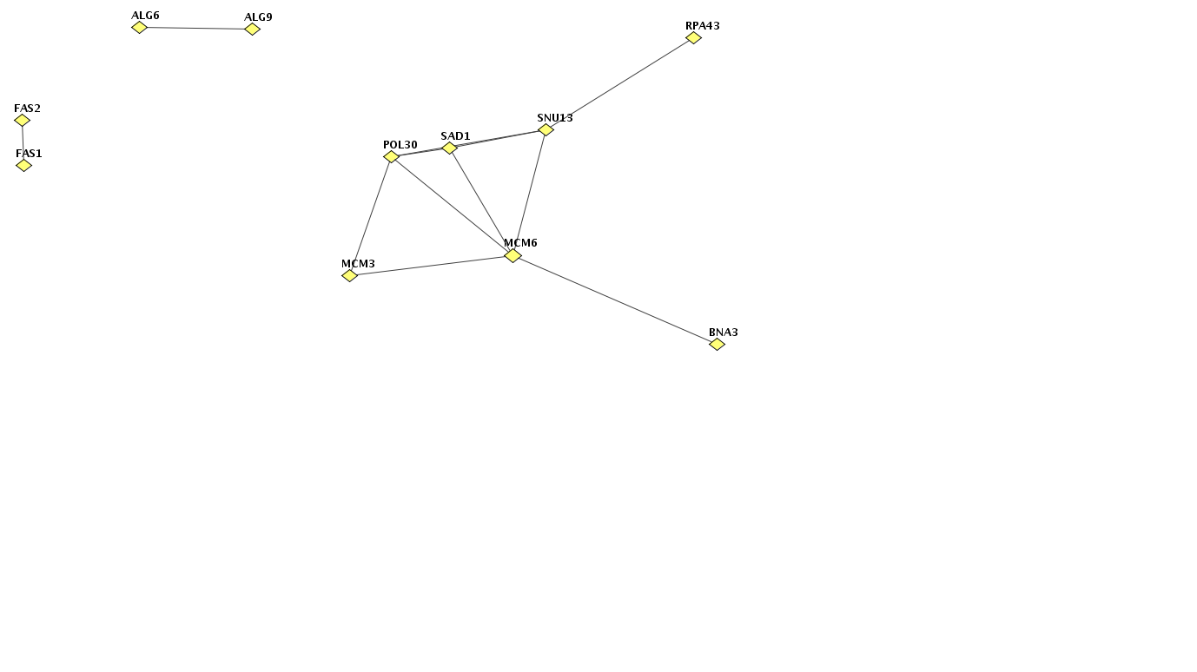
Funcoup
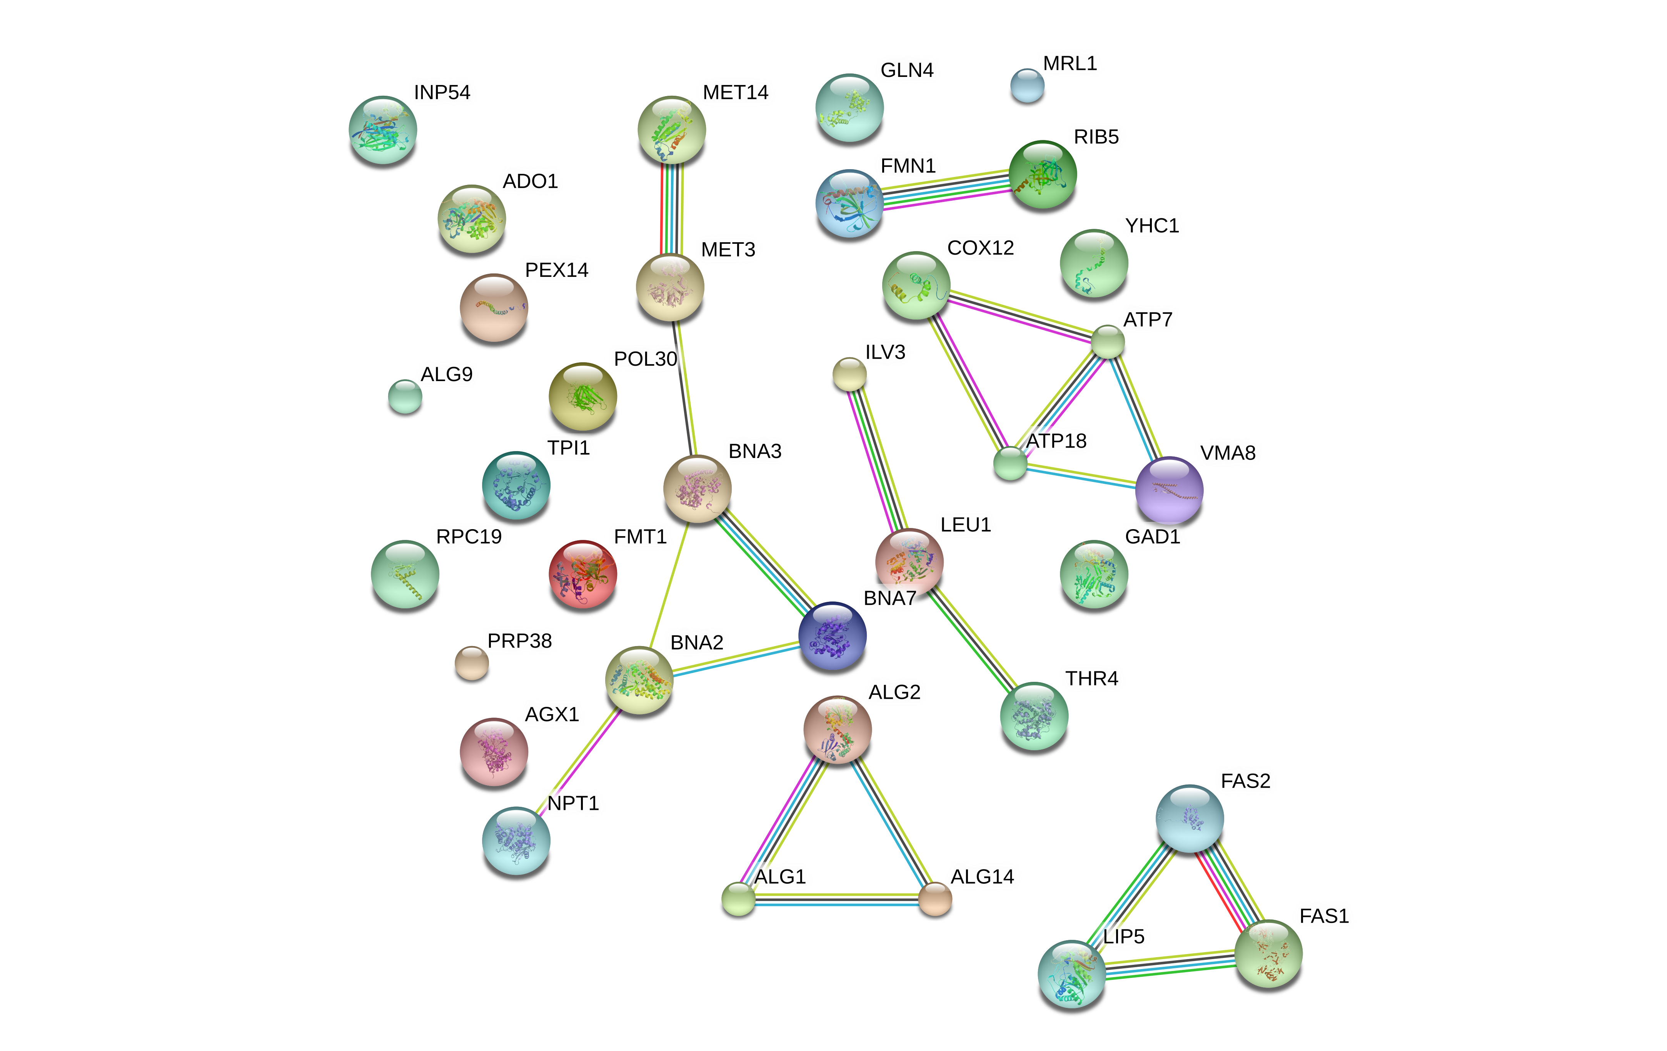 | 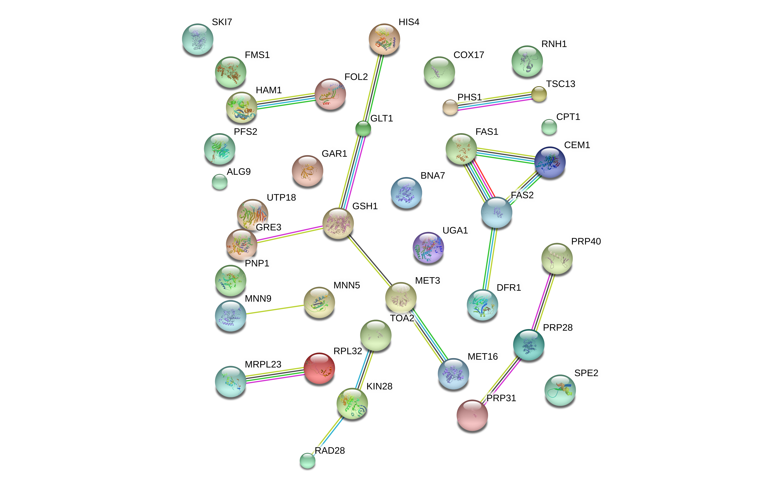
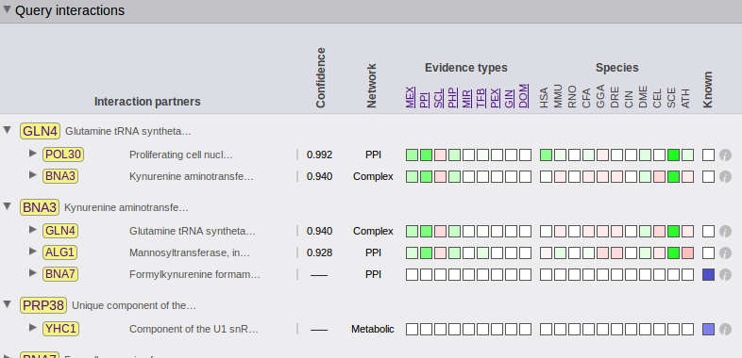

b. What is the most common evidence type with high confidence (>0.9)?

Funcoup
set26
set54

c. Can you explain the differences in terms of underlying data sources in the
databases?

