**Exercise 1:**

Study the program below and write the questions and answers in MS word and save it as exercise4.docx.

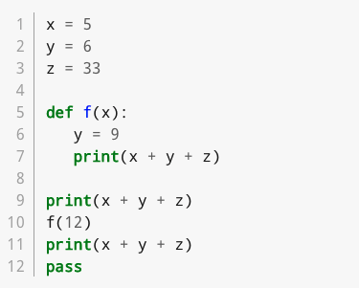

1. What is the output of the program?

44

55

44

1. Which line contains a function header?

Line 5

1. Which line(s) constitute the main program?

Line 5, Line 6 , Line 7

1. Is there a local variable defined anywhere? If so what is its scope?

y is the local variable and its scope is the body of function f.

1. Does the function f return a value?

No

1. Does the function f reference any global variables?

Yes

1. Which lines constitute a function body?

Line 6 and Line 7

1. Are there any arguments used in the program? If so what and where are they? (tricky)

Yes, 12 is an argument because its being assigned as a value to the parameter x in line 10.

1. Are there any parameters defined in the program? Explain.

Yes x is defined as a parameter in function f because it’s a variable to store value of an argument

1. What does the last line do?

Acts as a place holder for future code.