**Test5：Registered**

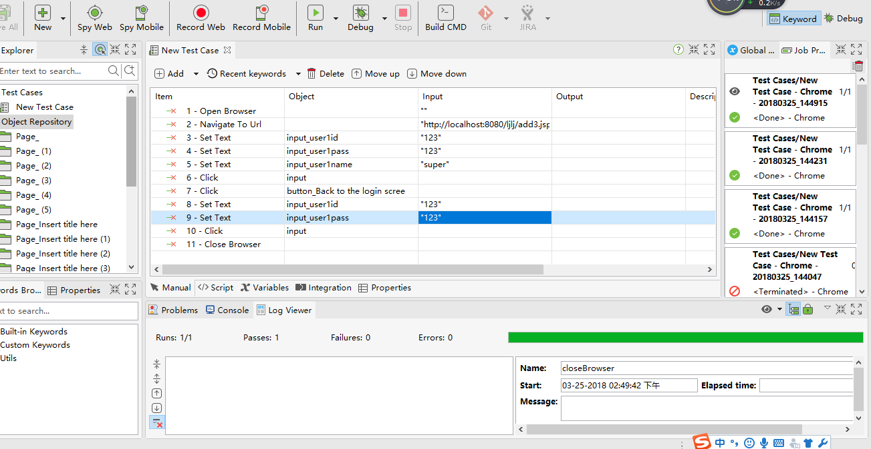

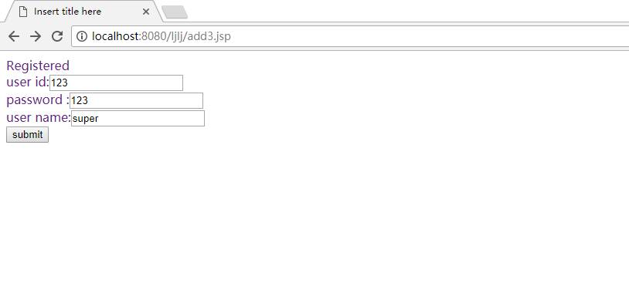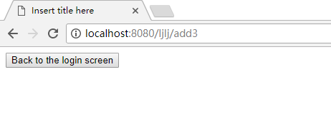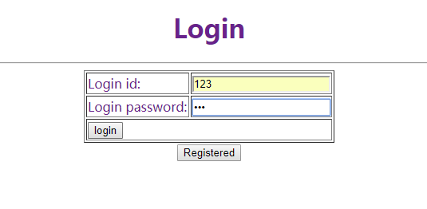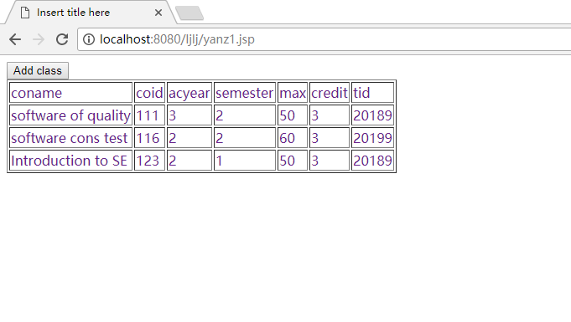WebUI.*openBrowser*('')

WebUI.*navigateToUrl*('http://localhost:8080/ljlj/add3.jsp')

WebUI.*setText*(*findTestObject*('Page_Insert title here (6)/input_user1id'), '123')

WebUI.*setText*(*findTestObject*('Page_Insert title here (6)/input_user1pass'), '123')

WebUI.*setText*(*findTestObject*('Page_Insert title here (6)/input_user1name'), 'super')

WebUI.*click*(*findTestObject*('Page_Insert title here (6)/input'))

WebUI.*click*(*findTestObject*('Page_Insert title here (6)/button_Back to the login scree'))

WebUI.*setText*(*findTestObject*('Page_ (5)/input_user1id'), '123')

WebUI.*setText*(*findTestObject*('Page_ (5)/input_user1pass'), '123')

WebUI.*click*(*findTestObject*('Page_ (5)/input'))

WebUI.*closeBrowser*()

**Test6：Add class(student)**

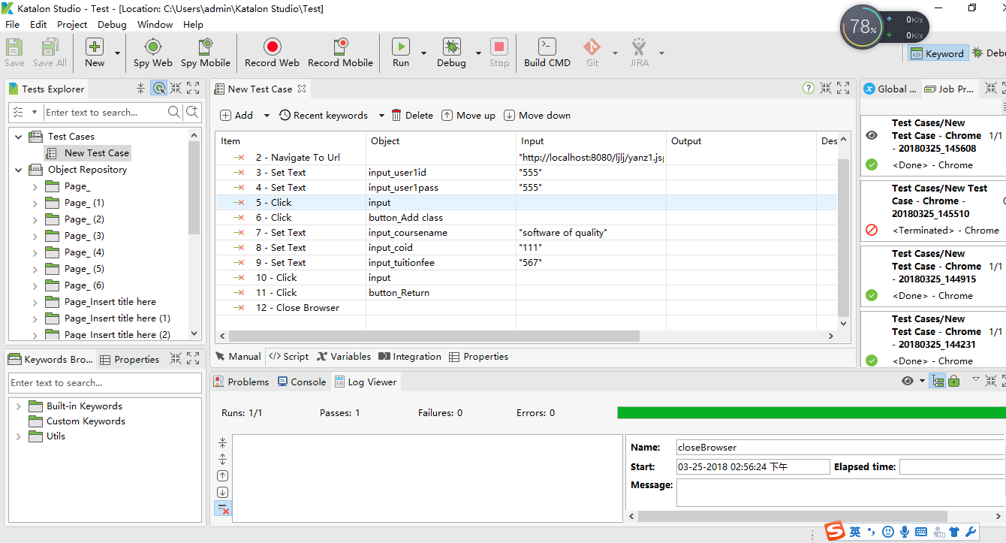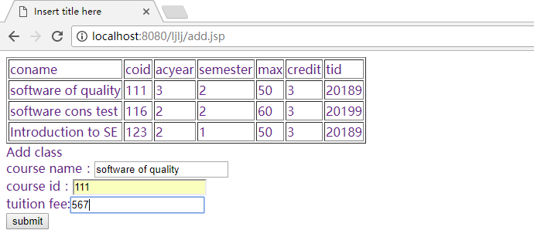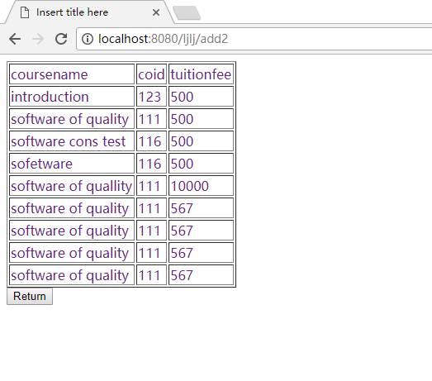

WebUI.*openBrowser*('')

WebUI.*navigateToUrl*('http://localhost:8080/ljlj/yanz1.jsp')

WebUI.*setText*(*findTestObject*('Page_ (6)/input_user1id'), '555')

WebUI.*setText*(*findTestObject*('Page_ (6)/input_user1pass'), '555')

WebUI.*click*(*findTestObject*('Page_ (6)/input'))

WebUI.*click*(*findTestObject*('Page_Insert title here (7)/button_Add class'))

WebUI.*setText*(*findTestObject*('Page_Insert title here (7)/input_coursename'), 'software of quality')

WebUI.*setText*(*findTestObject*('Page_Insert title here (7)/input_coid'), '111')

WebUI.*setText*(*findTestObject*('Page_Insert title here (7)/input_tuitionfee'), '567')

WebUI.*click*(*findTestObject*('Page_Insert title here (7)/input'))

WebUI.*click*(*findTestObject*('Page_Insert title here (7)/button_Return'))

WebUI.*closeBrowser*()