1、用户接口

**/user/login** post

Request name,password

Response

Fail：false

Success:true

2.检验注册用户名是否已存在

**/user/register_check** post

Request name

Response:

Fail:false

Success:true

3.注册

**/user/register**  post

Request：

Username,password,photo

Response:

Fail:false

Success:true

4.获取用户登陆信息

**/user/get_user_info** get

Request:name

Success:

User:

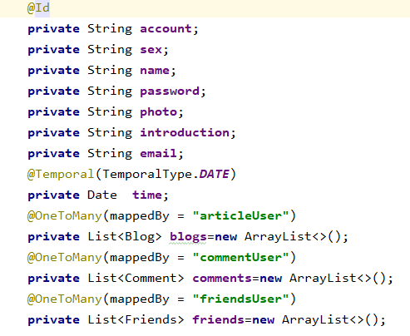

5.用户信息设置

/user/settings put

Request:User user

Success:true

Fail:false

6.前端获取评论

**/comment/show/{articleId}** Get

Request:articleId

Response: List<Comment>

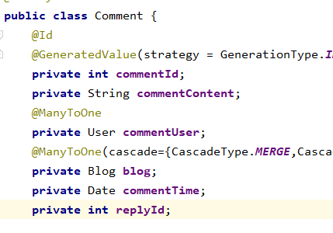

7.后端存储发布的评论

**/comment/publish** post

Request:Comment comment

Response:

Success:true

Fail:false

8.修改评论

**/comment/update** put

Request:Comment comment

Response:

Success:true

Fail:false