ALEX KINYUA, CLEOPAS KARANJA, BRIANNAH CHELANGAT, MELISA ACHIENG, CHRISTOPHER KARIUKI.

AI POWERED JOB-SCAM DETECTION SYSTEM
HAKIKI HIRE

Table of Contents
CHAPTER 1 4
1.1 INTRODUCTION: BUSINESS UNDERSTANDING 4
1.2 PROBLEM STATEMENT 4
1.2.1 BUSINESS OBJECTIVE 5
1.2.2 STAKEHOLDERS AND BENEFACTORS 5
1.2.3 METRICS OF SUCCESS 6
1.3 CURRENT RECRUITMENT AND FLOW AS IS: 6
1.4 PROPOSED SYSTEM ARCHITECTURE: 7
CHAPTER 2 10
2.1 DATA UNDERSTANDING: 10
2.1.1 DATA COLLECTION & DATA SOURCES 10
2.1.2 DATA UNDERSTANDING 10
CHAPTER 3 13
3.1 DATA PREPARATION 13
3.1.1 IMPORTING LIBRARIES 13
3.1.2 LOAD THE DATASET 13
3.1.3 DATA CLEANING 14
3.1.4 COLUMN REMOVAL AND FORMAT STANDARDIZATION 14
3.1.5 LABEL PREPARATION 15
3.1.6 FEATURE ENGINEERING 15
3.1.7 TEXT TRANSFORMATION FOR MODELLING 16
3.1.8 EXPLORATORY DATA ANALYSIS 17
CHAPTER 4 19
4.1 MODELLING 19
4.2 MODELLING APPROACH 19
4.3 TARGET PREPARATION 19
4.4 FIRST MODEL 19
4.5 MODEL COMPARISON BETWEEN THE FIRST, SECOND AND THIRD MODEL: 21
4.6 HYPERPARAMETER OPTIMIZATION 21
4.7 PROBABILITY ANALYSIS AND THRESHOLD SELECTION 22
4.8 FINAL MODEL SELECTION 24
4.9 MODEL INTERPRETABILITY 24
4.10 FINAL EVALUATION 25
CHAPTER 5 26
5.1 EVALUATION 26
5.1.1 EVALUATION METRICS 26
5.1.2 VALIDATION EVALUATION 26
5.1.3 THRESHOLD SELECTION 27
5.1.4 FINAL EVALUATION ON THE REAL HOLDOUT 27
5.1.5 AUC PERFORMANCE ACROSS MODELLING STAGE 28
5.1.6 LIMITATIONS 28
CHAPTER 6 28
6.1 DEPLOYMENT ARCHITECTURE 28
6.2 LIVE DEPLOYMENT 29
6.3 INFRASTRUCTURE CONFIGURATION 29
6.4 ENVIRONMENT CONFIGURATION 29
6.5 DEPLOYMENT VERIFICATION 29
6.6 DEPLOYMENT CONSTRAINTS 29
References 30

Figure 1 System Architecture 7
Figure 2 Job Seeker UI 8
Figure 3 Admin/Government login 8
Figure 4 Dashboard Interface 9
Figure 5 Dashboard walkthrough 9
Figure 6 Fraud class distribution 11
Figure 7 Description length 12
Figure 8 Imported Libraries 13
Figure 9 Loading of the datasets. 13
Figure 10 Data cleaning 14
Figure 11 Column removal 15
Figure 12 Label preparation 15
Figure 13 Feature Engineering 16
Figure 14 Text transformation. 16
Figure 15 Work type distribution. 17
Figure 16 Experience level distribution. 18
Figure 17 Average description length by fraud class 18
Figure 18 Target preparation 19
Figure 19 Logistic Regression Modelling 20
Figure 20 Hyperparameter optimization 22
Figure 21 Classification threshold 23
Figure 22 Final Model selection 24
Figure 23 Model interpretability 24

CHAPTER 1

1.1 INTRODUCTION: BUSINESS UNDERSTANDING
The growth of employment opportunities advertised through online platforms has made it easier for Kenyans to search and apply for jobs. However, this has also created opportunities for fraudsters to advertise fake employment opportunities. The Kenya Revenue Authority (KRA) has warned the public about fraudulent recruitment messages that falsely claim to offer employment and may be used to obtain money or personal information from job seekers. KRA also emphasizes that it does not charge any fees during its recruitment process. This demonstrates the need for greater awareness and mechanisms for identifying potentially fraudulent job advertisements in Kenya. (KRA, 2026)
(DCI, 2025)Fraudulent recruitment is also a documented problem investigated by Kenyan law-enforcement authorities. In January 2024, the Directorate of Criminal Investigations (DCI) reported the arrest of individuals involved in a fraudulent overseas recruitment drive in Nairobi. According to the DCI report, approximately 1,000 job seekers were affected by the recruitment exercise, which had been flagged as a scam by the National Employment Authority. The DCI even created a hash tag #FichuakwaDCI where they gave a number, call 0800 722 203 at no cost to report anonymously. These cases demonstrate the financial impact that fraudulent recruitment can have on Kenyan job seekers.
Government institutions have also warned Kenyans about scammers impersonating legitimate organizations. The Kenya National Bureau of Statistics (KNBS), for example, has previously warned the public about fake job advertisements circulated through social media and advised applicants to verify recruitment information through its official platforms. NITA identifies warning signs such as requests for payment, the use of free email services, and recruitment conducted through unauthorized platforms such as WhatsApp. These warnings provide examples of characteristics that can potentially be considered when developing a system for detecting suspicious job advertisements.
Based on this business problem, the goal of the project is to develop a machine-learning system that can assist in identifying potentially fraudulent job advertisements in the Kenyan employment market. The system will analyse information contained in job postings, including the job title, description, company, location, salary, employment type, email address, URL and other relevant characteristics, to identify patterns associated with fraudulent postings. The intended outcome is to provide job seekers with an additional layer of protection by automatically screening job advertisements and identifying those that may require further verification. The system is intended to support, rather than replace, human verification and official recruitment channels. (NITA, 2026) (KNBS, 2018)

1.2 PROBLEM STATEMENT
The increasing use of online platforms for recruitment has created greater access to employment opportunities, but it has also provided fraudsters with new ways of targeting job seekers through fake employment advertisements. In Kenya and even overseas for example, Data from the U.S. Federal Trade Commission (FTC) show that reported job and employment-agency scams increased substantially between 2020 and 2024, with reported losses rising from approximately $90 million to $501 million. The FTC has also identified the increasing use of online and text-based "task scams", in which individuals are offered fake employment opportunities and later asked to provide their own money. (Commission, 2024)
Despite warnings from authorities and existing methods of reporting fraudulent recruitment, job seekers still find it difficult to determine whether an online job advertisement is legitimate before interacting with the recruiter or providing personal information. Therefore, there is a need for an automated approach that can analyse job advertisements and identify characteristics associated with fraudulent postings. This project seeks to address this problem by developing a machine-learning model that can classify job advertisements as legitimate or potentially fraudulent, providing job seekers with an additional tool for identifying suspicious employment opportunities.

1.2.1 BUSINESS OBJECTIVE
- Build a classification model that predicts the fraud-risk of a job posting using the posting's text (title, description and requirements) and available structured fields such as company, location, salary range, work type, experience level and qualification.
- Apply NLP using TF-IDF with unigram and bigram features to capture linguistic signals associated with fraud-risk postings, including payment language, suspicious contact patterns and other textual cues.
- Provide Kenya-specific verification signals, including relevant licensing or blacklist information, as a separate verification layer that complements the machine-learning prediction rather than serving as a training feature.
- Surface interpretable reasons behind predictions using Logistic Regression coefficients and structured signals so that the output provides useful context for human review.
- Evaluate and compare the Logistic Regression TF-IDF baseline, Hybrid Logistic Regression and Hybrid LinearSVC, then select the model that provides the best balance of performance, probability estimates and interpretability.
- Package the trained model behind a web application and API that accepts job-posting information and returns a fraud-risk prediction and supporting analysis.

1.2.2 STAKEHOLDERS AND BENEFACTORS
A working scam-detection system benefits several distinct groups, each with a different stake in the outcome:
- Kenyan job seekers the primary beneficiaries, especially youth aged 18–34 who face the highest unemployment rates and are the most-targeted group for both local job scams and overseas trafficking recruitment; they gain an early warning before sharing personal data, paying a fee, or travelling.
- Local job boards and recruitment platforms (e.g. BrighterMonday, Fuzu, MyJobsInKenya) which can integrate the model into posting-moderation pipelines to flag suspicious listings before publication, reducing platform liability and protecting user trust.
- Ministry of Labour and Social Protection / National Employment Authority which currently deregisters fraudulent agencies reactively (680 delisted in November 2025 alone); an automated screening tool could help flag risky agencies and postings earlier and complement the existing licensed-agency register.
- Ministry of Foreign and Diaspora Affairs and Kenyan missions abroad which handle rescue and repatriation of trafficking victims and issue public warnings about fraudulent overseas job schemes; early detection reduces the number of Kenyans who travel into trafficking situations in the first place.
- Directorate of Criminal Investigations (DCI) and the Multi-Agency Labour Mobility Taskforce: which can use aggregated red-flag data from the model to identify emerging scam patterns, prioritise investigations, and corroborate victim complaints.
- County governments and university/TVET career services: which can vet postings and recruitment drives shared with residents, students, and graduates before endorsing or forwarding them.
- Legitimate employers and recruitment agencies: whose brand and licenses are frequently impersonated by scammers; a detection system helps protect legitimate agency reputation and restores trust in the licensed recruitment sector.

1.2.3 METRICS OF SUCCESS
Because fraudulent postings are a small minority of all postings (typically under 5%), overall accuracy is a poor measure of success on its own. The project will instead prioritise:
- Recall on the fraudulent class: minimising the number of scam postings the model misses, since a missed scam carries a direct real-world cost to a user.
- Precision / false-positive rate: keeping the rate of legitimate postings incorrectly flagged low enough that the tool remains trustworthy and useful rather than a source of noise.
- F1-score and ROC-AUC: as balanced summary metrics given the class imbalance, used to compare candidate models.
Interpretability qualitative review confirming that the top reasons surfaced for a handful of held-out predictions match human intuition about why a posting looks fraudulent or legitimate.

1.3 CURRENT RECRUITMENT AND FLOW AS IS:
Before proposing a solution, it is important to understand how the current system already works, since the government's existing process is more developed than it first appears — the gap is in connectivity and timing, not a complete absence of controls.
- Agency licensing: recruitment agencies must apply to the National Employment Authority (NEA) with business registration, tax compliance, police clearance for directors, and a KES 1.5 million security bond for overseas recruitment. Applications are vetted by an inter-ministerial committee that includes the National Intelligence Service, a process that can take 2–8 months; licenses are renewable annually.
- Two unequally regulated tracks: overseas placements are technically required to route through NEAIMS, with licensed agencies submitting job orders that NEA verifies. Local job postings have no licensing touchpoint at all — under Section 55 of the Labour Institutions Act, only businesses operating as employment agencies (third parties connecting job seekers to employers, or charging a placement fee) require a license. A company advertising its own vacancy directly is not “operating an employment agency” and falls entirely outside this requirement, which is precisely the loophole scammers exploit by posing as direct employers rather than agencies.
- Verification exists but is optional and disconnected: NEAIMS provides a public “Verify Employment Agency” lookup tool, and NEA advises job seekers to check it before applying. However, nothing on a job board, Facebook post, or WhatsApp message prompts or requires this check, so it depends entirely on the job seeker remembering to visit a separate government website.
- Enforcement is reactive and batch-based: victims must self-report to the DCI or the Ministry of Labour's complaint desks. Complaints accumulate case by case, and enforcement follows only once enough have built up — recent examples include 44 agencies summoned in July 2025, 25 blacklisted in October 2024, 32 named in May 2025, and roughly 680–700 licenses revoked in a November 2025 crackdown. Each action came after a wave of harm had already occurred, and the government has not published the full list of agencies delisted in the November 2025 crackdown.
In short: the government already licenses agencies and maintains a verification tool, but that information never travels with a posting once it reaches the channels where job seekers actually encounter it, and correction only happens after victims have already come forward in large enough numbers. The proposed system is designed to close that specific gap — moving verification earlier and making it automatic — rather than to replace NEA's authority or invent a new one.

1.4 PROPOSED SYSTEM ARCHITECTURE:

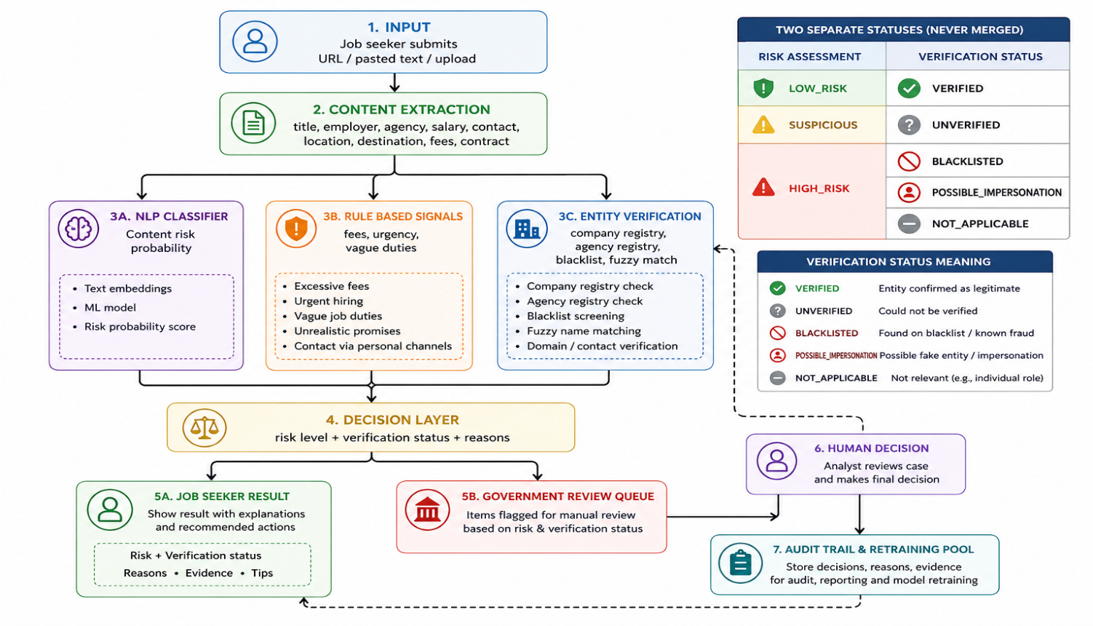
Figure 1 System Architecture
- The figure below shows the User Interface whereby the job seeker will be able to paste a job URL or a job description and the system will be able to scan through the job description and be able to know if the particular job is a scam or not, if it is flagged a scam, it will be pushed to the Government dashboard where an official will be able to do follow-up on the job. If the job is not a scam then the job seeker can be able to proceed to making an application.

Figure 2 Job Seeker UI

- In the figure below, shows how the admin will be able to login, check the risk level of particular job postings, see which location the job posting is, verification status of the particular job and be able to do a follow-up on the jobs that are flagged high-risk

Figure 3 Admin/Government login
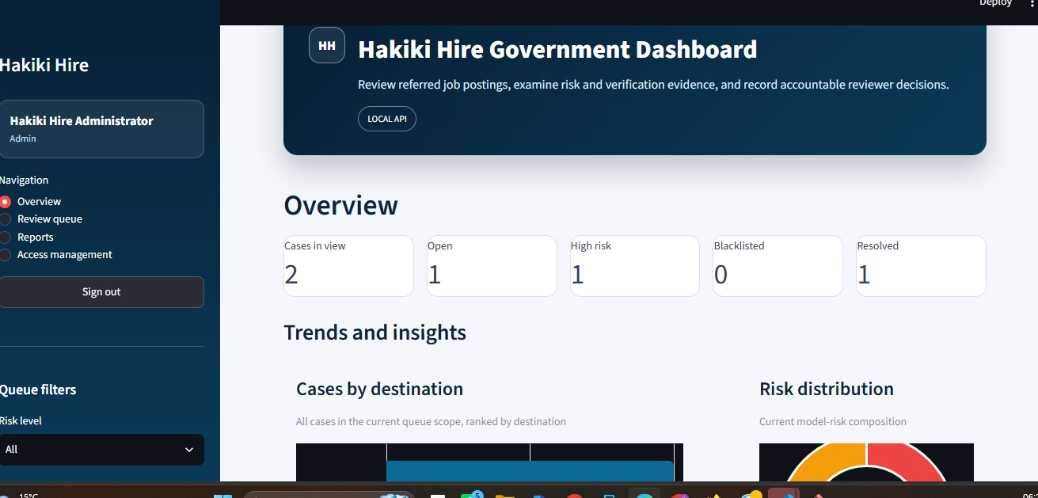
Figure 4 Dashboard Interface

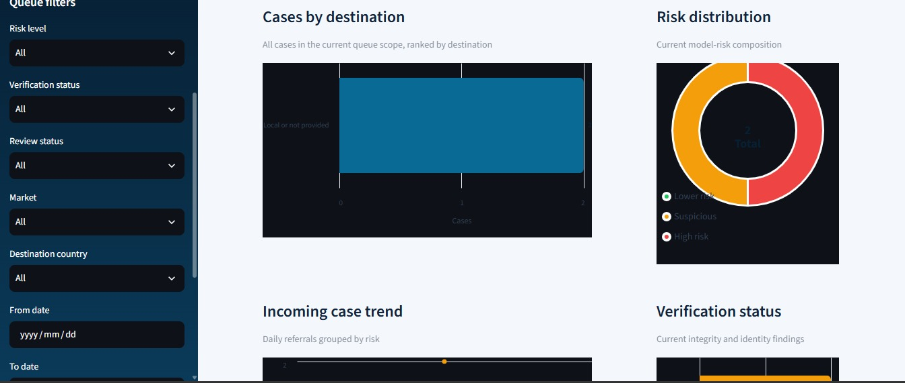
Figure 5 Dashboard walkthrough

CHAPTER 2

2.1 DATA UNDERSTANDING:
Data Understanding is the second phase of the project methodology, after Business Understanding. It covers identifying and collecting the data needed for the project, describing its structure, exploring it to surface early patterns, and verifying its quality before any cleaning, feature engineering, or modelling begins. In the project documentation, this section also gives the team, reviewers, and future collaborators a clear record of where the data came from, what it contains, and what limitations to account for in the long run.
Objective: The objective of the Data Understanding stage is to collect and analyse job-posting data, including Kenyan job postings and labelled fraud examples, to support the training and evaluation of a job scam classification model.

2.1.1 DATA COLLECTION & DATA SOURCES
In data collection, we were able to get data from multiple sources and be able to merge them to come up with a complete dataset for the project.
- Public benchmark dataset: Fake Job Postings (EMSCAD-Employment Scam Aegean Dataset), a general (non-Kenya-specific) fraud labels, used as the base source of real, labeled fraud/legitimate examples.
- Web scraping: job postings collected directly from five Kenyan job board websites — Fuzu (fuzu.com), PigiaMe (pigiame.co.ke), Corporate Staffing Services (corporatestaffing.co.ke), BrighterMonday Kenya (brightermonday.co.ke), and JobWeb Kenya (jobwebkenya.com). These postings carry no fraud label, since no ground truth exists for them.
- Synthetic augmentation: an additional 40,000-row synthetic dataset generated by the project team to grow labeled data volume for the Kenyan market context. It uses a three-class fraud scheme (0 = Legitimate, 1 = Suspicious, 2 = Fraudulent/Scam).
Challenges: a number of the target job-board sites had anti-scraping security measures in place that blocked automated access, which limited how much real Kenyan posting data could be collected directly. This was the main reason for supplementing scraped data with the EMSCAD benchmark and the synthetic dataset, rather than relying on scraped postings alone.

2.1.2 DATA UNDERSTANDING

Source | Origin | Size (rows × cols) | Ground-truth label?
Fake Job Postings (EMSCAD) | Public benchmark dataset (not scraped) | 17,880 × 18 | Yes — fraudulent
Fuzu Kenya | Scraped — fuzu.com | 666 × 7 | No
PigiaMe Kenya | Scraped — pigiame.co.ke | 1,500 × 8 | No
Corporate Staffing Kenya | Scraped — corporatestaffing.co.ke | 3,988 × 7 | No
BrighterMonday Kenya | Scraped — brightermonday.co.ke | 1,964 × 13 | No
JobWeb Kenya | Scraped — jobwebkenya.com | 5,323 × 9 | No
Synthetic Augmentation | Generated by project team (not scraped) | 40,000 × 13 | Yes — is_fraud (3-class, native)

Data Characteristics:
Column lists below are as loaded, in original order, before any standardization:
Fake Job Postings (EMSCAD): job_id, title, location, department, salary_range, company_profile, description, requirements, benefits, telecommuting, has_company_logo, has_questions, employment_type, required_experience, required_education, industry, function, fraudulent
Fuzu Kenya: title, company, location, salary_range, tags, description, source_url
PigiaMe Kenya: title, company, work_type, location, salary_range, posted, description, source_url
Corporate Staffing Kenya: title, industry, salary_range, location, deadline, description, source_url
BrighterMonday Kenya: title, company, category, location, work_type, salary_range, min_qualification, experience_level, experience_length, language_requirement, working_hours, description, source_url
JobWeb Kenya: title, company, location, state, job_type, job_category, closing_date, description, source_url
Synthetic Augmentation: title, company, location, industry_category, work_type, salary_range, experience_level, min_qualification, description, requirements, source_url, source_platform, is_fraud.

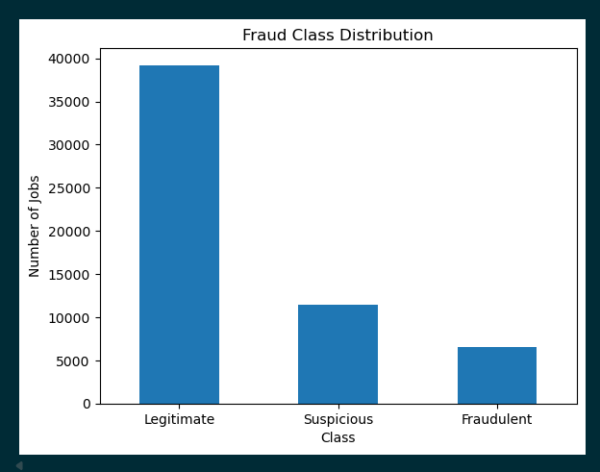
Figure 6 Fraud class distribution
The image above shows the number of Legitimate, Suspicious, and Fraudulent postings: 39,219, 11,426, and 6,505 respectively. It immediately shows the class imbalance, which is important for our classification problem.

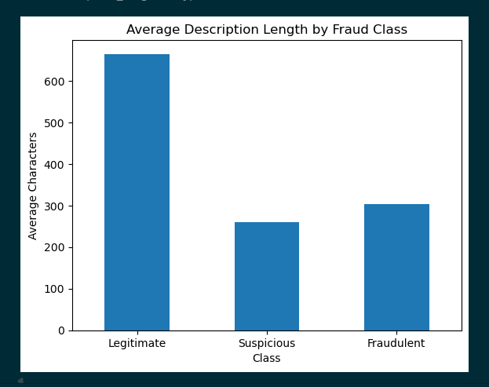
Figure 7 Description length

The figure above compares the average description length across the fraud classes. Our notebook specifically includes this visualization to examine whether fraudulent/suspicious postings differ in text length. This is useful because our model relies heavily on job-posting text, so showing how text characteristics differ between classes directly supports the ML objective.

CHAPTER 3

3.1 DATA PREPARATION
The goal of Data Preparation is to clean and transform the collected data into a consistent format that can support further analysis and machine-learning model development. The process also creates useful features that capture characteristics of job postings that may help distinguish legitimate jobs from scam-related postings.

3.1.1 IMPORTING LIBRARIES
In the notebook we first import the libraries needed for data handling and analysis. Pandas and NumPy are used for working with the datasets, while later cells use Matplotlib and Scikit-Learn for visualization, splitting, and modelling preparation.

Figure 8 Imported Libraries

3.1.2 LOAD THE DATASET
In the notebook, we load the six original datasets and one synthetic augmentation dataset. Each source is kept as a separate DataFrame(df) first, then the datasets are standardized and merged into a common job-posting structure for later analysis and modelling.
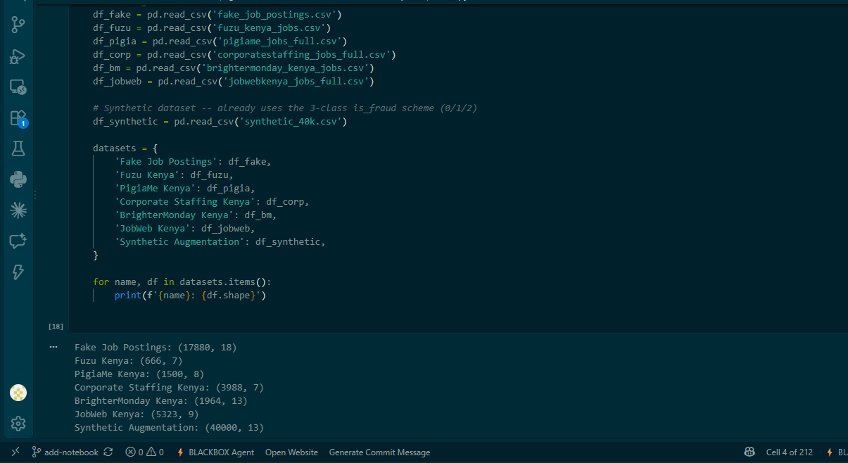
Figure 9 Loading of the datasets.

3.1.3 DATA CLEANING
The cleaning process standardizes the data before analysis. Missing categorical values are replaced with “Unknown”, missing text is replaced with an empty string, missing salary is recorded as “Not stated”, and rows without a usable job title are removed. Duplicate records are also checked before and after standardization.
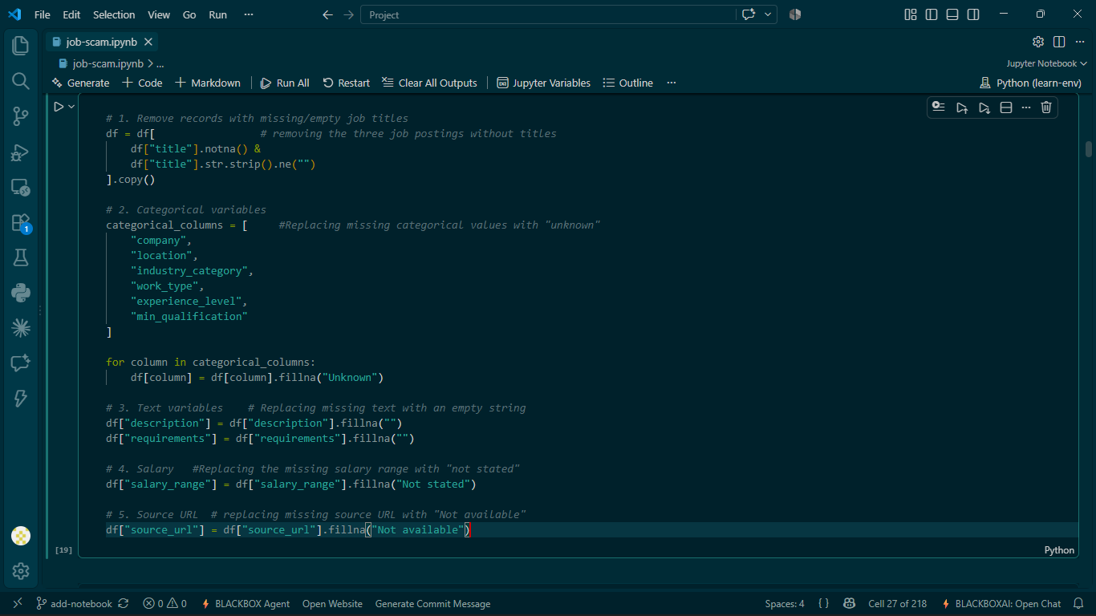
Figure 10 Data cleaning
- Records with missing or empty job titles are removed because the title is a key identifying field for a job posting.
- Two duplicate checks are performed at different stages. After standardization, 59 duplicate rows were identified in the prepared DataFrame and removed. Later, after merging the seven source datasets, the combined dataset contained 71,321 rows. An exact duplicate pass using title, company, location and description removed 1,019 records, leaving 70,302 integrated records for subsequent analysis and modelling.
- The cleaned data is then checked again for missing values, data types, and duplicate records.

3.1.4 COLUMN REMOVAL AND FORMAT STANDARDIZATION
Columns that are completely unavailable or not useful for the preparation workflow are removed rather than being filled with invented information. For example, the synthetic dataset contains a fully-null source_url column, which is dropped. Categorical values are also standardized so equivalent values use a consistent representation.
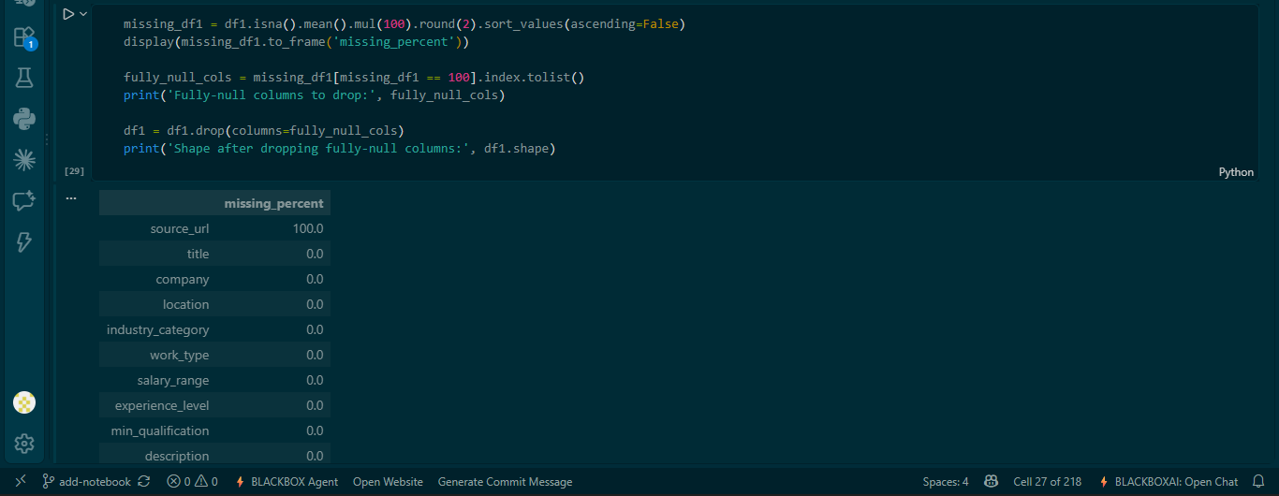
Figure 11 Column removal

3.1.5 LABEL PREPARATION
The project uses a three-class fraud label: 0 = Legitimate, 1 = Suspicious, and 2 = Fraudulent/Scam. Only records with known labels are used for supervised training. For the modelling task, the notebook also creates a binary target where Legitimate = 0 and Suspicious/Fraudulent = 1 (Fraud-risk). Unlabeled Kenyan job-board records remain separate rather than being assumed to be legitimate.
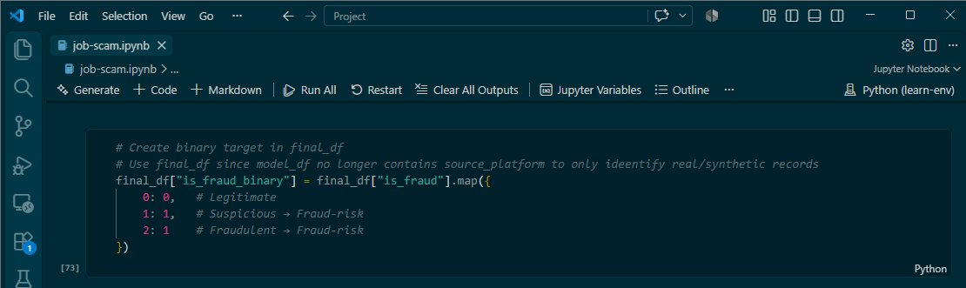
Figure 12 Label preparation

3.1.6 FEATURE ENGINEERING
Additional numerical features are created from each job posting to capture structural signals beyond the raw text. These include text lengths, word counts, URL/email/phone counts, uppercase-word counts, and indicators showing whether important fields such as company, salary, location, and requirements are missing.

Figure 13 Feature Engineering

3.1.7 TEXT TRANSFORMATION FOR MODELLING
The title, description, and requirements fields are combined into one text field. TF-IDF is then used to convert the job-posting text into numerical features using unigrams and bigrams, with a maximum vocabulary of 50,000 features. These text features are later combined with the structured numerical features for the hybrid model.
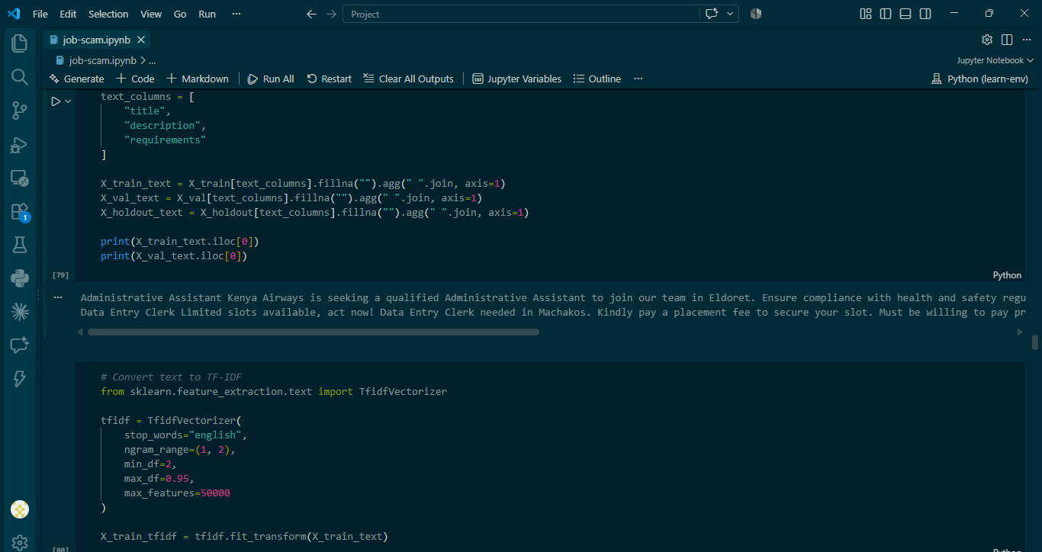
Figure 14 Text transformation.

3.1.8 EXPLORATORY DATA ANALYSIS
Before modelling, the notebook examines the prepared data to understand its structure and identify patterns that may be useful for fraud detection. The EDA includes univariate analysis such as work type and experience level distributions, as well as bivariate analysis such as average description length by fraud class. This is just but a couple of visuals that we were able to derive from the data and does not represent the whole EDA section.

WORK TYPE DISTRIBUTION
The bar graph below shows how the prepared job postings are distributed across different work types. Full-time and other categories make up a large share of the postings, while some records have missing or less common work-type information.

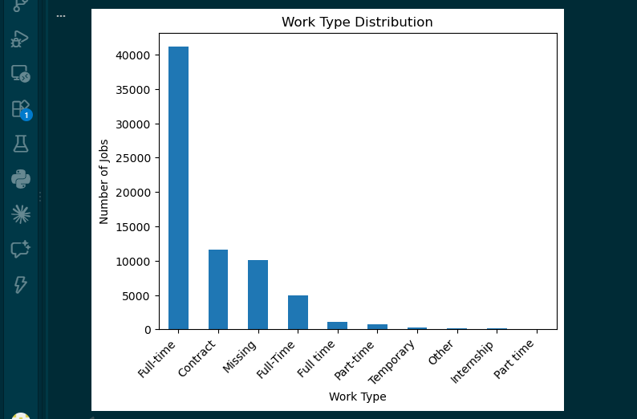
Figure 15 Work type distribution.

EXPERIENCE LEVEL DISTRIBUTION
The bar graph below shows the distribution of experience levels in the prepared dataset. It helps identify which levels are most common and highlights the variety of experience requirements represented in the job postings.

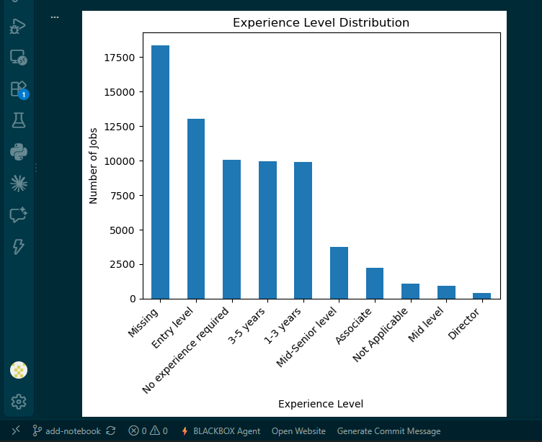
Figure 16 Experience level distribution.

AVERAGE DESCRIPTION LENGTH BY FRAUD
The bar graph compares average description length across the fraud classes. Legitimate postings have the longest average descriptions, while Suspicious and Fraudulent postings are shorter on average.
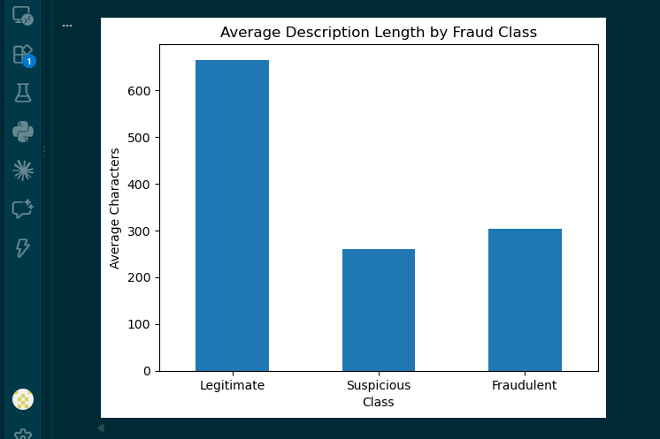
Figure 17 Average description length by fraud class

CHAPTER 4

4.1 MODELLING
The modelling stage uses the prepared job-posting data to train and compare machine-learning models that classify postings as Legitimate or Fraud-risk. The notebook first establishes a text-only baseline, then combines TF-IDF text features with structured features, tunes the strongest candidates, selects a classification threshold, and finally evaluates the chosen model on an untouched real-world holdout.

4.2 MODELLING APPROACH
The notebook follows a staged modelling approach rather than starting with a complex model immediately. This makes it possible to measure the contribution of structured features and then improve the strongest candidate through hyperparameter tuning.
- Baseline model: Logistic Regression using TF-IDF text features only.
- Second model: Hybrid Logistic Regression using TF-IDF plus structured numerical features.
- Third model: Hybrid LinearSVC using the same hybrid feature representation.
- Optimization: GridSearchCV is used to tune the strongest hybrid candidates.
- Final selection: Tuned Hybrid Logistic Regression is selected because it provides probabilities, competitive performance, and interpretable coefficients.

4.3 TARGET PREPARATION
For supervised modelling, the original three fraud classes are converted into a binary target. 0 represents Legitimate, while 1 represents Fraud-risk. The Suspicious (1) and Fraudulent/Scam (2) classes are combined into the Fraud-risk class.
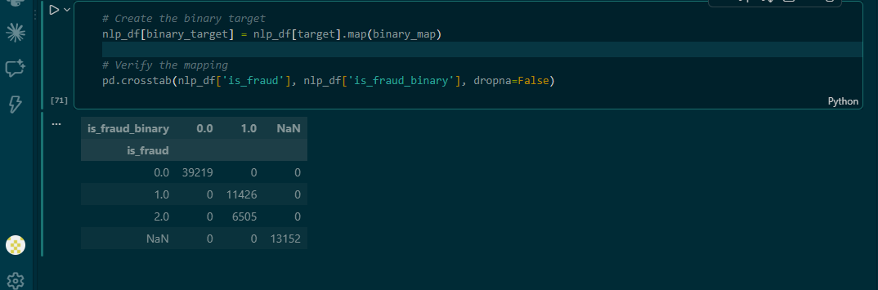
Figure 18 Target preparation

4.4 FIRST MODEL
The first model is a Logistic Regression classifier trained only on TF-IDF text features. It provides a simple and interpretable baseline for measuring how much fraud-risk information can be learned from the written job title, description, and requirements before adding structured features. Logistic Regression is also useful later because it produces class probabilities, which support risk ranking and threshold selection.
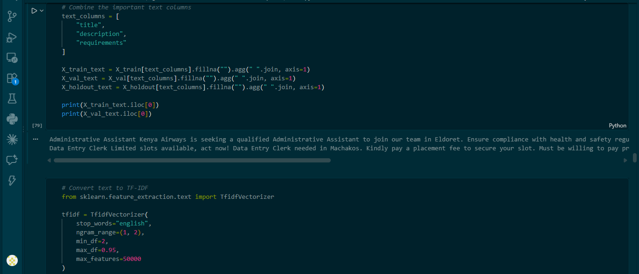
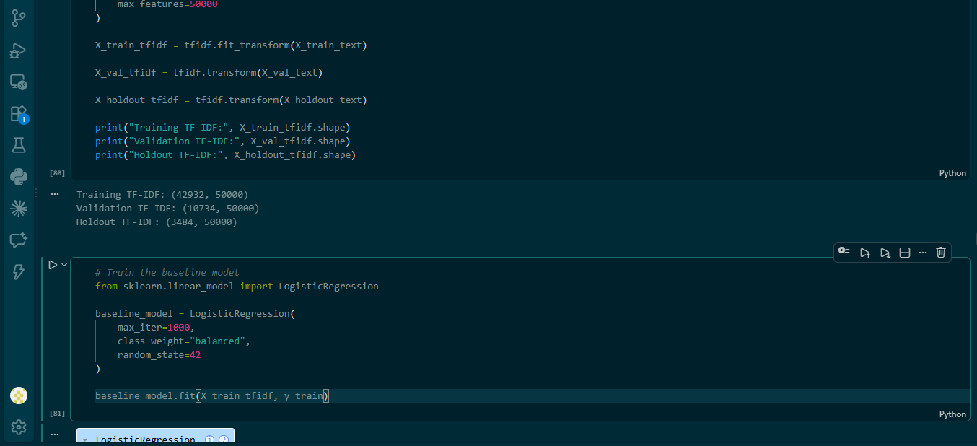
Figure 19 Logistic Regression Modelling
MODEL 1 EVALUATION METRICS: The notebook reports Accuracy, Precision, Recall, F1-score, ROC-AUC and PR-AUC. Because Fraud-risk is the less frequent class and missing a real scam is more costly than an occasional false alarm, particular attention is given to fraud-risk Recall and PR-AUC. PR-AUC is especially useful for judging performance on the less frequent positive class.
Metric | Interpreted Results
Precision | Shows how many jobs flagged as Fraud-risk were actually Fraud-risk.
Recall | Shows how many actual Fraud-risk jobs were successfully detected.
F1-score | Balances Precision and Recall in one measure.
ROC-AUC | Measures how well the model separates the two classes across thresholds.
PR-AUC | Focuses on the precision-recall trade-off for the fraud-risk class.
Accuracy | Overall proportion of correct predictions; used as a supplementary metric.

4.5 MODEL COMPARISON BETWEEN THE FIRST, SECOND AND THIRD MODEL:
The validation results show that the hybrid approaches are competitive with the text-only baseline. Hybrid LinearSVC gives the strongest validation F1 and recall, while Hybrid Logistic Regression is particularly strong on ROC-AUC and PR-AUC. The notebook therefore carries both hybrid candidates forward to tuning.

Model | Accuracy | Precision | Recall | F1 | ROC-AUC | PR-AUC
TF-IDF Logistic Regression | 0.9914 | 0.9988 | 0.9752 | 0.9869 | 0.9986 | 0.9979
Hybrid Logistic Regression | 0.9911 | 0.9929 | 0.9785 | 0.9857 | 0.9986 | 0.9981
Hybrid LinearSVC | 0.9947 | 0.9977 | 0.9852 | 0.9914 | 0.9983 | 0.9984

4.6 HYPERPARAMETER OPTIMIZATION
The two strongest hybrid candidates are tuned using GridSearchCV with 5-fold cross-validation. The C parameter is varied for each model, and Average Precision (PR-AUC) is used as the optimization score so that tuning is aligned with the project’s focus on the fraud-risk class.

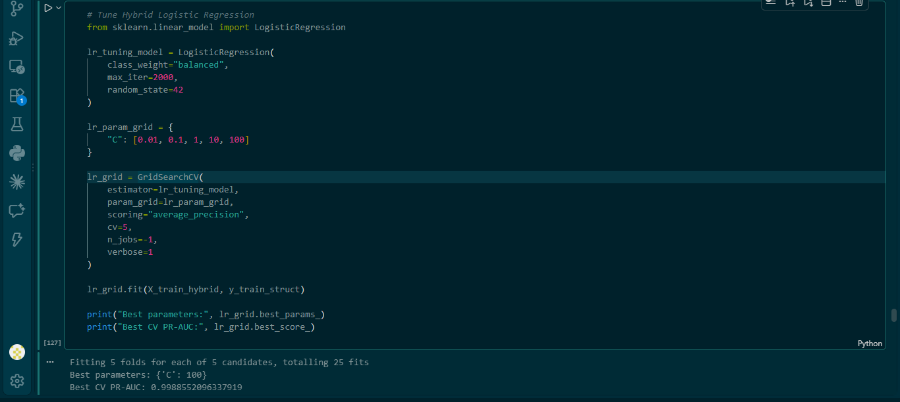
Figure 20 Hyperparameter optimization
Model | Search values for C | Best C | Best CV PR-AUC
Hybrid LinearSVC | 0.01, 0.1, 1, 10 | 1 | 0.9985
Hybrid Logistic Regression | 0.01, 0.1, 1, 10, 100 | 100 | 0.9989

4.7 PROBABILITY ANALYSIS AND THRESHOLD SELECTION
The tuned Logistic Regression model produces fraud-risk probabilities. Instead of automatically using the default 0.50 threshold, the notebook tests a range of thresholds and selects the threshold that gives the best validation F1.
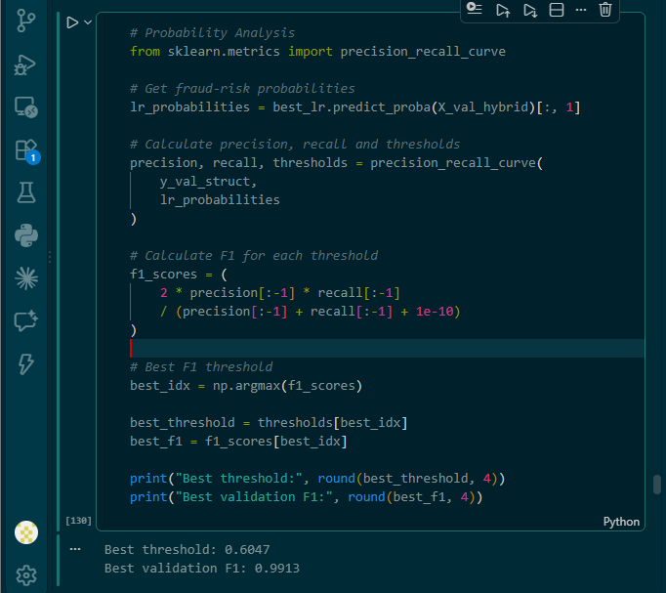
This gives the project a more suitable balance between catching fraud and limiting false alarms. The selected threshold is **0.6047**, producing a validation F1-score of **0.9913**. This threshold is chosen using validation data only; the real holdout remains untouched until final evaluation.
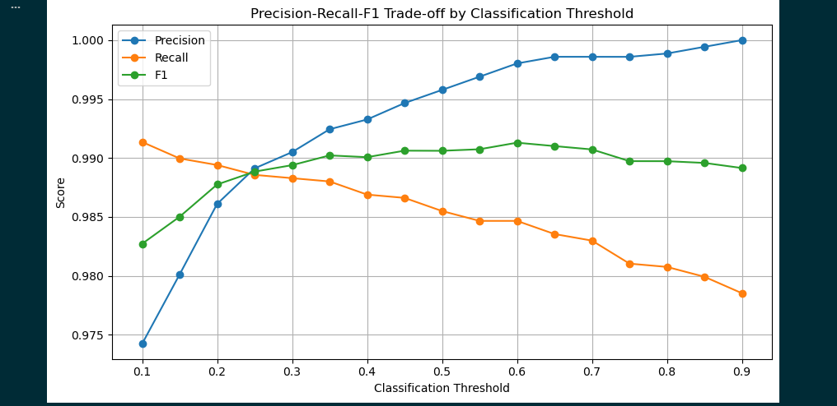
Figure 21 Classification threshold

4.8 FINAL MODEL SELECTION
The final candidates are the tuned Hybrid Logistic Regression and tuned Hybrid LinearSVC. LinearSVC has slightly higher validation F1 and Precision, but Logistic Regression has slightly higher ROC-AUC and PR-AUC and, importantly, provides calibrated probability estimates. The project needs probabilities for thresholding and ranking jobs by fraud risk. Logistic Regression also provides coefficients that can be inspected to explain which terms and structured signals push a prediction toward Fraud-risk.
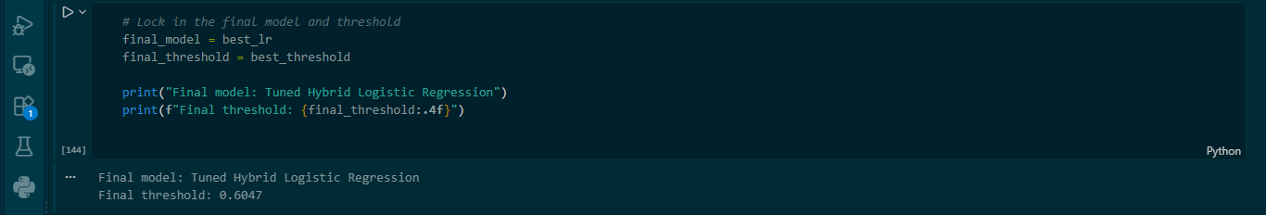
Figure 22 Final Model selection

4.9 MODEL INTERPRETABILITY
Because the selected model is linear, its coefficients can be mapped back to the TF-IDF vocabulary and structured features. Positive coefficients push a posting toward Fraud-risk, while negative coefficients push it toward Legitimate. However, the training data is synthetic-heavy, so some highly weighted terms can reflect synthetic generator templates rather than genuine scam language. These coefficients are dataset-specific associations and should support human review rather than be treated as universal scam rules.
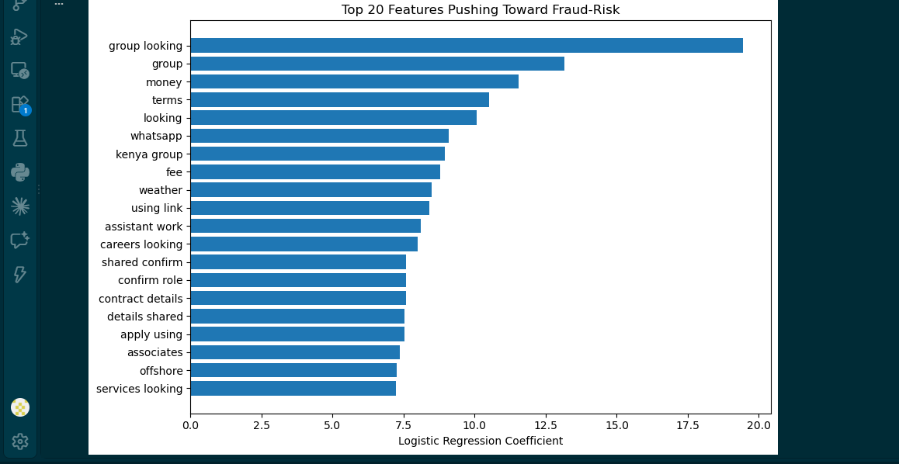
Figure 23 Model interpretability

4.10 FINAL EVALUATION
The final model is evaluated on the untouched real EMSCAD holdout. This is the most important evaluation in the notebook because the holdout was removed before model training and tuning. It therefore gives a better indication of real-world performance than the synthetic-heavy validation results.
Measure | Final real holdout result
Accuracy | ~0.99
Fraud-risk Precision | 0.99
Fraud-risk Recall | 0.92
Fraud-risk F1 | 0.96
ROC-AUC | 0.9947
PR-AUC | 0.9768
Confusion matrix | [[3313, 1], [13, 157]]
The confusion matrix shows 157 fraud-risk jobs correctly detected and 13 missed, while only 1 legitimate job was incorrectly flagged. This corresponds to 13 false negatives and 1 false positive on the 3,484-record real holdout.

Improvement from Baseline to Final Model
Model | Holdout ROC-AUC | Holdout PR-AUC
Baseline (TF-IDF only) | 0.9219 | 0.7034
Hybrid (untuned) | 0.9782 | 0.8396
Final (tuned, selected threshold) | 0.9947 | 0.9768
The holdout results show a clear improvement as the modelling pipeline becomes richer. Adding structured features substantially improves generalization beyond TF-IDF alone, and tuning plus threshold selection produces the strongest real-holdout performance.

CHAPTER 5

5.1 EVALUATION
The evaluation stage measures how well the trained fraud-detection models perform on data they have not used for fitting. The notebook evaluates accuracy, precision, recall, F1-score, ROC-AUC and PR-AUC, and gives particular attention to the fraud-risk class because missing a real scam is more costly than generating a false alarm.

5.1.1 EVALUATION METRICS
Metric | Meaning | Why it matters
Accuracy | Overall proportion of correct predictions. | Useful as a general summary, but not used alone because the classes are not perfectly balanced.
Precision | Of jobs predicted as Fraud-risk, the proportion that are actually Fraud-risk. | Shows how often a fraud warning is correct.
Recall | Of actual Fraud-risk jobs, the proportion detected by the model. | Important because missed scams are costly.
F1-score | Harmonic mean of precision and recall. | Balances false alarms and missed fraud.
ROC-AUC | Measures ranking performance across classification thresholds. | Higher values indicate better separation between Legitimate and Fraud-risk.
PR-AUC | Summarizes the precision-recall relationship across thresholds. | Especially useful when the fraud-risk class is less frequent.

5.1.2 VALIDATION EVALUATION

The validation set was used during model development to compare the baseline and hybrid approaches. The results show that all three models perform strongly, while the Hybrid LinearSVC has the highest validation recall and F1 among the untuned candidates.
Model | Accuracy | Precision | Recall | F1 | ROC-AUC | PR-AUC
TF-IDF Logistic Regression | 0.9914 | 0.9988 | 0.9752 | 0.9869 | 0.9986 | 0.9979
Hybrid Logistic Regression | 0.9911 | 0.9929 | 0.9785 | 0.9857 | 0.9986 | 0.9981
Hybrid LinearSVC | 0.9947 | 0.9977 | 0.9852 | 0.9914 | 0.9983 | 0.9984

5.1.3 THRESHOLD SELECTION
For the final Logistic Regression model, predictions were not fixed at the default 0.50 threshold. In the notebook, we examined precision, recall and F1 across several thresholds and selected the threshold that maximized validation F1. The selected threshold was 0.6047, with a validation F1-score of 0.9913. This threshold was then kept fixed for the final real-holdout evaluation.
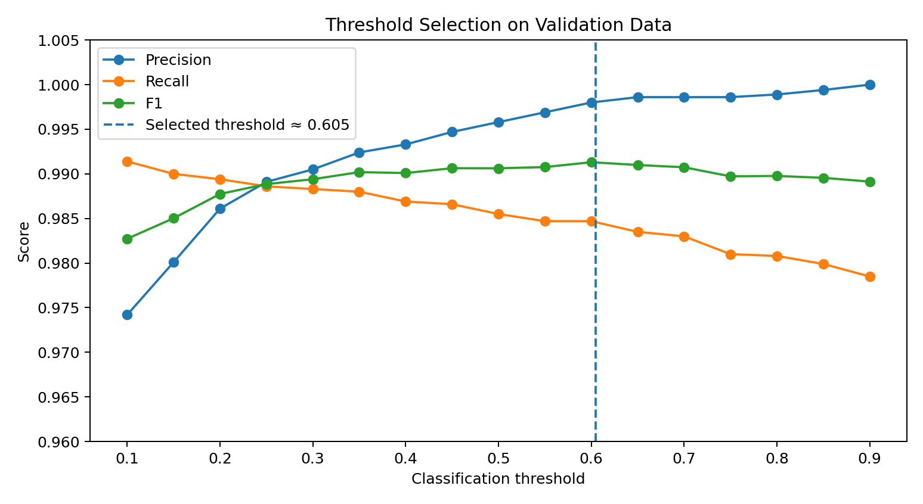

5.1.4 FINAL EVALUATION ON THE REAL HOLDOUT

The most important evaluation is the untouched real holdout. It contains 3,484 real labeled EMSCAD postings and was kept separate from training, validation, tuning and threshold selection. The final tuned Hybrid Logistic Regression was applied using the selected threshold of 0.6047. The notebook reports the following results:
Measure | Final real-holdout result
Accuracy | 1.00 (rounded in notebook; 3,470 / 3,484 correct)
Precision — Fraud-risk | 0.99
Recall — Fraud-risk | 0.92
F1 — Fraud-risk | 0.96
ROC-AUC | 0.9947
PR-AUC | 0.9768

5.1.5 AUC PERFORMANCE ACROSS MODELLING STAGE
We also compare ROC-AUC and PR-AUC on the real holdout as the modelling approach improves. Adding structured features produces a substantial improvement over TF-IDF alone, and tuning improves the final result further.
Model stage | Holdout ROC-AUC | Holdout PR-AUC
Baseline (TF-IDF only) | 0.9219 | 0.7034
Hybrid (untuned) | 0.9782 | 0.8396
Final (tuned, selected threshold) | 0.9947 | 0.9768

5.1.6 LIMITATIONS
• OCR is not currently supported, so image-only screenshots of job advertisements cannot be reliably analysed.
• The document input flow does not perform a strict document-type check, so a CV or other unrelated document may still receive a model result even though it is outside the intended job-posting use case.
• Some Kenyan job-board websites use anti-scraping measures that can block automated retrieval, limiting the amount of real local data that can be collected.
• The labelled training data is synthetic-heavy, while the scraped Kenyan job-board postings do not have ground-truth fraud labels. As a result, generalisation to independently confirmed Kenyan scam cases remains to be established.
• The deployed application does not yet require user authentication.

CHAPTER 6

6.1 DEPLOYMENT ARCHITECTURE
The system is deployed as three independently hosted components. This separation allows the interfaces to be updated without redeploying the prediction service, and allows the database to persist across application restarts.
Component | Platform | Purpose
PostgreSQL database | Render | Stores referred review cases and the audit trail
API service | Render | Hosts the assessment pipeline and review endpoints
Job seeker interface | Vercel | Public web interface for submitting listings
The API is the only component that communicates with the database. Both interfaces communicate exclusively with the API, which means the job seeker interface and the government dashboard read and write the same case records without any direct integration between them.

6.2 LIVE DEPLOYMENT
Component | URL
Job seeker interface | https://hakikihire.vercel.app
API service | https://hakiki-hire-government.onrender.com/
Interactive API documentation | https://job-scam-api-vbc3.onrender.com/docs

6.3 INFRASTRUCTURE CONFIGURATION
Infrastructure is defined declaratively in render.yaml at the repository root, which specifies the web service, the PostgreSQL instance, the Python runtime version, the build and start commands, and the reproduced from the repository rather than reconstructed from manual dashboard settings.
PostgreSQL was selected over SQLite for deployment because Render's filesystem is ephemeral. A file-based database would be discarded on every restart and every redeployment, taking all referred cases with it, and the government dashboard would show an empty queue after any deployment.

6.4 ENVIRONMENT CONFIGURATION
Variable | Component | Purpose
DATABASE_URL | API | PostgreSQL connection string, injected automatically
CORS_ORIGINS | API | Comma-separated list of permitted frontend origins
JWT_SECRET_KEY | API | Signing key for reviewer authentication tokens
VITE_API_URL | Job seeker interface | API base URL, inlined at build time
Cross-origin resource sharing is restricted to known frontend origins rather than permitting all origins, so the deployed API only accepts browser requests from the project's own interfaces.
Two adjustments were required for the hosted environment. Render supplies connection strings using the postgres:// scheme, which SQLAlchemy 2.0 no longer recognizes, so the configuration layer rewrites this to postgresql:// at load time. Permitted origins are read as comma-separated text rather than a JSON array, since deployment dashboards accept plain text more reliably.

6.5 DEPLOYMENT VERIFICATION
Following deployment, the pipeline was verified end to end against the hosted service. A listing naming a blacklisted recruitment agency and requesting an upfront mobile money payment returned a high-risk assessment with a blacklisted verification status, three supporting reasons, and a generated case identifier. The referred case was then retrieved through the case queue endpoint, confirming that the assessment pipeline, registry verification, and database persistence all function correctly in the hosted environment.

6.6 DEPLOYMENT CONSTRAINTS
The deployment uses free hosting tiers, which impose two limitations relevant to demonstration.The API service is suspended after fifteen minutes without traffic, and the first request following suspension takes approximately fifty seconds while the service restarts. Subsequent requests respond normally. The service should therefore be accessed shortly before any live demonstration.
The database instance is subject to a thirty-day retention limit under the free tier. This is acceptable for a capstone demonstration but would require a paid tier for any sustained operation.

References
Commission, F. T. (2024). New FTC Data Show a Big Jump in Reported Losses to Fraud to $12.5 Billion in 2024. Federal Trade Commission. From https://www.ftc.gov/news-events/news/press-releases/2025/03/new-ftc-data-show-big-jump-reported-losses-fraud-125-billion-2024?
DCI. (2025). FRAUDULENT RECRUITMENT DRIVE. Minisrry Of Interior and National Administration. Nairobi: DCI. From https://www.dci.go.ke/fraudulent-recruitment-drive-thwarted-arrest-suspects?
KNBS. (2018). CAUTION AGAINST FAKE JOB ADVERTISEMENT ON THE 2019 KENYA POPULATION AND HOUSING CENSUS. Nairobi: KNBS. From https://www.knbs.or.ke/caution-against-fake-job-advertisement-on-the-2019-kenya-population-and-housing-census/
KRA. (2026). Recruitment Fraud. Nairobi: KRA. From https://www.kra.go.ke/news-center/public-notices/586-recruitment-fraud?
NITA. (2026). NITA Disclaimer. Nairobi: National Industrial Training Authority. From https://nita.go.ke/media-centre/notices.html?

