Table of Contents
CHAPTER 1: 3
1.1 INTRODUCTION: BUSINESS UNDERSTANDING 3
1.2 PROBLEM STATEMENT: 3
1.2.1 BUSINESS OBJECTIVE 4
1.2.2 STAKEHOLDERS AND BENEFACTORS 4
1.2.3 METRICS OF SUCCESS 5
1.3 CURRENT RECRUITMENT AND FLOW AS IS: 5
1.4 PROPOSED SYSTEM ARCHITECTURE: 6

Figure 1 System Architecture 6
Figure 2 Job Seeker UI 7
Figure 3 Admin/ Government Dashboard 7

CHAPTER 1:

1.1 INTRODUCTION: BUSINESS UNDERSTANDING
The growth of employment opportunities advertised through online platforms has made it easier for Kenyans to search and apply for jobs. However, this has also created opportunities for fraudsters to advertise fake employment opportunities. The Kenya Revenue Authority (KRA) has warned the public about fraudulent recruitment messages that falsely claim to offer employment and may be used to obtain money or personal information from job seekers. KRA also emphasizes that it does not charge any fees during its recruitment process. This demonstrates the need for greater awareness and mechanisms for identifying potentially fraudulent job advertisements in Kenya. (KRA, 2026)
Fraudulent recruitment is also a documented problem investigated by Kenyan law-enforcement authorities. In January 2024, the Directorate of Criminal Investigations (DCI) reported the arrest of individuals involved in a fraudulent overseas recruitment drive in Nairobi. According to the DCI report, approximately 1,000 job seekers were affected by the recruitment exercise, which had been flagged as a scam by the National Employment Authority. The DCI even created a hash tag # FichuakwaDCI where they gave a number, call 0800 722 203 at no cost to report anonymously. Usiogope! ,which you can be able to reach them if you suspect that a particular job is a scam. These cases demonstrate the financial impact that fraudulent recruitment can have on Kenyan job seekers. (DCI, 2025)
Government institutions have also warned Kenyans about scammers impersonating legitimate organizations. The Kenya National Bureau of Statistics (KNBS), for example, has previously warned the public about fake job advertisements circulated through social media and advised applicants to verify recruitment information through its official platforms. NITA identifies warning signs such as requests for payment, the use of free email services, and recruitment conducted through unauthorized platforms such as WhatsApp. These warnings provide examples of characteristics that can potentially be considered when developing a system for detecting suspicious job advertisements.
Based on this business problem, the goal of the project is to develop a machine-learning system that can assist in identifying potentially fraudulent job advertisements in the Kenyan employment market. The system will analyse information contained in job postings, including the job title, description, company, location, salary, employment type, email address, URL and other relevant characteristics, to identify patterns associated with fraudulent postings. The intended outcome is to provide job seekers with an additional layer of protection by automatically screening job advertisements and identifying those that may require further verification. The system is intended to support, rather than replace, human verification and official recruitment channels. (NITA, 2026) (KNBS, 2018)

1.2 PROBLEM STATEMENT:
The increasing use of online platforms for recruitment has created greater access to employment opportunities, but it has also provided fraudsters with new ways of targeting job seekers through fake employment advertisements. In Kenya and even overseas for example, Data from the U.S. Federal Trade Commission (FTC) show that reported job and employment-agency scams increased substantially between 2020 and 2024, with reported losses rising from approximately $90 million to $501 million. The FTC has also identified the increasing use of online and text-based "task scams", in which individuals are offered fake employment opportunities and later asked to provide their own money. (Commission, 2024)
Despite warnings from authorities and existing methods of reporting fraudulent recruitment, job seekers still find it difficult to determine whether an online job advertisement is legitimate before interacting with the recruiter or providing personal information. Therefore, there is a need for an automated approach that can analyse job advertisements and identify characteristics associated with fraudulent postings. This project seeks to address this problem by developing a machine-learning model that can classify job advertisements as legitimate or potentially fraudulent, providing job seekers with an additional tool for identifying suspicious employment opportunities.

1.2.1 BUSINESS OBJECTIVE
- Build a classification model that predicts the probability that a given job posting is fraudulent, using the posting's text (title, description, requirements, benefits, company profile) and structured metadata (salary range, employment type, required experience/education, remote flag, presence of a company logo, screening questions).
- Apply NLP techniques (TF-IDF, word embeddings, and/or transformer-based sentence embeddings) to extract linguistic red flags associated with scams, such as urgency language, requests for upfront payment, vague job descriptions, and mismatched contact details.
- Extend the feature set with Kenya-specific red flags identified from local reporting — e.g. requests for visa/placement fees before travel, promises of overseas jobs outside Kenya's official bilateral labour agreement countries, and agencies that do not appear on the National Employment Authority's licensed-agency register or that match names on published delisted/blacklisted agency lists.
- Surface interpretable reasons behind each prediction (e.g. via feature importance, SHAP values, or rule-based flag extraction) so that the output is not just a score but an explanation a non-technical user can understand and act on.
- Evaluate and compare multiple modeling approaches (e.g. Logistic Regression, Gradient Boosting, and a fine-tuned/embedding-based NLP model) and select the one that best balances recall on the fraudulent class against false-positive rate.
- Package the model behind an interface (web app or API, with a low-bandwidth/USSD or WhatsApp-bot option considered for wider reach) that accepts a job posting and returns a scam-probability score and a list of contributing reasons.

1.2.2 STAKEHOLDERS AND BENEFACTORS
A working scam-detection system benefits several distinct groups, each with a different stake in the outcome:
- Kenyan job seekers — the primary beneficiaries, especially youth aged 18–34 who face the highest unemployment rates and are the most-targeted group for both local job scams and overseas trafficking recruitment; they gain an early warning before sharing personal data, paying a fee, or travelling.
- Local job boards and recruitment platforms (e.g. BrighterMonday, Fuzu, MyJobsInKenya) — which can integrate the model into posting-moderation pipelines to flag suspicious listings before publication, reducing platform liability and protecting user trust.
- Ministry of Labour and Social Protection / National Employment Authority — which currently deregisters fraudulent agencies reactively (680 delisted in November 2025 alone); an automated screening tool could help flag risky agencies and postings earlier and complement the existing licensed-agency register.
- Ministry of Foreign and Diaspora Affairs and Kenyan missions abroad — which handle rescue and repatriation of trafficking victims and issue public warnings about fraudulent overseas job schemes; early detection reduces the number of Kenyans who travel into trafficking situations in the first place.
- Directorate of Criminal Investigations (DCI) and the Multi-Agency Labour Mobility Taskforce — which can use aggregated red-flag data from the model to identify emerging scam patterns, prioritise investigations, and corroborate victim complaints.
- County governments and university/TVET career services — which can vet postings and recruitment drives shared with residents, students, and graduates before endorsing or forwarding them.
- Legitimate employers and recruitment agencies — whose brand and licenses are frequently impersonated by scammers; a detection system helps protect legitimate agency reputation and restores trust in the licensed recruitment sector.

1.2.3 METRICS OF SUCCESS
Because fraudulent postings are a small minority of all postings (typically under 5%), overall accuracy is a poor measure of success on its own. The project will instead prioritise:
- Recall on the fraudulent class — minimising the number of scam postings the model misses, since a missed scam carries a direct real-world cost to a user.
- Precision / false-positive rate — keeping the rate of legitimate postings incorrectly flagged low enough that the tool remains trustworthy and useful rather than a source of noise.
- F1-score and ROC-AUC — as balanced summary metrics given the class imbalance, used to compare candidate models.
Interpretability — qualitative review confirming that the top reasons surfaced for a handful of held-out predictions match human intuition about why a posting looks fraudulent or legitimate.

1.3 CURRENT RECRUITMENT AND FLOW AS IS:
Before proposing a solution, it is important to understand how the current system already works, since the government's existing process is more developed than it first appears — the gap is in connectivity and timing, not a complete absence of controls.
- Agency licensing: recruitment agencies must apply to the National Employment Authority (NEA) with business registration, tax compliance, police clearance for directors, and a KES 1.5 million security bond for overseas recruitment. Applications are vetted by an inter-ministerial committee that includes the National Intelligence Service, a process that can take 2–8 months; licenses are renewable annually.
- Two unequally regulated tracks: overseas placements are technically required to route through NEAIMS, with licensed agencies submitting job orders that NEA verifies. Local job postings have no licensing touchpoint at all — under Section 55 of the Labour Institutions Act, only businesses operating as employment agencies (third parties connecting job seekers to employers, or charging a placement fee) require a license. A company advertising its own vacancy directly is not “operating an employment agency” and falls entirely outside this requirement, which is precisely the loophole scammers exploit by posing as direct employers rather than agencies.
- Verification exists but is optional and disconnected: NEAIMS provides a public “Verify Employment Agency” lookup tool, and NEA advises job seekers to check it before applying. However, nothing on a job board, Facebook post, or WhatsApp message prompts or requires this check, so it depends entirely on the job seeker remembering to visit a separate government website.
- Enforcement is reactive and batch-based: victims must self-report to the DCI or the Ministry of Labour's complaint desks. Complaints accumulate case by case, and enforcement follows only once enough have built up — recent examples include 44 agencies summoned in July 2025, 25 blacklisted in October 2024, 32 named in May 2025, and roughly 680–700 licenses revoked in a November 2025 crackdown. Each action came after a wave of harm had already occurred, and the government has not published the full list of agencies delisted in the November 2025 crackdown.
In short: the government already licenses agencies and maintains a verification tool, but that information never travels with a posting once it reaches the channels where job seekers actually encounter it, and correction only happens after victims have already come forward in large enough numbers. The proposed system is designed to close that specific gap — moving verification earlier and making it automatic — rather than to replace NEA's authority or invent a new one.

1.4 PROPOSED SYSTEM ARCHITECTURE:

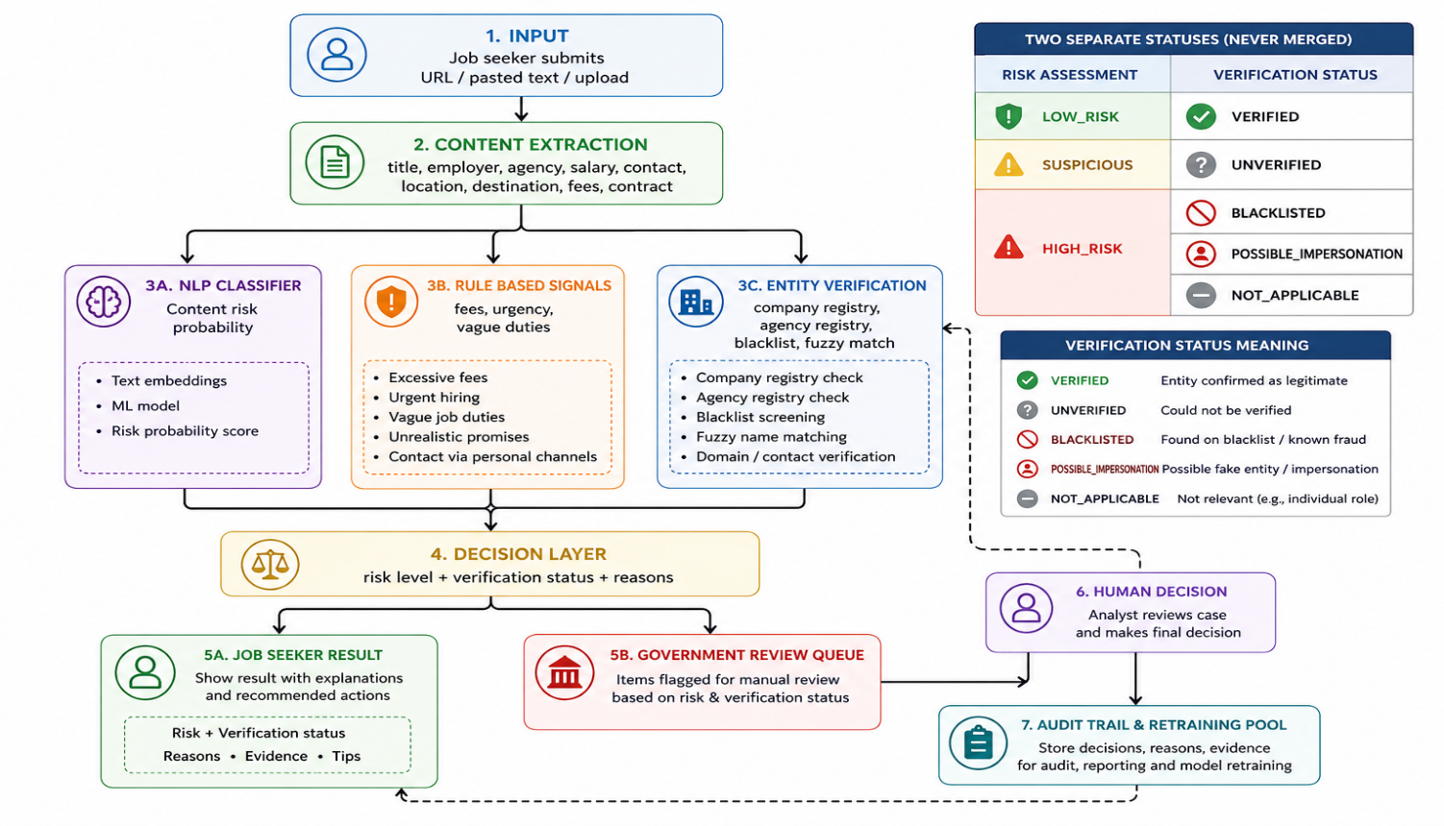
Figure 1 System Architecture
- The figure below shows the User Interface whereby the job seeker will be able to paste a job URL or a job description and the system will be able to scan through the job description and be able to know if the particular job is a scam or not, if it is flagged a scam, it will be pushed to the Government dashboard where an official will be able to do follow-up on the job. If the job is not a scam then the job seeker can be able to proceed to making an application.
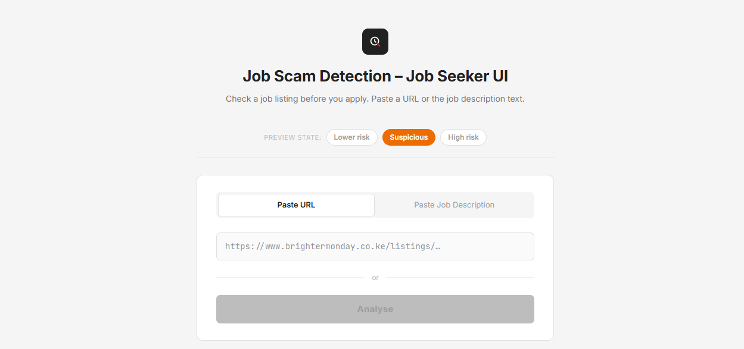
Figure 2 Job Seeker UI
- In the figure below, it shows where the Admin will be able to login, check the risk level of particular job postings, see which location the job posting is, verification status of the particular job and be able to do a follow-up on the jobs that are flagged high-risk
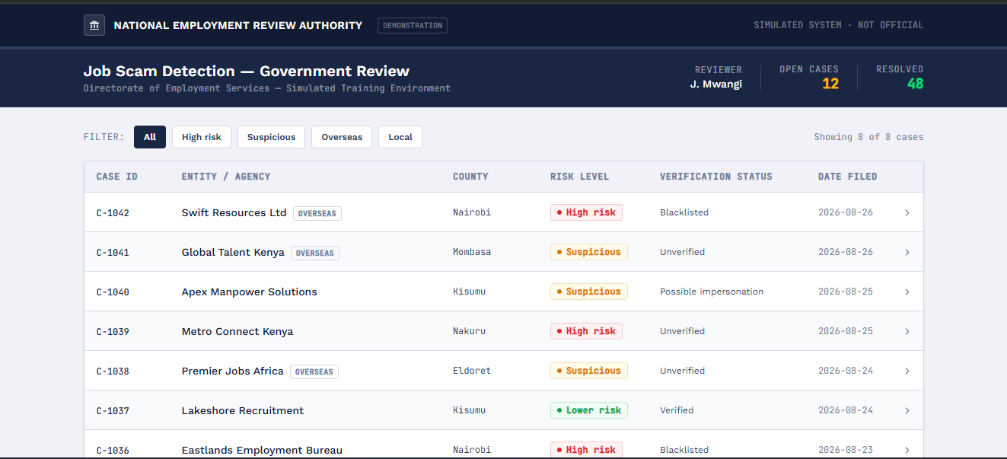
Figure 3 Admin/ Government Dashboard

CHAPTER 2:

2.1 DATA UNDERSTANDING:

References
Commission, F. T. (2024). New FTC Data Show a Big Jump in Reported Losses to Fraud to $12.5 Billion in 2024. Federal Trade Commission. From https://www.ftc.gov/news-events/news/press-releases/2025/03/new-ftc-data-show-big-jump-reported-losses-fraud-125-billion-2024?
DCI. (2025). FRAUDULENT RECRUITMENT DRIVE. Minisrry Of Interior and National Administration. Nairobi: DCI. From https://www.dci.go.ke/fraudulent-recruitment-drive-thwarted-arrest-suspects?
KNBS. (2018). CAUTION AGAINST FAKE JOB ADVERTISEMENT ON THE 2019 KENYA POPULATION AND HOUSING CENSUS. Nairobi: KNBS. From https://www.knbs.or.ke/caution-against-fake-job-advertisement-on-the-2019-kenya-population-and-housing-census/
KRA. (2026). Recruitment Fraud. Nairobi: KRA. From https://www.kra.go.ke/news-center/public-notices/586-recruitment-fraud?
NITA. (2026). NITA Disclaimer. Nairobi: National Industrial Training Authority. From https://nita.go.ke/media-centre/notices.html?

