csci3907-group2-project1

Matteo Sanchez-Dahl, Latifa Al Jlayel

2022-09-21

# R Markdown

This is an R Markdown document. Markdown is a simple formatting syntax for authoring HTML, PDF, and MS Word documents. For more details on using R Markdown see <http://rmarkdown.rstudio.com>.

When you click the **Knit** button a document will be generated that includes both content as well as the output of any embedded R code chunks within the document. You can embed an R code chunk like this:

## Including Plots

You can also embed plots, for example:

Note that the echo = FALSE parameter was added to the code chunk to prevent printing of the R code that generated the plot.

library(igraph)

##   
## Attaching package: 'igraph'

## The following objects are masked from 'package:stats':  
##   
## decompose, spectrum

## The following object is masked from 'package:base':  
##   
## union

library(sna)

## Loading required package: statnet.common

##   
## Attaching package: 'statnet.common'

## The following objects are masked from 'package:base':  
##   
## attr, order

## Loading required package: network

##   
## 'network' 1.17.2 (2022-05-20), part of the Statnet Project  
## * 'news(package="network")' for changes since last version  
## * 'citation("network")' for citation information  
## * 'https://statnet.org' for help, support, and other information

##   
## Attaching package: 'network'

## The following objects are masked from 'package:igraph':  
##   
## %c%, %s%, add.edges, add.vertices, delete.edges, delete.vertices,  
## get.edge.attribute, get.edges, get.vertex.attribute, is.bipartite,  
## is.directed, list.edge.attributes, list.vertex.attributes,  
## set.edge.attribute, set.vertex.attribute

## sna: Tools for Social Network Analysis  
## Version 2.7 created on 2022-05-09.  
## copyright (c) 2005, Carter T. Butts, University of California-Irvine  
## For citation information, type citation("sna").  
## Type help(package="sna") to get started.

##   
## Attaching package: 'sna'

## The following objects are masked from 'package:igraph':  
##   
## betweenness, bonpow, closeness, components, degree, dyad.census,  
## evcent, hierarchy, is.connected, neighborhood, triad.census

nodes <- as.matrix(read.table('data_subelj_jdk/ent_subelj_jdk_jdk_class_name.txt'))  
edges <- as.matrix(read.table('data_subelj_jdk/out_subelj_jdk_jdk.txt', sep = "", header = F, skip = 2))  
edges

## V1 V2  
## [1,] 1 2  
## [2,] 1 3  
## [3,] 1 4  
## [4,] 1 5  
## [5,] 1 5  
## [6,] 1 6  
## [7,] 1 4  
## [8,] 1 5  
## [9,] 1 4  
....

net <- graph_from_edgelist(edges, directed = TRUE)  
V(net)$name <- nodes  
net

## IGRAPH a8e5bbb DN-- 6434 150985 --   
## + attr: name (v/c)  
## + edges from a8e5bbb (vertex names):  
## [1] java.applet.Applet->java.awt.Panel   
## [2] java.applet.Applet->java.awt.Dimension  
## [3] java.applet.Applet->java.net.URL   
## [4] java.applet.Applet->java.lang.String   
## [5] java.applet.Applet->java.lang.String   
## [6] java.applet.Applet->java.util.Locale   
## [7] java.applet.Applet->java.net.URL   
## [8] java.applet.Applet->java.lang.String   
## + ... omitted several edges

histogram <- hist(igraph::degree(net))

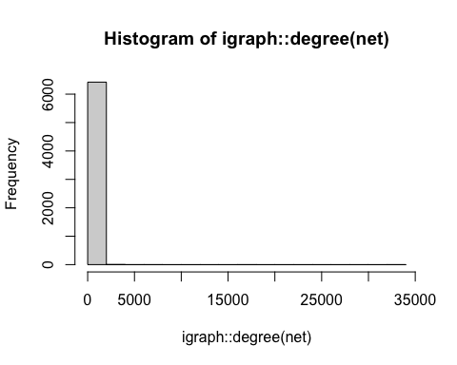

sg2000 <- induced_subgraph(net, igraph::V(net)[igraph::degree(net)>2000])  
plot(sg2000)

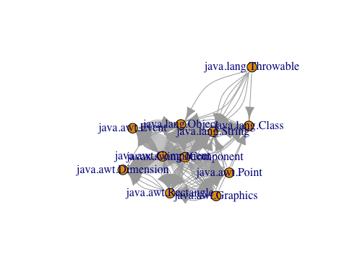

sgl2000 <- induced_subgraph(net, igraph::V(net)[igraph::degree(net)<2000])  
histogram <- hist(igraph::degree(sgl2000))

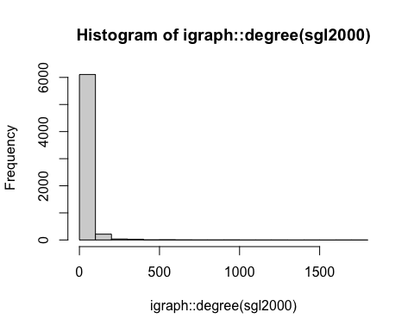

histogram <- hist(igraph::degree(net))



histogram <- hist(igraph::degree(net))



histogram <- hist(igraph::degree(net))



histogram <- hist(igraph::degree(net))

