**How to fold origami candy boxes**

This is a test

Have you ever annoyed that you don’t have candy boxes to pack the candies? Candies are easily melting in hot temperature. So it is not suitable to place them in the cabinet dispersedly. Maybe origami candy box can help.

How about folding origami candy box? Thus candy boxes can be had, which can be also as a home decoration. Shall we get down to folding?

**Materials acquired to fold origami candy boxes**

⚫ ⚫

Origami [paper](http://www.lovehobbycraft.com/b-402-paper-card.html) Scissors

**How to fold origami candy**

**boxes** ？

.

**Step 1: fold a pentacle shape**Fold the square paper to a pentacle shape. Note at the seventh step, a piece of scissors is needed to cut the extra part.

**Step 2: the ending work** Go on folding. Fold the upper five angles.

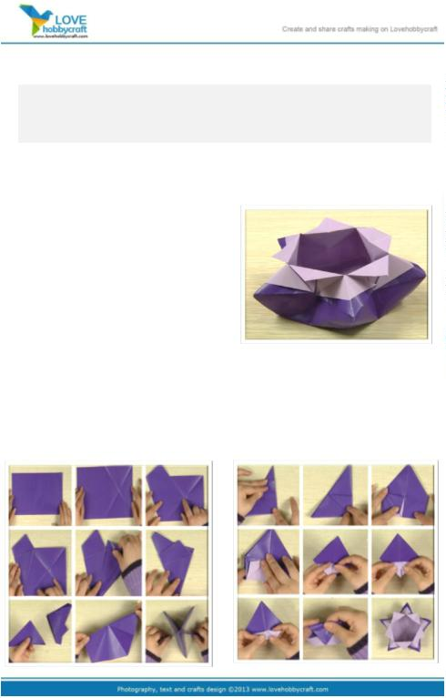

Then origami candy box is formed. Don’t you think candy boxes are practical and wonderful? Have

a try. And make a house to the candies.

Search the array of paper please click: <http://www.lovehobbycraft.com/>

