111111Title of the document
Subtitle #1
Text is normal, then bold, then italic, then underscore, and finally normal again. Now strikethrough, then double strikethrough, and underscore differently - with dashes. Another underscore is marked with yellow wave line. And then – underscore and strikethrough together! Here we have a superscript123 and a subscript456. This part of text has a red background. These words are shadowed to right side, these – shadowed (red) to top side, and these – reflected to bottom side. These two words are outlined with red solid line, and these two words – with solid dashed blue line. By the way, this entire paragraph is left-aligned.
This text is usual, but written with Arial font. This sentence is normal (Calibri), but font is drawn with red color. And now we have a green text. By the way, this entire paragraph is right-aligned.
Table name 1
Cell 1,1 (italic) | Cell 1,2 (left) | Cell 1,3 (right) | Cell 1,4 (center)
Cell 2,1 (bold) |  | Two vertical cells are merged together | Cell 2,4 (justify)
Cell 3,1 | Cell 3,2 | Two vertical cells are merged together | Cell 3,4
Two horizontal cells are merged together |  | Cell 4,3 | Cell 4,4
Cell 5,1 | Merged 3 horizontal and 3 vertical cells (align – bottom right)
Cell 6,1
Cell 7,1
Cell 8,1 | Cell 8,2 | Cell 8,3 | Cell 8,4
78 MiB? Not a little. This sentence has a 12pt font size. It has a superscript and a subscript. Again 11pt font size. I decided not to install MSI-pack. Why I must do it, when I can use 7zip, for example, to open it? When I had opened it, I saw, why installer is so big — it is because it contains compiled versions of one library for different versions of .NET Framework. Interesting approach. By the way, this entire paragraph is center-aligned. Hyperlink to the anchor blow.
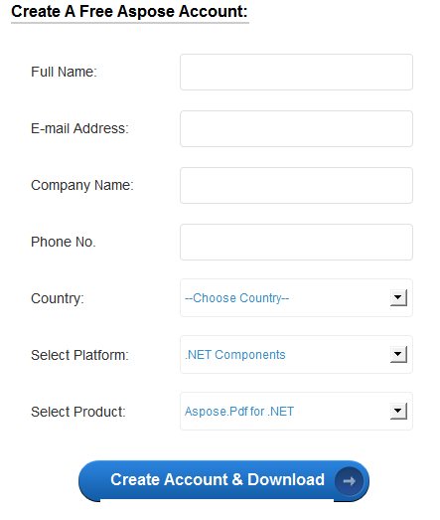
After googling for a several seconds I've found Aspose.PDF for .NET on Softpedia website: http://www.softpedia.com/get/Office-tools/PDF/AsposePdf.shtml
Кол-во бит | Знаковое | Беззнаковое
8 | SInt1 [-127 ; 127] | UInt1 [0; 254]
16 | SInt2 [-32767; 32767] | UInt2 [0; 65534]
32 | SInt4 [-2147483647; 2147483647] | UInt4 [0; 4294967294]
64 | SInt8 [-9223372036854775807; 9223372036854775807] | UInt8 [0; 18446744073709551614]
128 | SInt16 [?; ?] | UInt16 [0; ?]
Figure 1
under the table
another paragraph.
Subtitle #2
Small table |  |  | Vertical text | Vertical text from top to bottom
 | Shifted to right |  | Vertical text | Vertical text from top to bottom
One of the most rapidly growing features in the GroupDocs.Viewer for .NET is a watermark support. With this feature you can place any text over the document and specify a set of parameters which are discussed below. Watermarking allows you to add text to the document; this text will be placed over the document, overlapping the document content. By the way, this entire paragraph is justified. It has 1.5x inter-string multiplier.
Because of its intrinsic nature GroupDocs.Conversion can be used in any .NET application: desktop-based like console applications, WinForms, WPF, Windows services and web-based like ASP.NET, including WebForms and MVC. First string in this paragraph has indent. Line-spacing is single. Paragraph has a green background. This sentence is formatted as small-caps. And this is formatted as all-caps. The entire paragraph is justified.
This paragraph is left-aligned. This sentence is bounded by borders from all four sides, and this word has a yellow background. Its first line also has an indent with custom length, which is equal to 2.5 units (according to the ruler). This part of the sentence has increased letter spacing, and this – decreased. This part of the sentence is shifted to the top, and this – to the bottom. Here are: hyphen (-), medium dash (–), long dash (—). This sentence is underlined – all its words are underlined with solid blue lines, but spaces between words – not. This sentence is also underlined, but completely and with default (black) dashed line. In this sentence kerning is enabled. Scale of this sentence is 66%. And this one has 150%. Here is an anchor. Finally, there is a bottom horizontal line, which was formed by applying four subsequent “-” characters, below this paragraph.
Lists are below:
- Item #1.
  - Sub item #1-1.
  - Sub item #1-2.
    - Sub sub item #1-2-1.
    - Sub sub item #1-2-2.
  - Sub item #1-3.
- Item #2.
- Item #3.
  - Sub item #3-1 unordered.
    - Sub sub item #3-1-1 unordered
  - Sub item #3-2 unordered.
- Item #4.
  - Sub item #4-1 unordered.
  - Sub item #4-1 unordered.
- Item #5.
the end of lists.

Subtitle #3 – equations

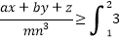
Some text after the formula with custom alignment
Symbols: j€£¥©®™≥≤÷×±≠∞Ωπµ
Another formula, but at this time it is right-aligned.

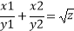
Subtitle #4 – developer tools

Checkboxes. Unchecked: ☐; checked: ☒.
Date selector: 09.12.2016
Formatted text box:
Standard text box:
Drop down list: Item 2
Combo box: Item1
Date and time: 12/6/2016 1:59 PM
Introduction
GroupDocs.Viewer is a web-oriented middleware designed to allow end-users to view different types of documents, such as PDF, DOC/DOCX, XLS/XLSX and so on right from their web-browsers, without need of installing any other software or browser plugins (such as Adobe Flash, Silverlight or Java applets). GroupDocs.Viewer, which is located and runs on the server-side, just transforms an input document to a set of images, HTML markup, CSS, JS and SVG, and then sends all these data to the client-side. Kentico is a pretty mature and advanced CMS, and is deeply focused on the document management. So it will be very interesting and useful to integrate the ability of viewing different documents into Kentico. Right now GroupDocs.Viewer exists in different forms: it is available as a .NET class library (DLL), Java library (JAR) and as a Cloud API (SaaS). Because Kentico is an ASP.NET project in its core, we will use GroupDocs.Viewer for .NET library. Because Kentico CMS basically is an ASP.NET WebForms project, we will use a GroupDocs.Viewer for .NET library. The big part of all features of the Kentico is located in the web parts. In terms of Kentico, web part is a component of the page with its own functionality. This conception is very similar to the ASP.NET web user controls (ASCX).

Standard footnote on page #1.
First standard footnote on page #2.
Second standard footnote on page #2.
Standard footnote on page #3.
First end footnote on page #1.
Second end footnote on page #1.
First end footnote on page #2.
Second end footnote on page #2.
First end footnote on page #3.

