Created with evaluation version of GroupDocs.Editor � Aspose Pty Ltd 2001-2024. All Rights Reserved.

Title of the document

Subtitle #1
Text is normal, then bold, then italic, then underscore, and finally normal again. Now strikethrough, then double strikethrough, and underscore differently - with dashes. Another underscore is marked with yellow wave line. And then – underscore and strikethrough together! Here we have a superscript123 and a subscript456. This part of text has a red background. These words are shadowed to right side, these – shadowed (red) to top side, and these – reflected to bottom side. These two words are outlined with red solid line, and these two words – with solid dashed blue line. These words have a gradient — from left top to right bottom. By the way, this entire paragraph is left-aligned.
This text is usual, but written with Arial font. This sentence is normal (Calibri), but font is drawn with red color. And now we have a green text. By the way, this entire paragraph is right-aligned.
Table name 1
Cell 1,1 (italic) | Cell 1,2 (left) | Cell 1,3 (right) | Cell 1,4 (center)
Cell 2,1 (bold) |  | Two vertical cells are merged together | Cell 2,4 (justify)
Cell 3,1 | Cell 3,2 | Two vertical cells are merged together | Cell 3,4
Two horizontal cells are merged together |  | Cell 4,3 | Cell 4,4
Cell 5,1 | Merged 3 horizontal and 3 vertical cells (align – bottom right)
Cell 6,1
Cell 7,1
Cell 8,1 | Cell 8,2 | Cell 8,3 | Cell 8,4
78 MiB? Not a little. This sentence has a 12pt font size. It has a superscript and a subscript. Again 11pt font size. I decided not to install MSI-pack. Why I must do it, when I can use 7zip, for example, to open it? When I had opened it, I saw, why installer is so big — it is because it contains compiled versions of one library for different versions of .NET Framework. Interesting approach. By the way, this entire paragraph is center-aligned. Hyperlink to the anchor blow.
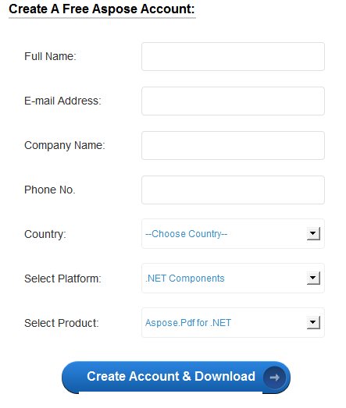
After googling for a several seconds I've found Aspose.PDF for .NET on Softpedia website: http://www.softpedia.com/get/Office-tools/PDF/AsposePdf.shtml
This text is usual, but “all caps” modifier is applied.
Кол-во бит | Знаковое | Беззнаковое
8 | SInt1 [-127 ; 127] | UInt1 [0; 254]
16 | SInt2 [-32767; 32767] | UInt2 [0; 65534]
32 | SInt4 [-2147483647; 2147483647] | UInt4 [0; 4294967294]
64 | SInt8 [-9223372036854775807; 9223372036854775807] | UInt8 [0; 18446744073709551614]
128 | SInt16 [?; ?] | UInt16 [0; ?]
Figure 1
under the table
another paragraph.

Subtitle #2
One of the most rapidly growing features in the GroupDocs.Viewer for .NET is a watermark support. With this feature you can place any text over the document and specify a set of parameters which are discussed below. Watermarking allows you to add text to the document; this text will be placed over the document, overlapping the document content. By the way, this entire paragraph is justified. It has 1.5x inter-string multiplier.
Small table |  |  | Vertical text | Vertical text from top to bottom
 | Shifted to right |  | Vertical text | Vertical text from top to bottom

Standard footnote on page #1.
See https://www.techrepublic.com/blog/microsoft-office/highlight-text-with-the-gradient-fill-effect-in-word/
First standard footnote on page #2.
Second standard footnote on page #2.
First end footnote on page #1.
Second end footnote on page #1.
First end footnote on page #2.
Second end footnote on page #2.

