Tests with embedding and images

There is an embedded diagram (circle chart) below this passage.

And there is an image below this paragraph, which is manually decreased and rotated right on 90 degrees.

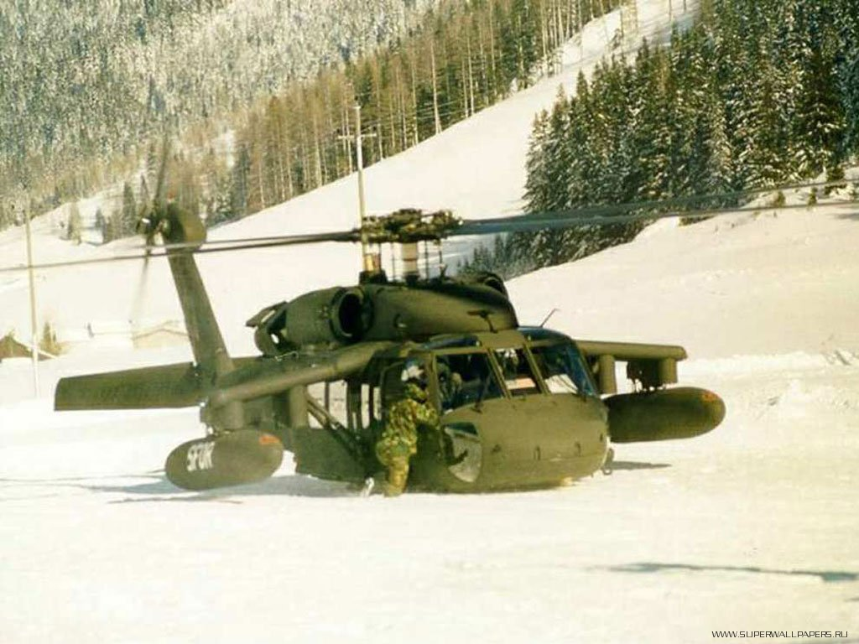

Smart art object is below this passage.

There is another image below this paragraph. It has a border with custom orange color and it has a mirror transform from left to right.

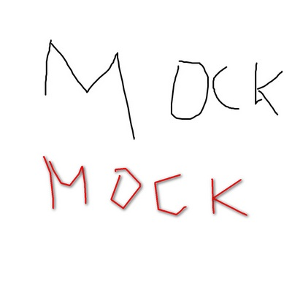

One more image is below. It is distorted – its height is decreased, while width is increased.

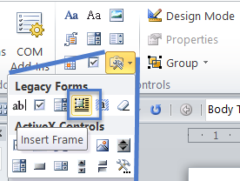

Here is some paragraph, because I want separate work with images (which is above) from the next part, which is below. And here we have a label.

[Введите цитату из документа или краткое описание интересного события. Надпись можно поместить в любое место документа. Для изменения форматирования надписи, содержащей броские цитаты, используйте вкладку "Средства рисования".]