

Meridian Outdoor Co. — Business Plan

FY2026 Strategic Plan

Table of Contents
Meridian Outdoor Co. — Business Plan 1
FY2026 Strategic Plan 1
Table of Contents 2
1. Executive Summary 3
2. Company Overview 3
2.1 Mission 3
2.2 History 3
3. Products & Services 3
3.1 Product Categories 3
4. Market Analysis 4
4.1 Target Market 4
4.2 Competitive Landscape 4
5. Financial Projections 4
6. Team 5
7. Appendix 5

1. Executive Summary
Meridian Outdoor Co. is a direct-to-consumer outdoor apparel and gear brand serving thru-hikers, backcountry travelers, and weekend adventurers. This plan outlines our strategy for fiscal year 2026, a year in which we expect to grow revenue by forty percent, expand into three new retail categories, and launch our sustainability certification program.
Our competitive advantage rests on three pillars: field-tested product design, a vertically integrated supply chain, and a community-first marketing model that reduces customer acquisition costs by thirty-eight percent compared to industry benchmarks. The combination gives us room to invest in durability and repairability without sacrificing margin.
Key highlights:
- Projected FY2026 revenue of $12.2M, up from $8.7M in FY2025.
- Launch of the Trailhead Pro apparel line in Q2 2026.
- Expansion into two new international markets: Canada and the United Kingdom.
- Sustainability certification for eighty percent of the product catalog.

2. Company Overview

2.1 Mission
To build outdoor gear our customers trust on the hardest miles of the trail — gear that lasts, repairs cleanly, and returns to the earth at the end of its life.

2.2 History
- 2018 — Company founded in Bend, Oregon by two former REI product designers.
- 2019 — First product line ships: the Meridian Pack 40L backpack.
- 2021 — $2M seed round closed; warehouse operations moved in-house.
- 2023 — Crossed $5M in annual revenue; launched the field-repair program.
- 2025 — Opened flagship retail store in Portland; began sustainability audit.

3. Products & Services

3.1 Product Categories
Our FY2026 catalog spans backpacks, footwear, apparel, outerwear, and cooking gear. The table below summarizes our flagship SKUs for the coming year.
SKU | Product | Category | MSRP
MP-040 | Meridian Pack 40L | Backpack | $189.00
MP-065 | Meridian Pack 65L | Backpack | $249.00
TB-010 | Trailhead Boot | Footwear | $219.00
CP-002 | Canyon Pant | Apparel | $129.00
SS-001 | Summit Shell | Outerwear | $299.00
CK-003 | Coalfire Kit | Cooking | $69.00

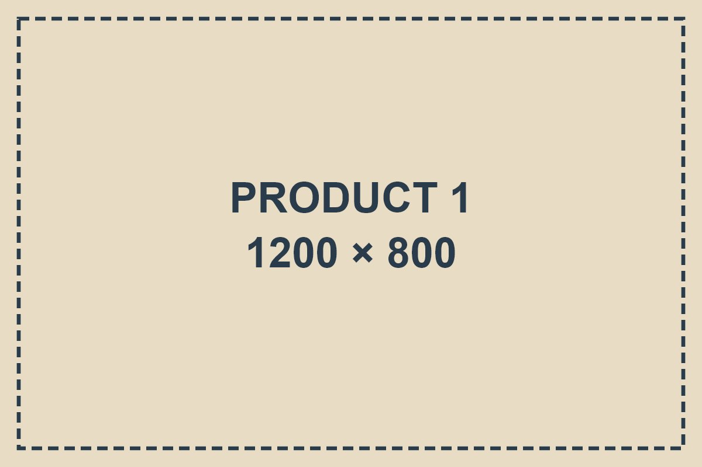

4. Market Analysis

4.1 Target Market
We serve three customer segments, each with distinct purchase patterns and price sensitivities.
- Thru-hikers — multi-week backpackers who prioritise weight, repairability, and durability over brand recognition.
- Weekend adventurers — families and young professionals who hike two to five trips per year and value comfort and convenience.
- Technical guides — industry professionals who require gear that can be serviced in the field and carry a reputation built on long-term reliability.

4.2 Competitive Landscape
The outdoor gear market is crowded but fragmented. Our three primary competitors each hold a narrow positioning that leaves room for a brand optimizing for durability across price tiers.
Competitor | Positioning | Weakness
Alpinista | Premium technical gear | High price point, limited catalog
Basecamp Co. | Mass-market durability | Inconsistent quality control
Ridgeline | Ultralight specialists | Narrow product mix; no apparel

5. Financial Projections
The following four-year projection assumes the launch of Trailhead Pro in Q2 2026 and the opening of two international markets in Q4 2026. Gross margin expansion reflects supplier consolidation and a shift toward in-house manufacturing for core SKUs.
Metric | FY2024 | FY2025 | FY2026 | FY2027
Revenue | $6.0M | $8.7M | $12.2M | $16.8M
Gross margin | 52% | 55% | 57% | 58%
Op. income | $0.6M | $1.2M | $2.1M | $3.4M
Employees | 24 | 38 | 54 | 72

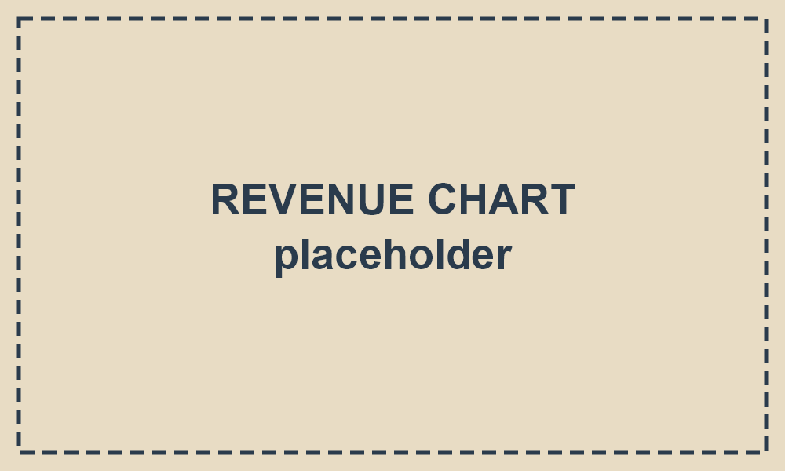

6. Team
Our leadership team combines outdoor industry experience with operational and financial discipline.
- Elena Márquez — Chief Executive Officer
- Jonas Park — Chief Financial Officer
- Priya Raman — Head of Product
- Tomás Ortega — Director of Operations
- Siri Nakamura — Head of Sustainability

7. Appendix
Supporting materials are available at the following locations:
Sustainability whitepaper
Supply chain audit (2025)
Product catalog (PDF)

