GroupDocs.Redaction for .NET

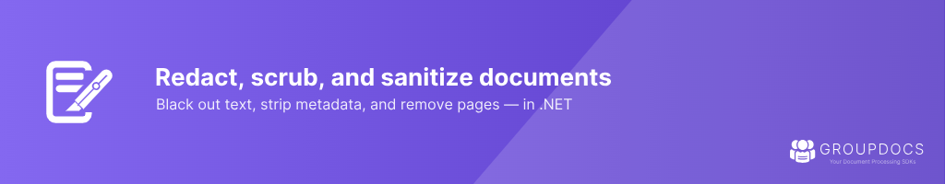

GroupDocs.Redaction for .NET is a powerful API designed to redact classified or sensitive data from a variety of document types within your .NET applications. It supports multiple redaction types including text, metadata, annotations, and image redactions. The API also integrates with OCR engines for redacting text within images and provides the ability to remove pages and embedded images, ensuring the comprehensive redaction of confidential information. GroupDocs.Redaction is highly versatile, supporting a wide range of document formats, making it an essential tool for any organization dealing with sensitive information.

Text Redactions

Exact Phrase Redaction
Search and redact specific phrases or text strings with case-sensitivity options.

Regex Redaction
Redact text based on regular expressions for flexible text matching.

Right-to-Left Support
Redaction of right-to-left text such as Arabic and Hebrew.

Page 1
Image Redactions



Image Area Redaction
Cover specific areas of images, such as headers or footers, with a colored box.

Embedded Image Redaction
Redact embedded images in documents, including PDF, Microsoft Office, and OpenOffice files.

EXIF Data Removal
Remove metadata (e.g., EXIF data) from images, acting as an "EXIF eraser."

Page 2
Annotation Redactions

Delete Annotations
Remove annotations, comments, and other markup from documents.

Redact Annotation Text
Redact sensitive data in annotations while keeping the annotations intact.

Metadata Redactions

Erase Metadata
Remove all metadata from a document, such as author, date created, and comments.

Metadata Search Redaction
Remove sensitive information from metadata fields using regular expressions.

Page Redactions

Remove Pages
Remove specific pages from documents such as PDFs, slideshows, or spreadsheets.
Page Area Filters
Apply redactions to specific areas on a page using coordinates.

Page 3
Rasterization

Convert to Raster Images
Redact sensitive data and save documents as raster images, making all data unsearchable.

Document Saving Options
Save redacted documents in either original format for further editing or in raster format for increased security.

File and Document Information

Document Info Retrieval
Retrieve metadata and page counts for any document format.

Page 4

