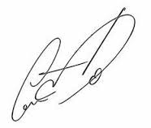GroupDocs
John Walkman
Jane Doe
Signature
Professional tools for professionals

