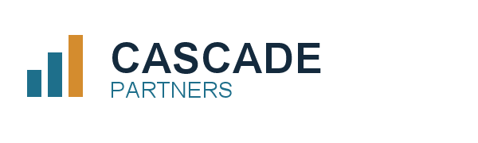

Statement of Work

Appendix A to the Aldergrove Manufacturing agreement
This statement of work expands the workstreams named in the agreement into concrete activities, owners and outputs. It is intended to be bound to the agreement as an appendix.

A.1 Discovery
Interview process owners across order intake, fulfilment and invoicing. Walk each step, record handoffs, and capture the systems of record involved.
- Twelve semi-structured interviews, sixty minutes each
- A process map per workstream, validated with the owner
- A register of handoffs, wait states and rework loops

A.2 Analysis
Model throughput against the constraint register and quantify the cost of each wait state. Options are appraised on effort, risk and expected recovery.

A.3 Roadmap
Sequence the remediations into waves that can be delivered without pausing operations, with effort estimates and a recommended owner for each.

A.4 Deliverables
Output | Format | Wave
Process maps | PDF | 1
Constraint register | XLSX | 1
Options appraisal | DOCX | 2
Remediation roadmap | PDF | 3

