Dashboards often provide at-a-glance views of KPIs (key performance indicators) relevant to a particular objective or business process. In the other, "dashboard" has another name for "progress report" or "report."

The "dashboard" is often displayed on a web page which is linked to a database that allows the report to be constantly updated. For example, a manufacturing dashboard may show numbers related to productivity such as number of parts manufactured, or number of failed quality inspections per hour. Similarly, a human resources dashboard may show numbers related to staff recruitment, retention and composition, for example number of open positions, or average days or cost per recruitment

Dashboard is Business Intelligence system where all the organizational digital data clubs in such a manner where company top management can understand and overlook all the activities in real-time (if integrated).

Dashboard is now playing key role in almost in every sector’s growth and in the modern working style it is the most important tool. There are many type of dashboard available like:

1. Activity Dashboard
2. Modular Dashboard
3. Executive Dashboard
4. Graphical Dashboard

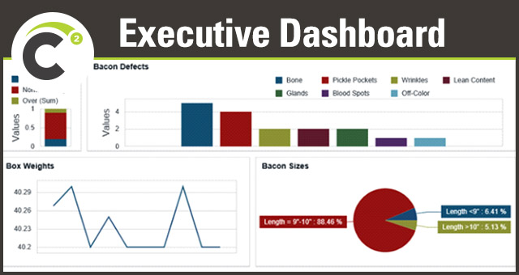

All type of Dashboards is kind of summarized reports for different type of positions.

Activity dashboards shows data for different data entries report to a supervisor or manager where he/she can views what is happening and where the issue is and who is responsible.