Dashboards often provide at-a-glance views of KPIs (key performance indicators) relevant to a particular objective or business process. In the other, "dashboard" has another name for "progress report" or "report."

The "dashboard" is often displayed on a web page which is linked to a database that allows the report to be constantly updated. For example, a manufacturing dashboard may show numbers related to productivity such as number of parts manufactured, or number of failed quality inspections per hour. Similarly, a human resources dashboard may show numbers related to staff recruitment, retention and composition, for example number of open positions, or average days or cost per recruitment

Dashboard is Business Intelligence system where all the organizational digital data clubs in such a manner where company top management can understand and overlook all the activities in real-time (if integrated).

Dashboard is now playing key role in almost in every sector’s growth and in the modern working style it is the most important tool. There are many type of dashboard available like:

1. Activity Dashboard
2. Modular Dashboard
3. Executive Dashboard
4. Graphical Dashboard

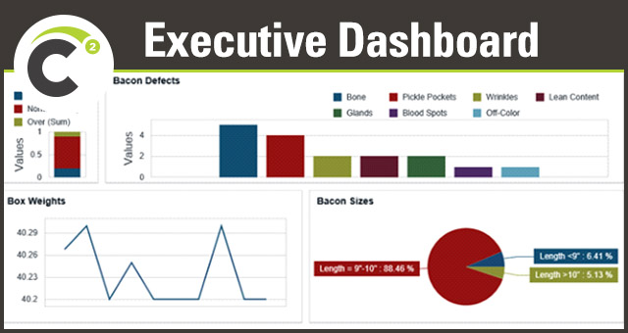

All type of Dashboards is kind of summarized reports for different type of positions.

Activity dashboards shows data for different data entries report to a supervisor or manager where he/she can views what is happening and where the issue is and who is responsible.

Modular Dashboards shows only relevant data of any module (like Financial, procurement etc.) where summarized reports of each activity and its impact and future prediction on some criteria.

Executive Dashboard is the most important type of system where all the activities, data entries of each module and users are represents in such a way that top management can understand it without having dep knowledge of each department and also it is very important to take decision of future.

Graphical Dashboard is type of system all the data represents in form of Charts and images and tabular form and also available in Mobile and web app apps specially designed for it.