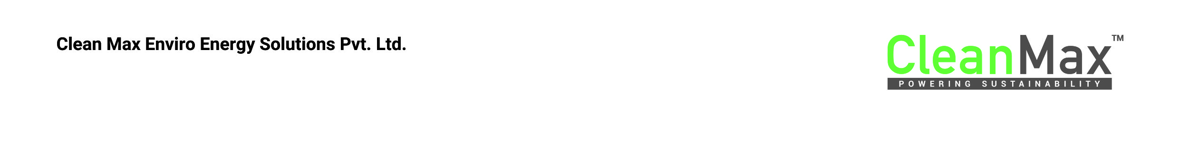

**Proposal for Supply of Renewable Power to Chrome Infosoft Solutions**

16 July 2024

**The Document is edited offline 16/07/24 17:34**

The following term sheet (the “**Term Sheet**”) is a summary of terms and conditions proposed by Clean Max Enviro Energy Solutions Pvt. Ltd. (“**Clean Max**”) for long-term consumption of renewable power by **Chrome Infosoft Solutions (“Consumer”)** from a Renewable Captive Generating Plant (“**RCGP**”). Both the Consumer and Clean Max shall be collectively known as the Parties (“**Parties**”). The Parties will execute an Energy Supply Agreement (“**ESA**”), Share Purchase Agreement (“**SPA**”), a Shareholders Agreement (“**SHA**”), and Performance Incentive Agreement (“**PIA**”) reflecting the commercial terms outlined herein.

|  |  |
| --- | --- |
| **Preface** | Clean Max intends to set-up a RCGP in a Special Purpose Vehicle (“**SPV” or “Supplier**”) under the captive model envisaged under the Electricity Act, 2003 and the rules framed thereunder as amended and notified from time to time (“**Electricity Laws**”). The Supplier shall enter into a contract with **Chrome Infosoft Solutions** (“**Consumer**”) to supply renewable energy to the Consumer in the state of Karnataka.  The SPV shall develop a **100** of Solar capacity and **40** of Wind capacityto supply ~**2.0 CR** of electricity annually (pre-grid losses) to the Consumer’sfacilities as described in Annexure III hereto (“**Contracted Quantity**”). Consumer will receive **~1.5 CR** at their facility (post losses based on current regulations) |
| **Intent** | The Parties shall ensure compliance with the below mentioned conditions, as mandated by the Electricity Laws, for the RCGP to qualify as a captive generating plant and maintain Captive Status (“**Captive Status**”):   1. not less than 26% (twenty six percent) of the equity share capital of the SPV is held by the Consumer (“**Ownership Test**”). Clean Max and / or its affiliates shall together hold 74% of the equity share capital of the SPV. 2. not less than 51% (fifty one percent) of the aggregate electricity generated in such plant, determined on an annual basis, is consumed by the Consumer for captive use (“**Consumption Test**”). 3. If a RCGP is set up with multiple Consumers, the consumption shall be in proportion to the shares held by the Consumers with a maximum variation of 10% (“**Proportionality Test**”).   The Parties agree that Consumer will consume the entire energy from the RCGP and Clean Max agrees not to supply energy from the RCGP to any additional customer without the prior written consent of the Consumer. |
| **Agreements to be signed** | The Parties shall sign the following definitive agreements to implement the arrangement (“**Definitive Agreements**”):   1. **Energy Supply Agreement (“ESA”)**: To be executed between the Supplier and Consumer. It finalizes the commercial terms of power supply. 2. **Share Purchase Agreement (“SPA”):** To be executed between Clean Max, the Consumer and the SPV/Supplier. It will include the terms of the purchase and sale of shares of the SPV to the Consumer. 3. **Shareholders Agreement (“SHA”):** To be executed between Clean Max, the Consumer and the SPV/Supplier. It will finalize Equity Shareholding in the Supplier, Governance Arrangements, Dividends, Entry and Exit of Consumers. 4. **Performance Incentive Agreement (“PIA”):** To be executed between Supplier and Consumer. Ensures that Supplier gets incentivized to the extent of the dividend payout from the SPV to the Consumer. This shall be in the form of additional tariff that is linked to dividend payouts. |
| **Entry into the Group Captive** | Consumer shall invest **INR 39 lakhs per MWp for Solar** and **INR 75 lakhs per MW for Wind** in the SPV for the Contracted Quantity (“Investment Amount”), which will correspond to a 69 equity capital contribution and ownership interest in the SPV. Clean Max shall contribute balance 70 of the equity capital contribution. The total investment required would be **~INR 139 crores** for a solar plant of capacity of @10 and wind plant of capacity of @11. The investment would proportionately increase/decrease for change in the plant capacity. |
| **Recovery of Dividends** | As an equity investor in the SPV, Consumer would be entitled to dividends from the SPV. However, these dividends would be returned to the SPV in the following way:   * The SPV would charge a performance incentive or an incremental tariff on top of the Tariff which would compensate for the actual dividend pay-out from the SPV.   The details of this would be covered in the Performance Incentive Agreement. |
| **Key Commercials** | Consumer will be billed on a per-kWh basis, as described below:   |  |  | | --- | --- | | **Group Captive Model** |  | | **Tenure** | **15 Years** | | **Lock-in Period** | **12** | | **ESA Tariff** | **INR 3.6/kWh** | | **YoY Escalation** | **0.7** | | **Contracted Capacity** | **140** | | **Contracted Quantity per annum** | **120** | | **Total Investment by Consumer** | **139** |   *Taxes, duties, losses, levies, and any other applicable charges including but not limited to open access charges such as wheeling, transmission, banking, SLDC (State Load Despatch Centre) charges and losses, etc. if applicable will be charged to the Consumer over and above the ESA Tariff described above. |

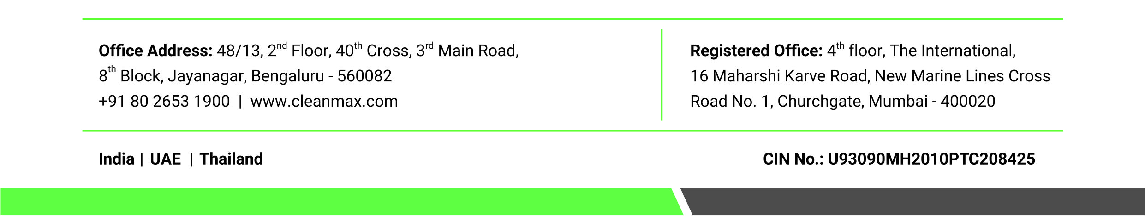

Input parameter : Solar Capacity

Input Parameter: Wind Capacity

Input Parameter:

Pre-loss supply (kWh)