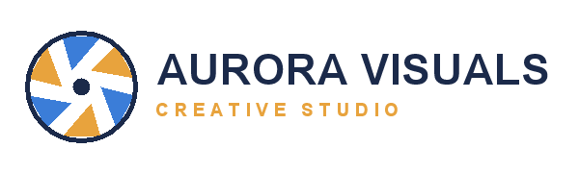

Project Proposal

Prepared for Northwind Coffee Roasters
Photography · Brand Design · Motion · 2026
Prepared by Mara Lindqvist, Creative Director

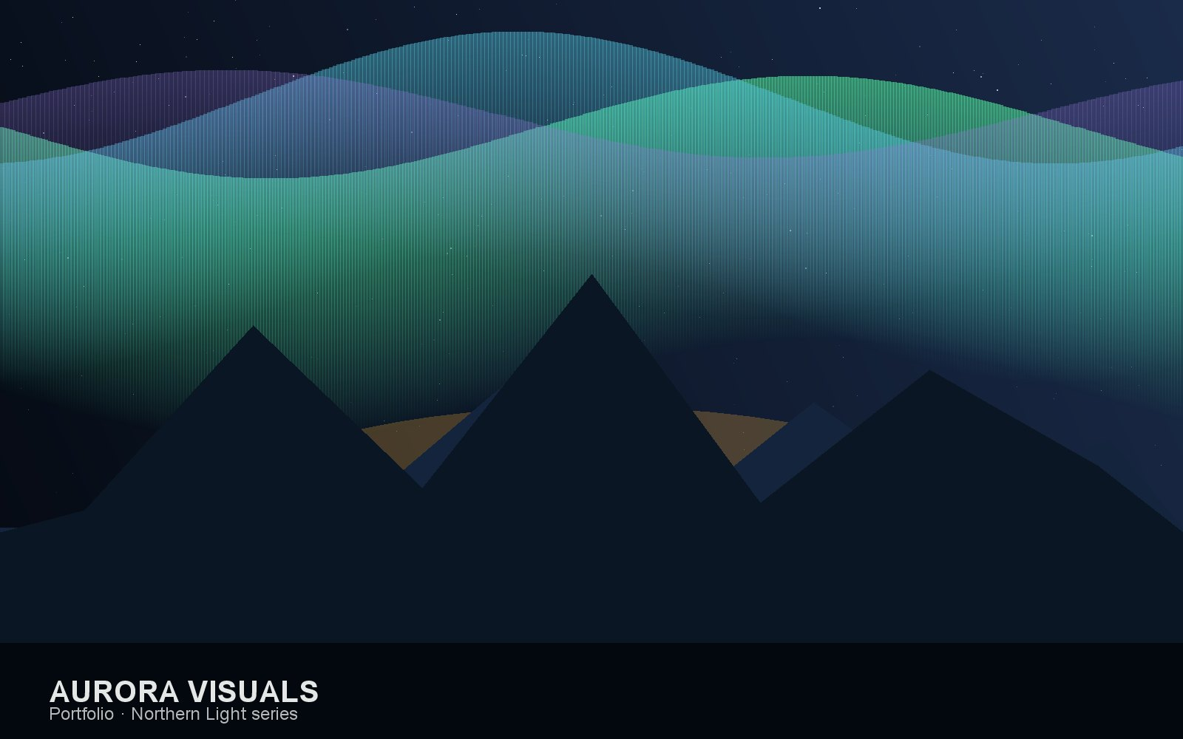
1. Overview
Aurora Visuals is a full-service creative studio specialising in photography, brand design, and motion. This proposal outlines the scope, schedule, and investment for a refreshed visual identity and launch campaign.
- Full-service studio: photography, brand identity, and motion under one roof.
- Senior creative leads on every engagement — no hand-offs to juniors.
- Licensed, watermark-protected delivery so client assets stay controlled.
- Average 12-day turnaround from brief to final delivery.

2. Services
The engagement draws on the following studio services. Rates are fixed for the duration of the project.
SKU | Service | Category | Rate
AV-PH-01 | Studio photography (half day) | Photography | $1,200
AV-PH-02 | On-location photography (full day) | Photography | $2,600
AV-BR-01 | Brand identity system | Brand Design | $8,500
AV-BR-02 | Pitch & sales deck design | Brand Design | $3,400
AV-MO-01 | Social motion pack (10 clips) | Motion | $4,200
AV-MO-02 | Brand film (60s) | Motion | $9,800

3. Timeline
- Week 1 — Discovery workshop and creative brief.
- Week 2 — Studio and on-location photography.
- Week 3 — Brand system and pitch-deck design.
- Week 4 — Motion pack production.
- Week 5 — Review, revisions, and watermark-protected delivery.

4. Investment
A summary of the fixed-fee investment by phase:
Phase | Deliverable | Fee
Photography | Studio + on-location shoot | $3,800
Brand design | Identity system + pitch deck | $11,900
Motion | Social pack + brand film | $14,000
Total | Fixed project fee | $29,700

5. Terms & Resources
Full terms, licensing, and the studio portfolio are available online:
· Master services agreement
· Asset licensing & watermark policy
· Studio portfolio

