Licensing .NET Applications

Introduction to Licensing

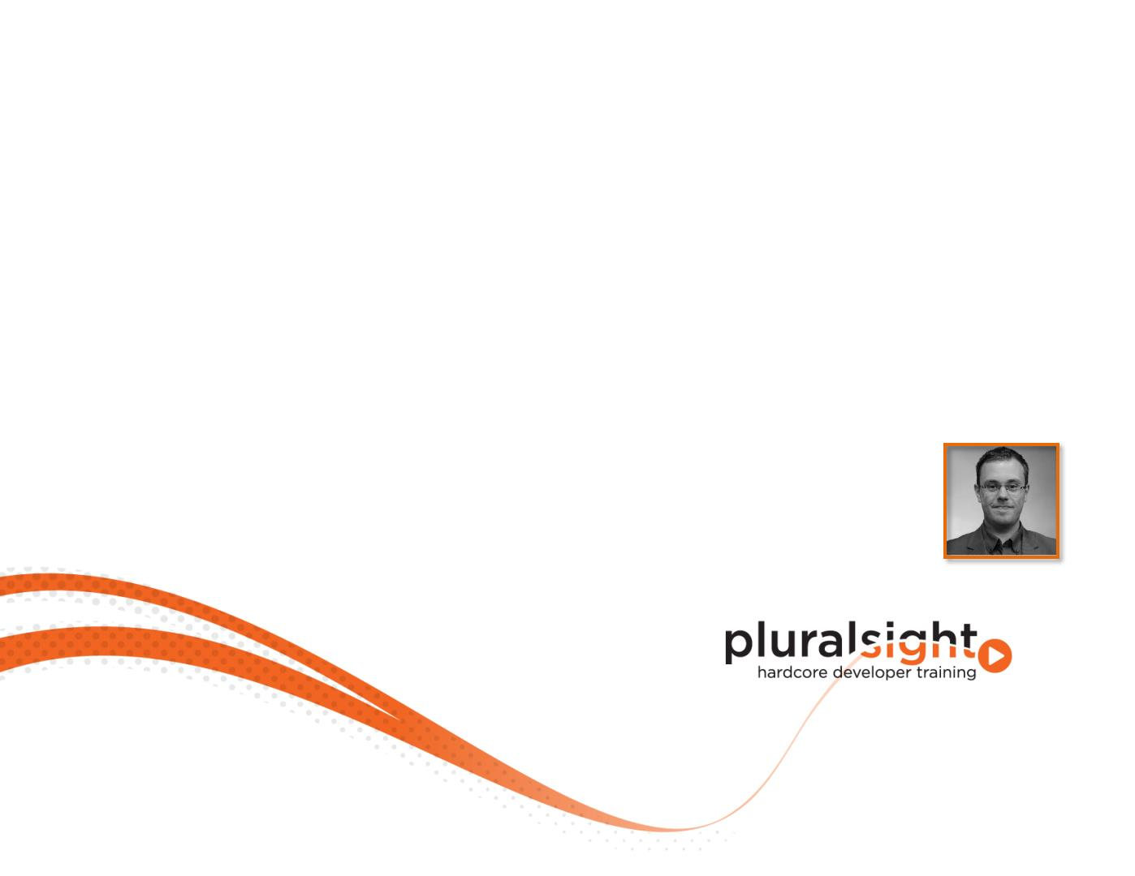

What is a License?

. Refers to a given permission

The permission itself

To the document recording the permission

Legal instrument governing specific rights

. What about a software license?

The same as a “normal“ license

Use or redistribute an application or code

End User License Agreement (EULA)

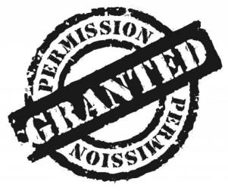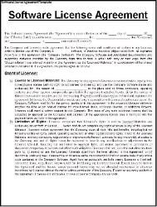

What is a License?

Organizational point of view

Legal instrument refers to permissions

Technical point of view

Grants a right to use software code to someone else

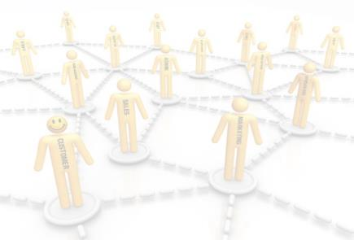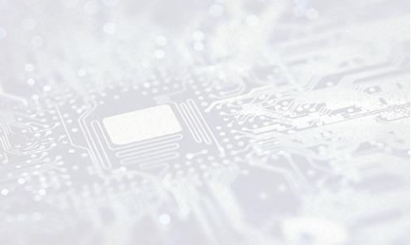

Different Software Licenses

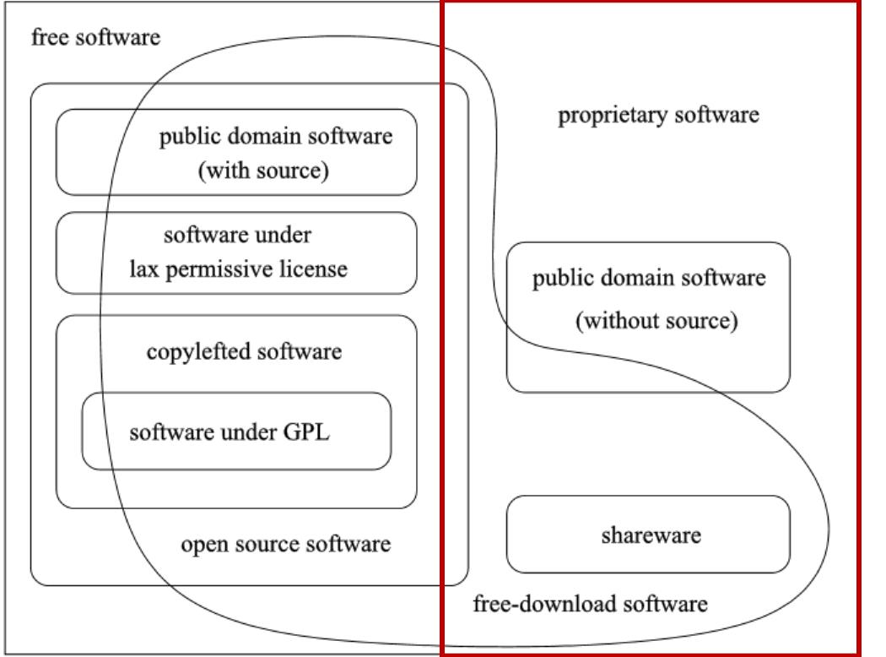

Why Licensing?

. We want to earn money

. Protect your application from being copied

. Reduce complexity for managing differences

. Get an overview of your customers/users



Why Licensing?

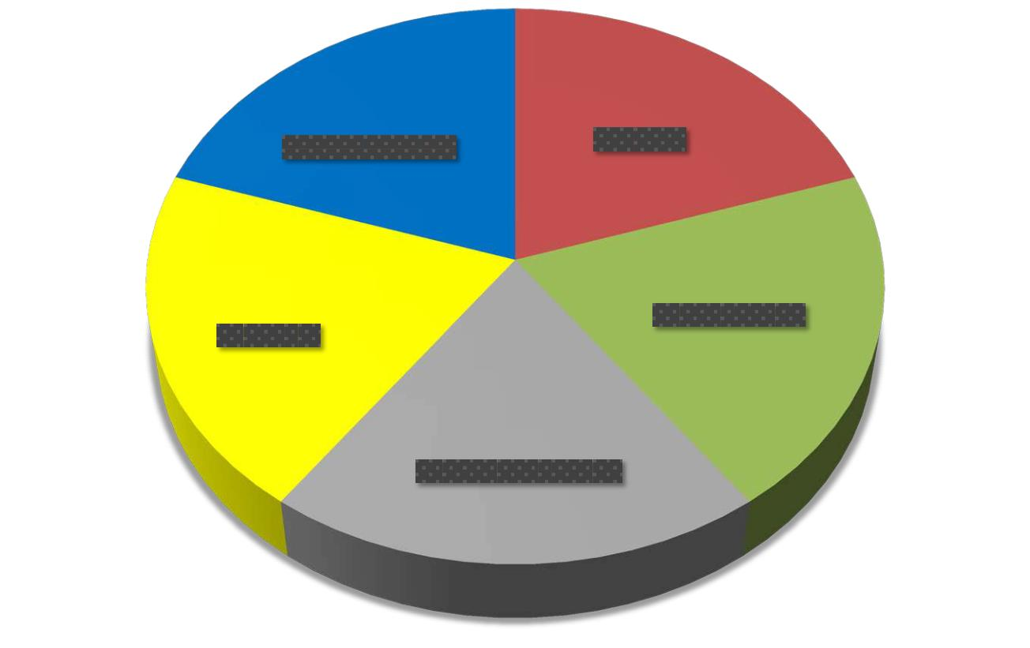

Software Licensing Patterns

. Different Policy Patterns

. Depends on your application and the requirements

. Often used patterns are

Identity

Time-based

Consumptive

Feature-based

. Also known as Software Licensing Patterns



Licensing Attributes

. Which data should be included in the license?

Known as characteristics or attributes

. Common examples are

Hardware/Machine dependencies?

Customer specific?

Concurrent users?

. Concrete recommendations are impossible!



License Management

. You need to organize your licensing model

Organizationally

Technically

. Manage licenses organizationally

Create/Update/Delete them

By whom and when?

Distribution process

. Manage licenses technically

Which technology should be used?

MD5 hash in a single file?

License keys (format, how to integrate)



Licensing Procedure

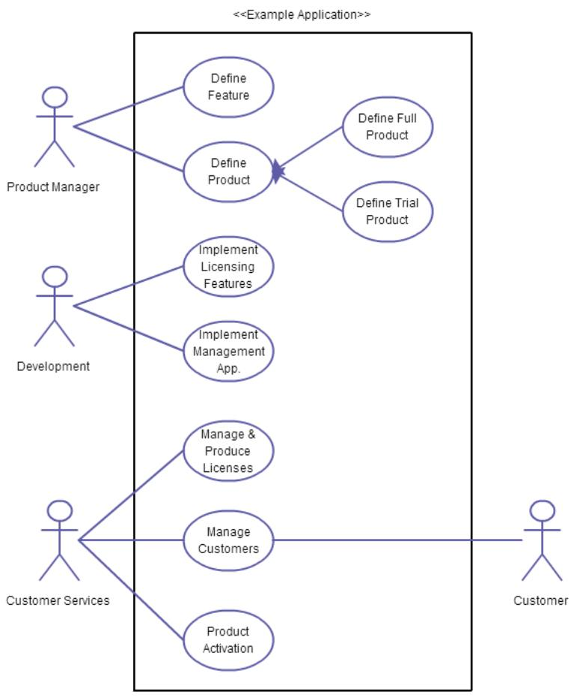

Licensing Procedure

. Don’t think phase oriented!

A licensing procedure isn’t waterfall-like

It effects all departments, processes and many employees



Summary

. A licensing model/procedure must be well planned!

. You have to think about…

… your users/customers and their concerns

… a licensing model and the advantages you expect

… the software license you want to use

… policy patterns and which of them fits best for you

… available licensing attributes

… the best way to create a license

… the deployment process

… the licensing procedure

… use cases of your licensing model and the effects for your organization

References

. Categories of free and nonfree software, GNU

~~http://goo.gl/FZB4hl~~, last visited 27.08.2013

. My thoughts on software piracy, balsamiq

. ~~http://goo.gl/fUVXfG~~, last visited 27.08.2013

. The Pattern Language of Software Licensing, Halina Kaminski, Mark

Perry University of Western Ontario,

~~http://goo.gl/IH4e6N~~

. Software Protection and Licensing, UML-Diagrams

~~http://goo.gl/XPr0Ib~~, last visited 27.08.2013

