Webcalendar to Odoo
calendar migration
-
Procedure

Table of contents
Introduction 1
Requirements 1
1 Export the calendar from Webcalendar 2
2 Webcalendar characters fix 3
3 Convert webcalendar.ics file to Thunderbird CSV file 4
4 Convert Thunderbird CSV file to Odoo CSV file 7
5 Import the "Odoo CSV file" in Odoo 16

Introduction
This procedure describes how to migrate a calendar from Webcalendar to Odoo.
This procedure must be repeated for each Webcalendar user account.

In this procedure, the user account example will be "osarrat".

Requirements
This procedure is tested to work with:
- Webcalendar v1.2.7
- Odoo v8
- Thunderbird v52.0.1, with Lightning plugin v5.4.0.1
- Windows 7
- LibreOffice 5.1.5.2

It might work with other configurations.

Export the calendar from Webcalendar

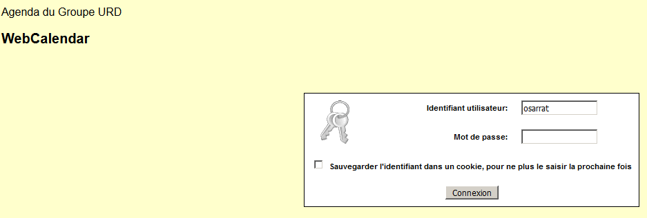
Log in in Webcalendar with the proper account credentials

Open Event > Export
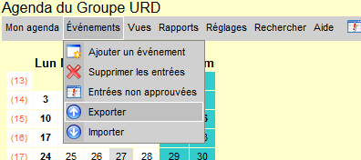

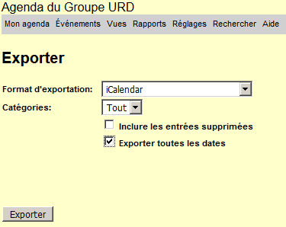
Export all dates
Check the "Export all dates" checkbox and click on the "Export" button.

Save the webcalendar-osarrat-all.ics exported file on your hard drive.

Webcalendar characters fix
Webcalendar has a bad management of charset in its exported files.
Those exported files must then be fixed to have proper characters.

Copy the "webcalendar-osarrat-all.ics" in the "2_Webcalendar_characters_fix" folder.

Rename the "webcalendar-osarrat-all.ics" file into "webcalendar.ics".

Run the "webcalendar_char_fix.ps1" PowerShell script in the "2_Webcalendar_characters_fix" folder; by selecting "Run with PowerShell" in the contextual menu of script.
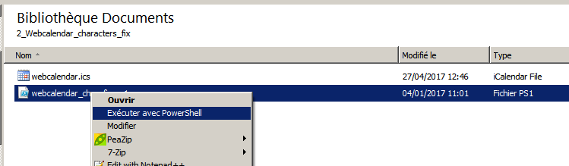

Wait until the end of the running of script... it might takes several minutes.
During the running of the script, don't close the powershell window which opens up at the start of the running, and which will close by itself when the script will have finished its job.
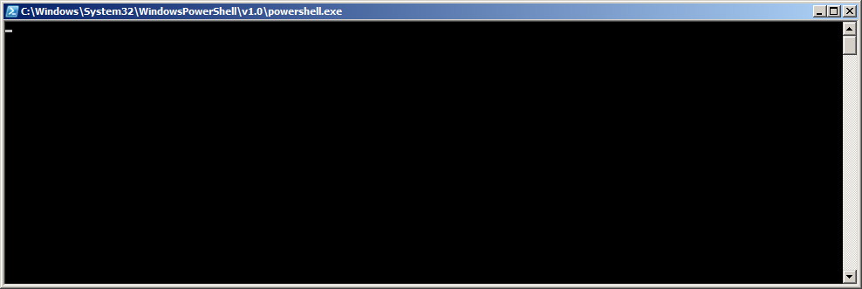

Convert webcalendar.ics file to Thunderbird CSV file

Open the Thunderbird Calendar tab.
Through the "Menu > Event & tasks > Calendar" menu item.
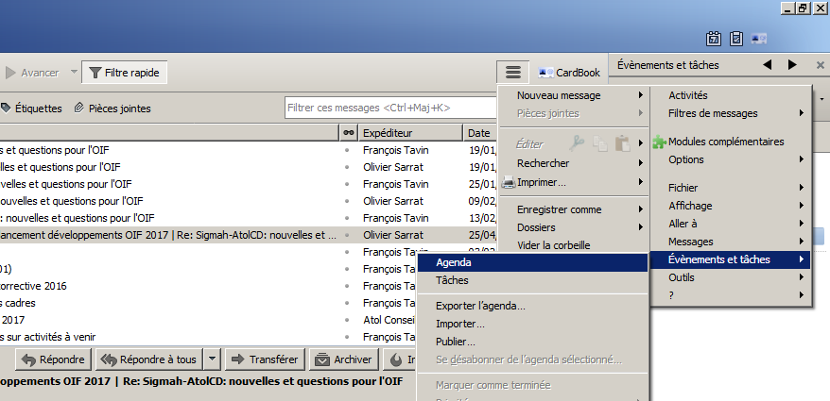

Open the "webcalendar.ics" file with Thunderbird.
Through the "Menu > File > Open > Calendar file" menu item.
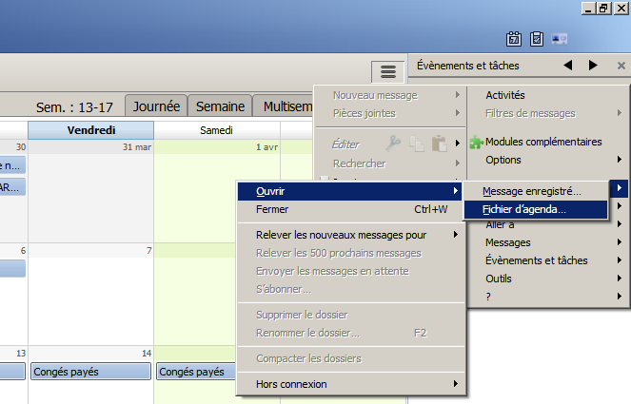

Open the Calendar exporter for the new "webcalendar" calendar.
Through the contextual menu "Export Calendar..." menu item (right-click on the "webcalendar" calendar).
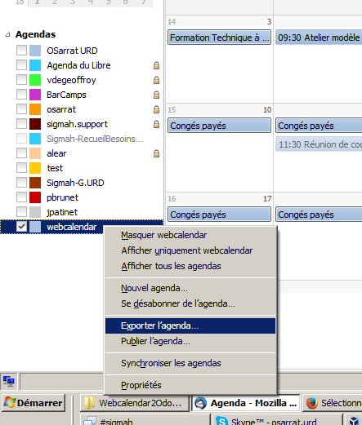

Select CSV as export Type, let "webcalendar.csv" as File name, check that you are saving in the "2_Webcalendar_characters_fix" folder, and click on the "Save" button.
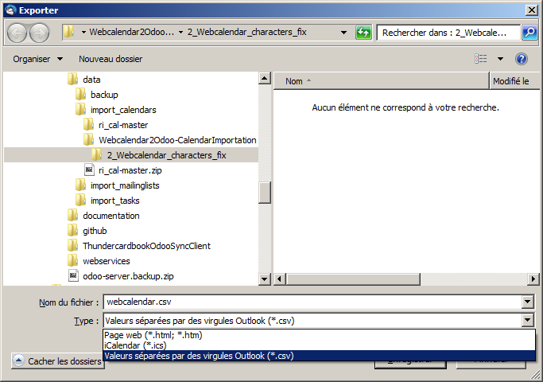

Select the "webcalendar" calendar in Thunderbird, and press the "Delete" key on your keyboard to delete this calendar from Thunderbird.

Confirm that you wish to unsubscribe from this "webcalendar" calendar in order to delete it.
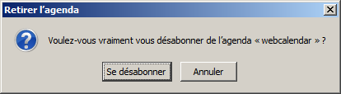

Convert Thunderbird CSV file to Odoo CSV file

Open with "LibreOffice Calc" the "webcalendar.csv" file in the "2_Webcalendar_characters_fix" folder.
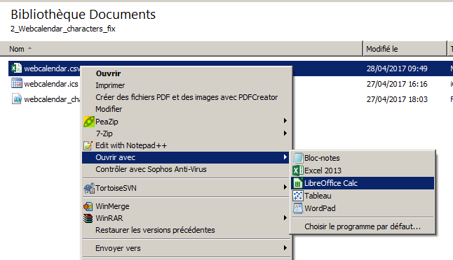

Confirm the LibreOffice Calc text import parameters as shown below, and click on the "OK" button..
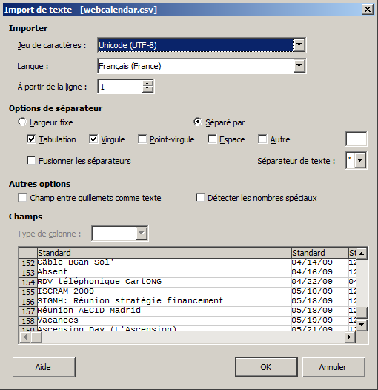

Copy the content of the imported "webcalendar.csv" file from LibreOffice Calc, and close it.
From the window which has just opened with the content of the "webcalendar.csv" file, press the "Ctrl+A" key shortcut to select all cells, and then the "Ctrl+C" key shortcut to copy.
Then close the window of this "webcalendar.csv" file opened with LibreOffice Calc.
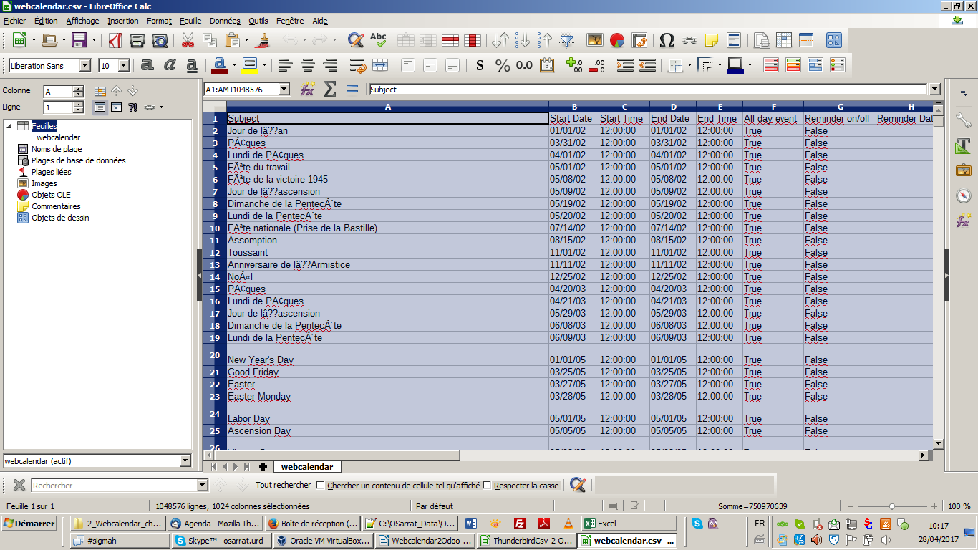

Open the "ThunderbirdCsv-2-OdooCsv.ods" OpenDocument Spreadsheet in the "4_ThunderbirdCsv-2-OdooCsv" folder.
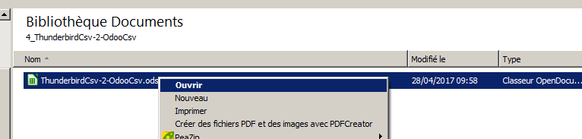

In the "ThunderbirdCSV" tab of this "ThunderbirdCsv-2-OdooCsv.ods" spreadsheet, remove all former content of the tab.
To do so, in the "ThunderbirdCSV" tab, press the "Ctrl+A" key shortcut to select all cells, and then the "Delete" key to delete all the selection.
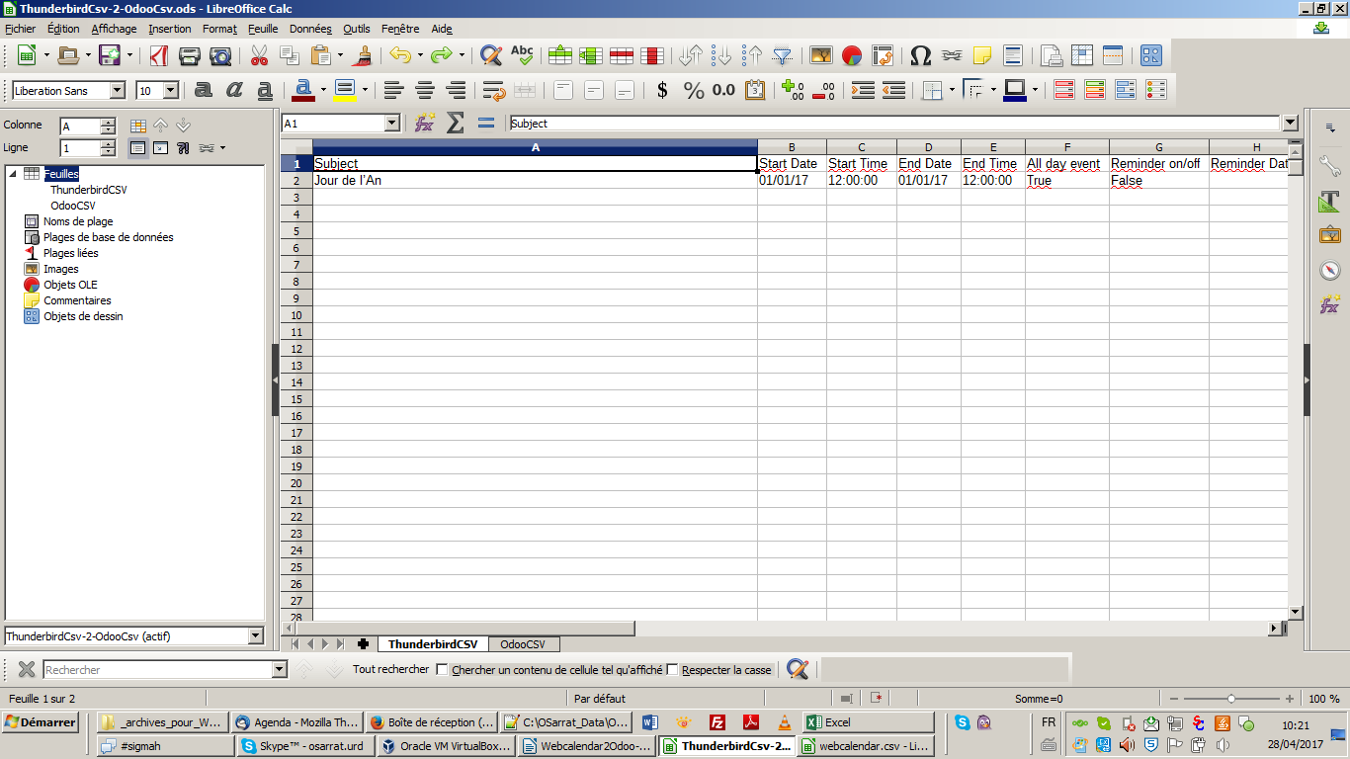

In the now empty "ThunderbirdCSV" tab, from the A1 cell, paste the "webcalendar.csv" content you have copied in step 4.3.
Select the "A1" cell in the "ThunderbirdCSV" tab, and press the "Ctrl+V" key shortcut to paste.

Go to the last row in the "ThunderbirdCSV" tab to know how many rows have been pasted.
Use the "Ctrl+Down" (down arrow in the Keyboard) key shortcut to jump to the last pasted row.
Remember the row number of this last row: in the the screenshot below, it is "1421" for example.

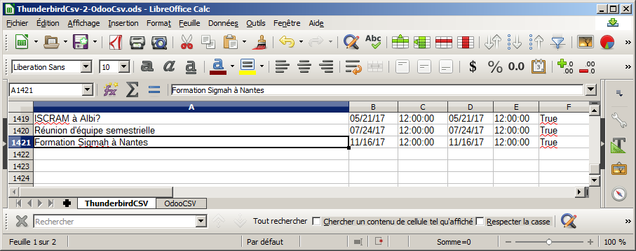

Open the "OdooCSV" tab of this "ThunderbirdCsv-2-OdooCsv.ods" spreadsheet.
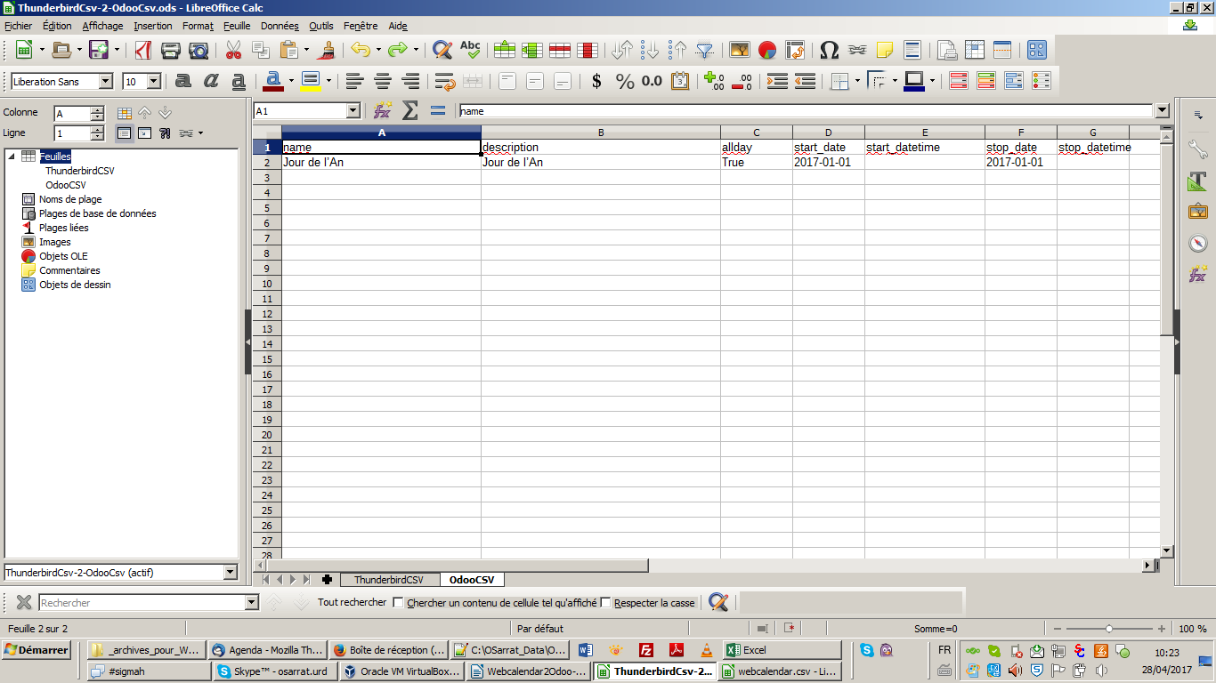

Select the "A2:G2" range of cells in the "OdooCSV" tab.
The result of this selection is shown below:
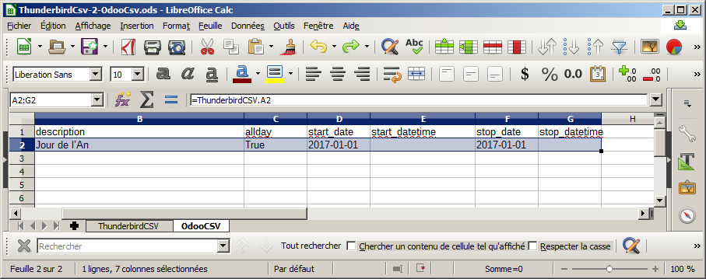

Replicate the "A2:G2" range of cells until for the number of rows you have counted in step 4.7.
To do so:
- move your mouse cursor on the little square at the bottom right of the "A2:G2" range (the square is circled in red in the just above screenshot until your mouse cursor is tranformed in a big + sign;
- press the mouse left button and keep it pressed ;
- move your cursor down until you select the number of row you have counted in step 4.7;
- release then the mouse left button.

The result should be something like:
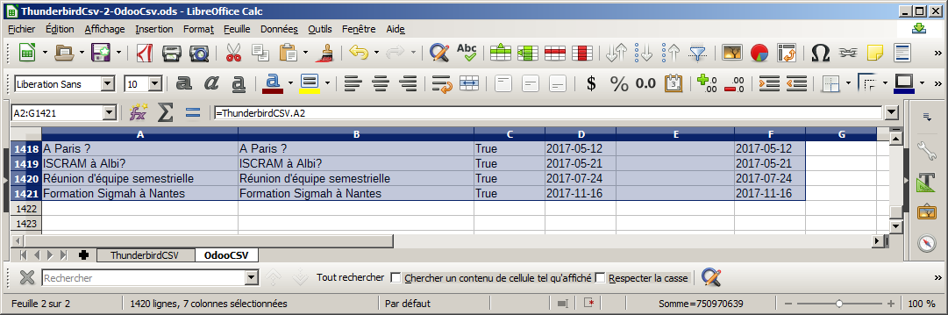

If your a set of extra rows filled with "0" at the bottom of your "OdooCSV" tab, delete them.

From the "OdooCSV" tab, click on the "File > Save a copy..." menu item.
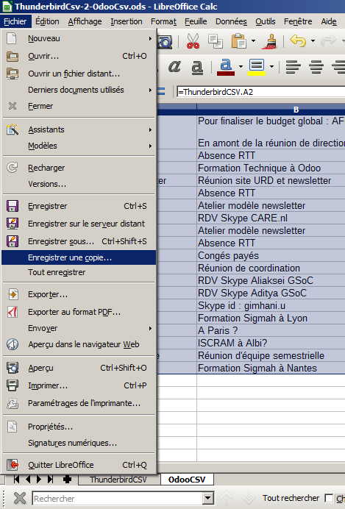

Select "CSV text" in the Type drop-down list of the "Save a copy" popup, let "ThunderbirdCsv-2-OdooCsv.csv" as file name, and click on the "Save" button.
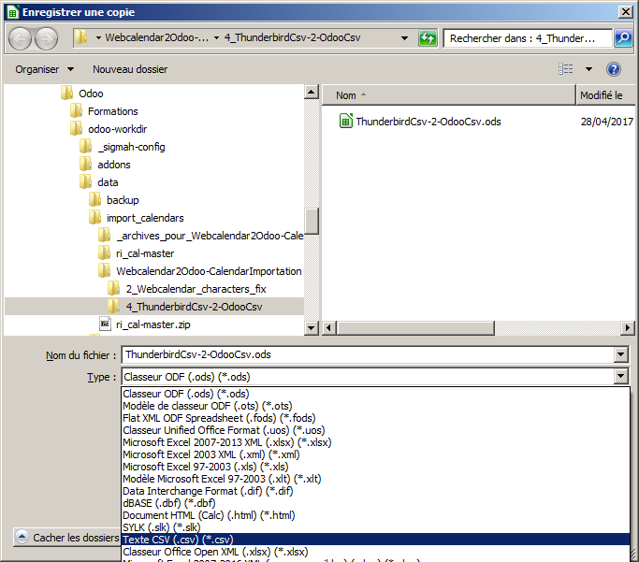

Configure the "Text files export" according to the screenshot below, and click on the "OK" button.
Don't forget in particular to set:
- the charset to "UTF8"
- to check the "put in quotes all text cells" checkbox
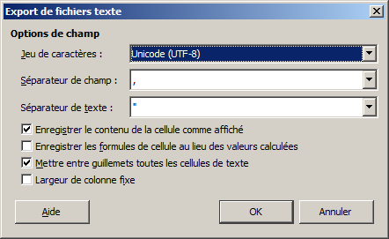

Click on the "OK" button for the warning about saving only the active sheet.
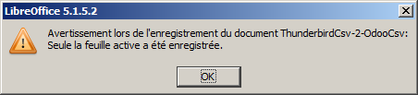

Import the "Odoo CSV file" in Odoo

Open your Odoo instance log in page.
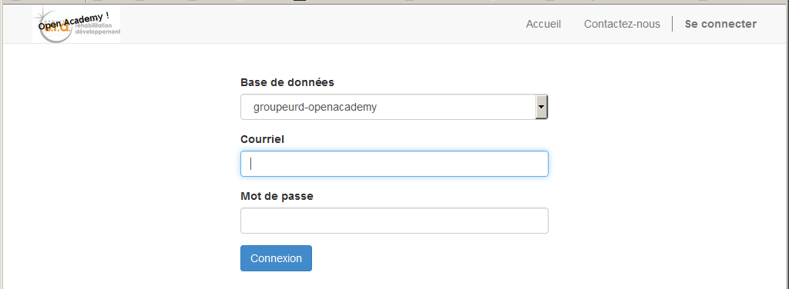

Open a user session with the credentials of the user you have exported the calendar in chapter 1 of this procedure.

Open the user calendar.
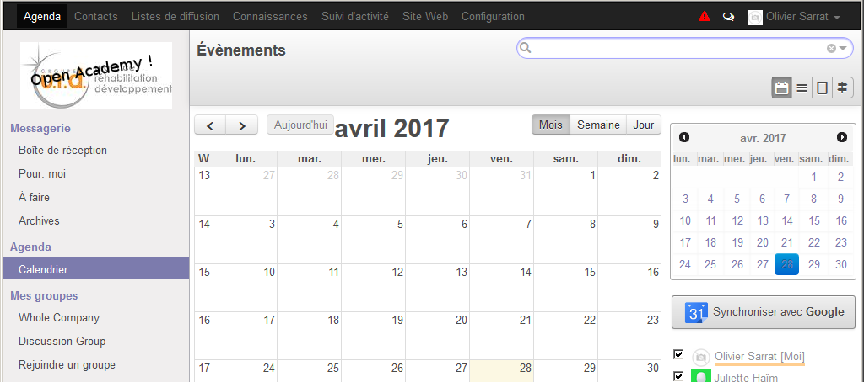

Shift the calendar from a calendar view to a list view (click on the List view button circled in red below).
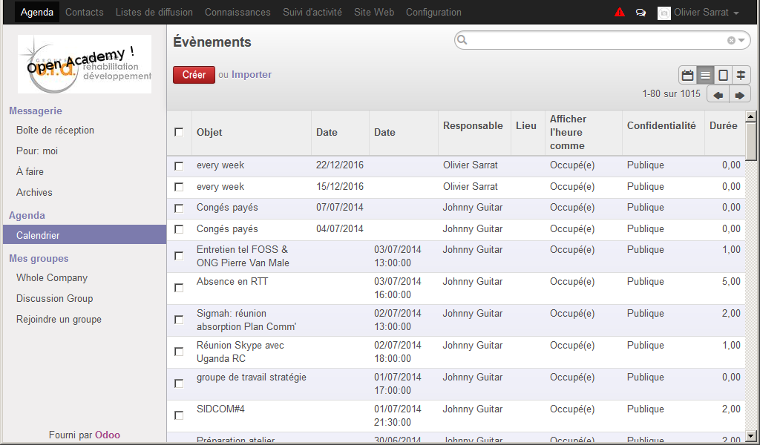

Click on the "Import" hyperlink (circled in yellow above)

Click on the "Browse..." button to select the CSV file to import.
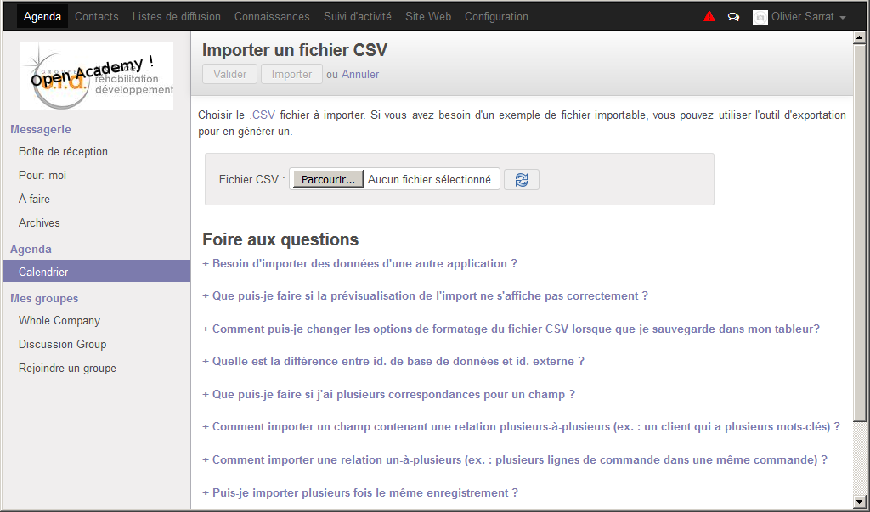

Browse your hard drive to open the "4_ThunderbirdCsv-2-OdooCsv" folder, select the "ThunderbirdCsv-2-OdooCsv.csv" file inside it and click on the "Open" button.
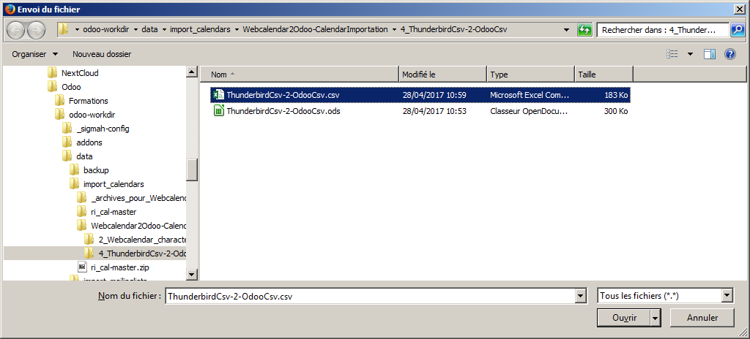

Now click on the "Validate" button to check if your file is completely valid.
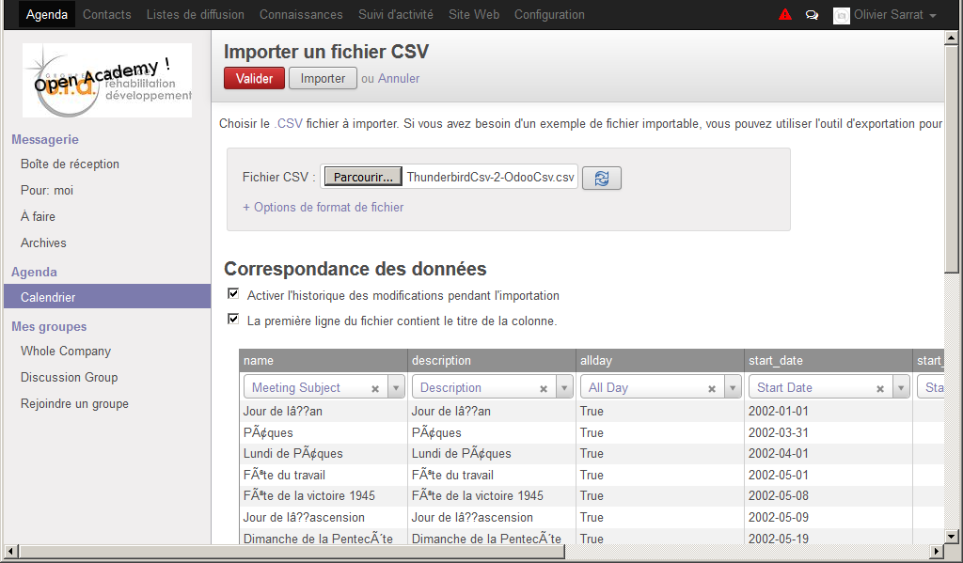

Wait until the end of the validation, as this process might take several minutes...
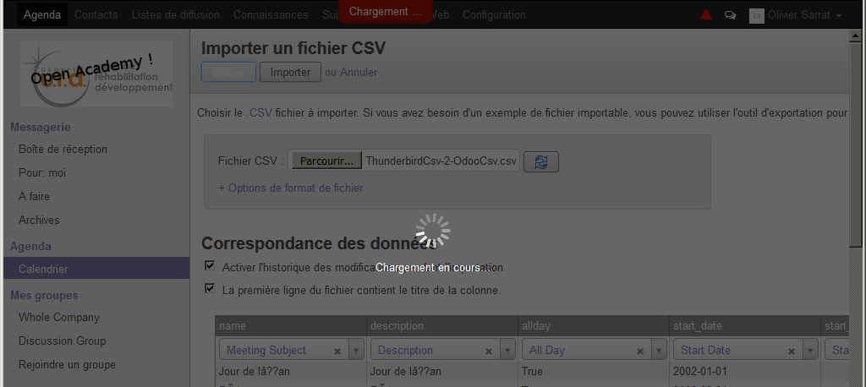

Finally, click on "Import" button to finish the migration !
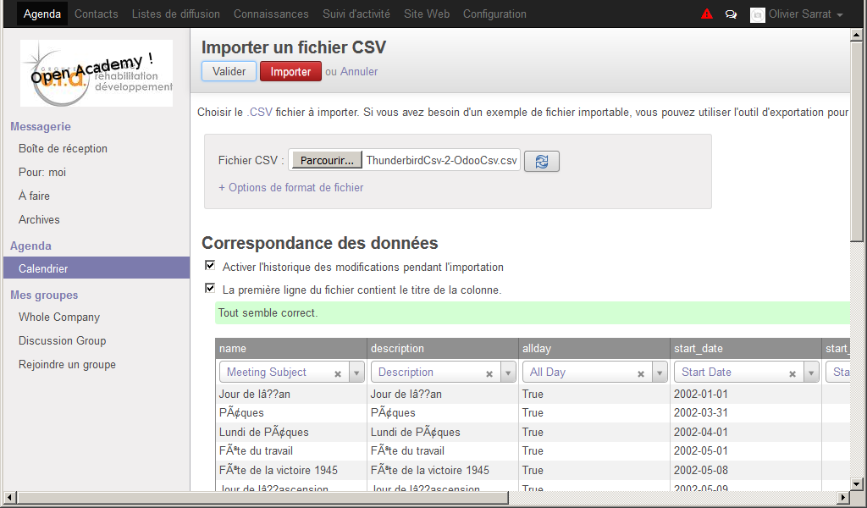

The importation can again take several minutes... so be patient... :)

