# Group Reflection

For Assignment 3 our group has maintained a similar process to that of Assignment 2 with some improvements which have positively impacted our work. In terms of our team dynamic and communication habits Assignment 3 has very much felt like a natural continuation of Assignment 2, with no dramatic changes in our work ethic aside from what could be called a more “specialized” approach to task allocation. As the purpose of Assignment 3 is to develop a project plan based off of one of the ideas of our group members, we have taken a different approach to allocating or choosing some of our tasks. Those who have knowledge or experience in some of the tasks required for our project plan were given certain sections as a way to provide higher quality work with less time needed to research those topics. Michael, the group member whose project idea was chosen for Assignment 3, greatly assisted with this as he provided content relating to his project idea which facilitated our work and provided us with a detailed vision for his project which we were able to further develop and build off of.

As for group communication, in addition to our regular Discord interactions we have allocated a time on Sunday Nights at around 7-7:30pm (AEST) where we all come online to discuss our work on Assignment 3, such as task allocation and our progress with any work we are currently doing for the Assignment. This has proved to be a major benefit for our work as it provides us with a way in which we can develop ideas, discuss tasks in depth and further develop the project plan with every group member present and able to interact, discuss and provide input in real time. Our regular communication could be improved somewhat, though this issue is mainly caused by issues relating to time zones and personal schedules differing between group members. This hasn’t impacted our work negatively in any major sense; however, it can be an issue at times when a certain group member wants to discuss something or needs feedback but no one is available to do so for indeterminate amounts of time. Overall despite these minor issues our group remains a comfortable and effective workspace in which we can operate in an effective and cordial manner.

# GitHub Log

Main

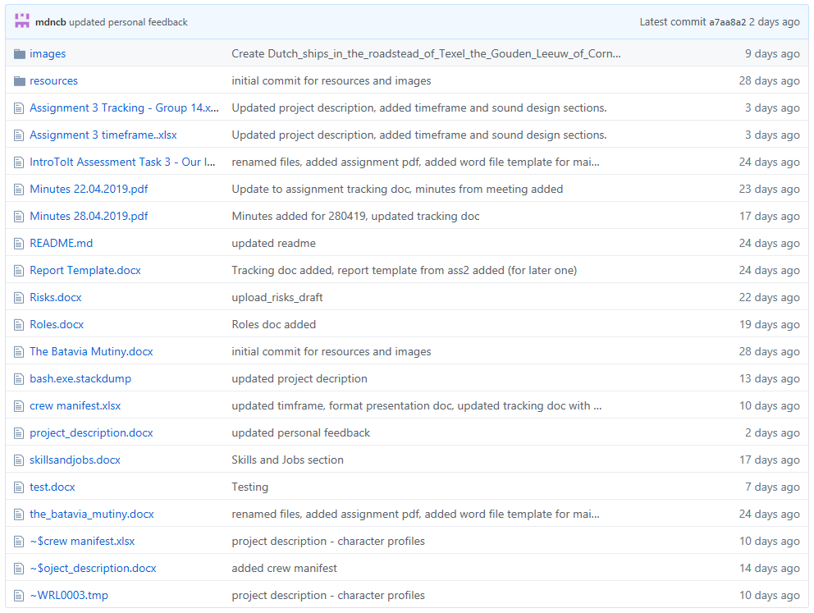

Main/Images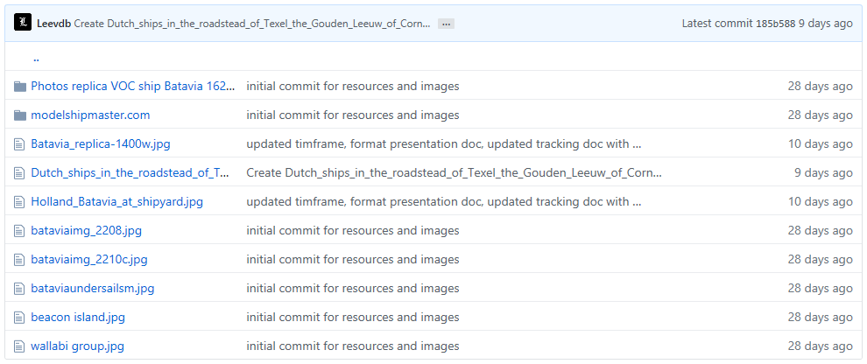

Main/Images/modelshipmaster.com

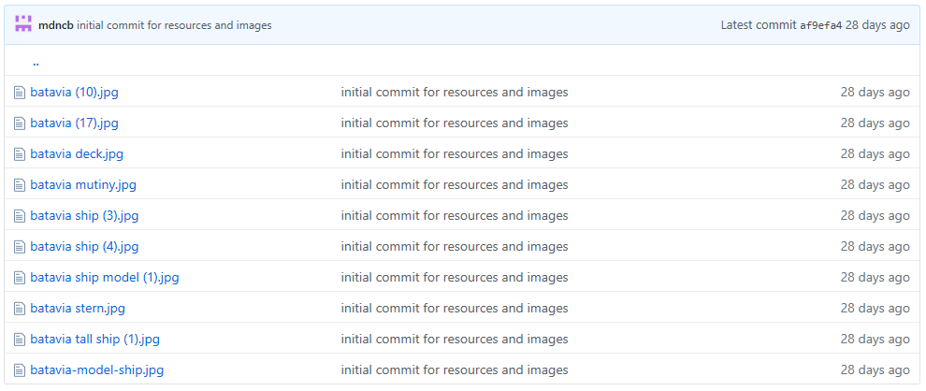

Main/Images/Photos replica VOC ship Batavia 1628 (Full list is 100+ files)

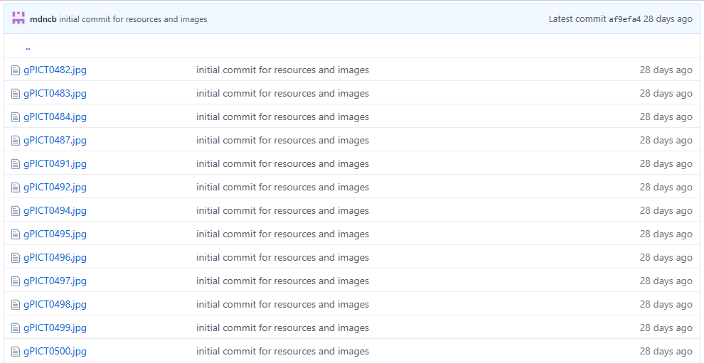

Main/Resources

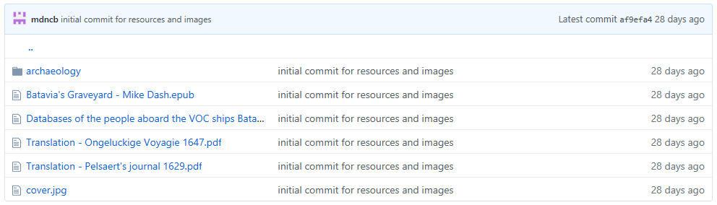

Main/Resources/Archaeology

