|  |
| --- |
|  |
|  |
| Assignment 3: Team Project  Group Fourteen |

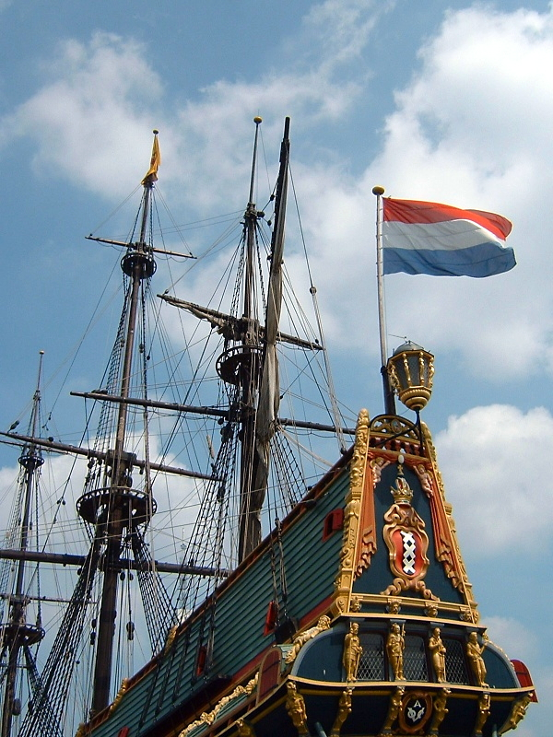

Introduction to Information Technology

COSC2196

RMI-CPT110

Acknowledgments:

Group Fourteen acknowledges that the idea and concept for the historical setting of the Batavia Mutiny for this project is entirely the intellectual property of Michael Seymour.

Cover image: Courtesy of Wikimedia Commons, Accessed 05 May 2019

<https://commons.wikimedia.org/wiki/File:Holland_Batavia_at_shipyard.jpg>

Contents

Contents 3

Team Profile 5

Meet the team 5

Nicholas Young 5

Lee van den Blink 6

Michael Seymour 7

Cory Atkinson 8

Nathan Christos 9

Harrison Williams 10

Group Processes 11

Career Plans 11

Tools 12

Group Website Links 12

Reflection on GitHub History 12

Project Description 13

Overview 13

Topic 13

Motivation 13

Landscape 14

Detailed description 15

Aims 15

Plans and Progress 16

Background - The Batavia Mutiny 16

The Game 17

Characters 18

Player Character 18

NPCs 19

Scenes: 24

Moral Choice Game Mechanic 26

Sound Design 29

Level and object Design 29

Sample sword design 29

[Part 4 Technicalities] 32](#_Toc8931824)

Scope and Limits 33

[Tools and Technologies] 33

Testing 34

Part 5: Timeframe 35

Part 6 37

Risks 37

Group processes and communications 37

Skills and Jobs 38

Game Designer 38

Writer 38

Programmer 39

3D Artist 39

Reflections 40

Individual reflections 40

Nicholas Young 40

Lee van den Blink 40

Michael Seymour 41

Cory Atkinson 41

Nathan Christos 41

Harrison Williams 41

Group reflection 42

Appendices 43

Appendix 1: GitHub Repository Documents (Sample) 43

Appendix 2: GitHub Repository Commit History 45

Appendix 3: Group Discord Discussions (Sample) 45

Appendix 4: Minutes of meetings (Sample) 45

Appendix 5: Sound Design Sample Soundtrack 46

Appendix 6: Sword design images 47

Team Profile

# Meet the team

## Nicholas Young

RMIT Student # s3793515

[Assignment 1 Profile](https://njyoung95.github.io/NJYWebsite/)

|  |  |
| --- | --- |
| “Ever since I was old enough to understand how to use computers, I have been constantly attached to them in some way, shape or form...” |  |

Young in name and in age, but don't let that deceive you. After completing high school Nicholas continued to pursue his interest in IT and studied both IT Networking and Level Design, and it currently studying his Bachelor of IT at RMIT. He discovered his natural affinity for all things IT while still young at high school, when he fixed a troublesome network issue using nothing but research and tenacity. Nicholas has self-taught himself many skills along the way through helping people with their own IT issues, which he then uses as an opportunity to further develop his own knowledge. In particular he has applied his self-learning ability to game level design, which he has pursued for a number of years, and has successfully designed his own levels for games. Aside from his pursuing further knowledge in game design he is also very interesting in developing his knowledge on IT networking.

## Lee van den Blink

RMIT Student # s3792973

[Assignment 1 Profile](https://leevdb.github.io/Lee-van-den-Blink/)

|  |  |
| --- | --- |
|  | “I'm incredibly inspired by the design and innovation that is continuously driving the games industry, which I feel runs in parallel with the IT industry and its technology...” |

With a decade long history in the vocational education sector, Lee has worked with database management and server management in both small and medium businesses. She is passionate about ‘clean data’ and using data analysis to paint a picture of what is really happening in a company based on the database information. Lee has also rolled out numerous upgrades to IT infrastructure and been responsible for training staff in new applications and software. She was first exposed to computers through playing 80’s adventure games with friends in primary school, and as technology improved her curiosity and involvement with technology has only increased. Being a teenager when floppy discs and dial up internet were still a thing, Lee sees that the world of IT has evolved so vastly and there's so much more to learn, and she wants to learn as much about it as she can. Being that technology and computers have been a part of her life for so long, it's no great surprise that Lee is an avid gamer in her spare time, which is somewhat limited these days as she’s also looking after her young family while working part time. Alongside video games she also enjoys playing netball and learning more about the world through listening to any number of the shows in her massive podcast library.

## Michael Seymour

RMIT Student # s3040138

[Assignment 1 Profile](https://mdncb.github.io/assignment1/)

|  |  |
| --- | --- |
| “My interest in IT comes from a life-long interest and curiosity in computers, although I am only now pursuing it with the goal to support myself professionally...” |  |

After leaving Australia 7 years ago on a one-way ticket to travel the world, Michael currently calls Moscow his city of residence, where he teaches English. He main interest is the pursuit of knowledge. A Bachelor of Arts graduate, Michael has continued his education into the IT industry, with a keen interest in learning more about software engineering. Seldom does he have downtime, as when he is not at work, he is often studying university, or any number of other online education. You could say studying is his biggest hobby, as he has completed numerous online courses to further his own knowledge on subjects, including maths, computer science and programming languages. Like many members of Group Fourteen, his interest in IT was first piqued at a young age with the family computer. He has witnessed the speed of evolution of the industry, and now understands that the world of IT has the ability to influence society, seeing first hand the differences between countries that have supported infrastructure, and those that are lacking. A few years ago Michael decided to remove himself from all social media, feeling the intrusiveness and ambiguity of the services far outweighed any benefit. This directly links with his interest in cybersecurity and privacy issues, where he hopes to specialise in his future career.

## Cory Atkinson

RMIT Student # s3775626

[Assignment 1 Profile](https://attikins.github.io/Attikins.github.io/dist/about.html)

|  |  |
| --- | --- |
|  | “Even to this day I believe there is so much more potential in the current 3D art and design market that hasn't yet been explored...” |

The seed for the idea of a career in IT was first planted in Cory at the young age of 10, by playing Halo: Combat Evolved on the XBOX. Unlike most other players at the time who just enjoyed the gameplay, Cory was intrigued by more than the game itself, but everything going on behind it: the hardware, the game mechanics, programming, the design. The seed took root and he pursed this interest further and while a teenager he learnt programming and even made his own “terrible 3d Games” to learn more about the craft around his passion. Fast forward to today and Cory passion about game design has only increased. Cory sees the potential for 3D art and design to be better and bolder, and he sees his current studies with RMIT as a big step towards learning more about his passion. His other main interests which he also approaches with passion and creativity are coffee and metal music.

## Nathan Christos

RMIT Student # s3788418

[Assignment 1 Profile](https://atamosmusic.github.io/itprofile-assessment01.git.io/)

|  |  |
| --- | --- |
| “A career in electronics has only fueled my desire to explore the fundamentals of computational processing and machine language...” |  |

Currently based in sunny Queensland where he works with electronic security and surveillance issues, Nathan originally grew up in a farming community in NSW. He was home schooled from a young age and it seems his quest for learning and knowledge was present from his early youth, as he continuously scored well above the curriculum standards. Eventually his natural curiosity for learning crossed paths with IT in the form of his family’s first computer. Nathan realised that computers were not magic, but machines, that could be understood and mastered. He has followed this curiosity with IT to a career in electronics, and plans to continue building on his insatiable quest for understanding by studying his Bachelor of Information Technology. Already being involved in electronics through his career, Nathan has many ideas for IT based projects and hope through further study he could bring these to fruition. His strong desire to always improve and master his skills has also been applied to his many and varied other interests which include archery, playing music professionally, being a Kung Fu Master, and being able to solve a Rubik’s cube!

## Harrison Williams

RMIT Student # s3791005

[Assignment 1 Profile](https://harryw77.github.io/Assignment_1/Index.html)

|  |  |
| --- | --- |
|  | “My interest in IT has been long running as my dad is very tech savvy, and introduced me to computers at a young age...” |

Harrison currently resides in Melbourne, and after VCE completed a year of Bachelor or Psychology, before deciding to pursue his interest in Information Technology, while also working as a baker's apprentice. When he's not rolling dough his enjoys listening to and playing music, reading, and gaming online with friends. His interest in information technology was stirred from youth, and he learned a great deal from his father who was more tech savvy than most, learning about things like running from the command line to use dosbox. This interest grew more in primary and high school, where Harrison found himself being Mr.-fix-it for everyone else’s It issues, thus enabling him to delve deeper into his own understanding of computers and systems. He found a natural affinity with computers, and also learnt he really enjoyed being able to help others and fix their issues. He pursued this interest further and taught himself HTML coding and python language, however baker’s hours don’t currently allow him much chance to continue this interest. He has decided to undertake a Bachelor of IT, as he believes there is great potential for him to find employment in an area he thoroughly enjoys, with the longer term goals of finding work in areas such as coding, connectivity systems, and servers and networking.

# Group Processes

As a group we used GitHub as a shared workspace for files and Discord as our communication platform for Assignment 2. This will be the same for Assignment 3 in terms of which platforms we will use. As the conclusion of assignment 2 a lot of the functionality of GitHub was better understood, which should reflect in a more accurate commit history for this assignment. With the assignment 2 project we split up the tasks evenly and each person worked on their sections more or less individually, with discord being the go between when minor questions cropped up. However the requirements of Assignment 3 require a more collaborative approach. We decided to have a weekly meeting via Discord (either voice chat or text chat), where we discuss the overall aims of where we can get to, what each person is able to work on, and where we are at with things. This still allows us the level of autonomy during the week to work on our task/s, but the ideas and decision making is shared towards out aims and expectations for the final project. We have all agreed that the beauty of Discord is leaving a question at any time will be answered the next time someone is online, and as a group we are all on regularly enough for this to be a comfortable solution. The meetings are minuted and shared on the GitHub repository so anyone unable to attend can quickly catch up on the discussion. Task allocations are clarified and agreed upon before the conclusion of the meetings, and these are also tracked on a separate tracking doc, as well as being a part of the timeframe allocation.

# Career Plans

Tools

For this project the main communication and sharing tools used were:

* GitHub
* Discord

# Group Website Links

Group website:

<https://groupfourteen.github.io/assignment2/>

Group Git repository:

<https://github.com/groupfourteen/assignment3>

# Reflection on GitHub History

Refer to *Appendix 1: GitHub Repository History – Sample* for evidence of GitHub files repository.

Refer to *Appendix 2: GitHub Repository History – Sample* for evidence of GitHub commit history.

Refer to *Appendix 3: Group Discord Discussion – Sample* for evidence of use of Discord.

Project Description

# Overview

## Topic

We plan to design an immersive and fulfilling moral choice role-playing game which is based on a historical event. In choosing this theme, we hope to capture the complexity of morally grey situations where the player must make decisions which are more than ‘good’ or ‘bad’, but rather actions with intended and unintended consequences. As the non-player characters will be based on real people, we hope to add an extra layer of depth and immersion to the game, allowing the player to feel emotionally invested in the various non-player characters and weigh their decisions and actions carefully throughout the game.

We hope to establish a standard of the genre which avoids the clichés and tropes which is the cause of a lot of similar games to fail to live up to their potential. Clichés such as good-bad dichotomies, linearity disguised as choice, and obvious ‘correct’ endings which enforce the artistic vision of the game designer rather than offering multiple conclusions depending on the choices made by the player throughout the game are some examples of frequent design errors. When implementing a moral choice system which feels organic and immersive, decisions should weigh heavily on the player’s conscience. We hope that this game will stand out from others of the genre and inspire other game developers to seek depth and complexity in future games where moral choices are a core aspect of the game design.

## Motivation

Our motivations for this project come from several sources: our desire to work professionally in game development; to push the boundaries of a genre we are all interested in; to create a hallmark title which we hope will influence other game studios to invest as heavily in story and characterisation. We believe that this project is interesting because, apart from the historical significance, relatively few games of this genre adequately (in our opinion) balance characterisation with action, with most AAA titles defaulting to action sequences and set pieces to drive dramatic events. Our vision of drama, and particularly of horror, is that jump-scares are startling, not scary: true horror is a disquieting, discomforting sensation that creeps under your skin. Horror can come from the darkest parts of the human psyche. Nothing more is needed for a true horror experience than to be a part of a group of desperate people, stuck on an island, willing to do anything to survive.

Obviously creating a game this ambitious would be equally complex. We hope it would demonstrate to future employers that we possess a great deal of drive, ambition, tenacity, and creativity to be a part of this project.

## Landscape

There is a variety of other games which utilise a moral choice game mechanic, even beyond the RPG genre. Where there is an opportunity for the player character and a non-player character to interact, there is the potential to bring a moral choice problem into the plot of the game. The idea of a moral choice game has almost become a genre itself, as seen in the likes of Telltale Games’ *The Walking Dead* series. Games which put moral choice as the foremost game mechanic are typically character studies which offer branching paths, multiple endings, and substantial replay value. The Walking Dead is very dialogue-focussed, playing almost like an interactive novel with occasional action set pieces. Other games which prominently feature moral choice as a gameplay mechanic can take more of an adventure game focus, such as David Cage’s *Detroit: Become Human*. In this game, the player controls multiple protagonists throughout the game and is also dialogue-heavy with action set-pieces, although it features far more logic puzzles in addition to the character studies.

Our project contains similarities to other games of this genre in that it is dialogue-heavy and focuses on characters, but there will be few action sequences. In order not to detract from the tone of the dialogue-driven gameplay, action will be strongly deterred. Instead, stealth will be strongly favoured. Stealth sequences will also be used sparingly, as the focus of the game will be in the player making decisions and being forced to confront the results of those decisions in the way they affect other characters as well as them player themselves.

# Detailed description

## Aims

The main aim of the project is to produce a unique game which is engaging, exciting, difficult, thought-provoking, and memorable. This main aim is really an amalgamation of all our individual project aims, the grand aim being to bring them all together seamlessly and effectively into the final product we envision.

These individual project aims are:

1. **To design and implement a moral choice framework within the game engine as the main gameplay mechanic.** This will require a lot of C++ code in Unreal Engine 4 to produce the result we want. This framework will be a system of statistics which shape a NPC’s personality within the game, and which will be altered throughout the game based on game events, many of which will be the result of actions or inactions taken by the player. In this way, although each NPC will begin with hard-coded personality presets, as the game progresses they may change (and indeed should be expected to change) their behaviour towards the player and/or other NPCs throughout the game, although not to an unacceptable degree. Some characters are not murderers and cannot be induced to become murderers, if it stays too far from their ‘baseline’ personality configuration.
2. **To develop realistic art assets which accurately reflect the real-life and historical locations.** The game itself takes place in two distinct locations: on board a ship, and within a coral archipelago. Because of this reduced number of levels, the art assets must be detailed and accurate in order to keep the player engaged and interested in seeing the same repeated locations throughout the game. We have many resources of the historical ship from contemporary illustrations and, most helpfully, photographs inside and outside of the full-sized replica moored in the Netherlands.
3. **To develop interesting NPCs which have unique personalities with depth and pathos.** The limited game locations are a deliberate measure to put the game’s focus on the characters. The game progresses not so much through skyboxes and chase sequences, but rather through character interactions, personality developments, creating alliances and friendships and making decisions which appeal to some while alienating others. This will be assisted by the fact that as a historical game, we can read directly into the personality of most key characters by their recorded actions, and in some cases their direct quotes from primary sources.
4. **To produce an atmospheric sound design which feels authentic and immersive.** As the game is ultimately a survival horror, the sound design is an integral part of creating the right atmosphere. The sounds of the sea and the creaking of wood will be obvious background sounds, but sound should also play a prominent role in stealth sections: the nearing and retreating sounds of footsteps on coral as the player hides among bushes and tents to escape detection will be one example where good sound design is integral to produce the right sensation of helplessness and fear in the player. The background music should also give the various scenes the right mood, weather this is a sense of urgency, panic or tension.

# Plans and Progress

## Background - The Batavia Mutiny

The 1629 mutiny of the VOC vessel Batavia has been overshadowed by numerous other extraordinary events of the Age of Sail: while it lacks the familiarity of the 1789 mutiny of HMS Bounty, it lacks none of the drama and intrigue and in fact dwarfs it in many terms of historical significance, and in bloodiness.

Batavia was built in the Dutch Republic, in 1628. A *retourschip*, she was designed and built to make multiple return trips to the far side of the world hauling cargoes of gold, precious metals, and building materials, and returning with spices. She was the pinnacle of Dutch maritime technology, and the pride of the VOC so much so that she was given the honour of being named after the capital city of the Dutch trading empire in the Dutch East Indies.

The senior officers appointed for Batavia's maiden voyage included the *Overmerchant* Francois Pelsaert, the Company's overseer and lead bureaucrat for the voyage, and the man with ultimate authority onboard surpassing that of even the Captain. The Captain, Ariaen Jacobsz, was a rough, no-nonsense career sailor who had previously worked with Pelsaert on a trading mission to India. These two men, the fastidious bureaucrat and the salt-of-the-earth sailor, were miles apart in ideology and personality, and had already developed a disliking for each other based on their previous collaboration.

The last-minute addition to the senior officers was Jeronimus Cornelisz. Cornelisz, an apothecary from Flanders, was escaping controversy and looked to the VOC navy in order to lie low. Having never set foot on a ship previously, but nevertheless valuable for his level of education, Jeronimus’s natural charm and gift of speech won him a commission for *Undermerchant*, technically third in command after the *Overmerchant* and Captain.

Collectively, these three were responsible for around 300 crew and passengers for the duration of the trip, which could be expected to last anywhere from between one to two years.

As could be expected, tensions rose repeatedly between the *Overmerchant* and the Captain during the journey. After a public humiliation at the Cape of Good Hope, the Captain, encouraged by the silver-tongued and opportunistic Jeronimus, began to plot a mutiny to take control of the ship, throw the Pelsaert and loyal crew overboard, and to begin a career pirating other merchant ships in the Indian Ocean.

Jeronimus Cornelisz was more than a simple apothecary. Born into a Flemish Anabaptist family, his religious views were heretical to the conservative Calvinistic Dutch mainstream. He was well-educated, highly-intelligent, and a gifted speaker. His philosophical musings came to conclude that no thought or deed could be truly sinful to a creation made in the image of the Divine. A psychopath with a messiah complex, he was extremely dangerous.

Weeks were spent plotting, planning and recruiting sailors and soldiers to the team of mutineers. However, mere days before the mutiny was to be put into effect, Batavia ran aground on the Houtman Abrolhos. A coral archipelago, the Houtman Abrolhos is 80 kilometres off the coast of Geraldton and was, at that time, known but completely unexplored. The Batavia survivors were stranded in one what is still today one of the most isolated parts of the world.

After unsuccessfully searching the archipelago for food and water, Pelsaert together with Captain Jacobsz and a small crew set out for Batavia, 3000 kilometres away across open sea, in an uncovered single-masted longboat. Their story alone deserves to be remembered as one of the most incredible feats of survival in maritime history.

But this story is not concerned with those who left, but rather with those who remained.

Back in the Abrolhos, Jeronimus Cornelisz had inherited total dominion over a flock of around 200 survivors. Determined to continue with the mutiny, he quickly assembled a council of his lead mutineers together with a new plan: to murder over a hundred men, women, and children, until there could be no resistance to seizing the rescue ship when it arrived.

## The Game

The story of the Batavia mutiny will be told over two Acts, with many stages in between. Each stage will provide numerous opportunities for the player to explore branching paths, and it is our intention that each decision will influence the game at some point.

The first Act will take play on Batavia, during the initial journal from Texel, in the Dutch Republic, to the Canary Islands, Senegal, Cape Town, and ending with the ship running aground on Morning Reef in the Houtman Abrolhos. The player will be involved in many key events during the journey, including:

* Directly associating with the main characters, interacting with and possibly befriending many common NPCs who turn out to hold various critical roles in the second Act;
* Investigating the rumours of mutiny, either for the benefit of the Overmerchant Pelsaert, or secretly for the Undermerchant Cornelisz, either with significant consequences;
* Assisting in the mutiny, and potentially engaging in acts of sabotage such as misdirecting the course of the ship, or participating in an assault on a member of the crew;
* Opposing the mutiny, and assisting the Overmerchant and loyal crew against acts of sabotage.

The second Act will take place entirely in the Houtman Abrolhos, beginning with transferring to Beacon Island (historically dubbed ‘Batavia’s Graveyard’ by the survivors) but also, depending on player decisions and outcomes, around the Abrolhos on other islands such as Long Island, Traitor’s Island, and East & West Wallabi Islands.

Batavia left the Dutch Republic with 341 souls on board. After the inevitable ravages of diseases at sea such as scurvy, and drownings during and after the running aground, the total number of survivors of the shipwreck was 322. Events which the player can become involved with during the second Act will include:

* Investigating the area for a suitable landing site for survivors;
* Transferring people and supplies to an island, or alternatively, remaining on board the wrecked Batavia with 70 or so other stranded survivors;
* Assisting survivors with establishing camps;
* Performing routine tasks for different factions, based on how much influence the player has gained towards NPCs during the game, and altering this influence further;
* Allying with the Undermerchant Cornelisz, or with other factions such as NPCs the player has bonded with in the first Act, or with soldiers, or with the family of the *Predikant* (priest);
* Performing tasks with more and more sinister intentions on behalf of Cornelisz and the mutineers, or alternatively, trying to diplomatically avoid drawing attention to oneself;
* Stealth/survival horror sequences of avoiding mutineers hunting for the player, or alternatively participating in murders and massacres to varying degrees of complicity;
* Making a final decision of which faction to remain with into the final phase of the game: mutineers, soldiers (transferred to another island), or remain unaffiliated;
* Battle sequences for or against mutineers and soldiers; two minor skirmishes, and one climactic final battle;
* A final race to the rescue ship to either inform the crew of the mutiny, or attempt to seize the ship.

Ariese, C. (2012). *Databases of the people aboard the VOC ships Batavia (1629) & Zeewijk (1725)*. Fremantle, W.A.: Australian National Centre of Excellence for Maritime Archaeology.

## Characters

### Player Character

The Player Character (PC) will be a youth called Gerrit Jansz. This is a generic name and not based on a specific historical figure, but there were many unnamed young men and boys on board. The PC’s age will give him the opportunity to be employed on the ship as a cabin servant, ultimately giving him access to all parts of the ship, the officers, and crew, whereas a common sailor would be restricted in ship’s access and society.

The importance of NPCs will change between Acts I and II, as at the beginning of Act II, some characters will leave the story until the conclusion, if at all. Accordingly, the important characters for each Act are listed as follows:

### NPCs

|  |
| --- |
| ACT I: |

|  |  |
| --- | --- |
| Name: | Francois Pelsaert |
| Position | Over Merchant/Commander |
| Origin: | Antwerp |
| Biography: | A career bureaucrat, Pelsaert is the Company’s man through and through. From the southern city Antwerp in Spanish Netherlands, he is conservative, serious, meticulous, and uncompromising. |

|  |  |
| --- | --- |
| Name: | Saloman des Champs |
| Position | Under merchant, secretary to Pelsaert |
| Origin: | Amsterdam |
| Biography: | The young personal assistant and secretary to Pelsaert, des Champs tries to be a Company man in the Commander’s image, but he is still young and inexperienced. He doesn’t possess the same natural authority, and although he thinks of himself as a moral person he can find himself being influenced by others. |

|  |  |
| --- | --- |
| Name: | Jeronimus Cornelisz |
| Position | Apothecary, Under Merchant (Third Officer) |
| Origin: | Leeuwarden |
| Biography: | From the far northern city Leeuwarden in Friesland, Cornelisz is in many ways to polar opposite of Pelsaert. Raised in an Anabaptist family, educated in free-thought schools, and formaly trained as an apothecary, Cornelisz is highly intelligent and possesses a gift of charm and speech which is almost supernatural. His heretical beliefs and associations in his adopted town Haarlem lead him to abandoning his wife and joining the VOC to escape almost certain arrest. He is a natural cult leader, and is the main antagonist of the game. |

|  |  |
| --- | --- |
| Name: | Ariaen Jacobsz |
| Position | Captain |
| Origin: | Durgerdam |
| Biography: | A rough, no-nonsense career sailor, Jacobsz is also in many ways a polar opposite of Pelsart. Jacobs has worked with Pelsart in the past and finds it difficult to hide his dislike for the Company man. After a raucous, drunken evening in Cape Town (a key event in the game), Jacobsz receives a humiliation from Pelsaert: a public dressing-down. Jacobsz’s hatred becomes unrestrained, and the opportunistic, silver-tongued Cornelisz steers his thoughts towards mutiny. |

|  |  |
| --- | --- |
| Name: | Jan Evertsz |
| Position | High Boatswain |
| Origin: | Monnickendam |
| Biography: | Another career sailor, like the Captain. As High Boatswain, Jan is the highest non-commissioned authority over the deck crew. Stern, highly-disciplined, and capable of severe cruelty, he is loyal to Captain Jacobsz and no-one else. His influence over the crew will be key to finding and selecting the most suitable, and trustworthy, men to join the mutiny. |

|  |  |
| --- | --- |
| Name: | Jacob Pietersz Steenhouwer |
| Position | Petty Officer |
| Origin: | Amsterdam |
| Biography: | Petty Officer Pietersz Steenhouwer (“stone-mason/stone-cutter”) has equal influence over the soldiers and military personnel on board Batavia as Boatswain Evertsz has over the general seamen. He is harsh, uncompromising, and highly-respected. He will be key to selecting and organising potential mutineers from among the soldiers on board, many of whom are already battle-hardened veterans of the Thirty Years’ War. |

|  |  |
| --- | --- |
| Name: | Guijsbert Bastiansz |
| Position | Predicant/Clergyman |
| Origin: | [Unknown] |
| Biography: | Guijbert Bastiansz is travelling to Batavia in the Dutch East Indies with his large family, consisting of his wife, Maria Schepens, and his seven children: Judith, Agnete, Bastian, Johannes, Pieter, Roelant, and Willemyntgien. As the conservative Calvinist, he is the philosophical antithesis of Cornelisz. |

|  |  |
| --- | --- |
| Name: | Lucretia Jans |
| Position | Passenger |
| Origin: | [Unknown] |
| Biography: | Lucretia (Creesje) travelling alone to Batavia to be reunited with her husband. As one of only a few women on board, and the only one without a male guardian, she attracts more than her share of unwanted attention. In particular, she attracts a lot of attention from the shamelessly uncouth Captain Jacobsz. When his advances fail to win her over, he instead succeeds in seducing her maid, Zwaantie, and the two delight in humiliating Creesje with this public scandal. Creesje becomes a pawn in the mutineers’ plan when, on the Captain’s orders, she is attacked and molested by a group of masked crewmen in an attempt to provoke ship-wide punishments, in order to precipitate a mutiny. |

|  |
| --- |
| ACT II: |

Jeronimus Cornelisz, Lucretia Jans, Guijbert Bastiansz, Saloman des Champs, and Jan Pietersz Steenhouwer all retain importance in Act II. Pelsaert, Evertsz, and Jacobsz all leave in the early part of Act II (as crew of the longboat sending for help) and only Pelsaert returns at the finale.

|  |  |
| --- | --- |
| Name: | Wiebbe Haijs |
| Position | Corporal |
| Origin: | Winschouten |
| Biography: | A Frisian like Cornelisz, Haijs is a soldier travelling to Batavia for garrison duty. After the ship runs aground, Cornelisz distributes groups of survivors around the archipelago under the pretence of searching for food and water, but actually this is a strategy to remove Company loyalists from the main group. Haijs is sent with a group of fellow loyal soldiers to the “High Island” (East Wallabi Island) and instructed by Cornelisz to light a fire signal if they find food, but in reality they were expected to be left to die. This plan backfires spectacularly when Haijs and his men do discover a large supply of food (native wallabies) and natural freshwater wells on the island. When their fire signals are ignored, their suspicions are aroused, and when survivors of the later massacres begin to arrive with stories (and scars) of the massacres, they build fortifications and wait for a decisive confrontation. Haijs is the leader of the Defenders of the High Island, the chief rival faction to Cornelisz’s Mutineers. |

**Mutineers and Murders:**

The following men are the principle murderers (although many others participate):

* Jan Hendricxsz - soldier
* Coenraat van Huijssen – soldier, cadet officer
* Davidt Seevanck - assistant
* Leenert Michielsz - soldier
* Lucas Gillisz – midshipman, VOC cadet officer
* Rutger Fredericxsz – locksmith
* Mattijs Beer – soldier, cadet officer
* Allert Jansz – gunner (cannon operator)
* Guijsbert van Welderen – soldier, cadet officer

They are all in their early to mid 20s, and many are veterans of the Thirty Years’ War and no doubt have already killed in their lifetime.

Van Huijssen, Seevanck, Pietersz, and van Welderen are killed at the climax of the second phase (of three phases) of Act II, in the course of first attack on the Defenders on Wiebbe Haijs’s island. During this attack, Jeronimus Cornelisz is also captured.

|  |  |
| --- | --- |
| Name: | Wouter Loos |
| Position | 20s |
| Origin: | Maastricht |
| Biography: | Wouter Loos is elected leader of the Mutineers after Cornelisz’s capture. He is responsible for at least two murders but is considerably different in temperament from the other mutineers, showing definite signs of empathy and reluctance to murder. He initiates (likely under duress) a final attack on the Defenders, however under his leadership the murders of the other innocent survivors cease. |

|  |  |
| --- | --- |
| Name: | Jan Pelgrom de Bye |
| Position | 18 |
| Origin: | Bemmel |
| Biography: | Jan is the youngest murderer and possibly the most deranged. He genuinely enjoys murder and begs for opportunities to kill. Even the other seasoned murderers find his enthusiasm for death disturbingly unusual. He is capricious, psychopathic, and unpredictable. |

## Scenes:

For Act I, much of the game will be hub-based: the player will be free to move around and interact with NPCs as they like. They will be able to accept optional side quests which develop the character’s standing with different NPCS, and other quests will drive the plot forward. Some side quests could include:

* Fetch quests (lost/stolen items)
* Performing routine tasks for officers (fetch quests, relaying orders, serving tables at officers’ dinners)
* Spy quests (attempting to find out information from NPCs by careful dialogue options, or by stealth and overhearing conversations)
* Performing tasks for crew (reefing/furling sails, lookout duty, cleaning duty)

Major events of Act I:

* Tutorial stages (movement, ship interactions such as going aloft)
* An emergency situation at the start of the voyage where Batavia temporarily runs around on sank banks during a storm (foreshadowing the finale of Act I)
* Significant interactions/quests involving the main characters (Pelsaert, Jeronimus Cornelisz, Captain Jacobsz, Predicant Bastiansz, Lucretia Jansz)
* Sierra Leone: Batavia takes on board a stranded Dutch boy
* The equator: a crossing-the-line ceremony, where the malicious streak of some of the crew begins to show
* Cape Town: While in port, Captain Jacobsz gets drunk and causes an uproar while visiting another Dutch vessel. He is publicly reprimanded by Pelsaert and humiliated in front of the crew.
* Quiet rumours of crew dissatisfaction and possibly mutiny around the ship. Player investigates.
* Pelsaert becomes dangerously ill with a fever and it’s uncertain whether he’ll live. Jeronimus and the Captain plot further together, rumours of mutiny continue.
* Captain Jacobsz tries and fails to seduce Lucretia Jansz, and so seduces her personal maid instead, which causes another scandal on board. Discipline begins to break down among the crew.
* Pelsaert unexpectedly recovers but lacks his previous authority due to recovering from the long sickness. Discipline remains fragile.
* Jeronimus and Cornelisz arrange for an attack of Lucretia Jansz in an attempt to provoke Pelsaert into harshly disciplining the whole crew, tipping the scales towards outright mutiny.
* The attack has caused a ship-wide scandal. Lucretia secretly tells Pelsaert that she recognised the voice of one of the attackers: Jan Evertsz, the boatswain. Pelsaert now realises how serious the lack of discipline is, and how close the ship is to mutiny.
* It’s early in the morning, just before dawn. While on watch, the Captain sees white wave peaks (an indication of shallow water) ahead in the distance. The watchman on duty suggests it’s the moon’s reflection off the waves. At full speed, Batavia runs aground on a remote coral reef in the Houtman Abrolhos.

Act II will be less hub-based and more specific in its structure as particular events must happen at certain times. This change of pacing will contrast with Act I: whereas Act I is more free-form and the player dictates the pace, Act II will feel like a river current where the player feels swept along by events, and things will be gradually taken out of their control.

Major events of Act II:

* Emergency situation: all hands try to float the ship off the reef (cutting cannons loose, throwing things overboard). General chaos ensures until the ship somewhat stabilises but is still firmly grounded on the reef.
* Dawn, and the player is sent aloft to get an overview of the area. The player has a glimpse of the coral islands of the Abrolhos, including all the major islands which will become important later, and begin to familiarise the player in the new setting.
* The ship is still aground and the Captain admits to the worst case scenario: the mast must be cut down to lose enough weight to float off the reef. The mast is cat down but the fall is misjudged and it lands on the ship, permanently pinning it to the reef. The ship must be abandoned.

At this point the player can go in one of two directions: staying on board, or transferring to the main island. Pelsaert, The Captain and some others transfer to the ship/longboat, while Jeronimus remains on board the ship with crew who turn to drunkenly looting the ship in the absence of other authority.

* After a few days, the ship sinks. All remaining survivors are transferred to the island they call Batavia’s Graveyard.
* Survivors search for food and water on other islands.
* Pelsaert, the Captain, Jan Evertsz, and others leave the Abrolhos in the longboat to get help from Batavia (the city in the Dutch East Indies). Jeronimus inherits authority over the survivors by default.
* The survivors build a tent settlement with scavenged items from the shipwreck
* Jeronimus forms a council from senior officers and begins to extends his authority. All valuable items, food, and weapons, are confiscated and put into a central storage.
* Two survivors are caught stealing wine from a barrel in the central storage. Jeronimus demands the council put them to death, but not enough councillors agree. Jeronimus uses his ultimate authority to dissolve the council and reforms it with his chosen mutineers.
* The two accused are formally exiled to another island; however, in reality they are sentenced to be drowned en route. They are the first to be killed.
* Jerominus orders groups of survivors to be placed around the different islands to search for food and water, and to signal if/when any is found. Wiebbe Haijs and his group of loyal soldiers are sent to the island furthest away.
* After a few days, more people are accused of stealing supplies. They are also “exiled” (drowned secretly). Survivors have mixed feelings: some think it’s justified to exile thieves, and some are sympathetic. Only Jeronimus and his council are aware of the murders so far.
* A fire signal is seen from Wiebbe Haijs’ island: they have found food and water and are signalling for a rescue. The survivors placed on Traitor’s Island, the nearest to Batavia’s Graveyard attempt to go there on makeshift rafts but Jeronimus orders his loyal mutineers to stop them. Some are drowned, but some swim ashore to Batavia’s Graveyard to plead with Jeronimus for help. He directly orders them to be killed, and all pretense of legal killings disappears: the murders are now done freely and openly on Jeronimus’ orders.
* Jeronimus orders multiple deaths and massacres over the following weeks. Some murders occur without direct orders when mutineers become too carried away in the moment, and the player must survive by stealth.
* Large massacres include: two separate events on Seal’s Island (a long island nearby Batavia’s Graveyard) of men, women and children; two massacres of all sick survivors in the sick tent, the massacre of Gijsbert Bastiansz’s entire family (except for himself and his eldest daughter). Many others are killed in ones or twos, virtually every day.

After surviving (or participating in) the worst phases of murders and massacres, the final phase of Act II begins:

* When supplies begin to run low, Jeronimus attempts to provoke a mutiny among some of Wiebbe Haijs’ men by feeding false information. His messenger is taken hostage. Jeronimus, out of hubris, then goes with some of his most dangerous mutineers and bodyguards to personally negotiate, but is himself captured and his bodyguards (some of the worst murderers) are killed.
* Wouter Loos takes command of the mutineers, and the murders cease. After a few days, he eventually attempts to defeat Wiebbe Haijs’ Defenders by direct assault.
* During the final battle, the mutineers (armed with muskets) begin to slowly make progress by picking off the Defenders from a distance. Suddenly an alarm is raised, and Pelsaert’s rescue ship is spotted on the horizon. Wouter Loos gives up all hope, but the other remaining mutineers fight on. Mutineers and Defenders scramble in a final boat race to the rescue ship either to warn them or take control.
* Epilogue: what happened to remaining mutineers, defenders, survivors, and the player’s fate.

## Moral Choice Game Mechanic

The primary mechanic of this game is its moral choice system. As we have mentioned at several points, it is our intention for every choice the player makes to produce some impact on the narrative of the game. There are different ways of accomplishing this: one way would be to code specific branching paths based on the player’s selection of specific dialogue trees. However, this would not produce the desired effect: some choices would inevitably have no effect on the narrative path, while on the other hand, it would require a lot of hard-coding specific paths into the game’s structure. The result would something akin to ‘Choose Your Own Adventure’ books of the past: lots of flavour text with inflexible branching paths.

Our vision is of a mechanic with a more dynamic, organic feel. As the game is primarily character-driven rather than combat-driven, creating interesting, unique NPC personalities in an immersive world is paramount. Our proposed game mechanic is therefore styled on each NPC possessing unique personality characteristics, coupled with stat modifiers associated with the player’s dialogue choices. Additionally, there would also be a time-based modifier which tracks the frequency of player interactions with any given NPC. In this way, if a player has little to no interaction with an NPC, that the player’s standing with that NPC is unlikely to raise above a predetermined baseline. On the other hand, more frequent, positive interactions are likely to raise the player’s standing with that NPC considerably. Finally, events throughout Acts I and II can also modify NPC personality statistics. For example, a particularly dramatic or shocking event may produce a permanent effect on an NPC’s Boldness attribute.

Although a lengthy programming task, for a game with a relatively small cast of three hundred characters the idea of programming a unique personality for each is by no means outside the realms of possibility for a dedicated team.

As the principle of this mechanic is that of dynamic personalities, the statistics this will be based on will be similar to character traits seen in tests. These traits would include:

* Empathy/Psychopathy
* Agreeableness/Individualism
* Charisma/Repulsion
* Aggression/Timidity
* Spontaneity/Conservatism
* Morale

Significant traits are paired (as indicated above), and an NPC’s stats would be expected to move towards one end or the other of each trait throughout the game; a key point to note is that each NPC would be programmed with a minimum ‘baseline’ for each category. For instance, the principle murderers, and the antagonist Jeronimus Cornelisz, can all be expected to have a very low threshold for empathy but a high range for psychopathy. Conversely, the Predicant Gijsbert Bastiansz, as a devoutly religious character, would never be expected to develop a high psychopathy score, not even when events in Act II result in the murder of almost his entire family; it is within the nature of his character to maintain high ranges for Empathy and Conservatism, and events which may push other characters towards Aggression may in fact push certain other characters towards Timidity.

It is important to note that a high score for Psychopathy does not necessarily equate to propensity to murder: it is used in a neutral sense to indicate an opposite of emotional empathy. That being said, a high range for Psychopathy is very likely to correlate with a greater likelihood of an NPC to commit or assist with a murder. Likewise, a high Empathy score is not necessarily positive: an NPC with an unusually high Empathy score is likely to have significantly reduce prospects of survival, as they may put themselves in danger for the sake of protecting others; it could result in an NPC who tries to appease the Mutineers failing to do so on account of being able to fulfil an order to murder.

Character examples:

Jeronimus Cornelis

Jeronimus is a complicated character. While it would be easy simply to give him maximum Psychopathy, this would be an error. If he is developed with maximum statistics at the start of the game, his character will have nothing to build towards by the finale. Also, it’s debateable whether Jeronimus would possess the highest Psychopathy of all the NPCs: what makes all the NPCs unique is the unique combination of all their stats.

Here is an example of how Jeronimus’s statistics would appear near the start of the game:

* Empathy/Psychopathy: 30-70
* Agreeableness/Individualism: 45-55
* Charisma/Repulsion: 75-25
* Aggression/Timidity: 40-60
* Spontaneity/Caution: 20-80
* Morale: 75

It can be expected that as the game progresses, Jeronimus will develop increasingly higher stats for Psychopathy, Agreeableness, Charisma, Aggression, and Spontaneity.

Francois Pelsaert has less depth, and his character develops very little over the course Act I (it should be remembered that he appears only briefly in Act II). He is a strict, uncompromising servant of the VOC, and his statistics reflect this:

* Empathy/Psychopathy: 25-75
* Agreeableness/Individualism: 40-60
* Charisma/Repulsion: 40-60
* Aggression/Timidity: 65-35
* Spontaneity/Caution: 35-65
* Morale: 60

It may be surprising that Pelsaert initially possesses higher Psychopathy than Jeronimus, however this is a reflection of his aloof personality, which is supported hi his relatively high stats for Individualism and Repulsion. He begins with lowered Morale which continues to lower throughout Act I. It can be expected that the other stats which will increase are Empathy, Agreeableness, Timidity, and Caution.

We hope that by implementing a dynamic system such as this, we can find a balance between guiding NPCs towards expected personality behaviours while also fostering a game world which feels inhabited by authentic characters who behave realistically in accordance with their surroundings, the events that transpire, and their own moral background.

## Sound Design

Being a game concept of suspense and immersion, the sound design needs to be effective at adding to and heightening these aspects as part of the gaming experience.

Along with some samples of the type of ambient sound that would be required we’ve put together a sample track list for the game, majority of songs sourced are from the Kevin MacLeod royalty free music collection, available at: <https://incompetech.com/>.

Majority of the themes are menacing and tension building. Some are more up-tempo for when decisions and actions have to be made quickly, while others are more subtle and unnerving.

There are also a few more light hearted tracks for the early game when the characters and relationships are still being established, and the chaos hasn’t fully erupted following the ship wreck.

Refer to *Appendix 4* for a full list of links for the sample sound track.

## Level and object Design

There are two main areas that would require 3d programming and modelling for the levels. These are the Batavia ship for majority of Act I, and the second being the setting of the ship wreck of Beacon Island for Act II.

There are already a number of sources available that could be referenced when the programmers are developing the level design for these. The Western Australia Museum has a lot of information and archives around the Batavia Mutiny, including a visualisation of Beacon Island done in Unity.

<http://museum.wa.gov.au/maritime-archaeology-db/beacon-island-visualisation>

### Sample sword design

Nicholas Young developed a 3D model of a sword that could be used in the game. This was done via

The original image is a sabre from the time period and sourced from <https://www.wallacecollection.org/>.

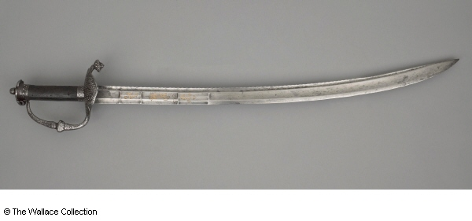

*Initial development – The curve of the blade is hand drawn.*

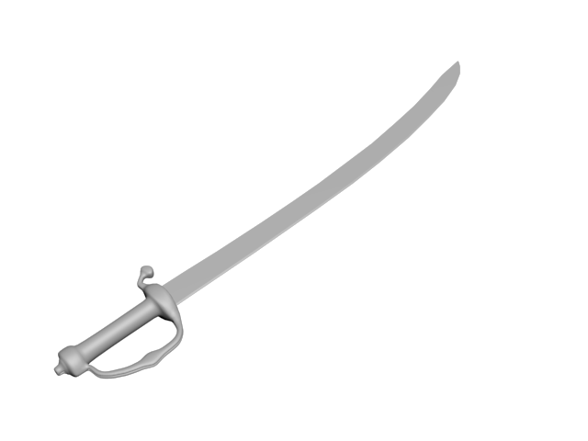

*With textures added.*

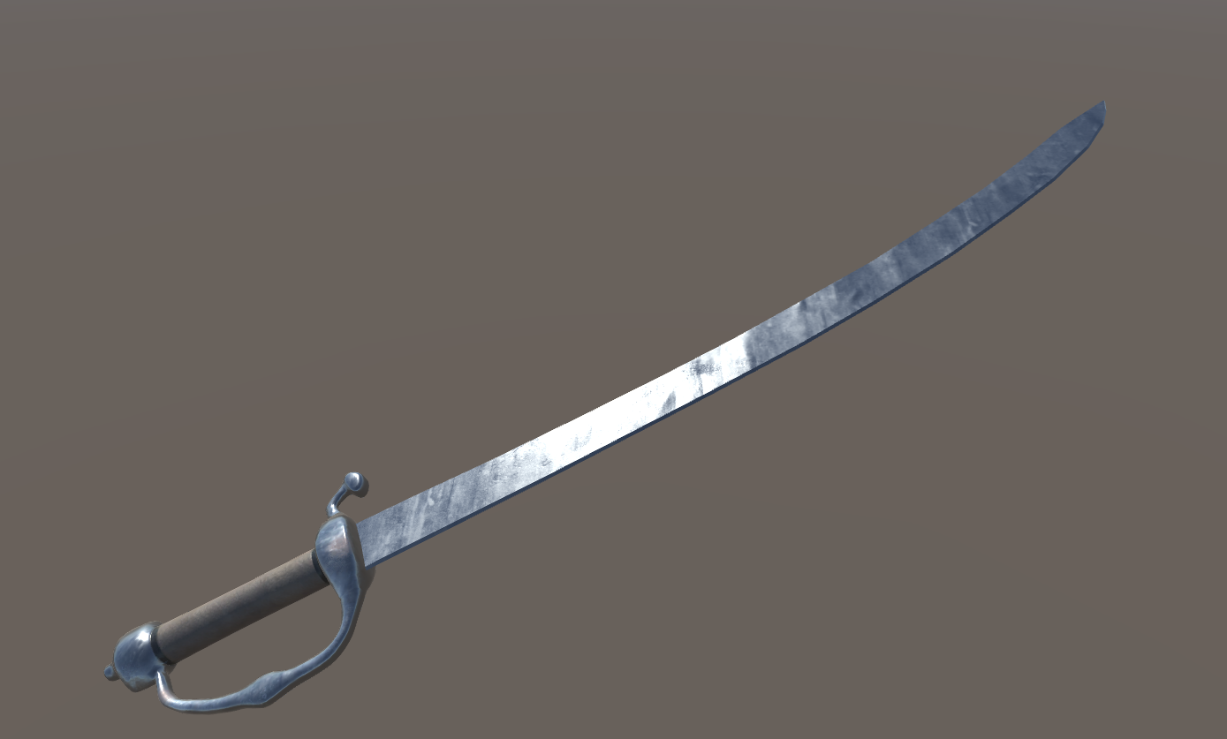

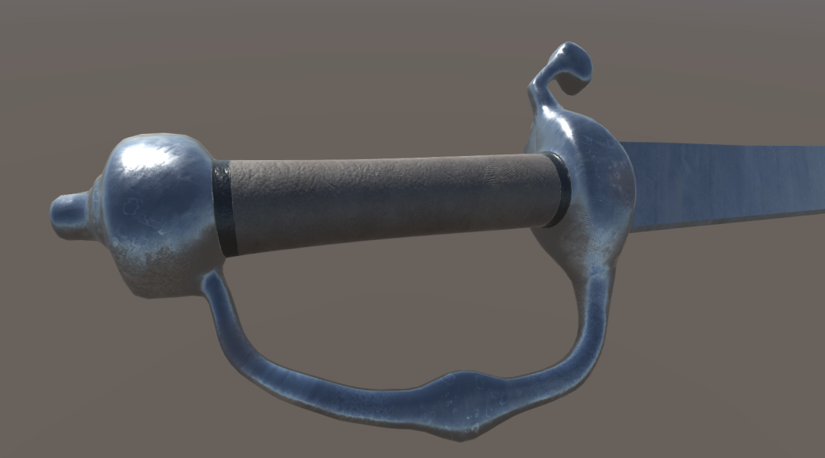

Refer to *Appendix 6: Sword design images* for additional photos of development.

# Part 4 Technicalities]

Firstly, we want to acknowledge for a project this size there are many more roles and skills required then what the team currently has capacity for, and we are all planning on wearing many hats throughout the project as we work on the different areas of the game. That being said, everyone has areas of preference and skill that gives them a leaning towards a particular role. We have allocated some specific roles in the group based on individual skills sets.

* **Michael Seymour** – Lead Designer. The concept and story of this project are from Michael’s original idea from Assignment 1, making him Lead Designer on the project.
* **Lee van den Blink** - Project Coordinator/Sound – Lee is skilled in project management, minute taking and keeping track of the tasks required and allocations.
* **Cory Atkinson** – Programmer/Design – Cory has experience in programming and game design and mechanics, so queries around this part of the project are well suited to him.
* **Nickolas Young** – Level and Art Design - Nick has some background in level and art design around game projects and this is also an area he is wanting to develop further for his ideal job.
* **Nathan Christos** – Marketing, Research and Development. This role was suited to Nathan as he’s efficient at sourcing whatever unknown information is needed and quickly getting up to speed.
* **Harrison Williams** – Research and Development. Harry was happy to take up a research-based role to take the opportunity to learn more about game development.

Other key roles that would be required for the completion of the project would include Art Director, Quality Assurance, environment artist and sound engineer/composer.

## Scope and Limits

From the outset we already knew that this project was far bigger than the timeframe of 4 weeks to bring it to anywhere nearing completion.  In a way this allowed us to realistically discuss from the outset what our expectation regarding production would be.

We decided that the best way to approach the game was to aim at creating enough of a picture of the final product, with the idea that this would then be presented to an investor or company that would be interested in taking the project on and completing the development. Essentially, we are providing the design framework for the game to then be developed with.  There would still be a great deal of writing, planning and programming and development that would be required to bring this project anywhere near completion.

The time frame section outlines this as well but the main aims for Group Fourteen to produce by the end of the assignment would be:

* -An outline of the event in history that the game is based on - The Batavia Mutiny in 1629.
* -Description of the player character and key NPCs with background outlines.
* -An outline of the main story arc based on the historical event.
* -Description of the major events in Act I and Act II.
* -Describe the Hub based design for quests in Act I, and the story driven arc of Act II
* -Overview of the Moral Choice Game Mechanic, which is a key component of determining if specific choices are available/successful.
* -An overview of the level design and object design.
* -Develop a sample soundtrack to communicate the atmosphere and feel of the game and describe the sound direction for the game.
* -Develop a presentation to accurately represents the scope and aims of the game, with the intent of presenting to a potential investor.

There are many areas that would require additional development, which are also outlined in the time frame section. These include but are not limited to:

* -Finalising the branching story pathways
* -Finalising the moral choice and influence system including the impact this will have on the potential pathways.
* -Completing the script.
* -Development of graphic elements (this includes animation of characters, level design, 3D modelling, the Head Ups Display (HUD.)
* -Programming the various gameplay mechanics
* -Testing/Debugging processes
* -Marketing and demographic research

## [Tools and Technologies]

*[*What software or other tools are required by the project? Are there any software licenses needed? Is there any hardware needed (beyond a standard laptop or something similar)? This needs to be precise (e.g. Windows Movie Maker Version 45.3) but needn't be long. You should also include a brief description of any prior experience any group members have had with the tools and technologies you list.*]*

[ - One paragraph (no minimum but be concise)]

## Testing

This project will require the presence of a dedicated Quality Assurance (QA) team to ensure the final product is an issue free experience for consumers. The QA team will work closely with developers from the earliest stages of the project to the release of the final product, testing builds from prototype and pre-alpha to final for the purpose of delivering feedback and issue reports which the developers can read and act on in order to fix bugs and improve the overall gameplay experience. The QA team’s duties will evolve with the project, as will the size of the QA team as the project grows and the testing of an increasing amount of content is required.

The duties of Quality Assurance staff are primarily meticulously and repeatedly performing actions in the game depending on what is required to be tested, whether it’s a new mechanic, a new level or a new graphical implementation. If an issue or bug is found by a QA tester, it must be thoroughly documented with as much detail as possible regarding the bug itself and the tester’s actions prior to and during the bug’s occurrence. The documented issue – the bug report, can then be passed on to the development team which can act on the information given and fix the issue. QA testers should possess good English and technical writing skills, so they are able to note and document issues in an accurate and practical manner which can easily be read and understood by others.

The hiring standards for a Quality Assurance tester could be summarized as the following:

* High School Diploma should be required.
* Should be familiar with video games as a medium and should have a lot of experience playing a wide variety of video games.
* Should have strong written and verbal communication skills.
* Experience within the games industry and/or prior experience software testing is a plus.
* Experience with technical writing is a plus.

There is no concrete standard for the ideal amount of Quality Assurance Testers on a development team, though 1 tester for anywhere from 2 to 4 developers is generally accepted as a good amount – though having highly experienced or dedicated testers is more valuable to the testing process than simply having many testers.

# Part 5: Timeframe





# Part 6

## Risks

Risks What risks can you identify for your project? There will always be some generic risks (such as computers breaking down the night before a deadline, health and family issues, and institutional changes). Do not include generic risks such as these. The idea is to be as specific as you can to your project. For example, if your topic is to develop a game, there may be a risk that the software you choose to work with may be very difficult to learn, poorly documented, or not turn out to have the features that it claims it has. These properties are often only discovered once you have started working with the software, and so unless you have had lots of experience with the particular tool, there is always a risk that it may not work as well as you believe it should, no matter how much prior research you do. Similar comments apply to hardware.

Risk analysis for works entailing completion of Project-MCS are numerous in nature as this is a somewhat ambiguous task at the time of project planning. Risks as follow are identified in order of urgency.

1**- Complacency**; The MCS project is a sizeable undertaking which is expected to evolve over the duration of design. Understanding this the number one risk is failing to identify future risks as they arise further into the project. Measures to be taken should include regular management meetings involving the senior design staff and purposeful effort to identify any new risks having arisen with implementation of new strategies, staff and or technologies.

2- Intellectual Property; All members operating under the banner of groupFOURTEEN and having access to creative content pertaining to Project-MCS will be required to sign the officiated legal documentation regarding Intellectual Property. All Members of Project-MCS are to understand any content or related works commissioned as per the project brief are property of groupFOURTEEN for the contractual timeframe signed upon.

3- Private Information; Extreme care is to be taken throughout the duration of the project to ensure any sensitive information regarding it's creation is not leaked. Furthermore to this, members of the project are encouraged to avoid sharing information with other project members where unnecessary. Diligence is to be taken keeping the project scope up to date and ensuring members only work on components stipulated within the documentation.

4- Project Dissolution; Project-MCS as previously mentioned, is an elaborate undertaking. As observed in the industry, many Indie games fail to see completion due to many factors, most notably differing artistic vision. Planning is to be done entailing various stages throughout the design incorporating benchmarks of completion. These benchmarks will be stages at which Project-MCS can be either repurposed or scaled back to retain efforts in a worst case scenario.

5- Poor Product; While many potential risks could be highlighted, a fundamental risk often ignored is bad overall product quality. Many Indie and even triple A titles fail to meet the quality of product as depicted in planning. Measures are to be taken to ensure Project-MCS does not fail at meeting desired quality by implementing KPI benchmarks and conducting regular peer reviews.

## Group processes and communications

[*Communication between group members is arguably the most important aspect of your project. Past experience has shown that communication breakdowns between group members is the most common cause of project failures, so it is vital that you specify at the outset the means and expected frequency of communication between group members. How will your group communicate? How often will meetings take place? Will these be face-to-face, or using technologies such as Skype? Or Facebook? Or email? Or text? Or ... ?? What will you do if you have a group member who does not respond to communications? You should expect contact between group members at least twice a week. You can always make contact more often if you wish, but you do need to know what minimum*  
*frequency is expected from all members of your group.*]

[ - One paragraph]

Skills and Jobs

For this project to undergo meaningful progress it is crucial that those employed are highly skilled at their role and possess excellent communication qualities. The four key individuals employed to work on this project will be required to be in constant communication with each other in order to maintain a consistent idea of what the project is, what they need to do and how they need to go about achieving their tasks. They will be responsible for developing an early prototype of the project which will represent what the ultimate outcome is aiming to achieve. This prototype will need to be playable and it – as well as the development behind it, should be comprehensible to any future hires so they can clearly understand what the project is, the development process and the desired outcome of the project.

The four crucial roles that will be relevant to developing this prototype will be:

# Game Designer

* + The Game Designer will be responsible for creating and developing the core mechanics of the project, defining the gameplay for the purpose of creating a fun, immersive and engrossing experience for the player. They will work closely with other departments and should be able to communicate and discuss ideas effectively while ensuring that a shared vision is maintained across the development team. The Game Designer’s initial responsibilities will be writing a Game Design Document which will house *all* relevant information about the game which can be referenced by all members of the project. The Game Designer should also be experienced at using Unreal Engine 4, as they will need to be able to develop the prototype in-engine during the later stages of its development.

# Writer

* + The Writer will be responsible for constructing the story, scenarios, quests and dialogue that closely reflect the events of the Batavia Mutiny while introducing elements that will allow for an engrossing player experience during gameplay – as one of those who remained in the Abrolhos. The writer will be required to become familiar with the events of the Batavia Mutiny - and the historical period it occurred, so they will be able to create realistic scenarios while maintaining historical accuracy when it is relevant. The writer would be required to communicate closely with the Game Designer during the writing process and be able to take feedback and use it to alter their work if necessary. They should be experienced at using word processors such as Microsoft Word.

# Programmer

* + The Programmer will be responsible for implementing the gameplay systems and mechanics into the prototype. They will work closely with the Game Designer, discussing and creating decided upon features necessary for the prototype to fulfill its purpose and allowing the player to interact and perform actions in the game world in a seamless manner that does not hinder gameplay or the user experience. While the systems the programmer designs for the prototype do not have to be of shippable quality, they should perform their function and the code should be clearly documented and expandable for further development. The programmer must be experienced in the C++ scripting language for game design purposes and Unreal Engine 4.

# 3D Artist

* + The 3D Artist will be responsible for creating 3D assets of both placeholder and final pass quality. These assets will be used in the prototype version of the project to populate the island with static and dynamic props such as foliage and man-made equipment. They will also be required to design placeholder human character models that can be used as stand ins for the prototype until the art team is expanded. The artist will be required to study the time period and the location in which the game takes place so they can accurately recreate the equipment the sailors may have used and the environmental aspects of the island (foliage, rocks, coral, etc.). Due to the scale of the task, it will be acceptable for the artist to create assets of placeholder quality, though these assets must be legible to those playing and the artist must be able to create high quality assets if required. The artist must be experienced in an industry standard 3D modelling program such as Blender, Autodesk 3DS Max or Autodesk Maya. Experience in art tools such as Substance Designer and Substance Painter is a plus.

It is essential to note that these four roles are the minimum requirement to develop a small prototype of what will be the final project. The team will need to be expanded in future to accommodate for a multitude of required roles such as sound designers, voice actors, an art team for both 2D and 3D assets with various specialties (Concept art, Characters/Weapons/Environment, animation), an expanded game design team, programmers specializing in gameplay, systems and engine and more.

Reflections

Refer to *Appendix 1: GitHub Repository History – Sample* for evidence of GitHub commit history.

Refer to *Appendix 2: Group Discord Discussion – Sample* for evidence of use of Discord.

# Individual reflections

### Nicholas Young

This assignment has been an interesting and educational experience for me in a multitude of ways. I feel like I was able to effectively utilize my knowledge of game design while performing written tasks and I was able to learn a bit more about 3D asset creation and texturing through the creation of a 17th century sword to be used as visual content for our project. I also found learning about the Batavia Mutiny – the subject of the game we are writing our project plan for – to be very interesting and educational. I did feel however that I did not contribute as much as I could or should have, and I wish that I had been more proactive in procuring tasks for myself earlier in the stages of the assignment.

As in Assignment 2, I feel our group performed exceptionally and addressed our problem of lack of structured communication effectively going into this assignment in the form of weekly catch ups on Discord. This has helped us gain and solidify our footing at the beginning of each week, ensuring we know what’s happening with other group members and where we are at with our various tasks. It was surprising to me how effective these catch up sessions were, especially as I personally did not think they would be that impactful beforehand.

### Lee van den Blink

After completing assignment 2 I felt confident to continue to build on this momentum with my fellow team mates. We realised from the outset that assignment 3 (and 5) required more collaboration as a whole. Deciding to add a weekly catch up with everyone really assisted with this as we could collectively think through the challenges, and agree on tasks going forward. I think one thing that really benefited this project was having a clear vision of what the project was about. This was aided greatly by Michael’s vast knowledge of the event, and I felt like we were all able to make good contributions with ideas on game mechanics and design. I thoroughly enjoyed getting the change to pretend to be a sound designer for an atmospheric, dark and emotive game. I feel like each member of the group played to their strengths and took ownership. We caught up regularly with our meetings, and communicated constantly outside of this as well.

If I had to improve one thing it would be everyone attend each meeting so we didn’t feel the need to allocate tasks, but to be realistic this would be pretty hard to do with everyone’s availability being so varied, and is only a minor nitpick.

Something else I’ve really enjoyed as part of this project is through our constant group discussions on Discord, I’ve learnt a lot from my group members about software and programming courses, and other pathways I can potentially take to learn more about development. I’ve just scratched the surface of the things that are required for game development, but I at least have an idea of where I can potentially start, thanks to the knowledge of my team mates.

I’ve always known when it comes to group work that communication and planning is key, and I’ve been extremely pleased to be part of a team where it really felt like a shared goal, along with a shared enthusiasm for the topic, really helped us to collaborate and create a game framework that I think we can all be really proud of.

### Michael Seymour

I remember, in the early weeks of the course when we were sharing our ideas for our main project, I pitched the idea for the game which we’ve outlined here in this report. I was very happy to have it chosen as the topic has been a pet research project of mine for years. To be able to properly sit and plan through some of the details that had previously been vaguely floating around my head has been very enjoyable.

One thing which went well was the regularity we kept with our weekly scheduled online meetings since our group members are scattered around Australia (and myself on the other side of the world), and the enthusiasm everyone always brought to them, despite other obligations we’ve all had. Having said that, it wasn’t always possible to have all the members available online regularly, due to the obvious difficulties of personal life events and time zones.

Something which was surprising to me was the mix of excitement and responsibility I felt as the lead designer of this project. At first, I was very excited for the group to choose my idea, but during the course of writing the project I’ve also felt anxiety over what the final result will be, and whether my idea is good enough to support the assignment. But the team has been a wonderful support to rely on from start to finish, with everyone always willing to offer helpful advice, additions and feedback, and we’ve had very enthusiastic and productive weekly team meetings. I’m very pleased with and proud of what we have accomplished together.

### Cory Atkinson

### Nathan Christos

### Harrison Williams

# Group reflection

For Assignment 3 our group has maintained a similar process to that of Assignment 2 with some improvements which have positively impacted our work. In terms of our team dynamic and communication habits Assignment 3 has very much felt like a natural continuation of Assignment 2, with no dramatic changes in our work ethic aside from what could be called a more “specialized” approach to task allocation. As the purpose of Assignment 3 is to develop a project plan based off of one of the ideas of our group members, we have taken a different approach to allocating or choosing some of our tasks. Those who have knowledge or experience in some of the tasks required for our project plan were given certain sections as a way to provide higher quality work with less time needed to research those topics. Michael, the group member whose project idea was chosen for Assignment 3, greatly assisted with this as he provided content relating to his project idea which facilitated our work and provided us with a detailed vision for his project which we were able to further develop and build off of.

As for group communication, in addition to our regular Discord interactions we have allocated a time on Sunday Nights at around 7-7:30pm (AEST) where we all come online to discuss our work on Assignment 3, such as task allocation and our progress with any work we are currently doing for the Assignment. This has proved to be a major benefit for our work as it provides us with a way in which we can develop ideas, discuss tasks in depth and further develop the project plan with every group member present and able to interact, discuss and provide input in real time. Our regular communication could be improved somewhat, though this issue is mainly caused by issues relating to time zones and personal schedules differing between group members. This hasn’t impacted our work negatively in any major sense; however, it can be an issue at times when a certain group member wants to discuss something or needs feedback but no one is available to do so for indeterminate amounts of time. Overall despite these minor issues our group remains a comfortable and effective workspace in which we can operate in an effective and cordial manner.

Appendices

# Appendix 1: GitHub Repository Documents (Sample)

Main

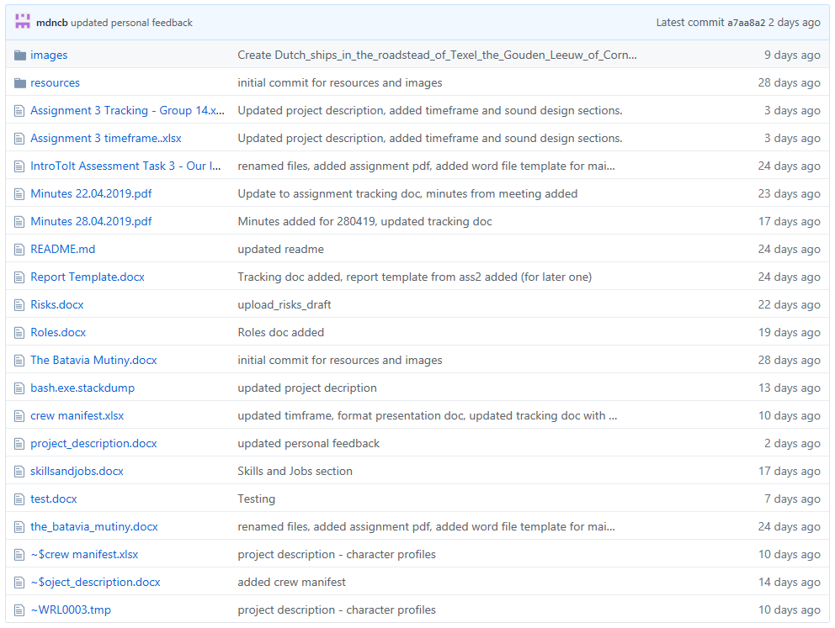

Main/Images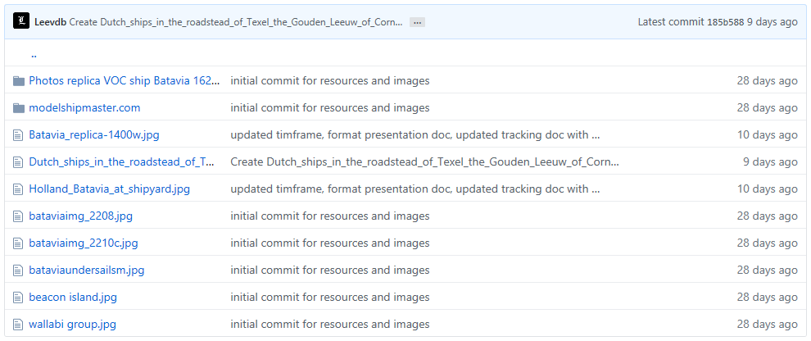

Main/Images/modelshipmaster.com

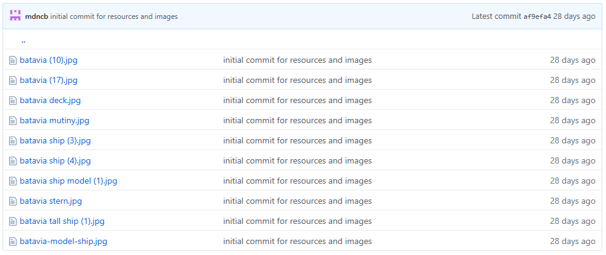

Main/Images/Photos replica VOC ship Batavia 1628 (Full list is 100+ files)

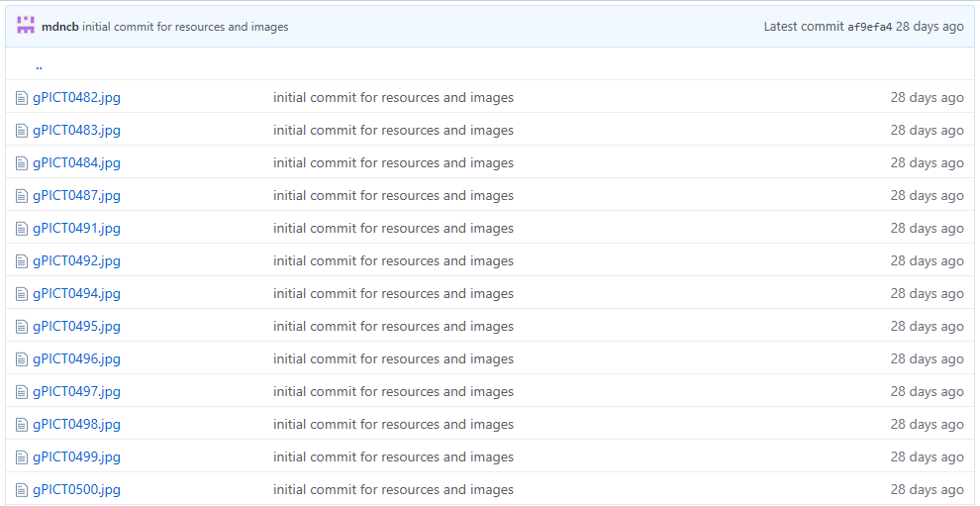

Main/Resources

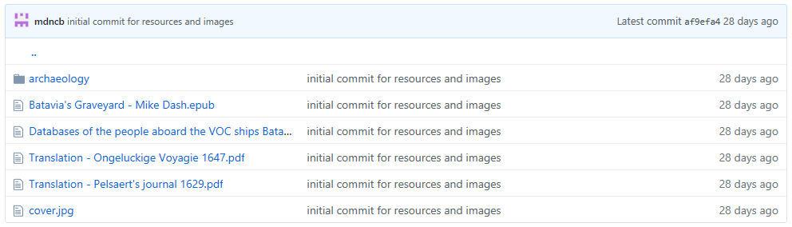

Main/Resources/Archaeology

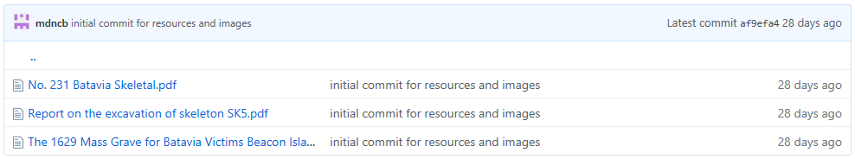

# Appendix 2: GitHub Repository Commit History

# Appendix 3: Group Discord Discussions (Sample)

# Appendix 4: Minutes of meetings (Sample)

# Appendix 5: Sound Design Sample Soundtrack

Ambiance

These are on YouTube, we may be required to purchase or recreate these as they are copyright protected, so these are listed as reference sources only at this stage.

|  |  |
| --- | --- |
| Pirate Ships Ambient sounds | https://www.youtube.com/watch?v=HxGOs62HQjk |
| Storm at Sea | <https://www.youtube.com/watch?v=AsD5u6k6dKI> |
| Island Sounds | <https://www.youtube.com/watch?v=DGIXT7ce3vQ> |

Music & Themes

The following tracks are all sourced from [Kevin Macleod](https://en.wikipedia.org/wiki/Kevin_MacLeod) and are royalty free. All are available from <https://incompetech.com/>

Click on each Track name to be taken to a YouTube video of the song.

|  |  |
| --- | --- |
| Track Name | Description |
| [Lord of the land](https://www.youtube.com/watch?v=GK-ewcB8p7g) | Slightly chirpy, upbeat and unassuming. Used early game when things are going well and still fun, before the player is thrust into the conflict. |
| [Unseen Horrors](https://www.youtube.com/watch?v=YYDPjM1z2ZU) | Menacing, discordant, extremely tense. Impossible to relax |
| [Teller of the tales](https://www.youtube.com/watch?v=i-Pg3apUIWA) | Folksy with a medieval villager theme. Another track suited to early game and introduction stages of the game. |
| [Dark Times](https://www.youtube.com/watch?v=NhvlLyYe2iY) | Slow, sombre, dark and sorrowful. |
| [Anguish](https://www.youtube.com/watch?v=cR8V-JLRfNI&list=PLx53r85FKaLyGUec4f9LJUXuCfrFRUV15&index=66) | Gentle and unnerving. Perfect for scenes that require sneaking and stealth |
| [Bittersweet](https://www.youtube.com/watch?v=H6ydejhm4EY&list=PLx53r85FKaLyGUec4f9LJUXuCfrFRUV15&index=36) | Sorrowful, reflective. A moment of solitude or solace. Mostly solace. |
| [Malicious](https://www.youtube.com/watch?v=DKgojP9ZKfA&list=PLx53r85FKaLyGUec4f9LJUXuCfrFRUV15&index=24) | lightly subtle, but still an underlying sense of unease. This isn’t the action scene, but this may be used the scene or two before it all really goes down. |
| [Morgana Rides](https://www.youtube.com/watch?v=-dEn77yy_1U&list=PLx53r85FKaLyGUec4f9LJUXuCfrFRUV15&index=1) |  |
| [Darkling](https://www.youtube.com/watch?v=e9zKKirJJbc&list=PLx53r85FKaLyGUec4f9LJUXuCfrFRUV15&index=19) | Pulsing, upbeat and tension building. |

Inspirational tracks (copyright protected)

Assassins Creed 3 OST / Lorne Balfe – The Aquila (<https://youtu.be/N2JIByYimZI>)

The main theme of this track swells like the waves, and evokes feelings of trepidation, conflict, and determination.

# Appendix 6: Sword design images

The original image is a sabre from the time period and sourced from <https://www.wallacecollection.org/>.



*Initial development – Image 1 and 2 below. The curve of the blade is hand drawn.*





*Image 3, 4, 5,6 – Textures added.*





