Software Design Specification

* **Purpose**

The purpose of this document is to give to our team members and all developers around the world a visual perspective of the workflow and interaction among various components of our **Event Manager System**.

* **Scope**

This SDS (software design specification) document is centered on the design and structure aspect of boundaries, controls and back-end processes.

Here implementation and testing will not be emphasized, but however some illustration of implementation may be seen.

* **Definitions, acronyms and abbreviation**

|  |  |  |
| --- | --- | --- |
| **Items** | **Types** | **Description** |
| **UI** | Acronym | User Interface |
| **Auth** | Abbreviation | Authentication |
| **DB_Manager** | Abbreviation | Database Manager |
| **GUI** | Acronym | Graphical User Interface |
| **Info** | Abbreviation | Information |

* **Sequence diagrams**

**Login**

The login process of Event Manager is describe as follow:

The user types his username and password through the GUI, which will create and **Authentication** object.

**Authentication** class will create a **DB_Manager object** by sending a requestCheck.

From there DB_Manager object will finally make selectQuery to the database and return a **User** object back to the **Authentication** which will check if the result is null then throw and exception otherwise relay the **User** info.

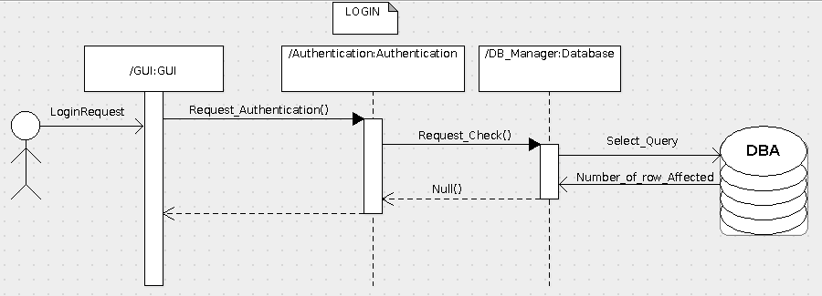

**Sign up**

As for the Signup process. The user will enter his personal details into the appropriate fields provided by the GUI (First Name, Last Name, email, e.t.c). The GUI then creates a Registration object via the **Request_Registration()** function. When this is done the **Registration** class further creates a **DB_Manager object by** making a **Registration_Inquiry()** and the **DB_Manager** finally sends an **Insert_Query()** to the **Database** which responds with a Boolean *true*/*false* and the number of rows affected. The **DB_Manager class** handles this **Database response** accordingly by creating a **User object** and sending it back to the **Registration** and finally to the **GUI** in case of a Boolean *true*, or by sending anull value back to the **GUI** through the **Registration** in the case of a Boolean *false*.

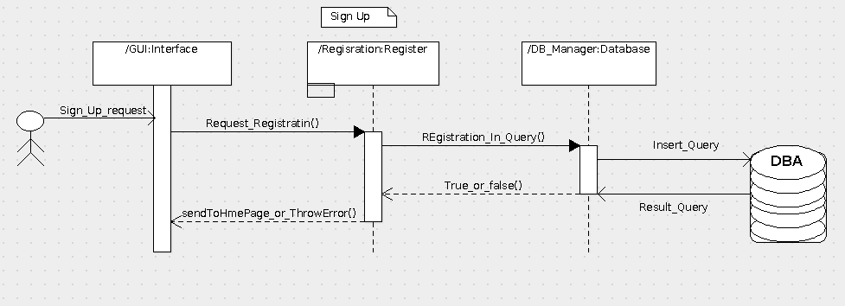

**Logout**

In the Logout sequence, the user simply interacts with a *Log* *out* button provided by the **GUI**. From here the **GUI** creates a **Session** **object** via a **Send_Session_Close()** function which returns a *Session* *close* back to the **GUI**.

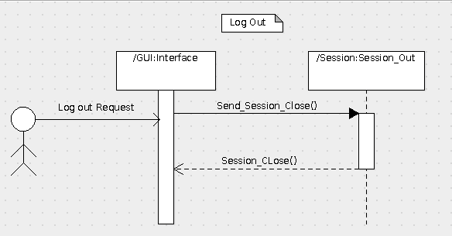

**Join Even**

To complete the join event process, the user begins by clicking a *Join* *Event* button provided by the GUI which then relays the users **Join_Request()** to the **DB_Manager**. From here an Update_Quary is sent to the Database which responds with a *number of rows affected* response and a Boolean *true*/*false* which is finally sent back to the **GUI**.

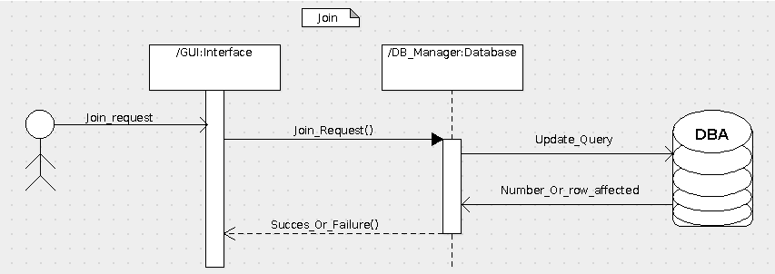

**Display Profile Info**

In order for the user to view his/her profile info, the user clicks on a *View* *Profile* button provided by the GUI. A **DB_Manager** **object** will be created by the GUI via a **View_User_Info()** function. The **DB_Manager** **class** will the send a **Select_Quary()** to the Database which will then respond with a **quaryResult**. The **DB_Manager** will then respond to the *Query* *Result* by returning a **User** **object** to the **User** **class** which will then relay it back to the **GUI**.

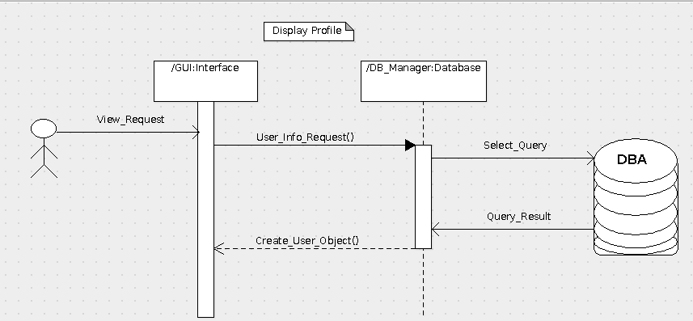

**Create Event**

To create an event, the user interacts with a *Create* *Event* button provided by the **GUI** by simply clicking the button. The GUI then creates Authentication object via the **Create_Event_Request()** function. The Authentication class further creates a DB_Manager object through the **Add_Event()** function and the **DB_Manager** finally sends a **Select_Query()** to the **Database** and begins to handle the *Select* *Result* returned by the **Database** which of course is of Boolean form. In the case of a false, the **DB_Manager** will send a *null*/*false* value to the **Authentication** which will relay an Event creation fail to the **GUI**. However in the case of a true, the **DB_Manager** will interact with the Database once more by sending an **Insertion_Quary()** to the Database and handles the response which will more likely be a number of rows affected and a Boolean true accordingly. The result is then sent to the Authentication and finally relayed back to the **GUI** as an Event Creation success or Boolean true. No **user** **object** is required here as no User info needs to be displayed.

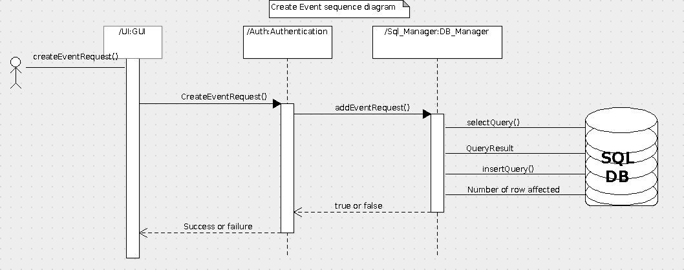

**Search Even**

In the search for Event process, the will enter Event info of the Event he/she is looking for in a search field provided by the **GUI**. Preferably in most cases this will be the Event Name. A **SearchAgent** **object** is then created by the **GUI** via the **Search_Request()** function. The **SearchAgent** then creates a **DB_Manager** **object** through the **Search_Event()** and finally the **DB_Manager** sends **Select_Quary()** to the **Database** which further responds with a *Select* *Result*(Boolean *true*/*false*). The Select Result is handled appropriately by the **DB_Manager** and an **Event** **object** is created by the **DB_Manager** **class** and sent back to the **GUI** as an Event Search *success* through the **SearchAgent** **class** for the Boolean *true* case. In the case of a false *Select* *Result* from the Database, the **DB_Manager** will send a null value to the **SearchAgent** **class** which will relay it to the **GUI** as an Event Search failure.

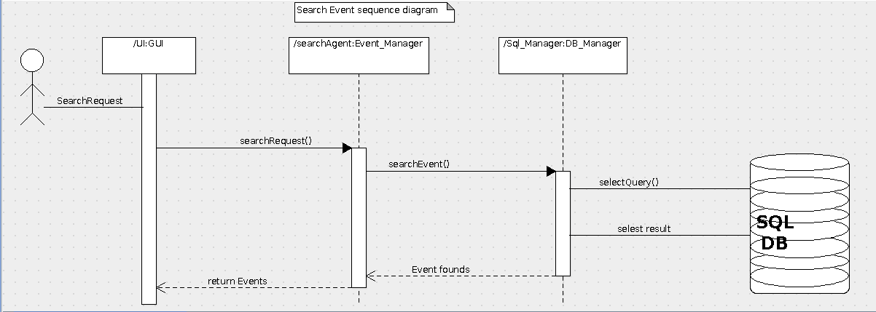

**Delete Event**

In the delete event process, the user enters the Event info of the Event he/she intends to delete and clicks on a *Delete* button. All these interfaces will be provided by the **GUI**. When this is done, an **Authentication** **object** will be created by the **GUI** via the **Delete_Request()** function. From here the **Authentication** class creates a **DB_Manager** **object** through a **Request_Event()** function and the **DB_Manager** finally sends a *Select Query* to the Database which will return a *Select* *Result*(Boolean *true*/*false*). In the case of a *true* Boolean value, the **DB_Manager** will return the Boolean *true* to the **Authentication** class which will then create another **DB_Manager** **object** but this time through the **Delete_Event()** function and the **DB_Manager** will interact with the Database once again, but this time with a *Delete* *Query*. A Boolean *true* and *number* *of rows* *affected* *response* is handled by the **DB_Manager** once again assuming no network or other errors occurred and is sent to the **Authentication** class which further relays the response(Boolean *true*) back to the **GUI** as a *Deletion* *success*. However in the case of a Boolean *false* *Select* *Result* response from the Database, the **DB_Manager** sends the result which is a *null* value to the **Authentication**, which further relays it to the **GUI** as a *Deletion* *fail*.

**User Interface Preview**