***GROUP 4***

**ASSIGNMENTNT**

**DBI202 – Bookstore management system**

# TABLE OF CONTENTS

## Problem statement …………………………………………………………………………………………….

### Describe the problem ……………………………………………………………………………………………………….

### System Business Description …………………………………………………………………………………………………..

## entity – er …………………………………………………………………………………………

### List of data constraints …………………………………………………………………………………………..

### ER Diagram

### …………………………………………………………………………………………….

## data dictionary ………………………………………………………………………………………………………….

### Database and table ……………………………………………………………………………………….………………….

### full diagram ……………………………………………………………………………………….………………….

### create trigger ……………………………………………………………………………………….………………….

## SQL COMMAND

### sell report ………………………………………………………………………………………………………

### number of book sold report ……………………………………………………………………………………………………

### number of buyer report

### …………………………………………………………………………………

### book with highest sale volume

### ……………………………………………………………

### top 5 buyer report

### ………………………………………………………………….

# Problem statement:

## Describe the problem:

_ In the modern age of technology, the Internet has played a significant role in people's lives. It has greatly improved the quality of life and standards of living for many individuals. The Internet has expanded into various fields and levels. E-commerce is one of the sectors that has emerged in recent years. Online bookstores have helped many book lovers by making it easy for them to purchase books online. Sometimes it is not convenient to visit a traditional bookstore, as it is limited by operating hours, the availability of a specific book, its location, and most importantly, the necessary space to store many books. Such limitations have led to the development of e-commerce industries related to bookstores. Our project is to create a database for a simple e-commerce website, containing various types of books so that consumers can shop online.

## System Business Description:

2.1. Book Management:

_ Add books:

+Administrators have the right to add information about new books to the system.

+Required information includes book title, author, price, inventory quantity, and other details.

_ Edit books:

+Administrators have the right to edit information about books.

+Update information such as book title, author, price, inventory quantity, and other details.

_ Delete books: Administrators can delete book information from the system.

_ Update quantity: The system will update the quantity of books remaining in stock.

2.2. Book Category Management:

_ Create book categories:

+Administrators have the right to create new book categories.

+Each category has a name to describe its content.

_ Manage book categories:

+Administrators have the ability to add or delete books from categories.

+Users can search for books based on categories for easy browsing and selection.

2.3. Customer Management:

_ Manage personal information:

+The system will update basic customer information when customers fill out information in the purchase form.

+For convenience in contacting to confirm orders and identify returning customers.

_ Registration:

+Customers can register an account on the website.

+Required information includes username, password, first and last name, email, address, and phone number.

_Login: Users can log in with their username and password.

2.4. Order Processing:

_Receive orders:

+The system receives orders from users after they have selected books and proceeded to payment.

+Record information about the order, the products ordered, and customer contact information.

2.5. Order Status Management:

_ Update order status:

+Administrators can update the status of orders from "Processing" to "Shipped" and "Received."

+The system automatically updates the status based on the order processing.

2.6. Payment:

_ Payment processing:

+The system processes payments for orders using online payment methods such as credit cards, e-wallets, or direct payments.

+Record payment information and update the payment status of orders.

2.7. Statistical Reporting:

_ Export daily, monthly, yearly reports:

+Revenue report.

+Report on the number of books sold.

+Report on the number of customers.

+Books with the highest sales.

+Top purchasing customers.

# II. entity – er:

1. List of data constraints:Base on the problem description and management objectives, we can present several entities and attributes of the entity as follow:

* Student: **StudentID, GuardID,** First Name, Last Name, Email, Phone, Gender, Course, Role, Country.
* Register: **RoomID, StudentID,** Check-In, CheckPrice.
* Room: **RoomID** ,Name Dom, Floor, Location, Number Bed, Gender, Status.
* Fix Detail: **RoomID, ItemID,** Fixer, Date Report, Date Dix, Quantity.
* Items: **ItemID**, Name, Content, Price.
* Student Penalize: **StudentID, PenalizeID,** Date, Quantity.
* Penalize: **PenalizeID**, Name, Price.
* Guard: **GuardID*,*** First Name, Last Name, Email, Phone.
* Manager room: **RoomID**, **GuardID,** Name Dom, Price.

## 2. ER Diagram:

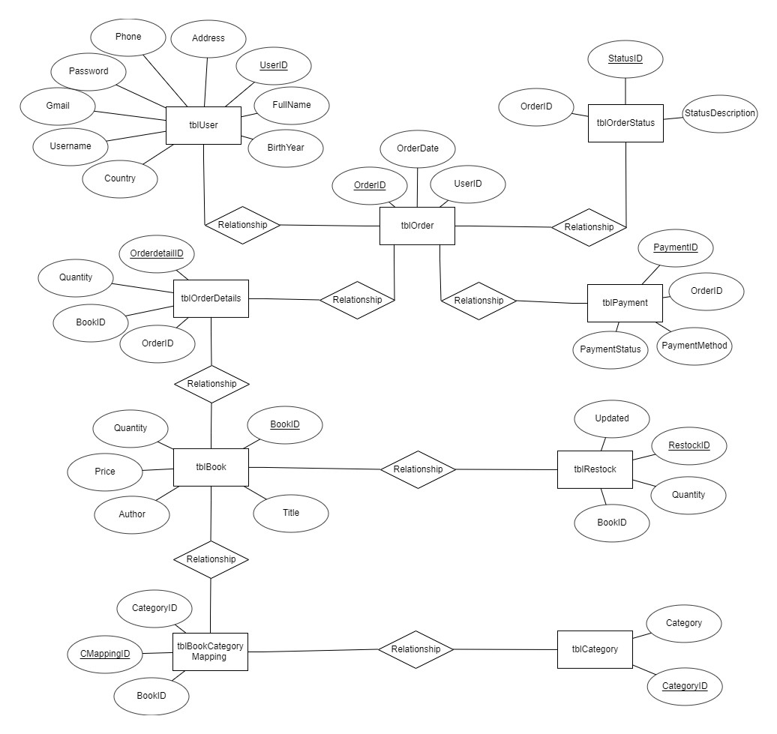

# data dictionary

Just for example on some tables (other table are similar, you have to define all the tables in your database). Note: to run the query you have to define the table 1 first then go to the side tables much

## 1. database and table

### cREATE DATABASE **PROJECTDBI202**

--create database

CREATE DATABASE BOOK_STORE

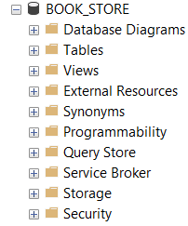

### **Create table book**

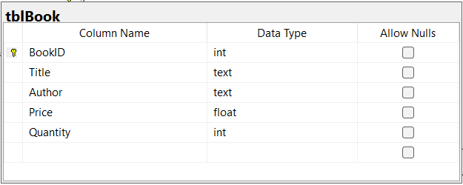

***Code:***

--create table Book

CREATE TABLE tblBook (

BookID INT PRIMARY KEY,

Title TEXT,

Author TEXT,

Price FLOAT,

Quantity INT)

***Example:***

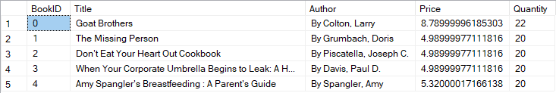

### **Create table REstock**

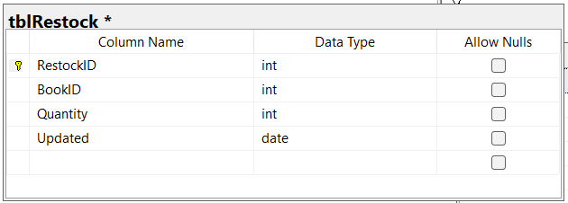

***Code:***

--create table restock

CREATE TABLE tblRestock (

RestockID INT PRIMARY KEY,

BookID INT FOREIGN KEY REFERENCES tblBook(BookID),

Quantity INT,

Updated DATE);

***Example:***

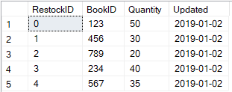

### **Create table Category**

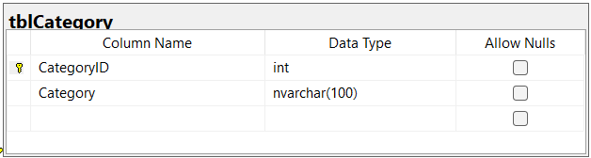

***Code:***

--create table category

CREATE TABLE tblCategory (

CategoryID INT PRIMARY KEY,

Category NVARCHAR(100));

***Example:***

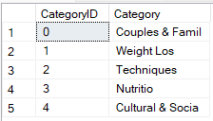

### Create TABLE **BOOK category mapping**

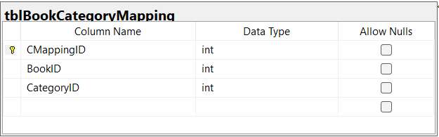

***Code:***

--create table Book Category Mapping

CREATE TABLE tblBookCategoryMapping (

CMappingID INT PRIMARY KEY,

BookID INT FOREIGN KEY REFERENCES tblBook(BookID),

CategoryID INT FOREIGN KEY REFERENCES tblCategory(CategoryID));

***Example:***

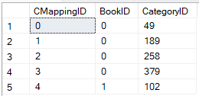

### create table user

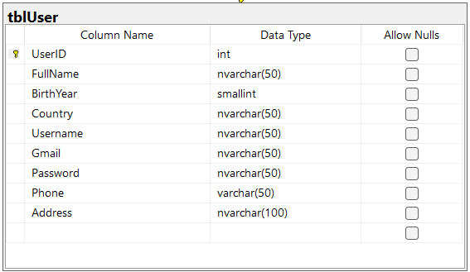

***Code:***

--create table user

CREATE TABLE tblUser (

UserID INT PRIMARY KEY,

FullName NVARCHAR(50),

BirthYear SMALLINT,

Country NVARCHAR(50),

UserName NVARCHAR(50),

Gmail NVARCHAR(50),

[Password] NVARCHAR(50),

Phone VARCHAR(50),

[Address] NVARCHAR(100));

***Example:***

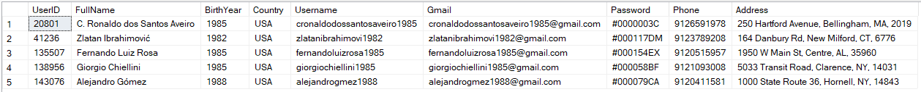

### create table **order**

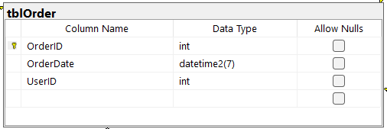

***Code:***

--create table order

CREATE TABLE tblOrder (

OrderID INT PRIMARY KEY,

OderDate DATETIME2(7),

UserID INT FOREIGN KEY REFERENCES tblUser(UserID));

***Example:***

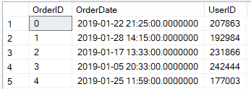

### create table **order detail**

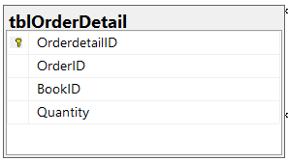

***Code:***

--create table order detail

CREATE TABLE tblOrderDetail (

OrderDetailID INT PRIMARY KEY,

OrderID INT FOREIGN KEY REFERENCES tblOrder(OrderID),

BookID INT FOREIGN KEY REFERENCES tblBook(BookID),

Quantity TINYINT);

***Example:***

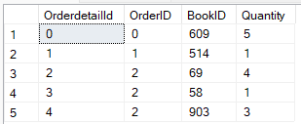

### Create table **order status**

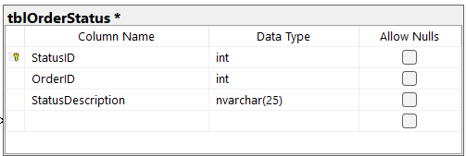

***Code:***

--create table order status

CREATE TABLE tblOrderStatus (

StatusID INT PRIMARY KEY,

OrderID INT FOREIGN KEY REFERENCES tblOrder(OrderID),

StatusDescription NVARCHAR(25) CHECK (StatusDecription IN ('Cancelled', 'Delivered', 'Processing')));

***Example:***

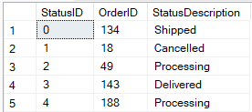

### create table **payment**

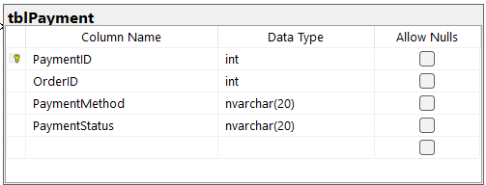

***Code:***

--create table payment

CREATE TABLE tblPayment (

PaymentID INT PRIMARY KEY,

OrderID INT FOREIGN KEY REFERENCES tblOrder(OrderID),

PaymentMethod NVARCHAR(20),

PaymentStatus NVARCHAR(25) CHECK (PaymentStatus IN ('Completed', 'Pending')));

***Example:***

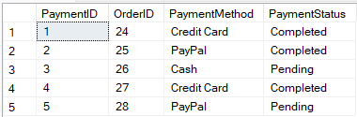

|  |  |
| --- | --- |
| full diagram |  |

## Create Trigger

### Create Trigger update book quantity through restock

-- Create trigger update book quantity

CREATE TRIGGER trgUpdateBookQuantity

ON tblRestock

AFTER INSERT

AS

BEGIN

UPDATE b

SET b.Quantity = b.Quantity + i.Quantity

FROM tblBook b

INNER JOIN inserted i ON b.BookID = i.BookID;

END;

***Example:***

### Create Trigger update book quantity through Order Status

-- Create trigger update book quantity through order status

CREATE TRIGGER trgUpdateBookQuantityOrder

ON tblOrderStatus

AFTER UPDATE

AS

BEGIN

SET NOCOUNT ON;

IF UPDATE(StatusDescription)

BEGIN

UPDATE b

SET b.Quantity = b.Quantity - od.Quantity

FROM tblBook AS b

INNER JOIN tblOrderDetail od ON b.BookID = od.BookID

INNER JOIN inserted i ON i.OrderID = od.OrderID

INNER JOIN deleted d ON i.OrderID = d.OrderID

WHERE i.StatusDescription = 'Delivered' AND d.StatusDescription != 'Delivered';

END

END;

***Example:***

### Create Trigger update Status description through payment status

-- Create trigger update status description through payment status

CREATE TRIGGER trgUpdateOrderStatus

ON tblPayment

AFTER INSERT

AS

BEGIN

SET NOCOUNT ON;

UPDATE tblOrderStatus

SET StatusDescription = 'Processing'

WHERE OrderID = (SELECT i.OrderID FROM inserted i WHERE i.PaymentStatus = 'Completed');

END;

# sql command

## Sale report

***Code:***

***Result:***

## Number of books sold report

***Code:***

***Result:***

## number of buyer report

***Code:***

***Result:***

## Book with the highest sales volume

***Code:***

***Result:***

## top 5 buyer report

***Code:***

***Result:***