Introduction to RMarkdown

Greg Rousell

13/06/2020

## R Markdown with a Word Template

This is an R Markdown document that knits to a Word template. Using this feature you can control the appearance of your documents.

The flextable package will format R data frames into tables. For more information on flextable see: <https://ardata-fr.github.io/flextable-book/index.html>

summary_table <- iris %>%   
 group_by (Species) %>%   
 summarise (`Sepal Length` = round (mean (Sepal.Length),1),  
 `Sepal Width` = round (mean (Sepal.Width),1)  
 )   
  
summary_table %>%   
 flextable()

| Species | Sepal Length | Sepal Width |
| --- | --- | --- |
| setosa | 5.0 | 3.4 |
| versicolor | 5.9 | 2.8 |
| virginica | 6.6 | 3.0 |

## Including Plots

You can also embed plots, for example:

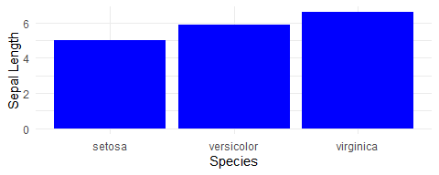

Note that the echo = FALSE parameter was added to the code chunk to prevent printing of the R code that generated the plot.