Performance Measurement

Writer:Qin Sheng

Date: 2013-9-17

Chapter 1: Introduction
Background:
Searching algorithm is widely used in our daily life, for example, we may use Google or Baidu to search the information we want, and different websites may have different speed. It is no wonder we all want to seek help from a swifter one. So it requires us to design a better algorithm. So we would like to choose a simple task--comparison between ”sequential search” and “binary search”, in order to find out the disparity while dealing with the same problem.
Problem description:
If we are given N integers from 0 to N-1, and we are supposed to search out N(which is not in the array), thus making a worst situation which takes us the most time.
Now we are supposed to compare two algorithm, one of which is “sequential search” which scans through the list from left to right, while the other one is “binary search” which checks if the number is the middle element, if not, choose the larger part or the smaller part to do the same procedure.
Our project includes these three steps:
(1) Implement an iterative version and a recursive version of binary search, together with an iterative version and a recursive version of sequential search;
(2) Analyze the worst case complexities of the above four versions of searching methods;
(3) Measure and compare the worst case performances of the above four functions for
N = 100, 500, 1000, 2000, 4000, 6000, 8000, 10000.

Chapter 2: Algorithm Specification
Sequential search(iterative version):
for i=0 to n-1 do
if a[i]==n then
we have find the right element, i is its index
else
continue;

Sequential search(recursive version):
void sequential_search(int i, int m, int n, int a[] )
{
if(a[i]==m)
return; //we have find out tht right element, i is its index
else
sequential_search(i+1,m,n,a);
}

Binary search(iterative version) ：
while (l<=r)
{
mid=a[(l+r)>>1];
if (mid==m) break; /
if (mid>m) r=((l+r)>>1)-1;
if (mid<m) l=((l+r)>>1)+1; }
return;
}

Binary search(recursive version):
void binary_search(int m, int l, int r, int a[])
{
int mid=(l+r)/2;
if a[mid]==m
return; //we have find out the right element and mid is its index
if a[mid]>m
binary_search(m, l, mid, a)
else
binary_search(m, mid, r, a);
}

Chapter 3: Testing Results
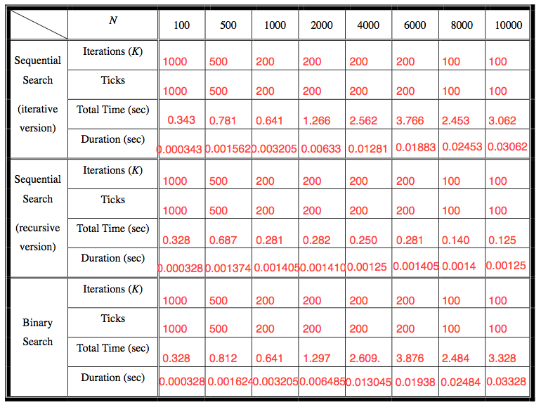

Chapter 4: Analysis and Comments
sequential search(iterative version)的time complexity为o(n)，故可以看到，随着N的增大，单次运行时间都呈现显著增长，与o(n)契合的很好
sequential search(recursive version)的time complexity为o(log n)，当N增大到一定值时，运行时间的增长十分有限甚至趋于平缓。
binary search的time complexity为o(n)，结论同第一种算法基本类似。
比较三种算法容易发现，在处理N较大的情况，o(log n)比o(n)具有明显的优势。

Appendix: Source Code (in C)
#include <stdio.h>
#include <string.h>
#include <time.h>

clock_t start, stop;
double duration;
char file_name[12];
int ticks[8]={1000,500,200,200,200,200,100,100}; //initialize ticks
int k, f;
void count_time(int i);
void liner_search(int x, int m, int n, int a[10005]);
void run_prog();

int main()
{
int i;
strcpy(file_name,"p1_case0.txt"); //initialize the file name of incoming data

//----------------------
FILE *fp1, *fp2;
freopen(file_name,"r",stdin);
freopen("result.txt","w",stdout);
//----------------------*/

for (i=1;i<=8;i++)
{
file_name[7]=i+'0'; //set file name
freopen(file_name,"r",stdin);
count_time(i); //run programs and get time
fclose(stdin);
}
return 0;
}
void count_time(int i)
{
int ti;

start=clock();
for (ti=0;ti<=ticks[i-1];ti++) run_prog();
stop=clock();
duration=((double)(stop-start))/CLK_TCK;
printf("No, %d : %.4lf\n", i, duration);
return;
}
/*
void run_prog()
{
int i;
int m, n;
int a[10005]; //array a[] is for storing data
scanf("%d ", &n); //n is the capacity of data
scanf("%d\n", &m); //m is the number we are looking for
for (i=1;i<=n;i++) scanf("%d ", &a[i]); //get data
f=0; //f=0 means the number are not found yet. f=1 means we've found the number
for (i=1;i<=n;i++) //scan numbers in data by order, maximum n times
if (a[i]==m){ //if we find number m
f=1; //lable
break;
}
return;
}
*/

void run_prog()
{
int i, m, n;
int a[10005];
f=k=0;
scanf("%d ", &n);
scanf("%d\n", &m);
for (i=1;i<=n;i++) scanf("%d ", &a[i]);
liner_search(1, m, n, a); //call function liner_search to complete the process
return;
}
void liner_search(int x, int m, int n, int a[10005]) //x:we are checking xth number in the data array
{
if (a[x]==m){ //if we find number m
f=1; //lable
k=x; //return the answer
return; //quit this recursive function
}
if (x>n) return; //if the largest number in data is still smaller the m, quit function
liner_search(x+1, m, n, a); //if we have not find the number m, continue searching
}

/*
void run_prog()
{
int i, m, n;
int a[10005];
f=k=0;
scanf("%d ", &n);
scanf("%d\n", &m);
for (i=1;i<=n;i++)
scanf("%d ", &a[i]);
int mid; //mid: the middle number of the sequence now
int l,r; //l: the starting of now using sequence; r: the ending of now using sequence
l=1; r=n; //initialize the searching range
while ((l<r)||(l==r)) //if l>r, we are sure that m is not in data and we can stop searching
{
mid=a[(l+r)>>1]; //initializing min
if (mid==m) break; //if we find m in data, quit searching process
if (mid>m) r=((l+r)>>1)-1; //if m should be in the left part of now using sequence, change the searching range
if (mid<m) l=((l+r)>>1)+1; //if m should be in the right part of now using sequence, change the searching range
}
// if (mid!=m) printf("NOT FOUND.\n"); //mid!=m stands for not finding m
// else printf("No.%d\n",(l+r)>>1);
return;
}

*/Declaration
We hereby declare that all the work done in this project titled "XXX" is of our independent effort as a group.
Duty Assignments:
Programmer:安磊
Tester: 陈炯坚
Report Writer: 秦昇

