Progress so far 02/01/2016:
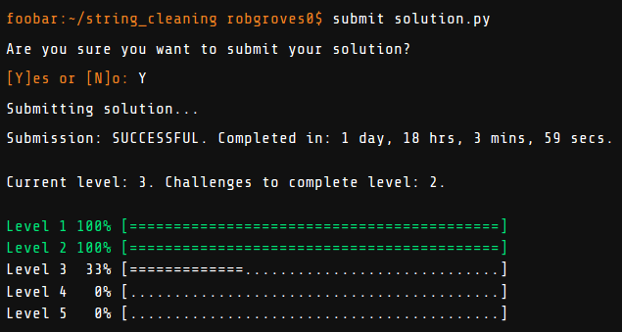
This one was a bit easier 02/07/2016:
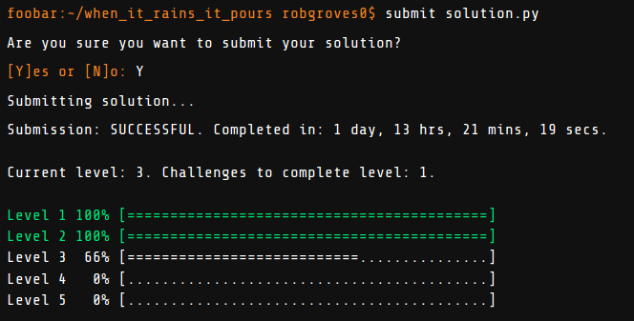

02/15/16:
I was stumped on this one and resorted to googling. Unfortunately, I found an incredibly simple answer, and once seen, it couldn't be unseen. Next time, I won't look for solutions.
