ENTERPRISE TECHNICAL SPECIFICATION & SYSTEM ARCHITECTURE
GYM AI SaaS Platform
Next-Generation Multi-Tenant Gym Management, AI Personal Coaching & Intelligent Kiosk Platform
Attribute | Specification Details
Project Name | GYM AI SaaS (Multi-Tenant Fitness Operating System)
Architecture Pattern | Multi-Tenant Modular Monolith with Tenant Scoping & RBAC
Backend Core | Node.js 20+, Express 4.21, TypeScript 5.7, Mongoose 8.12, MongoDB 8+
Frontend Core | React 19, Vite 6, Tailwind CSS 4, React Router 7, Zustand 5
Target Platforms | Responsive Web Application, Member Mobile Web PWA, Front-Desk Kiosk Scan Terminal
External Integrations | Razorpay, Meta WhatsApp Cloud API, Firebase FCM, Cloudinary, OpenAI, Google Gemini
Document Status | Production Complete — Exhaustive Architectural & Implementation Blueprint
Documentation Date | September 2026
Codebase Location | d:\Projects\gym_ai_SaaS

[DOCUMENT PURPOSE & SCOPE] This document contains a line-by-line, module-by-module, and field-by-field breakdown of the entire GYM AI SaaS platform. It serves as the definitive reference manual for architects, developers, DevOps engineers, and security auditors.

1. Executive Summary & System Topology
GYM AI SaaS is a production-grade, multi-tenant software-as-a-service (SaaS) platform architected to digitize and automate the entire operational lifecycle of modern fitness centers, gym chains, personal trainers, and gym members. Unlike traditional legacy desktop gym software or fragmented point solutions, GYM AI integrates front-desk point-of-sale operations, automated attendance, dynamic QR access control, exercise and nutrition programming, member progress tracking, gamification streaks, and multi-channel messaging with autonomous AI intelligence.

1.1 Hierarchical Multi-Tenant Topology
The system implements a rigid hierarchical organizational tree ensuring multi-branch support with zero cross-tenant data leakage:
- Tier 1 — Super Administrator (SUPER_ADMIN): Platform operators who manage global SaaS subscriptions, approve onboarding inquiries, oversee cross-gym platform health, manage global platform invoices, configure tier pricing, and control global exercise libraries.
- Tier 2 — Gym Organization (GYM_OWNER): Tenant boundary representing a gym business entity. A Gym owns branding, billing settings, membership plan catalogs, store products, staff payroll/trainers, financial accounts, and can own multiple physical branch locations.
- Tier 3 — Branch / Facility (BRANCH_MANAGER): Physical gym facility under a parent Gym entity. Features localized staff rosters, physical geofenced coordinates (latitude/longitude/radius), localized equipment inventories, attendance streams, and front-desk reception terminals.
- Tier 4 — Trainers & Instructors (TRAINER): Personal trainers attached to a gym/branch who manage assigned member client rosters, author personalized workout blueprints, design nutritional diets, evaluate client recovery, and review logged exercise performance.
- Tier 5 — Members & Athletes (MEMBER): Gym members possessing mobile dashboard access for attendance check-in passes, real-time workout set/rep logging, macro tracking, progress photo uploads, AI fitness coach chat, and streak gamification.
- Tier 6 — Reception Kiosk (KIOSK): A dedicated, locked front-desk scanning terminal role restricted to dynamic QR attendance validation and rapid check-in without exposing administrative or sensitive billing data.
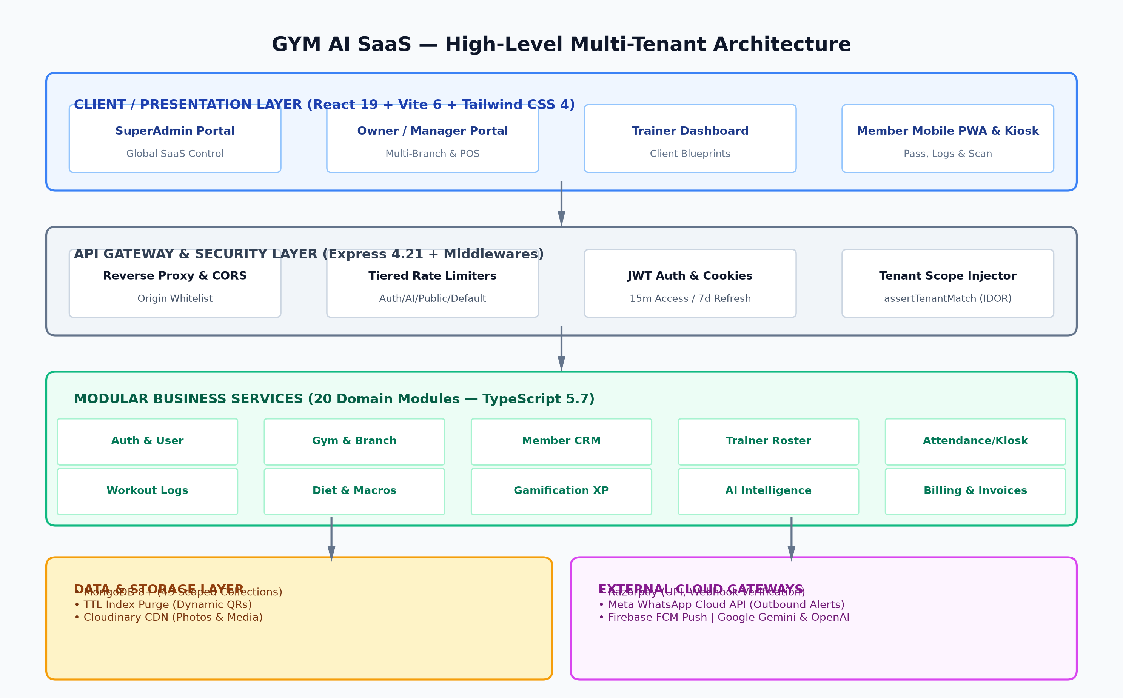
Figure: 1.1: GYM AI SaaS High-Level Multi-Tenant System Architecture Topology

1.2 Core Platform Capabilities Matrix
Subsystem | Operational Role | Primary Technical Mechanism
Dynamic Attendance & Access Control | Fraud-free check-ins & kiosks | Single-use dynamic QR session tokens (TTL: 25s), static QR verification, and GPS geofence validation.
AI Personal Coach & Assistant | 24/7 Member workout & diet mentor | Dual LLM architecture (Gemini 2.5 Flash / OpenAI GPT-4o-mini) grounded in user workouts, sleep, and hydration logs.
AI Business & Revenue Advisor | Autonomous executive insights for owners | Predictive churn risk engine, revenue forecasting, peak-hour heatmaps, and plan profitability analytics.
Workout & Exercise Engine | Digital training log & plan builder | Catalog of 100+ exercises, weekly split blueprints (PPL, Full Body), real-time set/rep/weight logging, and volume calculation.
Gamification & Retention Loop | Member engagement & habit forming | XP reward ledger, tiered level milestones, rest-day grace periods (up to 2 rest days/week), and competitive gym leaderboards.
Billing & POS Accounting | Revenue lifecycle & invoices | Dual billing engines: Member billing (Razorpay, UPI, cash, cards) and SaaS Platform billing (Stripe/Razorpay tier upgrades).
Multi-Channel Messaging Hub | Automated member alerts & reminders | Meta WhatsApp Cloud API integration, Firebase Cloud Messaging (FCM) web push notifications, and daily automated cron sweeps.
Equipment & Maintenance Tracker | Gym asset lifecycle management | Asset registry, maintenance due triggers, condition status tracking, and repair expense correlation.
GDPR & Data Privacy Suite | Regulatory compliance & user rights | Self-service JSON data export and account deletion request workflows with cancellation windows.

2. Technology Stack & Tooling Rationale
The architecture follows a clean, modular monolith pattern in TypeScript. This pattern was deliberately selected over microservices to eliminate distributed transaction latency, maintain strict ACID transactions across billing and attendance, and drastically simplify deployment while preserving clean domain-driven module boundaries.
Layer | Technology | Version | Architecture Justification
Runtime Engine | Node.js | v20+ LTS | Asynchronous non-blocking I/O event loop ideal for concurrent WebSocket/HTTP check-ins and cron schedules.
Backend Framework | Express.js | 4.21.2 | Lightweight, battle-tested HTTP server with comprehensive middleware composability.
Language | TypeScript | 5.7.3 | End-to-end static typing across database models, controllers, services, API contracts, and frontend stores.
Primary Database | MongoDB | 8.0+ Enterprise | Document-oriented schema flexibility allowing embedded workout sets, multi-branch structures, and high-throughput write scalability.
Object Data Modeling (ODM) | Mongoose | 8.12.1 | Schema validation, middleware hooks, population, compound indexing, and TTL auto-cleanup.
Schema Validation | Zod | 3.24.2 | Runtime schema parsing and strict type-safe validation for all incoming HTTP requests, query params, and env configs.
Authentication & Crypto | JWT & BcryptJS | JWT 9.0 / Bcrypt 3.0 | Dual-token authentication with HMAC-SHA256 access tokens and bcrypt salted password hashing (10 rounds).
Scheduled Tasks | Node-Cron | 3.0.3 | In-process cron scheduling for daily membership renewals, birthday greetings, churn assessments, and trial sweeps.
PDF Generation | PDFKit | 0.16.0 | Programmatic vector PDF rendering for member payment invoices and platform subscription receipts.
QR Code Engine | node-qrcode / jsqr | QR 1.5 / jsQR 1.4 | Server-side dynamic dataURL generation paired with client-side HTML5 canvas video stream scanning.
Cloud Storage | Cloudinary | 2.5.1 | Secure media CDN for member progress photos, gym logos, and user avatars with automatic image optimization.
Push Messaging | Firebase Admin SDK | 13.1.0 | Enterprise FCM push notification dispatch across web browsers and mobile clients.
WhatsApp Messaging | Meta WhatsApp Cloud API | Graph v20+ | Direct REST integration for conversational message delivery, membership notices, and payment receipts.
Payment Gateway | Razorpay SDK | 2.9.8 | Standard Indian & international payment gateway for UPI, cards, netbanking, and cryptographic webhook verification.
AI Models | OpenAI & Google Gemini | GPT-4o-mini / Gemini 2.5 | Dual multi-provider AI architecture with automated fallback handling on quota exhaustion or provider errors.
Frontend UI Engine | React | 19.0.0 | Modern React with concurrent rendering, hooks, and component lifecycle management.
Frontend Build Tool | Vite | 6.1.0 | Ultra-fast lightning build pipeline with Hot Module Replacement (HMR) and optimized tree-shaking.
CSS Framework | Tailwind CSS | 4.0.6 | Modern utility-first styling with custom CSS design tokens, smooth animations, and dark mode support.
State Management | Zustand | 5.0.3 | Lightweight, boilerplate-free global state store for auth session, tenant info, and persistent user profile.
Frontend Routing | React Router | 7.1.5 | Declarative client-side routing with nested layout shells and role-based route guards.

3. Environment Variables & System Configuration
The application utilizes Zod schema validation in backend/src/config/env.ts to strictly validate all environment variables at startup. If any critical variable is missing or malformed, the process immediately halts with descriptive error messages, preventing silent runtime failures.
Variable Name | Type | Default Value | Description & Security Implication
PORT | Number | 5000 | HTTP port on which Express server listens.
NODE_ENV | String | development | Environment mode ('development', 'production', 'test'). Toggles detailed Morgan logs and stack traces.
CLIENT_URL | String | http://localhost:5173 | Allowed CORS origins (comma-separated). Strict check required for credentials and cookies.
MONGO_URI | String | Required | Full MongoDB connection string with credentials, database name, and replica-set parameters.
JWT_ACCESS_SECRET | String | Required | Cryptographic secret used to sign short-lived access tokens (HMAC SHA-256).
JWT_REFRESH_SECRET | String | Required | Cryptographic secret used to sign long-lived refresh tokens stored in HTTP-only cookies.
JWT_QR_SECRET | String | gymai-qr-secret... | Secret key used to cryptographically encode and verify static member check-in QR codes.
JWT_ACCESS_EXPIRY | String | 15m | Access token lifespan. Kept short (15 minutes) to minimize token hijack exposure window.
JWT_REFRESH_EXPIRY | String | 7d | Refresh token lifespan (7 days). Refreshes are rotated in database on each consumption.
SALT_ROUNDS | Number | 10 | Bcrypt hashing cost factor for user passwords.
RATE_LIMIT_WINDOW_MS | Number | 900000 (15m) | Time window in milliseconds for IP-based rate limiting buckets.
RATE_LIMIT_MAX | Number | 300 | Maximum requests per window for general authenticated API endpoints.
RATE_LIMIT_AUTH_MAX | Number | 15 | Strict rate limit for login/register endpoints to thwart brute-force password guessing.
RATE_LIMIT_PUBLIC_MAX | Number | 30 | Rate limit on public trial lead capture and inquiry endpoints to block automated spam bots.
ENABLE_RATE_LIMIT_IN_DEV | Boolean | false | Allows bypassing rate limit throttling during local integration tests and development.
CLOUDINARY_CLOUD_NAME | String | Optional | Cloudinary cloud name for media bucket storage.
CLOUDINARY_API_KEY | String | Optional | Cloudinary API key.
CLOUDINARY_API_SECRET | String | Optional | Cloudinary API secret key.
FIREBASE_PROJECT_ID | String | Optional | Google Firebase project identifier for Web Push FCM.
FIREBASE_CLIENT_EMAIL | String | Optional | Firebase service account client email.
FIREBASE_PRIVATE_KEY | String | Optional | Firebase service account PEM private key for OAuth2 token generation.
RAZORPAY_KEY_ID | String | Optional | Razorpay Public API Key used for order creation and frontend checkout.
RAZORPAY_KEY_SECRET | String | Optional | Razorpay Secret Key used for server-to-server API calls.
RAZORPAY_WEBHOOK_SECRET | String | Optional | Shared webhook secret used to verify payment capture signature.
OWNER_INVITE_CODE | String | Optional | Secret invitation pass-code required to register a GYM_OWNER account, locking unauthorized onboarding.
OPENAI_API_KEY | String | Optional | OpenAI API key for ChatGPT models.
OPENAI_MODEL | String | gpt-4o-mini | Default OpenAI model name.
GEMINI_API_KEY | String | Optional | Google Gemini API key.
GEMINI_MODEL | String | gemini-3.5-flash-lite | Default Gemini model name used as primary cost-efficient AI coach engine.
AI_DAILY_USER_MESSAGE_LIMIT | Number | 5 | Daily message quota per member to control LLM token consumption and prevent abuse.
WHATSAPP_PHONE_NUMBER_ID | String | Optional | Meta Graph API Phone Number ID for WhatsApp Cloud business account.
WHATSAPP_ACCESS_TOKEN | String | Optional | Meta System User long-lived access token with whatsapp_business_messaging permissions.
WHATSAPP_BUSINESS_ACCOUNT_ID | String | Optional | Meta WhatsApp Business Account ID for template management.

4. Multi-Tenant Architecture, Security & Access Control
Multi-tenancy is enforced at the software architecture layer using strict tenant context injection and database-level query scoping. Unlike multi-database architectures that incur high DevOps and connection pool overhead, GYM AI uses a single partitioned database with cryptographic tenant context enforcement.

4.1 Tenant Context Scoping & IDOR Defense
Tenant enforcement is handled via the injectTenantScope middleware in backend/src/common/middlewares/tenant.middleware.ts:
- Cryptographic Tenant Extraction: When an authenticated user issues a request, their verified JWT payload is examined. For non-SuperAdmins, the gymId and branchId are strictly assigned from the verified token payload (req.user.gymId and req.user.branchId). Any user-supplied headers (e.g. x-gym-id) or query parameters are intentionally discarded to neutralize IDOR attacks.
- Service-Level Tenant Matching (assertTenantMatch): Every data modification service verifies that the target entity's gymId strictly equals req.tenant.gymId. If a malicious user attempts to update a member, payment, or equipment belonging to another gym, an immediate 403 Forbidden exception is raised.
- Real-Time Subscription Gatekeeper (checkGymActive): Before processing tenant routes, this middleware validates that the parent gym's status is ACTIVE and checks whether their SaaS trial has lapsed. If the trial has expired, the status is automatically transitioned to TRIAL_EXPIRED and access to operational features is blocked until upgraded.
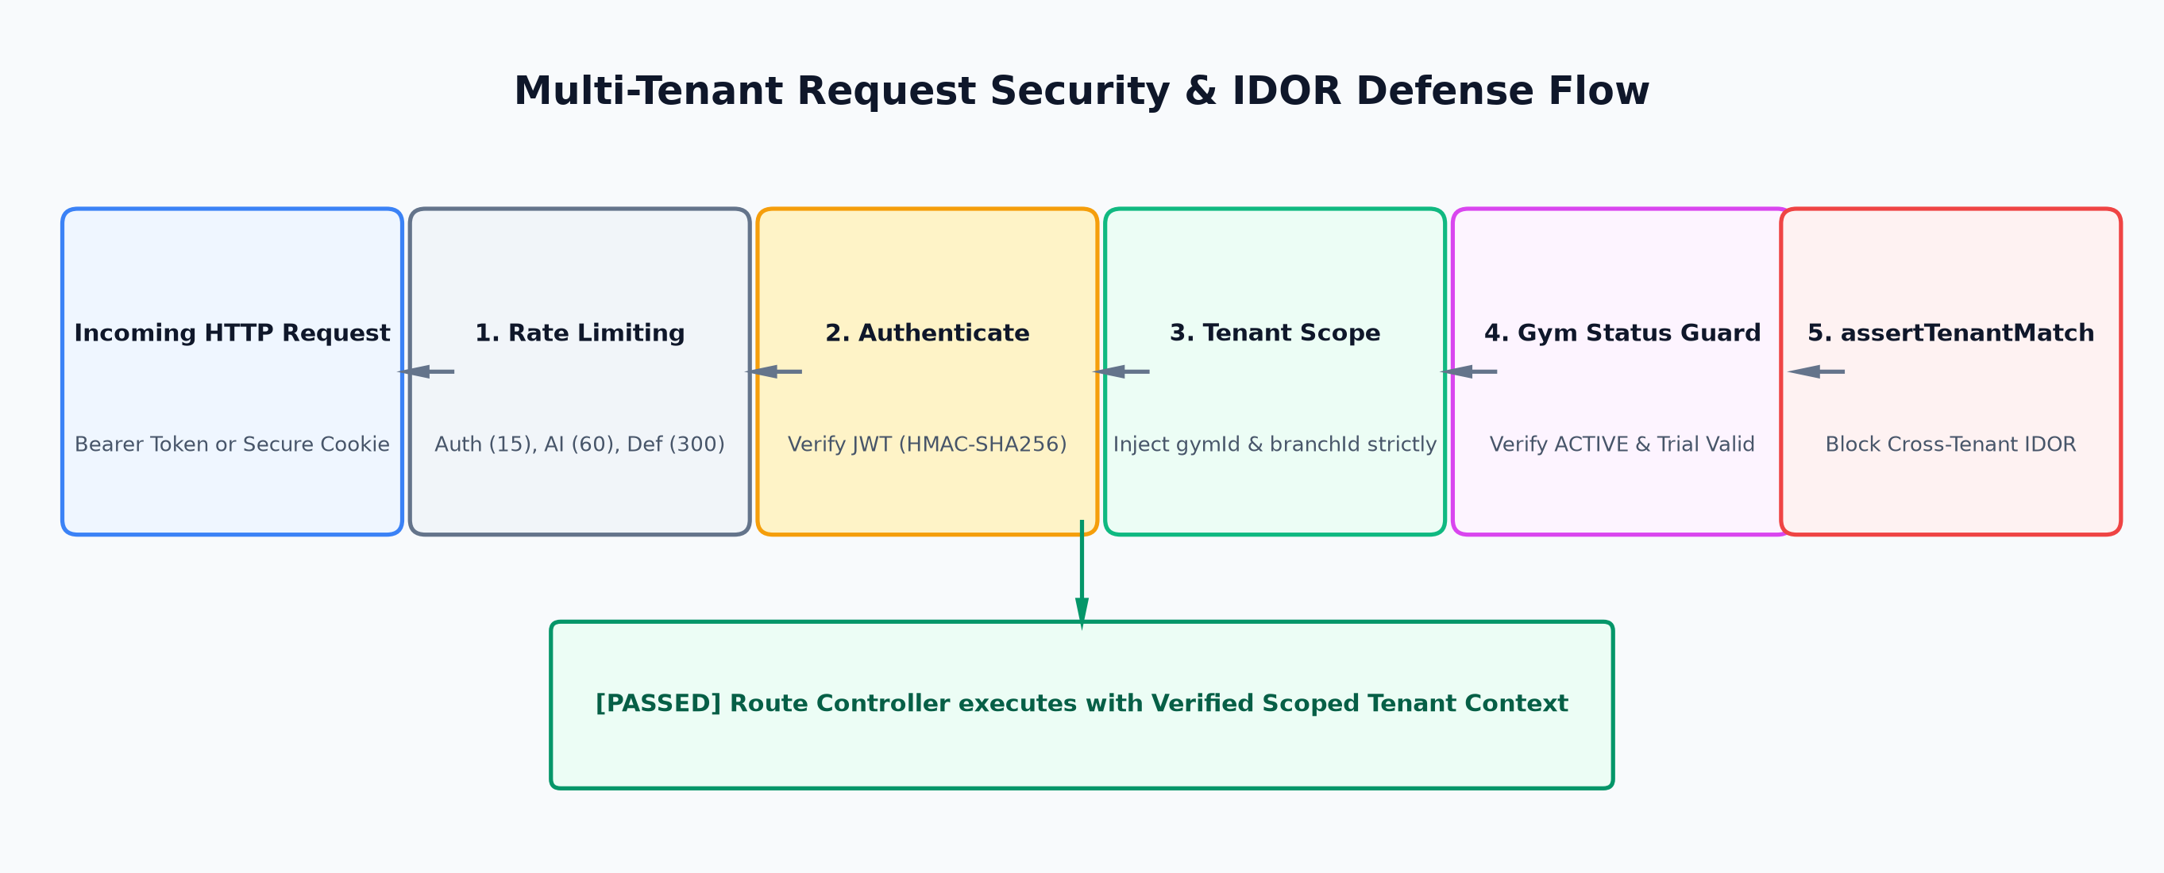
Figure: 4.1: Multi-Tenant Request Verification & IDOR Defense Flow

4.2 Dual-Token JWT Authentication Flow
Authentication employs an industry-standard dual-token architecture:
- Access Token (Short-Lived): Signed with JWT_ACCESS_SECRET, 15-minute lifespan. Transmitted either in the Authorization: Bearer <token> header or secure cookie. Carries user ID, role, gymId, and branchId.
- Refresh Token (Long-Lived & DB-Tracked): Signed with JWT_REFRESH_SECRET, 7-day lifespan. Stored in an HTTP-Only, SameSite=Strict, Secure cookie and indexed in the RefreshToken collection. Each refresh request rotates both tokens and deletes the previous refresh token to prevent replay attacks.

4.3 Role-Based Access Control (RBAC) Matrix
Functional Domain | SUPER_ADMIN | GYM_OWNER | BRANCH_MGR | TRAINER | MEMBER | KIOSK
Platform Analytics & SaaS Inquiries | FULL | NONE | NONE | NONE | NONE | NONE
SaaS Subscription & Plan Upgrades | FULL | FULL | NONE | NONE | NONE | NONE
Gym & Branch Configuration | FULL | FULL | READ-ONLY | NONE | NONE | NONE
Staff & Trainer Payroll/Roster | FULL | FULL | OWN BRANCH | NONE | NONE | NONE
Financial Reports & Gym Expenses | FULL | FULL | NONE | NONE | NONE | NONE
Member Payments & Invoicing (POS) | FULL | FULL | OWN BRANCH | NONE | OWN BILLS | NONE
Equipment & Maintenance Log | FULL | FULL | OWN BRANCH | NONE | NONE | NONE
Store Products & Inventory POS | FULL | FULL | OWN BRANCH | NONE | VIEW/BUY | NONE
Lead Capture & Sales Pipeline | FULL | FULL | OWN BRANCH | NONE | NONE | CREATE
Workout & Diet Blueprint Builder | FULL | FULL | OWN BRANCH | ASSIGNED | SELF-VIEW | NONE
Daily Workout Set/Rep Tracking | FULL | FULL | OWN BRANCH | ASSIGNED | SELF-LOG | NONE
Dynamic QR Attendance Check-In | FULL | FULL | FULL | VIEW | OWN PASS | SCAN TERMINAL
AI Fitness Coach Chatbot | FULL | NONE | NONE | TEST | ACTIVE (5/day) | NONE
AI Business Insights & Churn Risk | FULL | FULL | NONE | NONE | NONE | NONE

5. Database Architecture & Schema Dictionary
The platform features 43 distinct Mongoose schemas partitioned into 10 logical domain groups. Every model enforces timestamps (createdAt, updatedAt), indexes for high-frequency queries, and soft-delete semantics (isDeleted, deletedAt) to preserve audit trails and prevent accidental data destruction.

5.1 Organization & Identity Domain
Model / Entity | Schema Definition & Technical Field Mapping
User (user.model.ts) | Core authentication record. Stores fullName, email, phone, password (hashed, select: false), role (SUPER_ADMIN, GYM_OWNER, BRANCH_MANAGER, TRAINER, MEMBER, KIOSK), gymId, branchId, avatarUrl, failedLoginAttempts, lockUntil, and deletionRequestedAt.
Gym (gym.model.ts) | Tenant organization profile. Stores name, ownerId (ref: User), logoUrl, plan (TRIAL, BASIC, PRO, ENTERPRISE), status (ACTIVE, SUSPENDED, TRIAL_EXPIRED), trialEndsAt, subscriptionExpiresAt, billingEmail, isMultiBranch, settings (defaultTrialPassDays), and custom membershipPlans.
Branch (branch.model.ts) | Physical gym branch. Stores gymId, name, address (line1, city, state, pincode, country, geo), managerId, contactPhone, timezone (e.g. 'Asia/Kolkata'), location ({ lat, lng, radiusMeters }), and gpsVerificationEnabled.
OwnerGymAccess (ownerGymAccess.model.ts) | Mapping table supporting enterprise owners managing multiple gym franchises under a single master user identity.
Member (member.model.ts) | Complete gym member profile. Stores userId (ref: User), gymId, branchId, assignedTrainerId, membershipStatus (ACTIVE, EXPIRED, FROZEN, CANCELLED), membershipStartDate, membershipEndDate, planName, emergencyContact, healthInfo (height, weight, targetWeight, medicalConditions, injuries), fitnessGoals, qrCode (unique string), dateOfBirth, referralCode, referredByMemberId, currentStreakDays, longestStreakDays, totalXpPoints.
Trainer (trainer.model.ts) | Personal trainer profile. Stores userId, gymId, branchId, specializations (array of strings), bio, certifications (name, issuedBy, year), and maxMemberCapacity.

5.2 Attendance & Access Control Domain
Model / Entity | Schema Definition & Technical Field Mapping
Attendance (attendance.model.ts) | Session-level check-in log. Stores gymId, branchId, memberId, checkInAt, checkOutAt, durationMinutes, status (CHECKED_IN, CHECKED_OUT, ANOMALOUS), checkInSource (QR, MANUAL), checkOutSource, dayKey ('YYYY-MM-DD' in branch timezone), manualAuditReason. Features a partial unique index on { memberId: 1, status: 'CHECKED_IN' } enforcing the single-open-session invariant.
QRSession (qrSession.model.ts) | Ephemeral dynamic QR kiosk tokens. Stores gymId, branchId, qrToken, isConsumed, consumedByMemberId, expiresAt. Features a MongoDB TTL index on expiresAt ({ expireAfterSeconds: 0 }) that automatically purges expired tokens from disk.

5.3 Workout & Training Domain
Model / Entity | Schema Definition & Technical Field Mapping
Exercise (exercise.model.ts) | Master exercise directory. Stores name, category (chest, back, legs, shoulders, arms, core, cardio), equipmentNeeded, mechanics (compound, isolation), instructions, gifUrl, targetMuscles, gymId (null for global platform exercises, ObjectId for custom gym additions).
WorkoutPlan (workoutPlan.model.ts) | Prescribed training routine. Stores memberId, gymId, branchId, trainerId, title, description, level (beginner, intermediate, advanced), isActive, schedule (array of days containing dayLabel and assigned exercises with target sets, reps, restSeconds).
WorkoutLog (workoutLog.model.ts) | Live recorded member training session. Stores memberId, gymId, branchId, date, dayKey, workoutPlanId, completedAt, durationMinutes, exercises (array of exerciseId, name, notes, sets [{ setNumber, reps, weightKg, completed }]).

5.4 Nutrition & Biometrics Domain
Model / Entity | Schema Definition & Technical Field Mapping
DietPlan (dietPlan.model.ts) | Nutritional blueprint. Stores memberId, gymId, branchId, trainerId, title, dailyCalorieTarget, macros ({ proteinGrams, carbsGrams, fatGrams }), meals (array of mealType, timing, items [{ foodName, portion, calories, protein, carbs, fat }]), isActive.
DailyWellness (dailyWellness.model.ts) | Holistic recovery tracker. Stores memberId, dayKey, waterIntakeMl, sleepHours, mood ('great', 'good', 'okay', 'tired', 'stressed'), energyRating (1-5), muscleSorenessNotes.
WeightEntry (weightEntry.model.ts) | Chronological body weight record. Stores memberId, weightKg, recordedAt, notes.
ProgressPhoto (progressPhoto.model.ts) | Visual body composition check-in. Stores memberId, photoUrl, angle ('front', 'side', 'back'), recordedAt, notes, cloudinaryPublicId.

5.5 Gamification & Engagement Domain
Model / Entity | Schema Definition & Technical Field Mapping
MemberGameStats (memberGameStats.model.ts) | Real-time engagement state. Stores memberId, gymId, xp (experience points), level, currentStreak, longestStreak, lastActivityDayKey, restDays (weekday indices 0-6 exempt from streak breaking), streakGracePending, and awarded badges array.
MemberBadge (memberBadge.model.ts) | Earned achievement badge records with timestamp and unlock metadata.
Challenge (challenge.model.ts) | Gym community fitness competitions. Stores gymId, title, description, goalType (checkins, volume, streak), targetValue, startDate, endDate, rewardXp, participants array.
XpLedger (xpLedger.model.ts) | Immutable transaction ledger tracking all XP gains (amount, reason, entityRef, earnedAt).

5.6 Payments & Billing Domain
Model / Entity | Schema Definition & Technical Field Mapping
MemberPayment (memberPayment.model.ts) | Financial payment record for gym members. Stores gymId, branchId, memberId, amount, currency ('INR'), purpose ('membership_fee', 'personal_training', 'merchandise'), method ('cash', 'card', 'upi', 'bank_transfer', 'online'), status ('pending', 'paid', 'failed', 'refunded'), gatewayOrderId, gatewayPaymentId, invoiceNumber, recordedByUserId, paidAt, refundDetails.
InvoiceCounter (invoiceCounter.model.ts) | Atomic sequential counter generating unique, human-readable tax invoices (e.g. INV-2026-000042) partitioned by gym and year.
PlatformSubscription (platformSubscription.model.ts) | Gym SaaS platform tier subscription. Stores gymId, plan ('TRIAL', 'BASIC', 'PRO', 'ENTERPRISE'), billingCycle ('monthly', 'yearly'), amount, currentPeriodStart, currentPeriodEnd, autoRenew, status.
PlatformInvoice (platformInvoice.model.ts) | SaaS platform B2B billing invoice issued by the SuperAdmin to the gym owner.
PlatformSettings (platformSettings.model.ts) | Global SaaS system settings, pricing overrides, and platform configuration persisted in database.
PlatformUpgradeRequest (platformUpgradeRequest.model.ts) | In-app gym upgrade requests submitted by owners to transition between SaaS tiers.

5.7 AI Intelligence & Operations Domain
Model / Entity | Schema Definition & Technical Field Mapping
AIConversation (aiConversation.model.ts) | Chat session header. Stores memberId/userId, title, roleContext ('MEMBER', 'OWNER', 'TRAINER'), lastMessageAt, isArchived.
AIChatMessage (aiChatMessage.model.ts) | Individual dialogue turn. Stores conversationId, role ('user', 'model', 'assistant', 'system'), content, tokenCount.
AIReport (aiReport.model.ts) | Generated AI fitness evaluations and monthly progress summaries.
ChurnRiskAssessment (churnPrediction.model.ts) | Member retention risk record. Stores memberId, gymId, riskLevel ('HIGH', 'MEDIUM', 'LOW'), riskFactors array, score (0-100), daysSinceLastVisit, completionRateDropPercent, recommendedActions, assessedAt.
GoalPrediction (goalPrediction.model.ts) | Machine-learned goal ETA predictions based on historical adherence rates.

5.8 Operations, Assets & CRM Domain
Model / Entity | Schema Definition & Technical Field Mapping
Lead (lead.model.ts) | Prospective gym member pipeline. Stores gymId, branchId, fullName, phone, email, fitnessGoal, preferredTiming, status ('NEW', 'CONTACTED', 'TRIAL_SCHEDULED', 'CONVERTED', 'LOST'), notes array, assignedStaffId, trialPassDays.
Product (product.model.ts) | Pro-shop supplement and merchandise inventory. Stores gymId, branchId, name, category, sku, price, costPrice, stockQuantity, reorderThreshold, barcode.
Equipment (equipment.model.ts) | Gym machinery and asset registry. Stores gymId, branchId, name, category, serialNumber, purchaseDate, warrantyExpiresAt, status ('OPERATIONAL', 'MAINTENANCE_REQUIRED', 'OUT_OF_ORDER'), lastServicedAt, nextServiceDue.
Expense (expense.model.ts) | Gym operational overhead. Stores gymId, branchId, category ('RENT', 'UTILITIES', 'EQUIPMENT_MAINTENANCE', 'SALARIES', 'MARKETING', 'MISCELLANEOUS'), amount, description, expenseDate, paymentMethod, receiptUrl.
TrainerFeedback (trainerFeedback.model.ts) | Member ratings and evaluations submitted for personal trainers after sessions.
SaaSInquiry (saasInquiry.model.ts) | Prospective gym owner inquiry captured from the public SaaS marketing landing page.

5.9 Notifications, Background & Security Domain
Model / Entity | Schema Definition & Technical Field Mapping
Notification (notification.model.ts) | In-app and push notification document. Stores userId, gymId, title, body, type, isRead, readAt, metadata.
DeviceToken (deviceToken.model.ts) | Registered Web and mobile FCM device tokens mapped to user accounts for push notifications.
WhatsAppMessageLog (whatsAppMessageLog.model.ts) | Complete audit trail of outbound WhatsApp messages sent via Meta Cloud API, including delivery status, payload, and recipient phone.
RefreshToken (refreshToken.model.ts) | Persisted cryptographic refresh tokens allowing selective invalidation and multi-device logout.
MembershipReminderLog (membershipReminderLog.model.ts) | Deduplication log ensuring members are not sent redundant renewal notices within the same cycle.
BirthdayReminderLog (birthdayReminderLog.model.ts) | Deduplication log recording annual birthday greetings dispatched to members.

6. Backend Modules & API Catalog
The backend exposes 25 route modules mounted under /api/v1. Every endpoint enforces strict HTTP verbs, URL parameter validation via Zod, rate limiting, and RBAC authorization guards.

Authentication & Identity (/api/v1/auth)
Verb | Route Path | Auth / RBAC | Functional Description & Payload Logic
POST | /auth/register | Public / RateLimited | Registers a new member account with email, phone, password, and optional referral code.
POST | /auth/register-owner | InviteCode Protected | Creates a new Gym Owner account, tenant Gym organization, and primary branch.
POST | /auth/login | Public / RateLimited | Authenticates user credentials, sets HTTP-only refresh cookie, and returns access token.
POST | /auth/logout | Authenticated | Clears refresh cookie and revokes refresh token record from database.
POST | /auth/logout-all | Authenticated | Revokes all active sessions and refresh tokens across all user devices.
GET | /auth/me | Authenticated | Returns current authenticated user profile, active gym/branch context, and role.
POST | /auth/forgot-password | Public / RateLimited | Generates cryptographic password reset token and sends recovery instructions.
POST | /auth/reset-password | Public / RateLimited | Consumes reset token and applies newly hashed password.
PATCH | /auth/profile | Authenticated | Updates user's full name, phone number, or avatar URL.
PATCH | /auth/change-password | Authenticated | Changes user password after validating current password.
PATCH | /auth/users/:userId/reset-password | SUPER_ADMIN | Administrative override resetting user password.

Gym & Branch Management (/api/v1/gyms)
Verb | Route Path | Auth / RBAC | Functional Description & Payload Logic
GET | /gyms | SUPER_ADMIN | Lists all gym tenant organizations across the entire platform.
POST | /gyms | SUPER_ADMIN | Provisions a new Gym organization.
GET | /gyms/:gymId | OWNER / SUPER_ADMIN | Fetches organization details, branding, and billing settings.
PATCH | /gyms/:gymId | OWNER / SUPER_ADMIN | Updates gym organization metadata, logo URL, or trial pass duration.
DELETE | /gyms/:gymId | SUPER_ADMIN | Soft deletes gym organization and archives its branches.
PATCH | /gyms/:gymId/plan | SUPER_ADMIN | Directly modifies gym SaaS tier subscription plan.
GET | /gyms/:gymId/overview | OWNER / SUPER_ADMIN | Returns high-level KPI dashboard overview for gym.
GET | /gyms/:gymId/branches | OWNER / MGR / ADMIN | Lists all physical branches operating under the gym.
POST | /gyms/:gymId/branches | OWNER / SUPER_ADMIN | Provisions a new branch facility with address, timezone, and GPS geofence.
GET | /gyms/:gymId/branches/:branchId | OWNER / MGR / ADMIN | Fetches specific branch profile and coordinates.
PATCH | /gyms/:gymId/branches/:branchId | OWNER / SUPER_ADMIN | Updates branch address, phone, timezone, or geofence radius.
DELETE | /gyms/:gymId/branches/:branchId | OWNER / SUPER_ADMIN | Soft deletes branch.
PATCH | /gyms/:gymId/branches/:branchId/manager | OWNER / SUPER_ADMIN | Assigns a designated Branch Manager user.
GET | /gyms/:gymId/membership-plans | OWNER / MGR / ADMIN | Retrieves customized membership plans and duration pricing.
PUT | /gyms/:gymId/membership-plans | OWNER / SUPER_ADMIN | Updates membership catalog packages, prices, and badges.

Member CRM & Management (/api/v1/gyms/:gymId/members & /api/v1/members)
Verb | Route Path | Auth / RBAC | Functional Description & Payload Logic
GET | /gyms/:gymId/members | OWNER / MGR / ADMIN | Lists gym members with pagination, search, and status filters.
GET | /gyms/:gymId/branches/:branchId/members | OWNER / MGR / ADMIN | Lists members scoped to a specific branch.
POST | /gyms/:gymId/members | OWNER / MGR / ADMIN | Registers a new gym member, assigns plan, generates QR pass.
GET | /gyms/:gymId/members/:memberId | OWNER / MGR / TRAINER | Fetches detailed member profile, health metrics, and history.
PATCH | /gyms/:gymId/members/:memberId | OWNER / MGR / ADMIN | Updates member contact, health info, or assigned trainer.
DELETE | /gyms/:gymId/members/:memberId | OWNER / SUPER_ADMIN | Soft deletes member record.
PATCH | /gyms/:gymId/members/:memberId/freeze | OWNER / MGR / ADMIN | Freezes membership until specified date with reason.
PATCH | /gyms/:gymId/members/:memberId/extend | OWNER / MGR / ADMIN | Extends membership end date by N days.
PATCH | /gyms/:gymId/members/:memberId/cancel | OWNER / MGR / ADMIN | Cancels active membership.
PATCH | /gyms/:gymId/members/:memberId/renew | OWNER / MGR / ADMIN | Renews membership plan and computes new expiry date.
GET | /gyms/:gymId/members/:memberId/qr | OWNER / MGR / ADMIN | Fetches member static check-in QR code data URL.
POST | /gyms/:gymId/members/:memberId/regenerate-qr | OWNER / MGR / ADMIN | Regenerates member QR code string.
GET | /members/me | MEMBER | Self profile endpoint returning personal membership status and streak.
PATCH | /members/me | MEMBER | Self profile update for fitness goals and contact details.
GET | /members/me/referral-stats | MEMBER | Fetches member referral performance and reward points.
POST | /members/:memberId/referral-ask | OWNER / MGR | Sends an automated WhatsApp referral incentive ask to member.

Attendance & Kiosk Scan (/api/v1/attendance & /api/v1/gyms)
Verb | Route Path | Auth / RBAC | Functional Description & Payload Logic
POST | /attendance/check-in | Authenticated / KIOSK | Validates dynamic QR token or static payload, enforces membership validity and GPS geofence, records check-in session.
POST | /attendance/check-out | Authenticated / KIOSK | Closes open check-in session, calculates duration in minutes, awards workout XP.
POST | /attendance/manual | OWNER / MGR / ADMIN | Front-desk manual check-in override with mandatory audit reason.
GET | /gyms/:gymId/attendance/generate-qr | OWNER / MGR / KIOSK | Generates single-use dynamic QR code image with TTL (25 seconds) for kiosk display.
GET | /gyms/:gymId/attendance/daily | OWNER / MGR / ADMIN | Lists real-time check-in stream for today in branch timezone.
GET | /attendance/me/current | MEMBER | Returns member active open check-in session if currently at gym.
GET | /attendance/me/history | MEMBER | Returns member chronological attendance history.
GET | /attendance/me/stats | MEMBER | Calculates monthly visits, consistency rating, and streak metrics.
GET | /gyms/:gymId/attendance-heatmap | OWNER / MGR / ADMIN | Computes weekly attendance heatmaps and peak arrival distribution.

Workout Programming & Live Logs (/api/v1/workout-plans & /api/v1/workout-logs)
Verb | Route Path | Auth / RBAC | Functional Description & Payload Logic
GET | /exercises | Authenticated | Lists master exercise directory with category and muscle filters.
POST | /exercises | OWNER / TRAINER / ADMIN | Adds custom exercise to gym library.
POST | /exercises/seed-global | SUPER_ADMIN | Seeds 100+ standard global exercises with instructions and mechanics.
GET | /members/:memberId/workout-plans | OWNER / TRAINER / MEMBER | Lists training routine plans assigned to member.
GET | /members/:memberId/workout-plans/active | OWNER / TRAINER / MEMBER | Fetches member active workout blueprint.
POST | /members/:memberId/workout-plans | OWNER / TRAINER / ADMIN | Creates a customized multi-day workout blueprint.
PATCH | /workout-plans/:planId | OWNER / TRAINER / ADMIN | Updates exercise targets, sets, reps, or day assignments.
POST | /workout-plans/:planId/duplicate | OWNER / TRAINER | Clones existing plan template to another member.
POST | /workout-logs/start | MEMBER / TRAINER | Initiates live workout session pre-populated from active plan.
PATCH | /workout-logs/:logId/exercises/:exId/sets/:setNum | MEMBER / TRAINER | Records completed reps and weight (kg) for a specific set in real-time.
PATCH | /workout-logs/:logId/complete | MEMBER / TRAINER | Finalizes workout session, calculates total volume and XP.
GET | /workout-logs/today | MEMBER | Fetches today's workout plan and real-time exercise completion status.
GET | /members/:memberId/workout-logs | OWNER / TRAINER / MEMBER | Returns paginated past workout session logs.

AI Coach & Business Intelligence (/api/v1/ai)
Verb | Route Path | Auth / RBAC | Functional Description & Payload Logic
POST | /ai/chat/conversations | Authenticated / RateLimited | Initializes new AI chat conversation with initial message.
POST | /ai/chat/conversations/:id/messages | Authenticated / RateLimited | Sends user message to AI coach, returns grounded response with quota tracking.
GET | /ai/chat/conversations | Authenticated | Lists past user conversations.
GET | /ai/chat/conversations/:id/messages | Authenticated | Retrieves complete conversation dialogue history.
GET | /ai/chat/daily-limit | Authenticated | Returns remaining daily AI message quota.
GET | /ai/members/:memberId/suggestions | MEMBER / TRAINER / OWNER | Generates personalized workout adjustments based on adherence.
GET | /ai/members/:memberId/diet-recommendation | MEMBER / TRAINER / OWNER | Produces dietary macro recommendations based on goals and wellness.
GET | /ai/members/:memberId/goal-prediction | MEMBER / TRAINER / OWNER | Forecasts target weight / fitness goal achievement date.
GET | /ai/members/:memberId/recovery-status | MEMBER / TRAINER / OWNER | Analyzes sleep, hydration, and soreness to score muscular recovery.
GET | /ai/members/:memberId/upsell-recommendation | MEMBER / TRAINER / OWNER | Intelligently recommends gym supplements or personal training sessions.
GET | /ai/gyms/:gymId/at-risk-members | OWNER / MGR / ADMIN | Returns members flagged with high/medium churn risk and recommendations.
GET | /ai/gyms/:gymId/insights/weekly-digest | OWNER / SUPER_ADMIN | Generates executive weekly natural-language business digest.
GET | /ai/gyms/:gymId/insights/peak-hours | OWNER / SUPER_ADMIN | Analyzes attendance distribution to forecast facility rush hours.
GET | /ai/gyms/:gymId/insights/revenue-forecast | OWNER / SUPER_ADMIN | Forecasts next-month cash collections based on renewal cycles.

Billing, Payments & Invoices (/api/v1/gyms/:gymId/payments & /api/v1/billing)
Verb | Route Path | Auth / RBAC | Functional Description & Payload Logic
GET | /gyms/:gymId/payments | OWNER / MGR / ADMIN | Lists all member payments and invoices.
POST | /gyms/:gymId/payments/manual | OWNER / MGR / ADMIN | Records offline payment (cash, card, UPI, bank) and issues invoice.
POST | /gyms/:gymId/payments/online-order | MEMBER / OWNER | Creates Razorpay online checkout payment order with tenant keys.
PATCH | /gyms/:gymId/payments/:paymentId/refund | OWNER / SUPER_ADMIN | Processes payment refund and marks invoice refunded.
GET | /gyms/:gymId/payments/revenue-summary | OWNER / SUPER_ADMIN | Aggregates monthly and annual gym cash receipts.
GET | /gyms/:gymId/payments/me | MEMBER | Fetches member personal payment receipts and invoices.
GET | /billing/platform/invoices | OWNER / SUPER_ADMIN | Retrieves gym's SaaS platform subscription invoices.
POST | /billing/platform/upgrade | OWNER | Upgrades gym SaaS subscription tier (Basic, Pro, Enterprise).
POST | /billing/platform/gyms/:gymId/manual-payment | SUPER_ADMIN | SuperAdmin records manual offline B2B payment from gym.
POST | /billing/platform/gyms/:gymId/upgrade-request | OWNER | Submits request to SuperAdmin for enterprise quote or upgrade.
GET | /billing/platform/settings | SUPER_ADMIN | Retrieves global platform billing parameters and pricing rules.
PUT | /billing/platform/settings | SUPER_ADMIN | Updates global SaaS tier pricing and feature toggles.

Operations: Leads, Inventory, Equipment & Expenses (/api/v1)
Verb | Route Path | Auth / RBAC | Functional Description & Payload Logic
GET | /equipment | OWNER / MGR / ADMIN | Lists gym equipment and machinery inventory.
POST | /equipment | OWNER / MGR / ADMIN | Registers new gym asset and maintenance schedule.
PATCH | /equipment/:id | OWNER / MGR / ADMIN | Updates equipment condition or logs completed maintenance.
GET | /expenses | OWNER / SUPER_ADMIN | Lists operational overhead expenses with category split.
POST | /expenses | OWNER / SUPER_ADMIN | Logs gym expense (rent, electricity, repairs, salaries).
GET | /gyms/:gymId/dashboard/profit-summary | OWNER / SUPER_ADMIN | Computes Net Profit = Total Revenue - Total Expenses.
GET | /products | Authenticated | Lists gym store supplements, apparel, and merchandise.
POST | /products | OWNER / MGR / ADMIN | Adds new pro-shop inventory item with SKU and price.
POST | /products/:id/purchase | MEMBER / STAFF / OWNER | Processes pro-shop POS checkout and decrements inventory.
GET | /leads | OWNER / MGR / ADMIN | Lists prospective leads in CRM sales pipeline.
POST | /leads | OWNER / MGR / ADMIN | Captures new walk-in lead with fitness goal and trial date.
PATCH | /leads/:id/status | OWNER / MGR / ADMIN | Updates lead pipeline stage (New, Contacted, Trial, Converted, Lost).
POST | /leads/:id/convert | OWNER / MGR / ADMIN | Converts lead directly into active Member record.
GET | /public/branches/:branchId | Public | Public landing page data for gym branch trial pass signup.
POST | /public/leads | Public / RateLimited | Public prospective member trial pass registration.

7. Frontend Architecture, UI System & Role Portals
The frontend is built with React 19, TypeScript, Vite 6, and Tailwind CSS 4. It provides dedicated, role-tailored layout shells that restrict UI controls and sensitive metrics based on the authenticated user's role.

7.1 Layout Shell Architecture
- DashboardShell (Desktop & Tablet): Sidebar and header shell used by Gym Owners, Branch Managers, Trainers, and Reception staff. Features dynamic greeting ('Good Morning, John 👋'), active gym/branch badge, search bar, notifications bell with unread badge counter, and collapsible navigation grouped into primary and secondary operational domains.
- AdminShell (SuperAdmin): Specialized administrative portal providing cross-tenant gym oversight, SaaS billing management, global user searches, and platform settings.
- MobileShell (Member PWA Experience): App-like mobile shell featuring a fixed bottom-dock navigation bar (Home, Workout, AI Coach, Progress, Rewards). Designed specifically for one-handed smartphone ergonomics on the gym floor.
- ReceptionShell & Kiosk Scan Mode: Front-desk mode with streamlined check-in terminal UI, rapid walk-in lead registration, and POS payment recording.

7.2 Frontend Route Map & Component Catalog
Portal / Shell | Route Path | Page Component | Key UI Features & Workflow
Public / Guest | / | Landing.tsx | Marketing hero, feature carousels, pricing calculator, SaaS inquiry modal.
Public / Guest | /join/:branchId | JoinBranch.tsx | Branded gym trial pass registration page with branch address and timings.
Auth | /login | Login.tsx | Email/password auth, remember me, redirect to role dashboard.
Auth | /register | Register.tsx | Member self-registration and Owner onboarding with invite code verification.
Super Admin | /admin | AdminPanel.tsx | Platform metrics, active gyms, total ARR, SaaS inquiries queue.
Super Admin | /admin/gyms | Gyms.tsx | Gym management, subscription plan upgrades, soft-deletion.
Super Admin | /admin/branches | Branches.tsx | Global branch directory with manager assignments.
Super Admin | /admin/settings | AdminSettings.tsx | Global SaaS pricing overrides and system settings.
Owner / Mgr | /owner | OwnerDashboard.tsx | Live active members, today's check-ins, monthly revenue, churn alerts.
Owner / Mgr | /owner/members | Members.tsx | Member CRM table, quick search, freeze/renew actions, QR modal.
Owner / Mgr | /owner/attendance | Attendance.tsx | Live daily check-in stream, manual check-in modal, kiosk QR display.
Owner / Mgr | /owner/payments | Payments.tsx | POS offline payment recording, online orders, invoice receipts, refunds.
Owner / Mgr | /owner/reports | Reports.tsx | Live financial charts, revenue split, membership churn graphs, PDF exports.
Owner / Mgr | /owner/ai-insights | AIInsights.tsx | AI churn risk list, peak-hour heatmaps, revenue forecasts, weekly digest.
Owner / Mgr | /owner/inventory | Inventory.tsx | Pro-shop merchandise catalog, stock reorder alerts, POS checkout.
Owner / Mgr | /owner/equipment | Equipment.tsx | Asset directory, maintenance due schedules, condition status tags.
Owner Only | /owner/expenses | Expenses.tsx | Operational overhead logger, category distribution, net profit.
Owner Only | /owner/billing | Billing.tsx | Gym's SaaS tier subscription, invoice downloads, upgrade requests.
Trainer | /trainer | TrainerDashboard.tsx | Active client count, assigned workout adherence, client check-in status.
Trainer | /trainer/clients | MyClients.tsx | Assigned member cards with quick links to workout and diet plans.
Trainer | /trainer/workout-plans | WorkoutPlans.tsx | Weekly split builder (PPL, Full Body), exercise selector with sets/reps.
Trainer | /trainer/diet-plans | DietPlans.tsx | Nutritional macro calculator, meal schedule authoring, calorie targets.
Trainer | /trainer/progress | Progress.tsx | Client weight progression charts and photo check-in history review.
Trainer | /trainer/recovery-alerts | RecoveryAlerts.tsx | Muscular fatigue alerts based on logged sleep and soreness.
Reception / Kiosk | /reception | ReceptionDashboard.tsx | Fast check-in counter, front-desk arrival feed.
Reception / Kiosk | /reception/check-in | CheckIn.tsx | Camera QR scanner (jsQR) and live attendance status badge.
Reception | /reception/leads | Leads.tsx | Walk-in lead capture form, trial scheduler, and conversion trigger.
Member | /member | MemberHome.tsx | Active membership pass, today's scheduled workout, streak counter, XP badge.
Member | /member/workout-tracking | WorkoutTracking.tsx | Live set-by-set workout session logger (reps & weight entry with checks).
Member | /member/ai-coach | AICoach.tsx | Conversational AI chat interface with daily quota bar and quick prompts.
Member | /member/diet-plan | DietPlan.tsx | Daily meal schedule, macro progress bars (protein/carbs/fats), water logger.
Member | /member/progress | MemberProgress.tsx | Weight trend line chart, front/side/back photo gallery, daily wellness log.
Member | /member/rewards | Gamification.tsx | XP progression bar, level title, earned badge showcase, gym leaderboard.
Member | /member/attendance | MemberAttendance.tsx | Static QR check-in pass display and monthly visit calendar.

8. Core Mathematical Algorithms & Business Logic

8.1 Dynamic QR Code Single-Use TTL Algorithm
To prevent members from screenshotting and sharing static QR codes, the kiosk operates in Dynamic QR Mode:
- Token Generation: The front-desk kiosk requests GET /gyms/:gymId/attendance/generate-qr every 20 seconds. The server generates a cryptographically random token: crypto.randomBytes(32).toString('hex') and creates a record in QRSession with expiresAt = Date.now() + 25000.
- Atomic Single-Use Consumption: When scanned, the check-in service executes an atomic findOneAndUpdate({ qrToken, isConsumed: false, expiresAt: { $gt: new Date() } }, { $set: { isConsumed: true, consumedByMemberId } }). If the token was already consumed or expired, the check-in is rejected instantly.
- Automatic Purging: MongoDB's native TTL background thread automatically deletes expired documents via the { expiresAt: 1 }, { expireAfterSeconds: 0 } index.
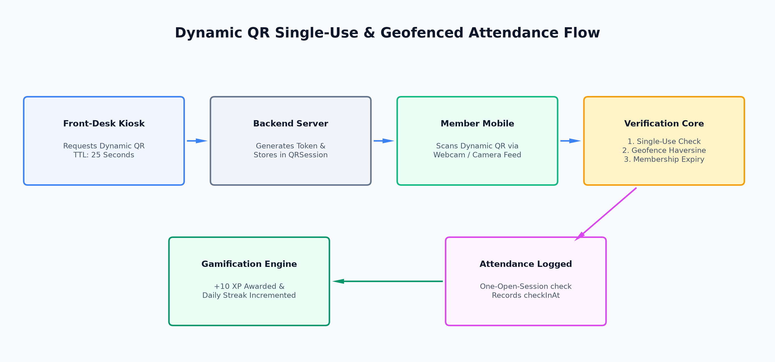
Figure: 8.1: Dynamic QR Single-Use & Geofenced Attendance Sequence Flow

8.2 GPS Geofencing Distance Calculation (Haversine Formula)
When a branch has gpsVerificationEnabled: true, mobile check-ins require device coordinates (lat, lng). The server executes the spherical Haversine formula in backend/src/common/utils/geo.ts to compute accurate surface distance in meters:
Formula: a = sin²(Δφ/2) + cos(φ1) ⋅ cos(φ2) ⋅ sin²(Δλ/2)
c = 2 ⋅ atan2( √a, √(1−a) )
d = R ⋅ c (where R = 6,371,000 meters)
If the calculated distance exceeds branch.location.radiusMeters (default: 150m), the check-in is rejected with a 403 Geofence Violation exception.

8.3 AI Member Churn Risk Prediction Scoring Engine
The ChurnPredictionService runs daily at 9:30 AM across all active gym members. It computes a deterministic risk score (0-100) based on 5 weighted adherence signals:
Adherence Factor | Evaluation Metric | Risk Weight / Trigger Rule
Recency of Attendance | Days since last checkInAt | > 14 days without visit = HIGH RISK flag; 7-14 days = MEDIUM RISK.
Workout Completion Decay | Last 30d completion % vs prior 30-60d window | Completion drop > 40% = Significant engagement decay penalty.
Streak Disruption | Broken streak days vs previous record | Consecutive unexcused missed workout days beyond member's chosen rest days.
Membership Expiration Proximity | Days until membershipEndDate | Expiring in < 7 days without renewal order = Churn vulnerability flag.
Payment Arrears | Latest payment status in MemberPayment | Failed or overdue payment flag automatically escalates risk category to HIGH.

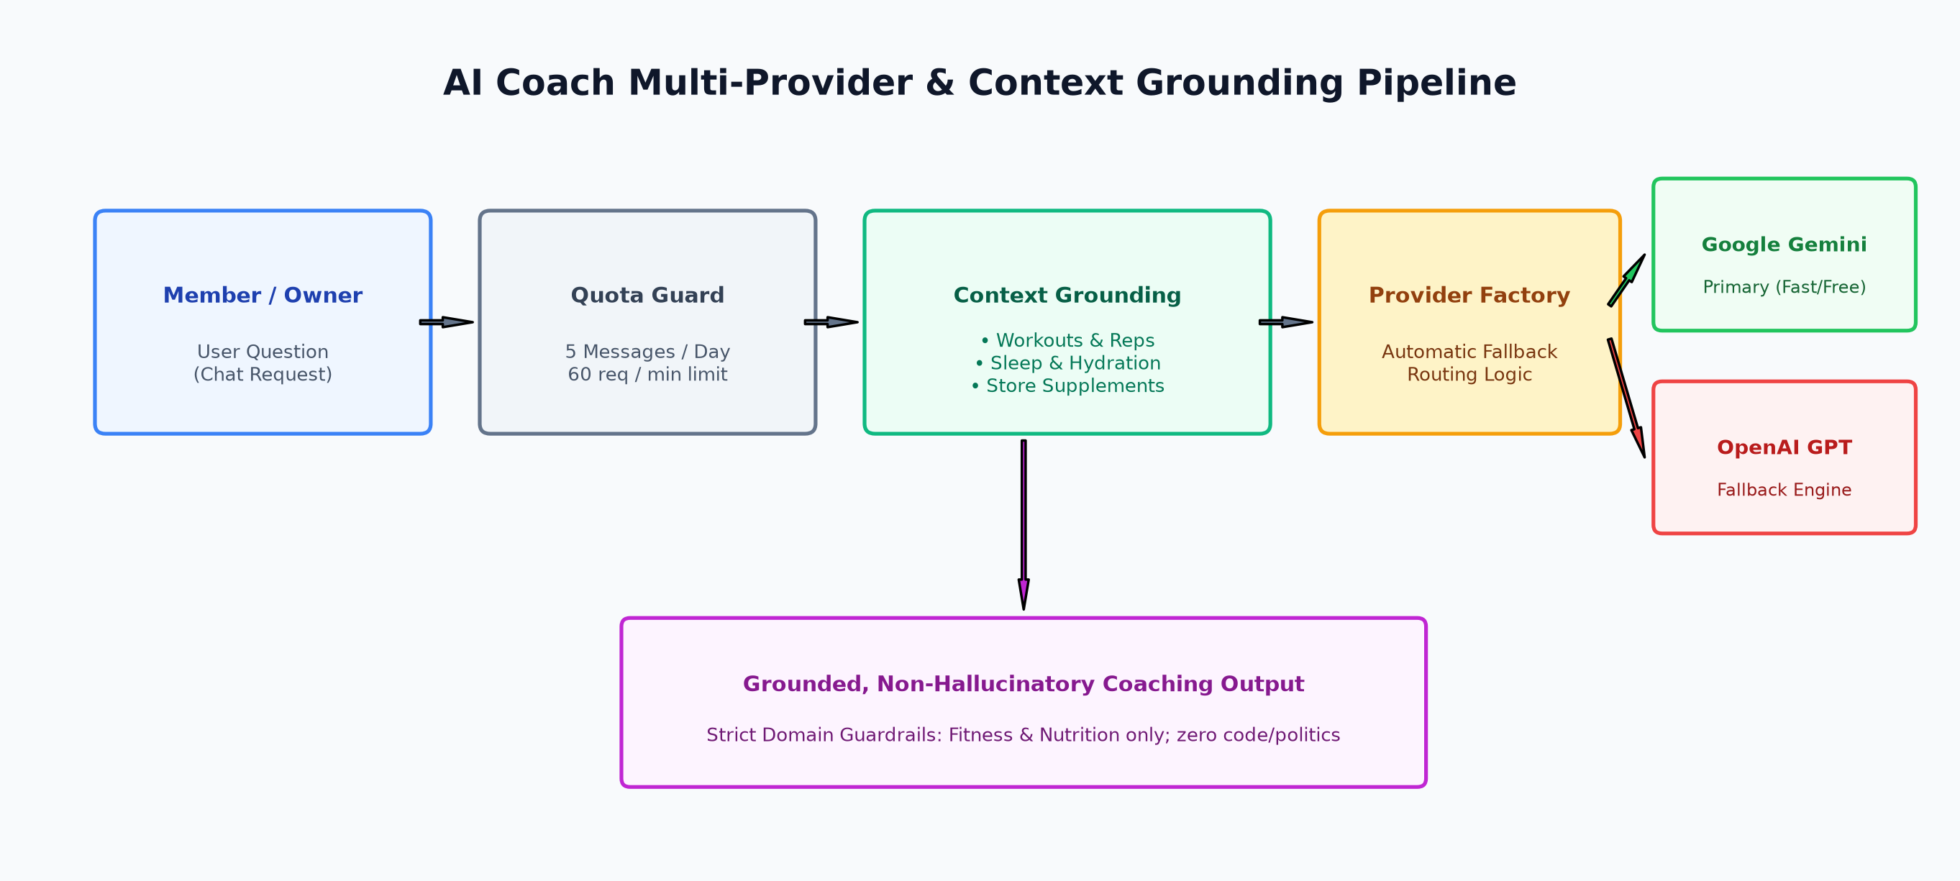
Figure: 8.3: AI Coach Multi-Provider & Context Grounding Pipeline

8.4 Gamification XP & Streak Engine with Rest-Day Grace
Gamification drives habit formation through XP rewards, levels, and protected streaks:
- XP Rewards: Attendance check-in awards +10 XP; completing a full workout session awards +20 XP; logging an exercise personal record awards +5 XP.
- Branch Timezone DayKey: All streak calculations use branch-local calendar days (dayKey = YYYY-MM-DD) computed via Intl.DateTimeFormat to prevent timezone skew errors across midnight.
- Rest-Day Protection: Members can declare up to 2 designated rest days per week (e.g., Thursday & Sunday). If a member does not check in on an official rest day, their streak is protected and does not reset to zero.

8.5 Sequential Atomic Tax Invoice Generation
To ensure legal compliance and audit readiness, tax invoices cannot rely on random UUIDs. The InvoiceCounter collection performs an atomic findOneAndUpdate({ gymId, year }, { $inc: { seq: 1 } }, { upsert: true, new: true }) to guarantee strictly increasing, contiguous invoice numbers formatted as INV-YYYY-XXXXXX for members and PINV-YYYY-XXXXXX for SaaS subscriptions.
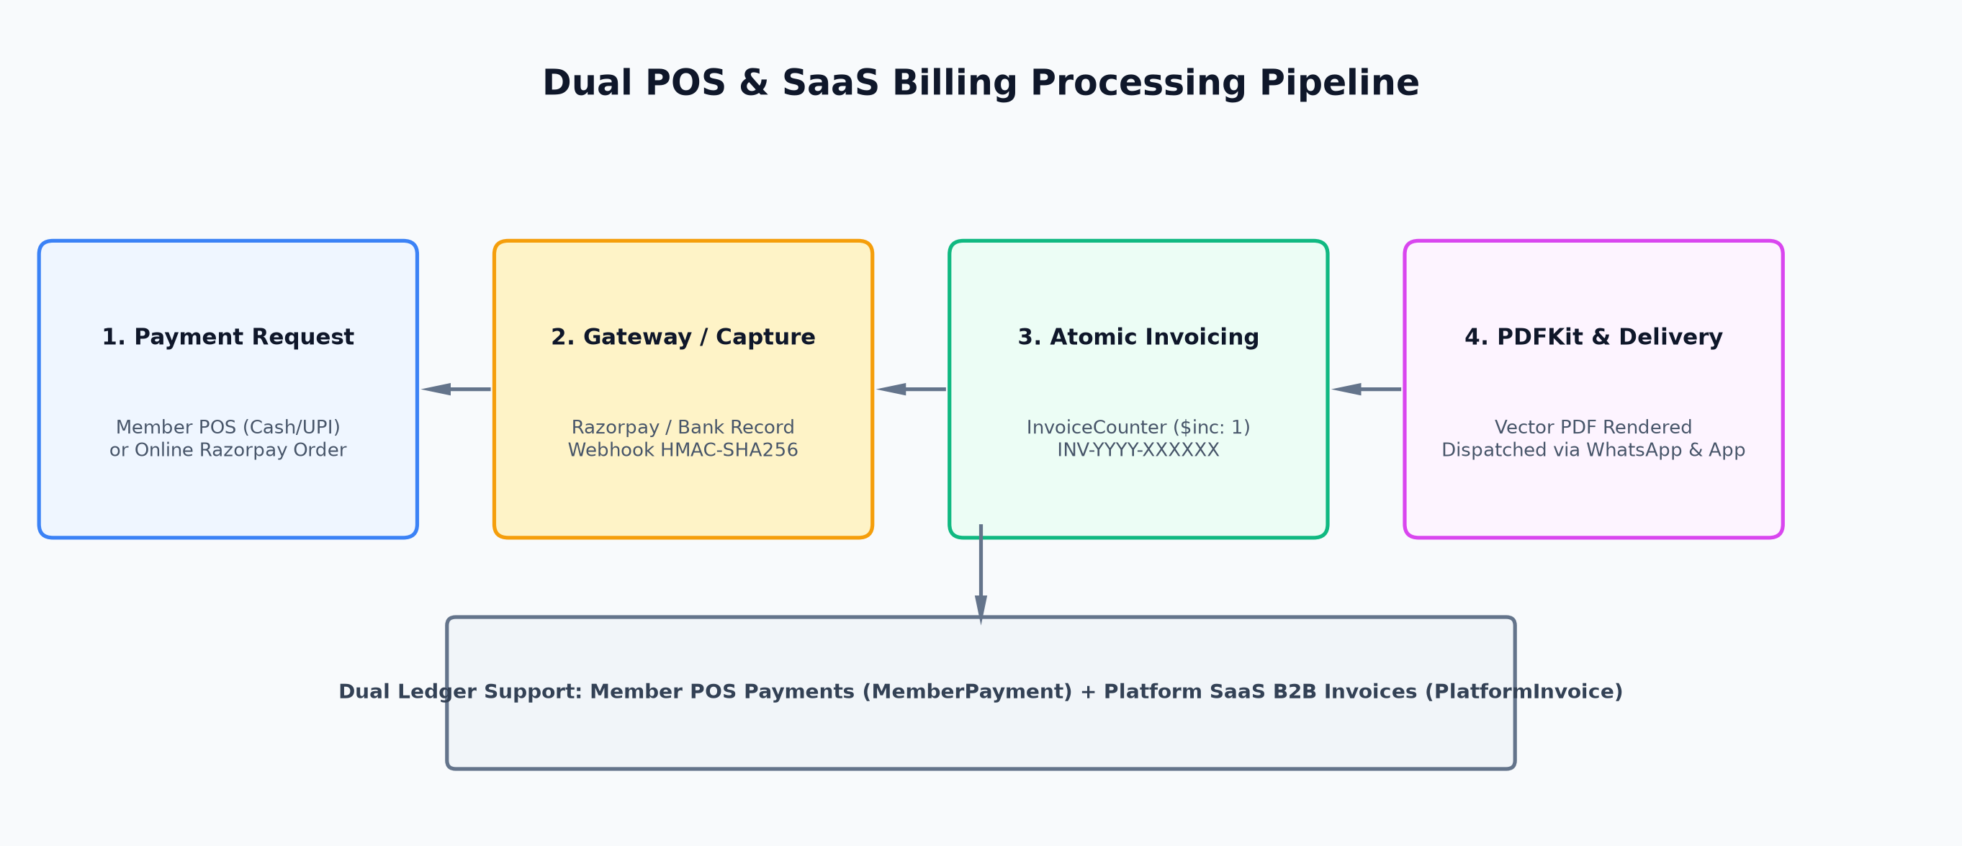
Figure: 8.5: Dual POS & SaaS Platform Billing Processing Pipeline

9. Third-Party Integrations Deep Dive

9.1 Razorpay Payment Gateway & Cryptographic Webhooks
The payment engine supports multi-tenant Razorpay integration:
- Order Creation (POST /gyms/:gymId/payments/online-order): Creates an order with Razorpay REST API using gym currency ('INR') and returns the orderId.
- Cryptographic Webhook Verification: Webhook payloads are verified using HMAC-SHA256: crypto.createHmac('sha256', RAZORPAY_WEBHOOK_SECRET).update(rawBody).digest('hex') matched against the x-razorpay-signature header. Only verified signatures trigger membership renewal and receipt issuance.

9.2 Meta WhatsApp Cloud API Integration
Located in backend/src/modules/notification/whatsapp/, this module connects directly to Meta's official Graph Cloud API (v20+):
- Automated Template Messages: Dispatches pre-approved templates for membership renewal reminders, payment confirmation receipts, welcome onboarding, and birthday wishes.
- Delivery Auditing: Every outbound message payload, recipient phone, and Meta message ID is recorded in WhatsAppMessageLog for delivery tracking and cost auditing.

9.3 Firebase Cloud Messaging (FCM) & Multi-Channel Push Architecture
Firebase Cloud Messaging (FCM) is the primary real-time push notification infrastructure for GYM AI SaaS, integrated via the official firebase-admin SDK (v13.1.0). It enables instant notifications to members, trainers, and gym owners across web browsers and progressive web apps (PWAs).
- Service Account Initialization (firebase.ts): Backend initializes the Admin SDK using FIREBASE_PROJECT_ID, FIREBASE_CLIENT_EMAIL, and FIREBASE_PRIVATE_KEY. If these variables are not present in local dev/testing, the system automatically falls back to a non-blocking degraded mock push mode, preventing app crashes.
- Device Token Management (DeviceToken & deviceToken.service.ts): Clients register active FCM tokens via POST /api/v1/notifications/device-token along with device metadata ('web', 'android', 'ios'). Tokens are mapped directly to the user's ObjectId with isActive: true.
- Multicast Batching & Dead Token Pruning (notification.service.ts): When sending notifications, the service invokes firebaseMessaging.sendEachForMulticast({ tokens, notification: { title, body }, data }). If Firebase returns error codes messaging/registration-token-not-registered or messaging/invalid-registration-token (e.g. user uninstalled or cleared browser data), the service automatically flags the token inactive in MongoDB, maintaining high deliverability.
- In-App Persistence First Principle: Before sending push notifications to FCM, every notification is stored in MongoDB (Notification collection) with isRead: false. This ensures users never miss critical updates even if their browser blocks push notifications or the device is offline.
- Core System Triggers: FCM push alerts are triggered across 8 core workflows: 1) Daily renewal reminders (7d/3d/1d/0d); 2) Annual birthday greetings & bonus XP; 3) Payment confirmation receipts; 4) Assigned workout blueprints from trainers; 5) Diet plan updates; 6) Gamification streak milestones and badge unlocks; 7) Churn risk intervention prompts; 8) Gym-wide emergency broadcast announcements from owners.
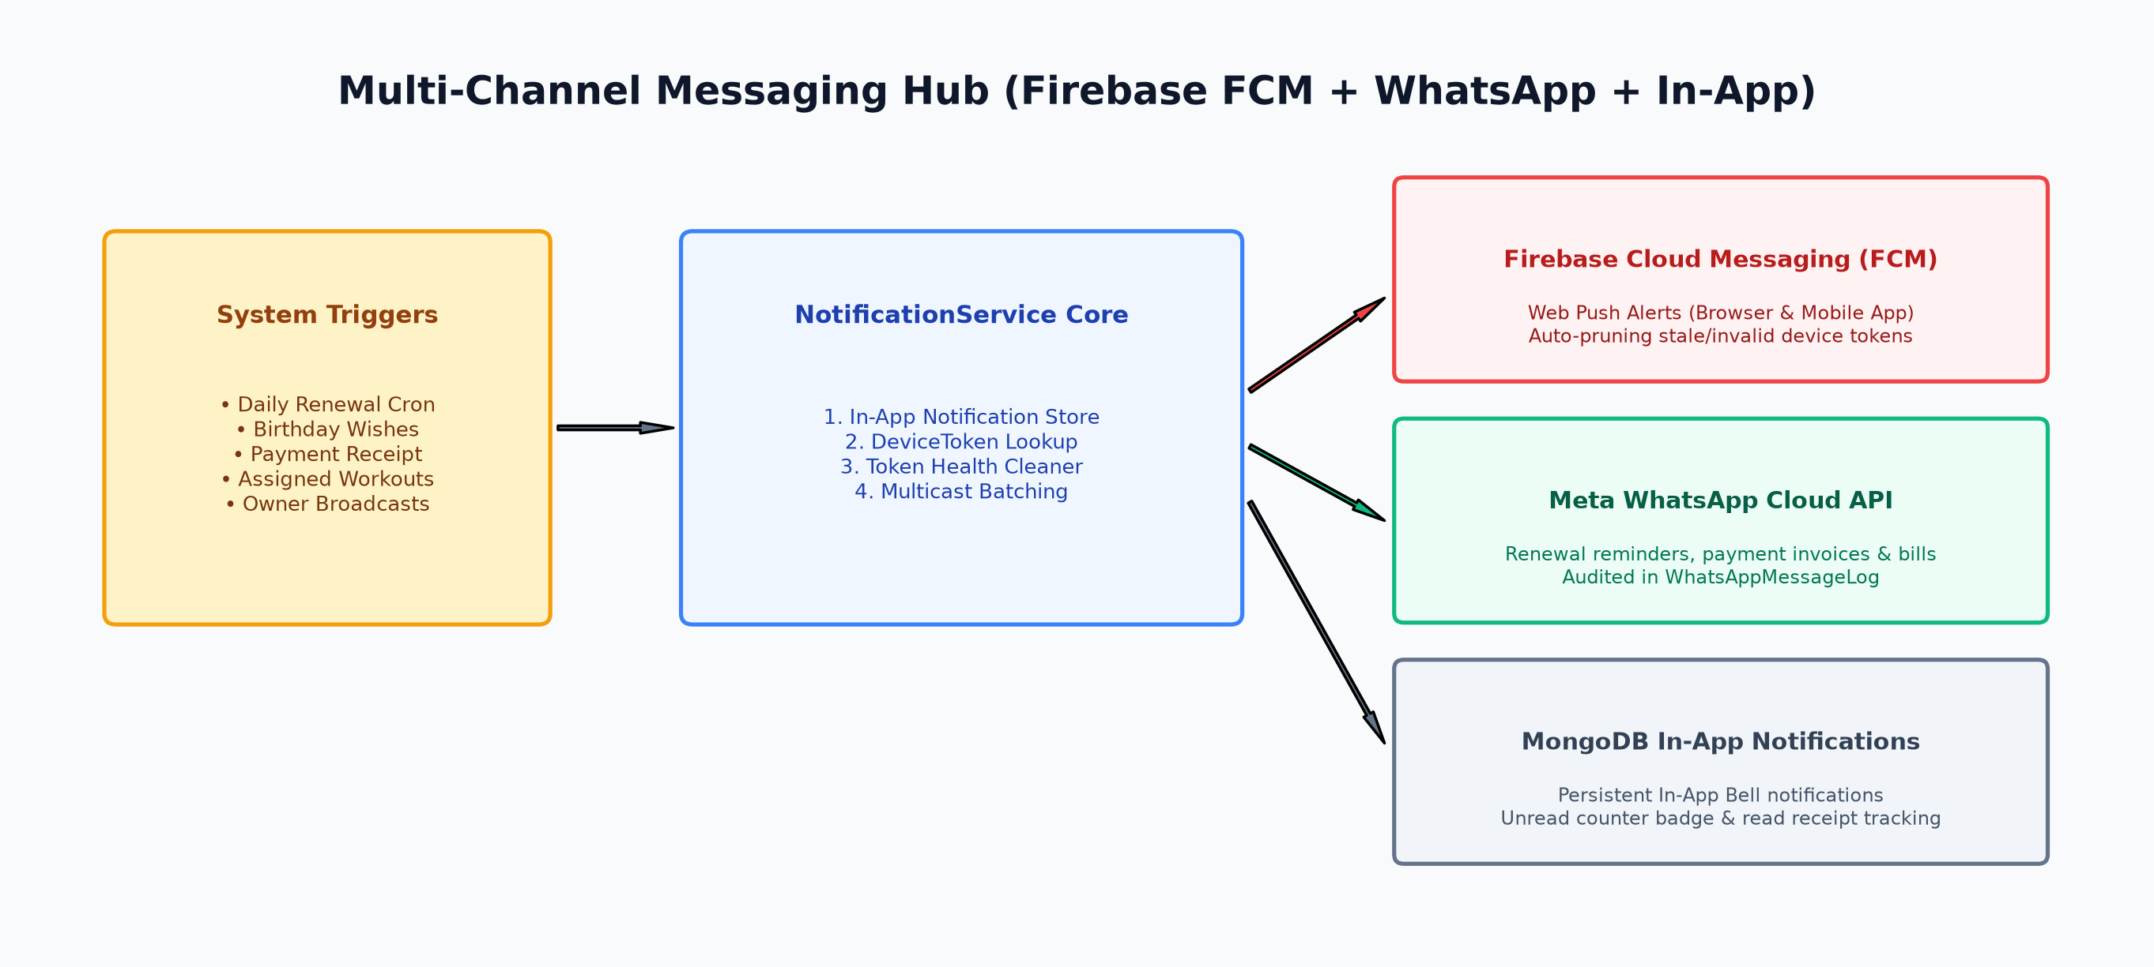
Figure: 9.3: Multi-Channel Messaging Hub & Firebase Cloud Messaging (FCM) Architecture

9.4 Multi-Provider AI Architecture (Google Gemini & OpenAI)
The AI Coach utilizes a resilient factory pattern (AIProviderFactory in backend/src/modules/aiCoach/providers/):
- Primary Provider (Google Gemini): Defaults to gemini-2.5-flash / gemini-3.5-flash-lite for ultra-fast response times and cost efficiency.
- Secondary Fallback (OpenAI): If Gemini experiences rate limiting, network timeout, or quota exhaustion, the factory automatically routes the request to OpenAI gpt-4o-mini without user disruption.
- Domain Guardrails & Zero Hallucination: Strict system prompts refuse off-topic inquiries (coding, politics, entertainment) and mandate citing live database metrics for gym financial queries.

10. Automated Background Cron Jobs & Schedulers
The background job engine is initialized on server startup via initCronJobs() in backend/src/jobs/index.ts using node-cron. These jobs automate essential operational retention and billing tasks:
Execution Time | Cron Pattern | Job Class / Service | Operational Action & Impact
09:00 AM Daily | 0 9 * * * | MembershipReminderJob | Scans active members expiring in 7 days, 3 days, 1 day, or today. Dispatches automated WhatsApp messages and FCM push alerts with renewal payment links.
09:15 AM Daily | 15 9 * * * | BirthdayReminderJob | Scans all members whose dateOfBirth matches today's month and day. Dispatches personalized birthday wishes and gym bonus reward XP.
09:30 AM Daily | 30 9 * * * | ChurnPredictionService | Iterates across all active gyms and assesses churn risk for every member based on attendance decay. Persists ChurnRiskAssessment records for owner review.
00:00 AM Midnight | 0 0 * * * | GymService & MemberService | Sweeps all gym SaaS trial dates (marking expired gyms as TRIAL_EXPIRED) and sweeps member membershipEndDate (marking expired passes as EXPIRED).

11. Technical Debt, Flaws Tracker & Resolution Status
An exhaustive codebase audit was conducted (tracked in project_flaws_analysis.md). 11 critical architectural flaws, dummy data fallbacks, and routing parity issues were resolved. 1 high-priority integration item remains open for frontend completion:

11.1 Active High-Priority Integration Item
[HIGH PRIORITY OPEN TASK] Issue: Frontend Razorpay Checkout SDK Modal Integration Missing.
Files Affected: backend/src/modules/payment/gateway/razorpay.gateway.ts and frontend/src/pages/owner/Payments.tsx.
Status: Backend order creation (POST /gyms/:gymId/payments/online-order) and webhook verification are complete. The frontend requires dynamically injecting https://checkout.razorpay.com/v1/checkout.js and triggering new window.Razorpay(options).open() upon order receipt.

11.2 Resolved Architectural Flaws Changelog
Area / Component | Original Defect / Technical Flaw | Architectural Resolution
Staff Management | Missing gym-level staff creation route (POST /gyms/:gymId/staff); branchless creation failed. | Added route aliases for /:gymId/staff and branch paths; added single-branch auto-assignment and branch selection dropdown in UI.
Equipment Tracking | Gym-wide equipment listing and creation route missing. | Registered route aliases at gym and branch levels; added branch dropdown and populated branch badges in equipment table.
Reception POS Payments | Premature success toast and swallowed catch block. | Moved success toast after backend confirmation; standardized errors with showApiErrorToast.
Owner Member CRM | Swallowed initial payment failure with false-positive toast. | Tracked payment status explicitly; triggers warning toast if member created but initial payment fails.
Owner Financial Reports | Hardcoded revenue splits (/ 4 weekly, 85/15 split). | Replaced hardcoded math with live date-grouped aggregations from paymentApi.listMemberPayments.
Reports Feedback & Churn | Fabricated counts (|| 1, || 3) in feedback charts. | Replaced fake fallback numbers with genuine zero counts and clean empty-state segments.
Consistency Tracker | Fake 16-day monthly attendance fallback. | Replaced with strict numeric check attendanceStats?.monthlyVisits ?? 0.
Admin Global Settings | Platform settings stored only in browser localStorage. | Built PlatformSettings MongoDB schema, controller, and routes under /api/v1/billing/platform/settings.
Member Gamification | Disconnected StreakGamificationHub component. | Fetched /gamification/me profile and integrated StreakGamificationHub at top of member view.
Member Dashboard | Unused paymentApi.getMyPayments API response. | Saved to state and rendered actionable Membership & Billing status banner.
Global Catch Handlers | Empty catch {} blocks across Admin, Owner, Trainer pages. | Standardized all catch handlers across the frontend to use showApiErrorToast and formatApiError.

12. Installation, Configuration & Deployment Guide

12.1 Prerequisites
- Node.js: Version 20.x LTS or higher.
- MongoDB: Version 7.0 or 8.0+ running locally or on MongoDB Atlas.
- Package Manager: npm v10+.

12.2 Local Development Setup
Follow these steps to run backend and frontend locally:
- 1. Clone & Navigate: cd d:\Projects\gym_ai_SaaS
- 2. Configure Backend Environment: cd backend && copy .env.example .env (Populate MONGO_URI, JWT secrets, and API keys).
- 3. Install Backend Dependencies: npm install
- 4. Start Backend Server: npm run dev (Runs on http://localhost:5000 with ts-node-dev).
- 5. Configure Frontend Environment: cd ../frontend && copy .env.example .env (Set VITE_API_URL=http://localhost:5000/api/v1).
- 6. Install Frontend Dependencies: npm install
- 7. Start Frontend Dev Server: npm run dev (Runs on http://localhost:5173 with Vite HMR).

12.3 Production Build & Deployment Checklist
- Backend Build: npm run build (Compiles TypeScript into dist/server.js).
- Frontend Build: npm run build (Compiles optimized production bundle into dist/).
- Reverse Proxy / HTTPS: Configure Nginx or Caddy with valid SSL certificates and proxy headers (X-Forwarded-For, X-Real-IP).
- Database Replica Set: Deploy MongoDB in a replica set configuration to support transactions and TTL index workers.
- CORS Origin Lock: Ensure CLIENT_URL in production .env contains only official domain names.

