Wooded meadows

Information from semi-natural communities section on the
Estonian Seminatural Community Conservation Association website.
pky.ee/en/seminatural-communities/wooden-meadows/characterization/

1. Characterization
Wooded meadows are one of the oldest ecosystems in the forest zone that have evolved through interactions between man and nature. These communities have offered means for living for more than a thousand years but nowadays they have disappeared almost from everywhere – only some tens of years has been enough for vanishing processes. The area of wooded meadows that has survived, corresponds approximately to an area of wooded meadows that once surrounded one western Estonian village.

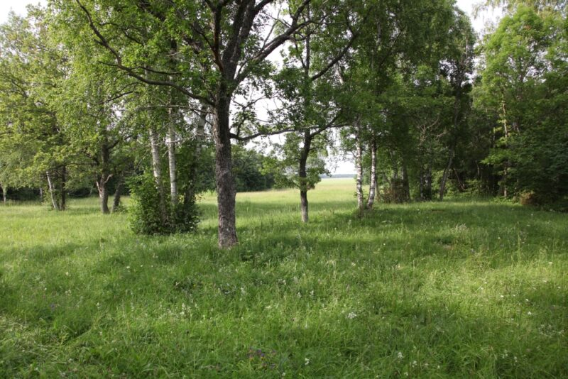Figure 1: Laelatu wooden meadow. Photo by Toomas Kukk
In Estonian agricultural literature the term ‘natural meadows’ is used, but in plant ecology these communities are known as ‘semi-natural communities’. An expression ‘wooded meadow’ is more common in scientific and specialised literature; local people mostly call these communities simply as ‘meadows’, ‘woods’, ‘hay gardens’ etc.

Wooded meadows are sparse natural wooded stands with regularly mowed herb layer. In terms of appearance and ecological conditions, wooded meadows are similar to parks, yet they are considerably older and initially arose from natural communities. Groups of trees and bushes of different species composition may be sparse or dense, but the presence of turf is characteristic of wooded meadows. Mowing is done usually every year. Wooded meadows can be subdivided in several ways: dry and moist meadows, species-poor and species-rich etc.

Wooded meadows were widespread in the Baltic Sea countries, especially in Estonia, Finland and Sweden. Fewer and less typical wooded meadows could be found in Norway, Denmark, Germany and in the mountains of Central Europe. Flooded wooded meadows were common on the banks of larger rivers in Lithuania and Latvia.

More info
Detailed overview in English about Estonian dry and fresh and paludified grasslands and instructions for the management and restoration.

2. Dynamics
How did wooded meadows develop and what are the reasons of their disappearance?

Communities resembling wooded meadows started to develop around ancient settlements about 7000-8000 years ago. Extensive cattle-breeding spread to Estonia about 4000 years ago, most probably this was the period when notable enlargement of the area of wooded meadows took place. In the end of the 19th century the area of mown and grazed wooded meadows had increased to 850 000 ha (18 per cent of Estonian area). After this natural meadows started to disappear. Some of these communities were cultivated and used as crop fields or intensive grasslands. Despite of those transitional processes the area of wooded meadows decreased quite slowly until the Second World War.

The collectivisation of farms was one of the first reasons why wooded meadows started to disappear quickly in the 1950ies. Land and animals were turned into common property; collective farmers were allowed to keep only some few animals and haymaking made no reason anymore. The decrease in the area of wooded meadows was mainly caused by the abandonment of manual labour that accompanied the transition to large-scale production. The changeover from extensive to intensive land-use was the reason why wooded meadows disappeared also in the whole of Western Europe.

3. Vegetation
Nowadays wooded meadows have raised interest because of the high small-scale species richness of herb layer. On calcareous wooded meadows there are commonly over 50 species per one square metre. This is much more than in any other community in the forest zone. On woodless meadows the number can be as high as 30 species, on alvars this can reach until 40. On five wooded meadows of western Estonia the species number per one square metre has been found to be higher than 60. On the wooded meadow of Laelatu in Läänemaa county 76 species on one square metre were described, on Vahenurme wooded meadow in Pärnumaa county the species richness was as high as 74. Small-scale species richness has been found to be higher only on some fragments of forest-steppes in Southern Russia. The world highest small-scale species richness was recorded on grazed mountain meadows in Argentina – up to 88 vascular plant species per one square metre.

There are several reasons that cause the high species richness:

- Regular mowing for a longer period of time. Attaining high species richness may require constant management because the insertion of species to the community takes place quite slowly.
- The heterogeneity of environmental conditions. Higher habitat diversity develops when two such different communities as forest and meadow are interweaved. Wooded meadows offer suitable conditions to the species adapted to forests as well as to the species typical of meadows, although the conditions of such habitats may not be optimal.
- Soil acidity (pH) affects species richness – less species are able to grow on acid soils than on neutral or calcareous. Species richness of the alkaline communities of western Estonia is several times higher than of the communities with acid soils in eastern and southern Estonia.
- Soil fertility is very important – it has been shown that species richness is lower on poor as well as on very fertile soils. The abundance of nutrients favours species that grow bigger and compete out species with slower and smaller growth rate. Soil moisture often shows the same effect.
- Large species pool, i.e. high species number of the surrounding communities. A plant community is an opened system and species richness can be maintained only, when the flora of the surrounding region (dispersal distance) is not impoverished. Consequently, the conservation of small but species-rich wooded meadows requires extensive protection zones.

Wooded meadows are unique examples of ecosystems, where the species richness and aesthetic value have grown as a result of human activities. The beauty of wooded meadows has been stressed by most of the visitors, who have made acquaintance with those communities.

4. Human impact
Wooded meadows served as sources of hay, wood, herbs, hazelnuts, mushrooms etc. Leaves and dead grass were the only fertilisers. In autumn, when hay had been mown, animals were grazed on wooded meadows. If animals are grazed on wooded meadows constantly from spring to autumn, the composition of herb layer will change, the density of shrub layer will grow etc. – these communities are called grazed pastures.

Wooded meadows have almost completely lost their economic importance nowadays – cultural grasslands support with hay, timber is made mainly from clear-cuttings. Wooded meadows that are not mown nor grazed overgrow quickly. Especially notable has been the disappearance of wooded meadows on Estonian islands.

5. Protection
About 70 ha of wooded meadows have survived on nature protection areas. The Laelatu wooded meadow in the nature protection area of Laelatu-Puhtu-Nehatu is most probably one of the most well-known wooded meadows of Estonia. On average 15 ha has been mown there every year. On Laelatu wooded meadow are situated the study sites, that have been investigated for tens of years. The equipment of the research station of Laelatu enables to carry on several studies on ecology, geography and meteorology.

The wooded meadows of Tagamõisa and Viidumäe nature reserves are most famous wooded meadows of Saaremaa Island. The preservation of Viidumäe wooded meadows has been maintained by working camps. Largest areas of flooded wooded meadows can be found in Soomaa National Park. The landscape protection areas of Vahenurme and Nedrema are in the preparation stage.

Difficulties in the conservation of wooded meadows appear because profits concerning biodiversity are indirect and the evaluation of economical benefits is complicated. But expenditures are concrete and need immediate investments. Compensation for mowing is most probably the only possibility to guarantee the management of wooded meadows in modern times. The further maintenance of those unique communities is a mission of both governmental institutions as well as non-governmental organisations.

