Technical Design for
file transfer replacement project


corporate integration hub
to Corporate source
Version 002

Contents
1 Document Review & Sign-off 3
Document Properties 3
Revision History 3
Document Approvers 3
Supporting Documents 3
2 Introduction 4
Purpose 4
Responsibility for this Document 4
Document Scope 4
Audience 4
3 Overview 5
Business and Technical Overview 5
4 Design 6
Interface/Service Pattern 6
4.1 SOA Invoked Sequence Diagram 6
Normal Flow Sequence Diagram 6
4.2 Event Driven Sequence Diagram 8
4.3 RTI Instructions 9
5 Operations 10
Restart/Recover conditions 10
6 Assumptions 10
- Document Review & Sign-off

Document Properties
Author | Creation Date | Last Updated | Version
Geoff Lyle | 05/04/2011 | 05/20/2011 | 002

Revision History
Ver. | Date | Description | Author
001 | 05/04/2011 | Initial Draft | Geoff Lyle
002 | 05/25/2011 | Upadted | Geoff Lyle

Document Approvers
Name | Role | Signature | Sign-off Date
Jeremy Sena | SysRepublic
Geoff Lyle | SysRepublic
Ned Bilkic | SOA Solution Architect
Soeren Ahrens | SOA Program Lead
Abhi Srivastava | SOA PD Lead

Supporting Documents
Document Title | Document Type | Author | Date | Location
Technical_Design_Ross_File_Transfer_Solution_Overview_v2 | Technical Design | Geoff Lyle | 5/5/2011
- Introduction

Purpose
The purpose of this document is to define the essential characteristics of the RTI Corporate Integration Hub to Corporate System file transfers initiated by the store to hub transfer process. The document will identify the communication internal to RTI and define the flow of data between the SOA, RTI, the Corporate Integration Hub and Corporate Source systems. Ross application and SOA teams are expected to reach a mutual agreement on the interface design prior to technical design.

Responsibility for this Document
Sysrepublic will own this document and subsequently is responsible for updates and versioning. All changes and additions are subject to review prior to sign off.

Document Scope
This document will cover, at a detailed level, the design as described by the functional requirements for communication between ROSS systems integration and application teams. The document details the solution design and features the Integration components to be used for interfacing with the end applications. The document will also feature the common exception handling service for the RTI processes.

This document is intended to provide the technical design pattern for all Corporate Integration Hub to Corporate sytem file transfers. Specific inetrface configuration sheets will detail the specifcs of a particular file transfer. This document will cover all manner of interface characteristics but should not exceed beyond the scope of defining the handshake for the interface.

The Sysrepublic team would use this document in the subsequent phases to build the integration components.

Audience
This document is intended for persons who seek to understand the high level agreement between the RTI component development team and consumers of the data which passes between of the RTI Corporate Integration Hub, Corporate sytems and the SOA integration team. The audience includes:
- Project Managers
- Functional Analysts
- Application Architects
- Software Developers
- Testing Analysts
- Production Support Personnel
- Overview

Business and Technical Overview
The purpose of this document is to provide a design pattern for any corporate hub to corporate destination transfer requirement that requires files to be delivered from all of the current stores in the Ross estate to a corporate destination by way of the integration hub. This document does not make any assumptions as to the 'business objective or purpose' of the files being transferred, this information will form part of the end to end design of the business application utilizing this file transfer solution.

The pattern described here will enable a repeatable mechanism to invoke the transfer of a file or set of files from the Corporate Integration Hub to a corporate destination via web service call from SOA or event driven rule native to the Hub.

The pattern will cater for the following transmission options
- SOA invocation
- Event driven invocation
- Flexible destination selection
- Flexible file renaming
- Compression
- Creation and explosion of ZIP archives for recursive directory requirements

The patterns described in this document will be invoked from the enterprise scheduler via the BPEL pattern described in detail in the document, ‘Techncial_Design_ BPEL_InvokeStoreRTIWS_sCA_Sync’, or maybe invoked via an event driven schedule native to the Hub.

Each file or set of files can be regarded as a 'transmission' from hub to store. Each transmission will be logged for audit purposes and alerting will be implemented to highlight non-transmission of data.

The file transfer solution will be built using the Sysrepublic RTI technology platform. RTI will provide the data movement and logging engine for all transmissions. For more information on RTI please see the 'RTI Help' documentation.

The following example interface types will be supported by the Pattern described in this Document:

RMS Data from Hub to RMS
EDW Data from Hub to Data warehouse
Zip Code Survey from to Data warehouse

- Design

Interface/Service Pattern
Service would follow point to point pattern and frequency of file transfers will be scheduled/ondemand.

SOA Invoked Sequence Diagram

Normal Flow Sequence Diagram

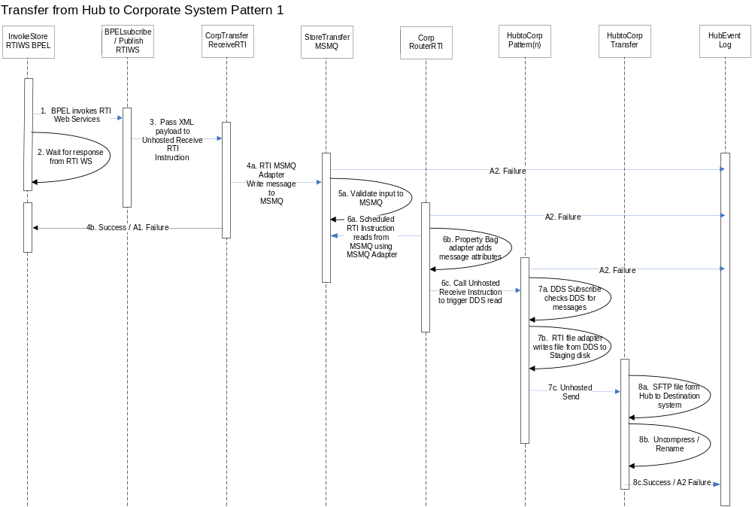

Normal Sequence Diagram Walkthrough
Normal Sequence # | Event | Component Invoked | Output | Alternate flow sequence#
1. | BPEL Calls RTI webservice pass XML payload:  InvokeRTIFileTransferRequestMessage | BPELsubcribe  RTIWS | RTI  instantiated.
2. | BPEL waits for RTI callback (success / failure) |  |  | A1
3. | BPELsubcribeRTIWS Web service calls unhosted RTI instruction | CorpTransfer  ReceiveRTI | CorpTransfer  ReceiveRTI Initiated | A1
4a. | MSMQ adapter writes transmission message to MSMQ | CorpTransfer  ReceiveRTI | Message added to StoreTransferMSMQ | A2
4b. | Callback SOA with Success Fail of the message receipt | InvokeStoreRTIWS BPEL | Webservice Callback | A1
5. | Validate message input to queue | StoreTransferMSMQ | None | A2
6a. | Scheduled RTI Instruction reads StoreTransferMSMQ looking for new transmission events: | CorpTransfer  RouterRTI | Property Bag Adpater | A2
6b. | RTI transform: Property Bag adapter adds message attributes from:  InvokeRTIFileTransferRequestMessage to Transmission Property Bag  RTI evaluates Property Bag to determine Pattern Instruction to invoke | CorpTransfer  RouterRTI:  Property Bag Adpater | Call Pattern Specific Unhosted Receive | A2
6c. | Call unhosted receive instruction to iniate push from Hub to Corporate Sytem | CorpTransfer  RouterRTI | Call to Corp Transfer Instruction | A2
7a. | DDS Subsribe checks for new messages on the Hub | HubtoCorp  Pattern(n)RTI | New DDS event identified | A2
7b. | RTI file adapter writes file from DDS to Hub staging area | HubtoCorp  Pattern(n)RTI | File available to move from Hub | A2
7c. | Call unhosted send instruction to move file from Hub to Destination directory | HubtoCorp  Pattern(n)RTI | SFTP Transfer | A2
8a | Unhosted send initiates SFTP transfer from Hub to Corporate System | HubtoCorp  Transfer | Invoke Transform | A2
8b. | Transform StepUncompress and rename at destination | HubtoCorp  Transfer | File transformed | A2
8c | On success write to Hub event log | HubtoCorp  Transfer | Message to HUB event log | A2

Alternate Walkthrough
Alternate Sequence # | Output/Action for alternate flow
A1 | RTI failure will call back error event to BPEL via BPELpublish  RTIWS
A2 | Error writes to HUB Event log using RTI event log adapter

Event Driven Sequence Diagram

Normal Flow Sequence Diagram

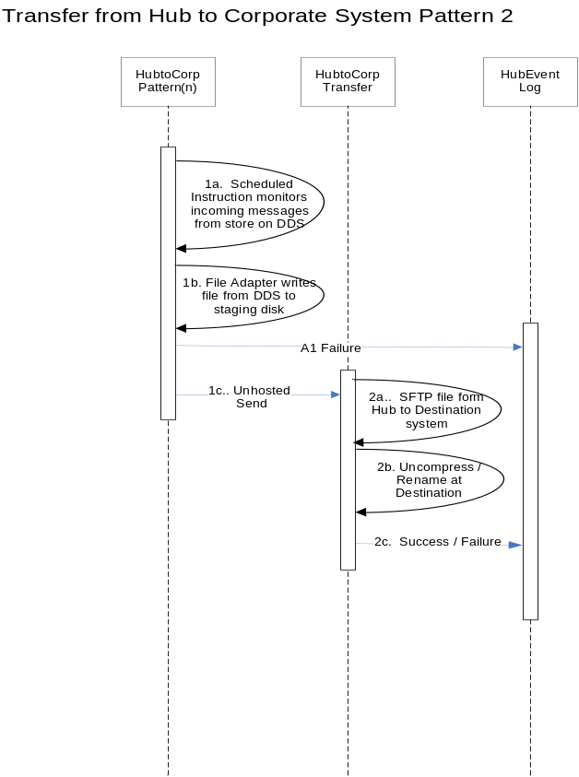

Normal Sequence Diagram Walkthrough
Normal Sequence # | Event | Component Invoked | Output | Alternate flow sequence#
1a. | Scheduled Instruction checks for new DDS messages on the Hub | HubtoCorp  Pattern(n)RTI | New DDS event identified | A1
1b. | RTI file adapter writes file from DDS to Hub staging area | HubtoCorp  Pattern(n)RTI | File available to move from Hub | A1
1c. | Call unhosted send instruction to move file from Hub to Destination directory | HubtoCorp  Pattern(n)RTI | SFTP Transfer | A1
2a | Unhosted send initiates SFTP transfer from Hub to Corporate System | HubtoCorp  Transfer | Invoke Transform | A1
2b. | Transform StepUncompress and rename at destination | HubtoCorp  Transfer | File transformed | A1
2c | On success write to Hub event log | HubtoCorp  Transfer | Message to HUB event log | A1

Alternate Walkthrough
Alternate Sequence # | Output/Action for alternate flow
A1 | Error writes to HUB Event log using RTI event log adapter

RTI Instructions
The following RTI instruction templates will be required for the Source to Hub Service:
Instruction Name | Type | Details
CorpTransfer  ReceiveRTI | UnHosted Receive | Unhosted instruction receives XML payload from web service and inserts to MSMQ on DB Server
Corp  RouterRTI | Scheduled | Scheduled instruction read from MSMQ and routes message to the appropriate transfer pattern
HubtoCorp  Pattern(n)RTI | Unhosted Receive | Unhosted instruction designed to interpret the contextual information of each transmission and perform the steps required to write the file to disk from the DDS database on the hub and move to the source system. Can be SOA invoked or Scheduled
HubtoCorpTransfer | UnHosted Send | Unhosted instruction moves file via SFTP from hub staging to destination directory.

Operations

Restart/Recover conditions
Failure Point | Description | Resubmit Functionality | Process Type | Guiding Principle | Support Procedure | Frequency
RTI Webservice | Fails to connect to Corporate Agent | Error occurs and callback SOA | N/A | Infrastructure Issue | ? | Low
RTI MSMQ Adapter | RTI fails insert to MSMQ | Error occurs and callback SOA | Add to Queue | Infrastructure Issue | ? | Low
RTI SFTP Adapter | Fail to connect to SFTP | Error occurs and callback SOA | SFTP Transfer | Infrastructure Issue | ? | Low
RTI DSS Adapter | Failure to connect to DB | Retry and Error occurs and callback SOA | DB Connect | Infrastructure Issue | ? | Low

Assumptions
ID | Description
1 | All the attributes defined in the message body of the invocation message should be treated as overrides for any default value defined in the RTI file transfer metadata.
2 | HubtoCorpPattern(n)RTI instruction is a variable component the specific instructions required will b determined by the details interface configuration sheets
3 | General Alert and Error handling of events in the DDS database will are included in the Solution Architecture Technical Design

