Store File Transfer


RTI Alerts and Monitoring
Technical Design

Version 001

Contents
1 Document Review & Sign-off 3
1.1 Document Properties 3
1.2 Revision History 3
1.3 Document Approvers 3
1.4 Supporting Documents 3
2 Introduction 4
2.1 Purpose 4
2.2 Responsibility for this Document 4
2.3 Document Scope 4
2.4 Audience 4
3 RTI Monitors and Alerts 5
4 DDS Alerts and Monitoring 7
5 RTI Agent Alerts 8
- Document Review & Sign-off

Document Properties
Author | Creation Date | Last Updated | Version
Geoff Lyle | 5/25/2011 | 5/28/2011 | 1.1

Revision History
Ver. | Date | Description | Author
1.0 | 5/25/2011 | Initial Draft | Geoff Lyle
1.1 | 5/28/2011 | Updated post review | Geoff Lyle

Document Approvers
Name | Role | Signature | Sign-off Date
Nediljko Bilkic | SOA Architecture Lead
Abhi Srivastava | SOA Lead
Soeren Ahrens | SOA Program Lead
Nathan Smith | SysRepublic Lead

Supporting Documents
Document Title | Document Type | Author | Date | Location
- Introduction

Purpose
This document describes the Standard RTI components which should be monitored for the File Transfer HUB, and provides a description of the Standard alerts that an RTI agent will generate for the Windows Event Log. This document also covers any assumptions/pre-requisites for the infrastructure as well as identifying the specific areas where monitoring would be required.

It is intended that this document serves as a working document as certain areas are subject to change over the lifetime of the RTI Infrastructure project as well as with the introduction of new interfaces. Where such changes do occur, examples being the introduction of additional Processing servers or changes to the server details (defined in the Appendices), it is expected that such changes will result in a new document version and a change log being recorded in the version history table in Document Control section.

Responsibility for this Document
The project team will own this document and subsequently is responsible for updates and versioning. All changes and additions are subject to review prior to sign off.

Document Scope
This document will cover the Standard errors and alerts the base components of the RT solution will generate. It is not intended to describe the specific error conditions that may occur related the functional alerting requirements of a specific interface or alerting conditions for the DDS Hub. The Specific Details of those requirements should be addressed as part of each interface functional interface or file transfer specification.

Audience
This document is intended for persons who seek to understand the design of the file transfer instructions for Pattern 1 Transfers: Same file form Corporate Hub to All Stores. The audience includes:
- Project Managers
- Functional Analysts
- Application Architects
- Software Developers
- Testing Analysts
- Production Support Personnel
- RTI Monitors and Alerts

This section details component specific monitoring which Sysrepublic recommends Ross setup with the CA UNICENTER Event Agent System Monitoring Tools for the support of the RTI infrastructure. Note that the scope of this section is restricted the components delivered by Sysrepublic and will therefore focus on only on the HUB Web and Database Servers as well as the SQL Server database jobs for the CMC and DDS databases.
It is expected that monitoring and alerting will be subject to changes or refinements depending on the alerts being raised once the system has been fully rolled out and operational for a duration of time. Sysrepublic recommend the error scenarios used for alerting be tested/replicated on the relevant environments to guarantee an accurate representation of the errors/warnings and the handling of these by the alerting applications being used. While such errors would typically be consistent, there is a possibility of variance between different environments which could have implications for the alerting applications being used.
Sysrepublic assume that processes and procedures to resolve issues detected during operational processing will be defined by the teams supporting the solution at a 1st and 2nd line level. Details on any testing to be performed in respect of this section, 3rd party alerting software and operational support processes are out of scope.
Sysrepublic assume General SQL Server availability and monitoring will be managed by existing infrastructure alerting guidelines. If RTI Components in the Integration Hub solution cannot access SQL server, those components will raise an error to the Windows event log in accordance with the specific scenario.
The table below describes components requiring monitoring for each applicable server. Note that the following checks need to be done for each individual server regardless of whether the server is in Active/Passive mode (or being accessed via a logical load balancer address):

Server | Component | Component Type | Details
Hub Web Server(s) | IIS Admin Service | Windows Service | Alert in the event the service is not running.
Hub Web Server(s) | Message Queuing | Windows Service | Alert in the event the service is not running.
Hub Web Server(s) | RTI Agent$[Instance] | Windows Service | Alert in the event the service is not running.
Hub Web Server(s) | RTI Broadcast Manager | Windows Service | Alert in the event the service is not running.
Hub Web Server(s) | World Wide Web Publishing Service | Windows Service | Alert in the event the service is not running.
Hub Web Server(s) | Source: RTI Agent* | Application Log | Alert on errors (only)
Hub Database Server | Message Queuing | Windows Service
Hub Database Server | RTI Agent$[Instance] | Windows Service
Hub Database Server | Source: RTI Agent* | Application Log | Alert on errors (only)
Hub Database Server | Source: Broadcast Manager | Application Log | Alert on errors (only)
Hub Database Server | DDS Database – All SQL Agent Jobs | SQL Agent Job | Alert on failure for all scheduled jobs.
Hub Database Server | CMC Database – All SQL Agent Jobs | SQL Agent Job | Alert on failure for all scheduled jobs.
Hub Database Server | CMC Databse – Service Pulse Alert | RTI | Alert if store does not communicate to Hub with x seconds / minutes
Hub Database Server | Scheduled DDS Alerts | RTI Instruction | Specific functional alerts configured to meet the requirements of the file transfer project

DDS Alerts and Monitoring
All DDS Alerts generated at System or Instruction level will be written to the Windows Application Event Log using the Event Log adapter native to RTI. In addition, some Alerts will have the capability of raising Alert messages back to SOA via the BPEL Callback Web Service. The two Alerts types are described below:

Hub Application Alerts:
The Alert message written to the log will be in the standard Windows log format, and will be available for integration with the CA UNICENTER Event Agent System Monitoring Tools. The Error log will have the following format:

Category ID | Event ID | Machine Name | Source | Severity | Error Description

Scheduled Alerts monitoring the DDS Database for specific conditions of an interface requirement will use the following design sequence:
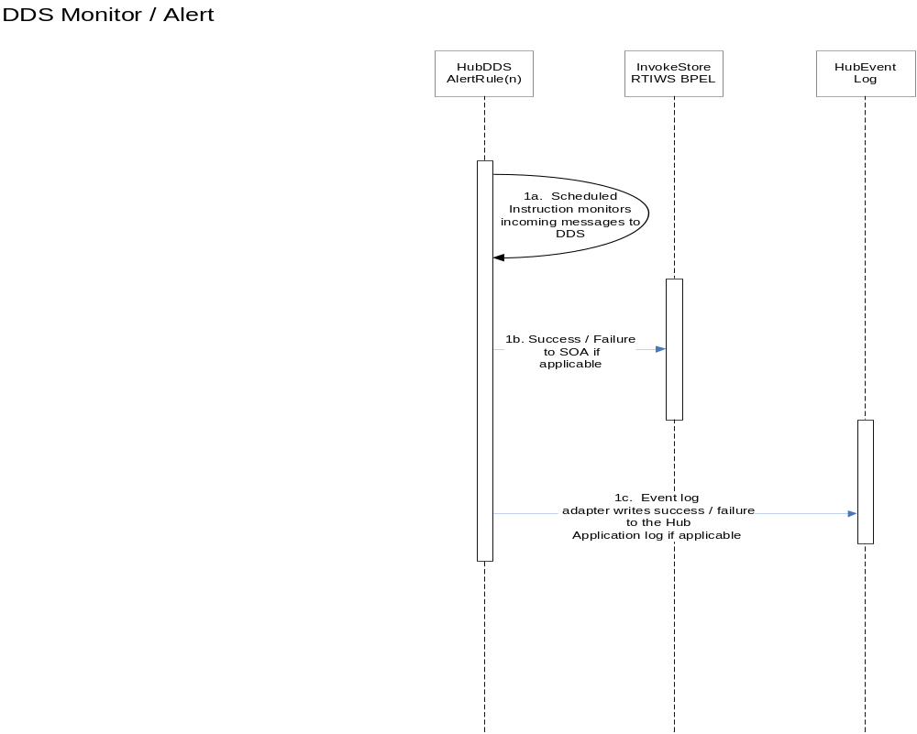

SOA Web Service Callbacks:
When conditions require a Success of Failure Alert message back to SOA via the BPEL Callback, RTI will deliver the alert message back to SOA via the InvokeRTIFileTransferResponseMessage schema described in theTechnical_Design_BPEL_InvokeRTIWS_sCA_Sync v002 document.

Corporate RTI Agent Alerts
All RTI Alerts generated at System or Instruction level will be written to the Windows Application Event Log using the Event Log adapter native to RTI. The Alert message written to the log will be in the standard Windows log format, and will be available for integration with the CA UNICENTER Event Agent System Monitoring Tools. The Error log will have the following format:

Alert Message Element | Description | Notes
Category ID | The category of Alert for RTI values would include RTI Infrastructure, RTI Application | To be used as a key routing field by the CA application to the appropriate Support team
Source | Architecture or Functional component which is threw the alert (Agent, DDS, RMS, EDW, etc.) | Used as key filed for routing by CA
Severity | Standard windows severity levels (Error, Warning, Information) | Only Errors will generated CA support processes
Event ID | A specific event id of the error message
Machine Name | The machine from which the alert originated
Description | A text description of the error / alert condition

Category ID | Event ID | Machine Name | Source | Severity | Error Description

The following section describes the standard alerts that an RTI Agent may create in the Windows Event Log if a system error occurs:

Event ID: 5
Severity: Warning
Reason: The RTI Agent cannot find (or access) the registry key\value HKEY_LOCAL_MACHINE\SOFTWARE\Sysrepublic\RTI 2.0\RTI Agent\Last Event Time. This key is used to store the time of the last event that was transmitted by the agent.
Impact: The RTI Agent will resend the same windows event log entries every time a service pulse is generated
Resolution: Create the key\value (as a string type) if it does not exist or reinstall the RTI product. If the key\value does exist ensure that the account used by the RTI Agent service has sufficient privileges to access this part of the registry

Event ID: 10
Severity: Error
Reason: The RTI Agent configuration file could not be loaded. The file exists in D:\Program Files\Sysrepublic\RTI 2.0\RTI Agent and is called Sysrepublic.RTI.RTIAgent.Configuration.xml. This file may have been removed, got corrupted or cannot be accessed by the agent using a specific security account
Impact: The RTI Agent service will not start and all instruction processing will be suspended
Resolution: Re-supply the file and ensure that the account used by the RTI Agent service has sufficient privileges to access the file and path

Event ID: 20
Severity: Error
Reason: The RTI Agent service could not create one or more system threads to assign instruction processing. It is not possible to define clear cases for this scenario.
Impact: Some RTI Agent processing will not start
Resolution: Check the Error Message and investigate the Exception Stack supplied. This may indicate reasons for the failure. Attempt to stop and start the RTI Agent service to determine if the issue is repeatable

Event ID: 25
Severity: Information
Reason: The RTI Agent service encountered a problem whilst stopping
Impact: None
Resolution: Check the Error Message and investigate the Exception Stack supplied. Start and Stop the RTI Agent service repeatedly to determine if the error reoccurs.

Event ID: 26
Severity: Information
Reason: A service stop request has been received by the RTI Agent service
Impact: All RTI Agent processing will not occur

Resolution: Determine if the service should be stopped

Event ID: 30
Severity: Warning
Reason: The RTI Agent service encountered a problem whilst stopping a service thread
Impact: None
Resolution: Check the Error Message and investigate the Exception Stack supplied. Start and Stop the RTI Agent service repeatedly to determine if the error reoccurs.

Event ID: 65
Severity: Warning
Reason: The instruction has been configured to run multi-threaded but one or more adapters are not thread safe
Impact: The instruction will run single threaded
Resolution: Ensure that the instruction configuration is correct.

Event ID: 85
Severity: Error
Reason: An instruction could not be started by the RTI Agent service
Impact: The instruction will not run
Resolution: Check the Error Message and investigate the Exception Stack supplied. Start and Stop the RTI Agent service repeatedly to determine if the error reoccurs.

Event ID: 90
Severity: Information
Reason: The RTI Agent service is being restarted due to either a configuration change or a server restart request
Impact: None
Resolution: None

Event ID: 95
Severity: Error
Reason: The RTI Agent service encountered a problem whilst restarting
Impact: The RTI Agent service will not start and all instruction processing will be suspended
Resolution: Check the Error Message and investigate the Exception Stack supplied. Issue more restarts via the RTI Agent Administrator to determine if the problem continues to occur.

Event ID: 100
Severity: Warning
Reason: An instruction thread has been in a state of execution for a time period that has exceeded the timeout value set in the instruction configuration. The instruction is being aborted and will be restarted
Impact: None
Resolution: Ensure that the instruction timeout value supplied is long enough for the operation to complete. Additionally, check that connectivity performance to external dependencies used by the instruction (e.g. remote servers, databases) is optimal

Event ID: 105
Severity: Warning
Reason: An instruction thread has been selected for timeout but could not be aborted
Impact: The transaction state of all adapters being used by the instruction may be inconsistent. This should not result in data loss however, under certain circumstances data duplication may be encountered
Resolution: Ensure that the instruction timeout value supplied is long enough for the operation to complete. Additionally, check that connectivity performance to external dependencies used by the instruction (e.g. remote servers, databases) is optimal

Event ID: 110
Severity: Error
Reason: An instruction thread could not be restarted after a timeout has been actioned
Impact: The instruction processing will be suspended
Resolution: Restart the RTI Agent service. Also check the Error Message and investigate the Exception Stack supplied

Event ID: 120
Severity: Warning
Reason: The time check processing against an instruction failed
Impact: Instructions will not be timed \out
Resolution: Restart the RTI Agent service. Also check the Error Message and investigate the Exception Stack supplied

Event ID: 125
Severity: Warning
Reason: The RTI Agent could not transmit a service pulse
Impact: The site will not have contacted the RTI Central Management Console (RTICMC) and therefore may appear inactive in the console. This event should be investigated if it persists for an hour or more
Resolution: Investigate the connectivity between:
- Store and PLSIHWEBDEV.ROS.com (NLB)
- PLSIHWEBDEV.ROS.com (NLB) and PLSIHWEBDEV01 (WebServer(s))
If connectivity is OK ensure that the MSMQ server is running on Database Server and start the service if it is not running
If MSMQ is running, ensure that the queues have not backed up significantly on Hub Database Server.
If the MSMQ server is using large amounts of RAM (i.e. 500MB - 1GB+) or disk space, this would indicate that MSMQ has a large volume of unprocessed messages

Event ID: 130
Severity: Warning
Reason: The RTI Agent could not successfully build the service pulse for transmission
Impact: The site will not have contacted the RTI Central Management Console (RTICMC) and therefore may appear inactive in the console
Resolution: Restart the RTI Agent service. Also check the Error Message and investigate the Exception Stack supplied

Event ID: 135
Severity: Warning
Reason: A transformation adapter has returned null data
Impact: Destination adapters on this instruction will not be invoked. Therefore data may not be transmitted
Resolution: This may be by design. Refer to the instruction design to determine if this should happen

Event ID: 140
Severity: Error
Reason: An instruction thread has failed and is being terminated
Impact: Instruction processing will be suspended
Resolution: Restart the RTI Agent service. Also check the Error Message and investigate the Exception Stack supplied

Event ID: 145
Severity: Warning
Reason: A problem was encountered on an instruction but the operations is being retried
Impact: The instruction processing will be retried but will not complete until the issue is resolved.
Resolution: This event should be investigated if it persists for an hour or more

Event ID: 150
Severity: Error
Reason: The on-completion task of an instruction could not be run
Impact: The instruction processing will complete but the on-complete task will not have been run
Resolution: Restart the RTI Agent service. Also check the Error Message and investigate the Exception Stack supplied. Ensure that the instruction configuration is correct

Event ID: 155
Severity: Error
Reason: The on-failure task of an instruction could not be run
Impact: The instruction processing will complete but the on- failure task will not have been run
Resolution: Restart the RTI Agent service. Also check the Error Message and investigate the Exception Stack supplied. Ensure that the instruction configuration is correct

Store RTI Agent Alerts

In order to limit the amount of monitoring and CA alert configuration on the Store ISP, the CMC will be the primary method of determining a potential error condition on the Store Agent. A service pulse alert instruction will be created to monitor the CMC for store service pulses. If the CMC has not logged a service pulse form the store within the agreed amount of time (5 minutes), the instruction will raise an Alert to the Event log on the Hub Database Server.

Support personnel will be responsible for troubleshooting the Service Pulse failure by looking to the Store ISP event log to determine the Agent error or network condition that may have been preventing the agent from communicating with the hub. The system alerts generated in the Store will be the same as the hub agent alerts listed in section 5 above.

All RTI Alerts generated on Store Agents at System or Instruction level will be written to the Windows Application Event Log using the Event Log adapter native to RTI. The Alert message written to the log will be in the standard Windows log format, and will be available for integration with the CA UNICENTER Event Agent System Monitoring Tools. The Error log will have the following format:

Alert Message Element | Description | Notes
Category ID | The category of Alert for RTI values would include RTI Infrastructure, RTI Application | To be used as a key routing field by the CA application to the appropriate Support team
Source | Architecture or Functional component which is threw the alert (Agent, DDS, RMS, EDW, etc.) | Used as key filed for routing by CA
Severity | Standard windows severity levels (Error, Warning, Information) | Only Errors will generated CA support processes
Event ID | A specific event id of the error message
Machine Name | The machine from which the alert originated
Description | A text description of the error / alert condition

