Communities
- Full range value shopper (Unkown / Bob)
- Brand aware Luxury Shopper (Anne)
- Quality Basics shopper (David)

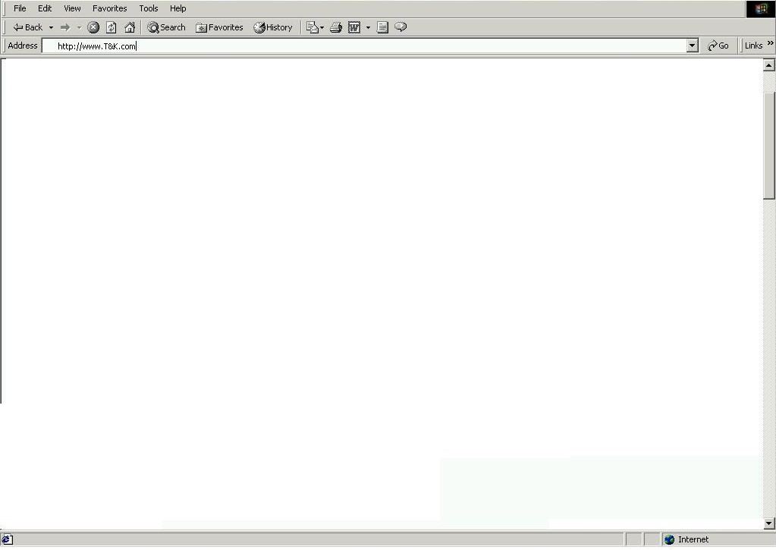

Home Page Template
BA_A
AD_A
AD_B
AD_C
IN_A
FP_A
FP_B
FP_D
FP_C

HP Banner Ad Ruleset:
- Select one Banner Ad from available choices

HP FP_A Ruleset:
- Select one featured product ad from the Food category where product characteristics match Community 1 profile
- Select one featured product ad from the Food category where product characteristics match Community 2 profile
- Select one featured product ad from the Food category where product characteristics match Community 3 profile

HP FP_B Ruleset:
- Select one featured product ad from the Apparel category where product characteristics match Community 1 profile
- Select one featured product ad from the Apparel category where product characteristics match Community 2 profile
- Select one featured product ad from the Apparel category where product characteristics match Community 3 profile

HP FP_C Ruleset:
- Select one featured product ad from the Housewares category where product characteristics match Community 1 profile
- Select one featured product ad from the Housewares category where product characteristics match Community 2 profile
- Select one featured product ad from the Housewares category where product characteristics match Community 3 profile

HP FP_D Ruleset:
- Select one featured product ad from the Housewares category where product characteristics match Community 1 profile
- Select one featured product ad from the Housewares category where product characteristics match Community 2 profile
- Select one featured product ad from the Housewares category where product characteristics match Community 3 profile

