Oracle Retail Predictive Application System: Ranging System

Range products after the event has been created in Range Control

Event has to be created and should be in ready status in Range Control

Double click the RPAS icon

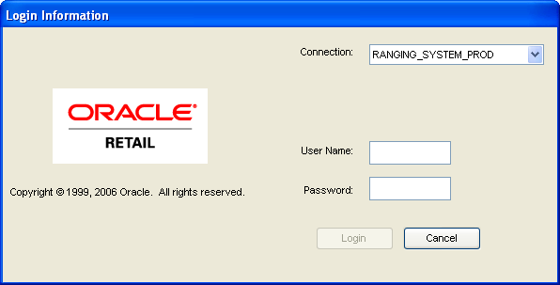 | Authenticate using the Login ID provided by your admin  cespino/cespino
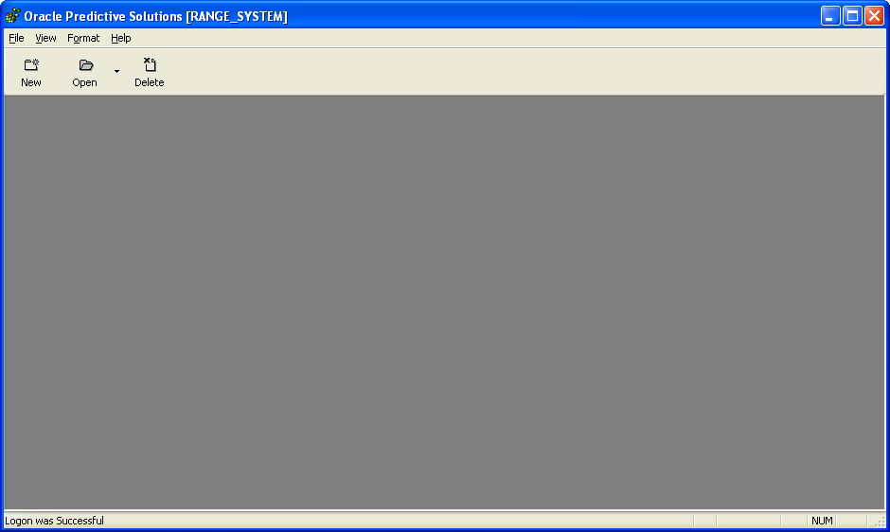 | On the upper left window, click on the NEW icon
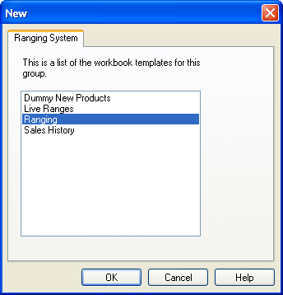 | Select Ranging then click OK
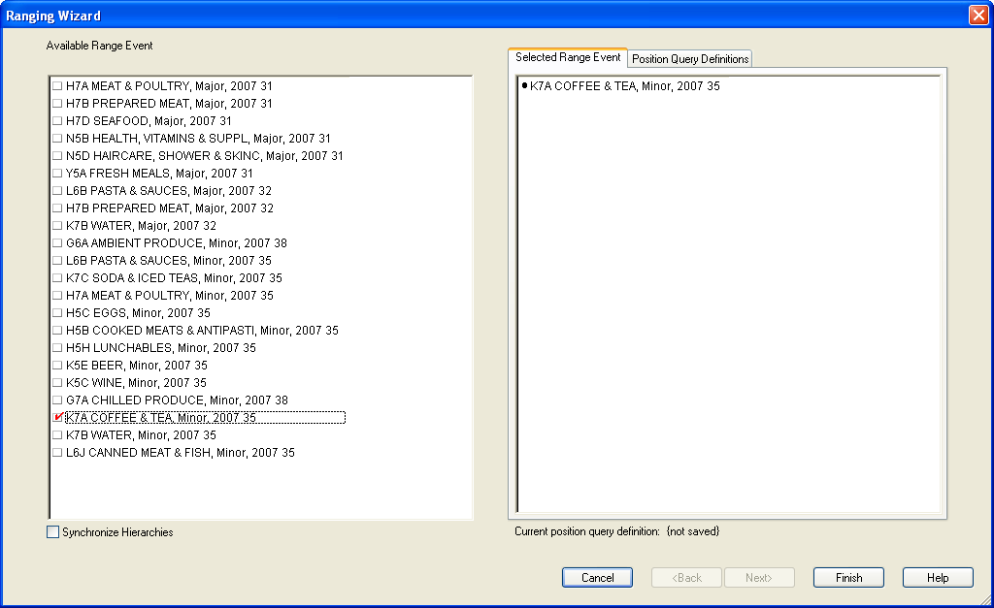 | Select the Event that you want to Range  Once you’ve selected the range that you selected will show up on the right frame of the window  You can only Range 1 event at a time  Click Finish button when you’re done
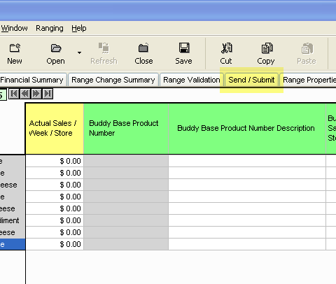 | Click on Send/Submit tab

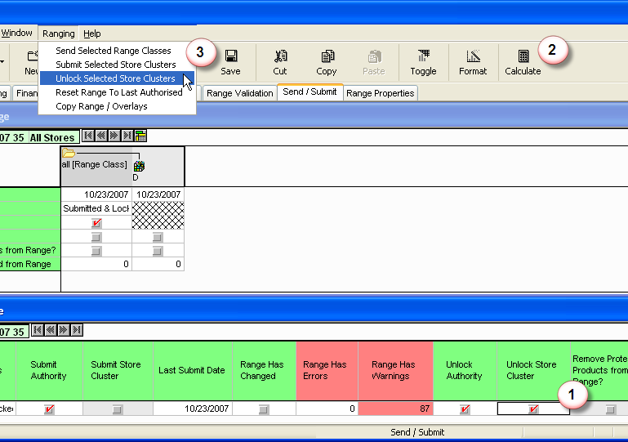 | ( 1 ) Check Unlock Store Cluster  ( 2 ) Click Calculate  ( 3 ) Click Ranging then select Unlock Selected Store Clusters

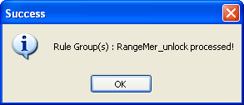 | A window will pop-up to confirm that the Store Clusters were Unlocked successfully  Click OK

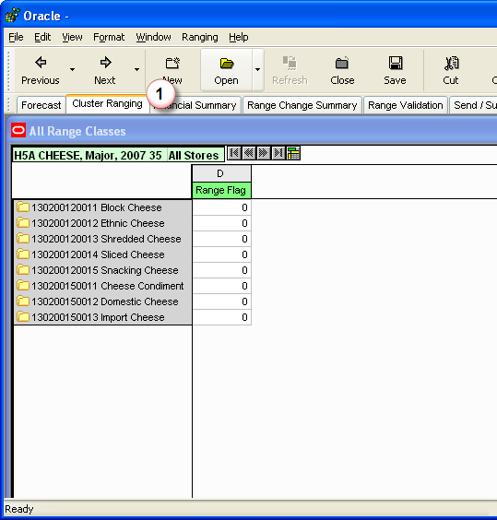 | ( 1 ) Click on Cluster Ranging tab to start Ranging

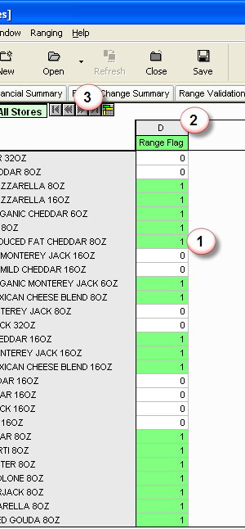 | Select the products that needs to be ranged  ( 1 ) On the left column, identify the products that you need to range. Enter 1 in column D for products that you want to be ranged, enter 0 for products that you don’t want to be ranged  ( 2 ) The D column indicates the Range Class, for certain Display Groups there could be 2 Range Classes defined  Range class are as follows:  A = 1 fixture  B = 2 fixtures  C = 3 fixtures  D = 4 fixtures  E = 5 fixtures  F = 6 fixtures  G = 7 fixtures  H = 8 fixtures  I = 9 fixtures  J = 10 fixtures  ( 3 ) Certain Display Groups could have multiple clusters, once you’re done ranging your current cluster select the button to work on the next cluster. If the icons are shaded then you don’t have any store clusters in this Display Group.

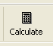 | Once you’re done ranging, click on the calculate button on the far right of the window
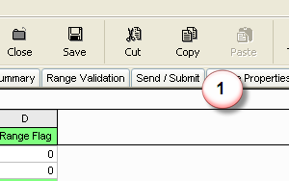 | Click Send / Submit tab
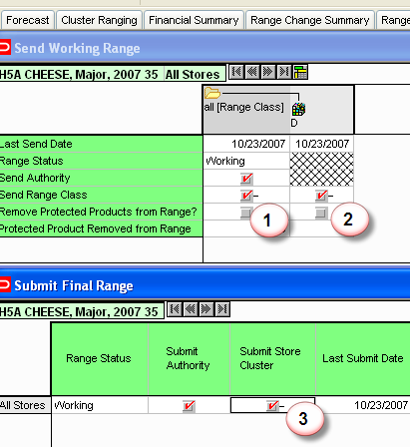 | Click both Send range Class Columns  ( 1 ) All Range Class column  ( 2 ) D column  ( 3 ) Click the All Stores box under the Submit Store column
 | Click on the calculate button on the far right of the window
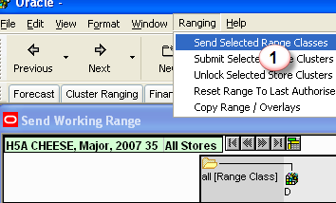 | From the menu  ( 1 ) Select Ranging then click Send Selected Range Classes

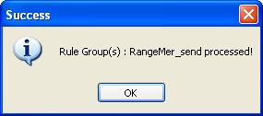 | A pop-up window will confirm that the Range and Cluster has been processed  Click OK
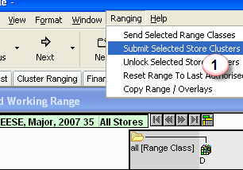 | From the menu  ( 1 ) Select Ranging then click Submit Selected Store Clusters
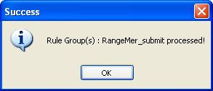 | A pop-up window will confirm that the Range and Cluster info has been processed  Click OK
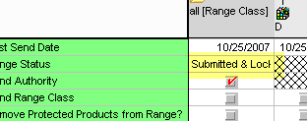 | The range status has been updated to Submitted & Locked
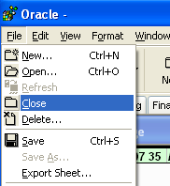 | To exit out of the Application  Select File then Close
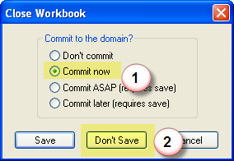 | A window will prompt you  ( 1 ) Select Commit Now  * Commit the changes to the database  Then  ( 2 ) Don’t Save  * By default it will try to save to your local machine, by selecting don’t save it will save it to the database
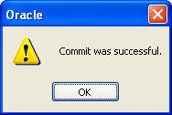 | A window will prompt you that the changes you’ve done are now saved to the database  Click OK
The application will return you back to a blank window, you can exit from here.

If you need to range more Display Groups, select the NEW icon.

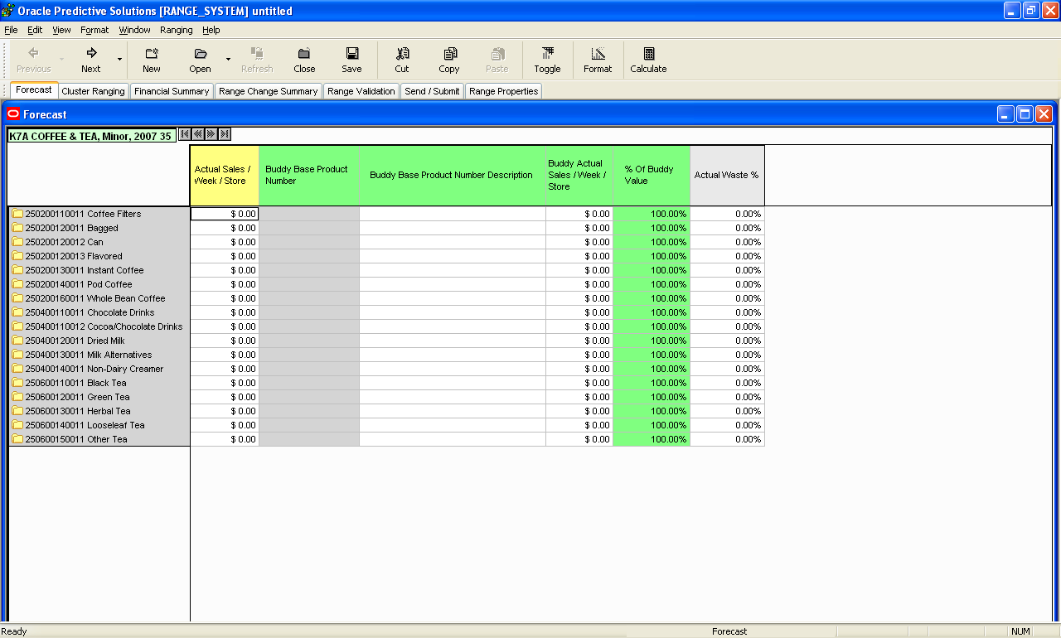

Click on Calculate
Click Send/Submit tab

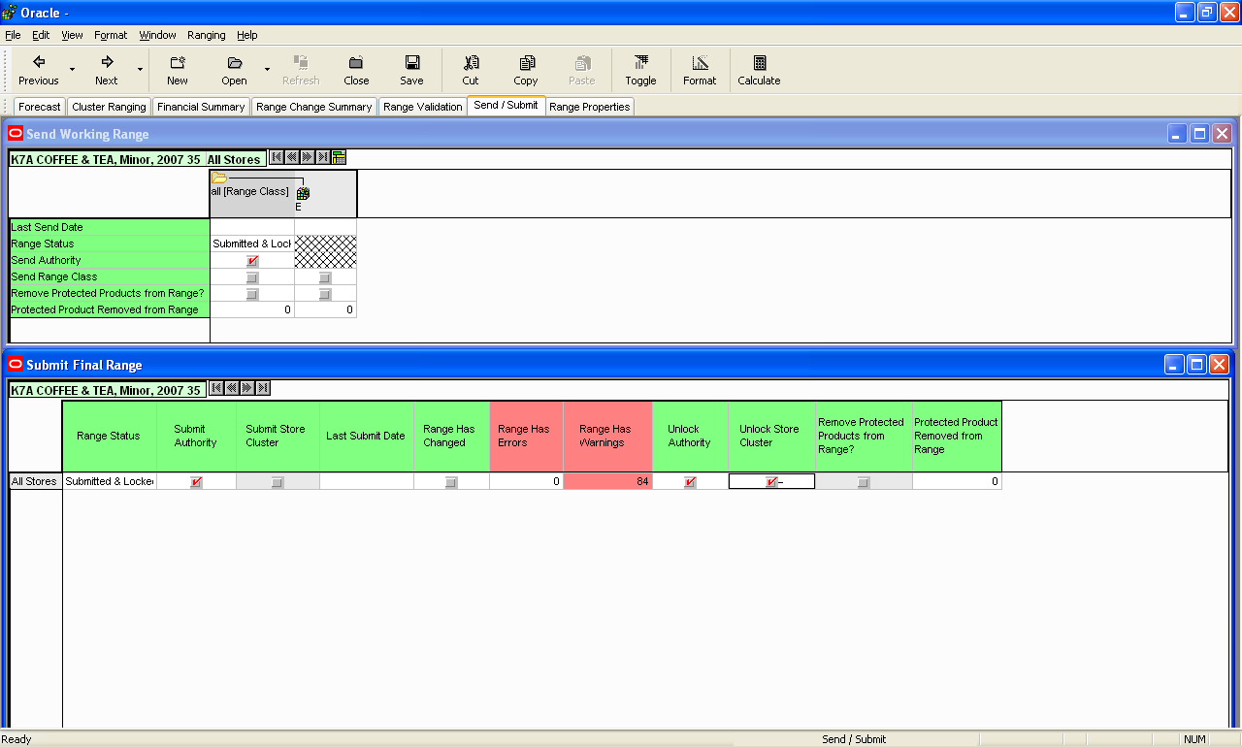

Click on Unlock Store Cluster (bottom right, 3rd row)
Then click Ranging (top menu) and select Unlock Selected Store Clusters

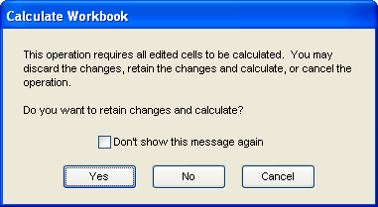

Select Yes

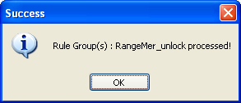

This will verify that the range was unlocked, then Click Ok.

Select Cluster Ranging Icon (see below)

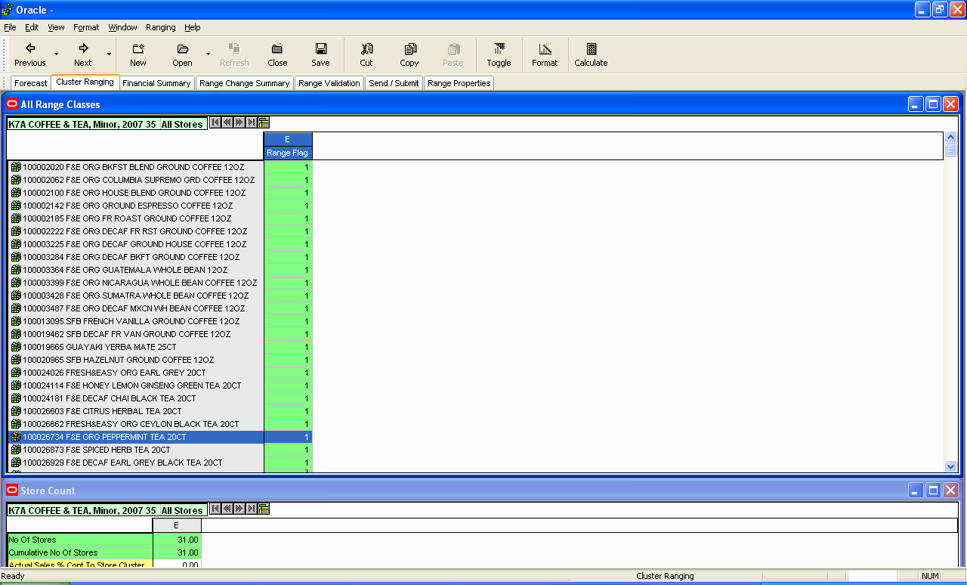

Add 1 for items you want to range, 0 for items you do not want to range or deleted/removed

The Column E indicates the number of MODs e.g.
A – 1
B – 2
C – 3
D – 4
E – 5
F – 6

Once you’ve made your changes

Then click CALCULATE

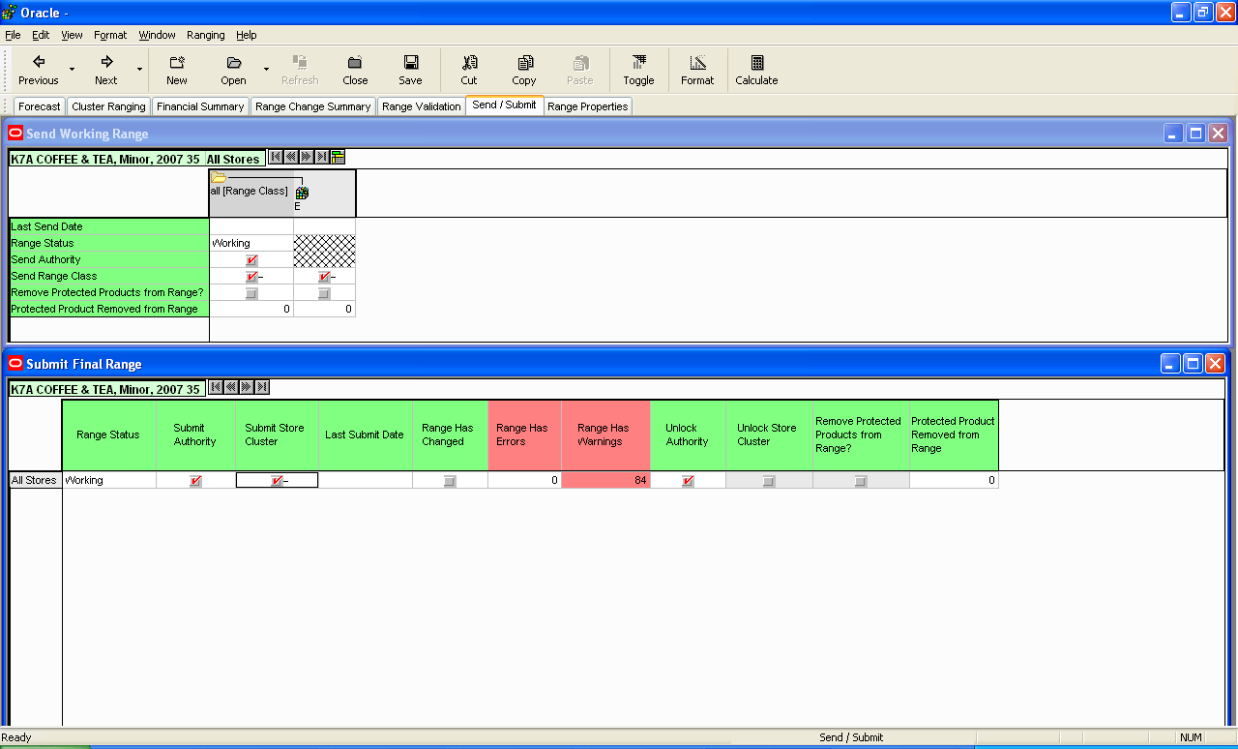

Click Send/Submit Tab
Click 2 Send Range Class buttons
Click Send Store Cluster button
Click Calculate
Click Ranging menu icon
Select Send Selected Range Class
You will be prompted with

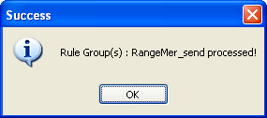

Click OK

Click Ranging menu
Select Submit Store Selected Cluster

You will be prompted with
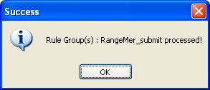

Click OK

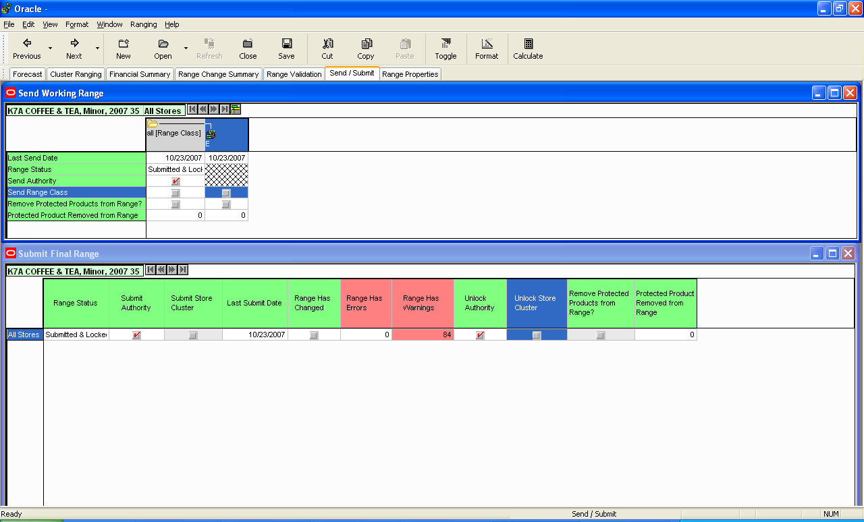

Status will now be Submitted & Locked (see grey column)

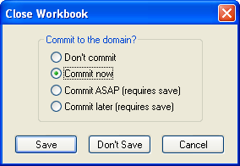

Click Close, then a window will prompt you
Select Commit Now and click Don’t Save

Window will prompt you for the following

